**HDC202309 – RFQ - Clarifications 2, received from 1st December up until 12.00 noon on the 8th ofDecember 2023**

1. Is there any information about the site's use before it was a motocross track?

**No, but extensive groundwork has previously been undertaken on over half of the old track and no issues found**.

1. Do you have any ground reports which provide information on ground make-up?

**It is a very sandy soil.** 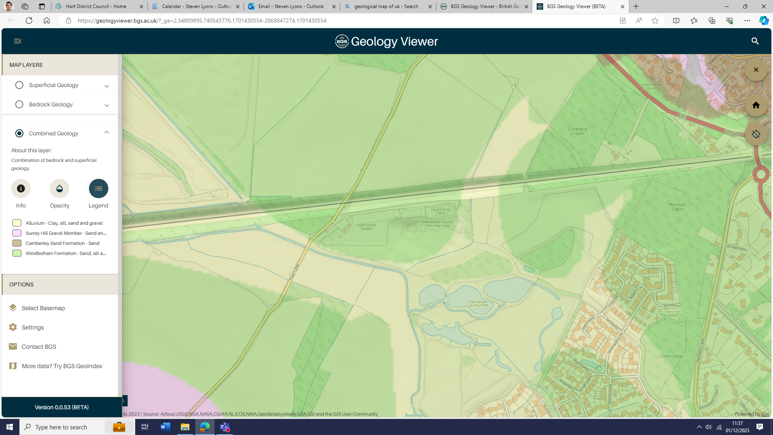

1. Are there any existing underground utility drawings that can be shared?

**There are no known services in the proposed area of works, but a power cable is in the ground near the railway line running under the access road and a water main in the field next door. Relevant drawings will be shared with the winning contractor.**

1. Is the existing fenced compound area adjacent to the car park available to use during construction e.g. for storing plant and materials?

**Yes, as stated in the RFQ.**

1. What can you tell us about the existing drainage dykes in the old motocross area? Who built them, why are they there?

**They were built to drain the motorcross track by the track builders.**

1. Is the war bunker a visitor attraction for members of the public? Is there anything else you can tell us about the war bunker that may impact the design and construction process?

**Future interpretation is planned for the bunker and for the public to come and look at it. Any course design needs to avoid it preferably passing behind it just uphill from it.**