

BLYTH TOWN COUNCIL

INVITATION TO TENDER

SKATE PARK SCHEME

MAY 2023
1. Introduction

  - Blyth Town Council propose to install a new Skate Park which must have a handover date prior to the end of September 2024. The successful contractor can program this work as soon as possible as can be shown in Section 18 of this document. This exciting project is designed to help enhance the Play and Sport Provision as provided by the Town Council within Blyth.

The new Skate Park is in the Isabella area of the town.

  - Within this invitation to tender, there is the opportunity to for interested companies to submit a price for this project as outlined.

2. Isabella Skate Park

The new Skate Park is to be installed at the location shown below.

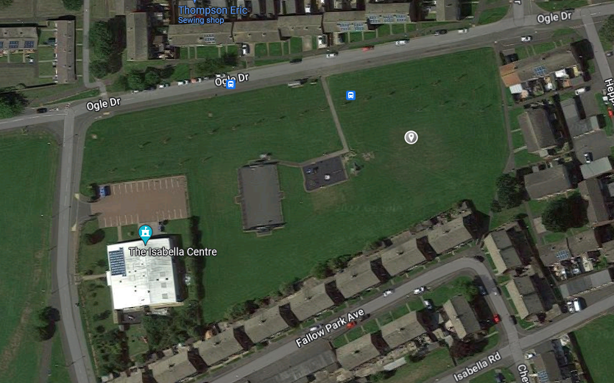
Location: https://goo.gl/maps/LJH7twkW1WLFS1wTA

This is a site where the existing ground is that of a grassed area.

The size of the park when the Council did a consultation exercise is, as a guide, 28 by 18 metres for the footprint of the skating element of the park. Any variation to this should be as minimal as possible in achieving the objectives detailed below.

The Council have agreed on objectives that they wish the Skate Park to meet (See Park Design brief below).

The Council have also agreed that the Park will be lit to allow greater use during the Autumn through to Spring months and that there will be landscaping surrounding the Park. These additions will be provided separately by another contractor.

Park Design
The contractor is to come up with a design that satisfies the following brief. The park must have 4 distinct zones as follows:
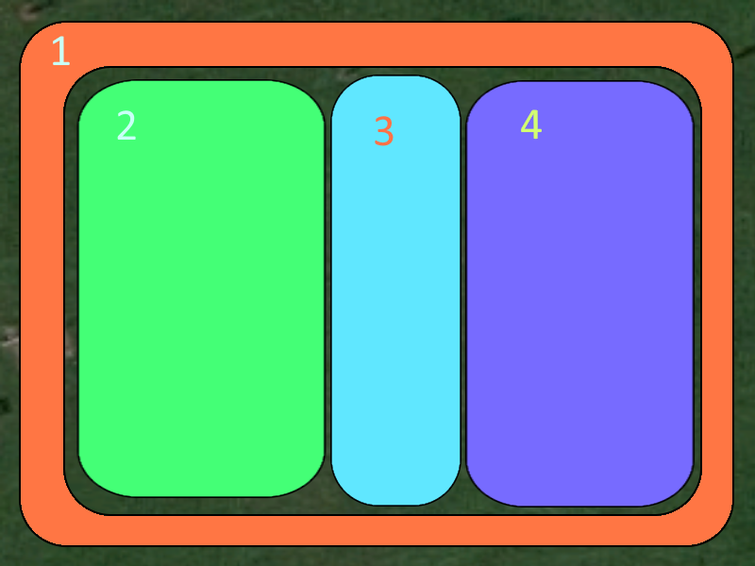

- A Fun Run
The idea for this is a mellow snake run running around the periphery of the park.
This would be a flowing undulating run with a few street and pool elements in. It is primarily to keep younger park users out of the main park but also to be a fun course for more experienced park users when empty.
- Plaza
This section will contain more street-type features (ledges, flat bars, manual pads, driveway, stair set, hips, pole jams, etc).
The idea behind this section is to appeal to the traditional street style skater.
Emphasis should be to have fun, progressive features that don’t demand too much effort to either progress to or skate but still offer a challenge to both new and seasoned park users.
- Space
As the name suggests. This section will be left clear to allow for some flat ground space for both beginners and flat ground skaters (eg: freestyle bmx or games of skate)
It’s also to facilitate portable and/or temporary skateable structures being brought to the park for events.
- Lumps and Bumps
This part of the park is fully for curved surfaces and smooth rolling transitions between flat and angles surfaces.
Obstacles like volcanoes, nipples, 1/4s, wall rides, banks-to-curbs, no-coping spines, roll-overs, doorways, jersey barriers, etc.
This part of the park is for transition park users to encourage lots of surf style skating and aerial stunts.

Design Considerations:

- Sizing
Proportions and shape of each area can vary with the design, but it is imperative that these zones exist and are visually distinct from each other.
- Less is more
Despite the many examples of features given, it’s imperative that each area is not too “busy” or designed in a way to inhibit the flow of traffic or stifle creativity when choosing lines.
- Obstacle variety
Although there are distinctly different sections of the park, designs can make use of obstacles in areas that add to park creativity and novelty (in a functional way). For example, pool coping on the banked corners on the fun run, a curved rail from nipple to nipple in Lumps and Bumps, etc.

The Council has a budget of £220,000 for this project and that Contractors should work within this, with their proposals.

The Skate Park will be located to the east of the path from Ogle Drive to the Olga Potts Play Area, and as such the small amount of paving groundworks required can be addressed separately by the Council.

Build Specification

A flood and surface water management assessment and plan should inform the design. The site should form a level bench taking into consideration the movement of water over and under the site. Appropriate mitigation will be implemented to ensure heaving of slabs is prevented.
In addition to this, the park construction should incorporate the following where applicable:

Earthworks

- Install stable clean fill material of not greater than 40mm in size, and layers of compacted material will not to exceed 200mm.

- All new and disturbed finished earthworks are to be turfed (artificial or other material) and evenly graded to tie into existing natural ground levels (not seeded).

- Earth surface shall be graded away from hardscapes to ensure no pooling of water occurs against hardscape edges.

Concrete

- A plan showing anticipated saw cuts shall be agreed upon. Saw cuts will be carried out in accordance with the plan unless otherwise agreed. Saw cut depth to be 30mm deep.
- Saw cut all slabs maximum of 24hrs after pour.
- Where pool coping is to be used it must be laid after the transition has been completed not before or during.
- All concrete to have burnished trowel finish.
- Cracks occurring within the first 12 months of installation are to be repaired by the contractor in accordance with the following requirements.

- Cracks up to 0.15mm no treatment
- From 0.15mm to 1.00mm epoxy crack injection
- 1.00mm wide removal and full reconstruction of crack
- Grading of the concrete surface to prevent any pooling of water.
- Curing of concrete, cover for 7 days with plastic or apply liquid membrane curing compound within 1 hour of concrete finishing.
- Use of non-corrosive bar chairs
- All exposed concrete surfaces are to be densified and sealed.

Steelwork
- Minimum 8mm rebar. All steelwork should be encased in 75mm concrete al round.
- Mesh rebar should not be used. In-situ metal formwork must not be used.
- All formwork should be wooden. This will ensure any defects post-pour can be identified when the formwork is removed.
- Maintenance programme to include yearly seal with appropriate sealant.

Community Engagement
In an effort to grow skatepark construction resource and expertise in the region, the contractor will employ a member of the local skate scene for the duration of the build project. This individual will have suitable experience in groundworks and construction prior to the commencement of the project.

3. General Information

  - At this stage we would like all of the works agreed to be started as soon as practicable in this financial year. The Council would hope that these discussions to agree a date could commence when we hope to notify the successful contractor in June 2023.

  - This document is designed to allow a potential supplier to apply a degree of flexibility with regard to the proposed design which should be to current British Standards and to the aims of the Council. This flexibility, if accepted, is to ensure where possible that users are given a variety should Skate Parks be visited nearby.

  - The Skate Park design is on the basis that it provides the necessary learning, play and skill development requirements for all ages.

5.4 Potential Contractors should ensure that they have sufficient information to submit a quotation. The information provided should be used as the basis of the submitted price, but if there are any queries whatsoever, please contact the Town Council.

5.5 The purpose of this brief is to obtain competitive tenders and to form the basis of the relevant appointment. However, the Council reserves the right to add to, omit from, or amend the brief in any way prior to the appointment of the supplier and execution of the works. Changes that materially affect the provision of services described herein and cause a change in the price then such altered services are agreed between the Council and the appointed Company.

5.6 Any solicitation and/or relationship to Town Councillors will preclude a quotation being submitted.

5.7 Any contract awarded will be in accordance with JCT Standards.

5.8 The Skate Park, although the responsibility of Blyth Town Council is under the land ownership of Northumberland County Council and the appropriate approvals for this work have been given.
5.9 Contractors should be aware that there may be other Contractors working alongside e.g., Street Lighting, Paving Contractor etc.

6. Assumptions and Constraints

6.1 Local Authority contracting, tendering and seeking quotations is strictly governed by the Standing Orders of the Town Council. It is fully transparent and is based on fair and genuine competition.

6.2 The contractor will provide a tender for a completion price, detailing costs as requested in Section 18 of this form.

6.3 The contractor shall hold, and provide, copies of the required insurance and public liability cover to a minimum of £5million.

6.4 The Town Council is committed to equal opportunities in all respects of its operation and encourages contractors to implement similar policies.

6.5 The contractor will comply with the latest Health and Safety at Work Act and shall hold the relevant Health and Safety certificates, including those specific to the job.

6.6 The contractor will hold in place a relevant written Health and Safety Policy and shall complete a risk assessment for the tasks to be undertaken.

6.7 The Contractor shall comply with the Control of Waste regulations.

7. General Requirements

7.1 The contractor shall be legally authorised to perform all aspects of the work quoted for.

7.2 The contractor should own or have legal access to the appropriate equipment to undertake the work quoted for.

7.4 The contractor must provide copies to the Town Council, of appropriate personal and public liability insurance cover, appropriate licenses and risk assessments within the tender submission. All such documents shall be current.

8. Change Management

8.1 Any alteration to the specifications agreed in the works order may be subject to the following change management procedures. A change management schedule will be signed by both parties in every instance.

8.2 Any changes to the specifications, where the tender price is reduced, will be with the express consent of the Town Clerk, and as agreed with the contractor.

8.3 Any changes to the specifications, where the agreed price is increased by under £500, will be with the express consent of the Town Clerk, and as agreed by the contractor. Any changes to the specifications, where the agreed price is increased by over £500, will be with the express consent of the Town Council, and as agreed by the contractor.

8.4 The contractor shall not instigate any changes to the schedule out with the change management procedures. Should the contractor do so then all costs will be borne by them and not from any contingency sum included in the submission or contract. They may also be required to rectify any changes that have been undertaken.

8.5 Any invoices issued for work that has not been authorised through the above procedure will be rejected.

9. Instructions to Contractors

9.1 It is the responsibility of the Contractor to obtain for themselves, at their own expense, any additional information necessary for the preparation of their tender.

9.2 All tenderers are required to satisfy themselves that they are in possession of sufficient information to prepare a detailed and fixed price offer. If any errors are made due to failure to obtain such information, the responsibility therein lies with the tenderer.

9.3 All information provided by Blyth Town Council in connection with this tender shall be treated as confidential by the Contractors, except where such information may be disclosed for the purpose of obtaining sureties and quotations necessary for the preparation and submission of the price.

9.4 All information submitted to the Town Council may need to be disclosed and/or published under the Freedom of Information Act. If the tenderer considers that any information included in the tender submission is commercially sensitive, it will need to be identified and an explanation in broad terms of what harm might result from disclosure provided. However, this information may still be disclosed should the Town Council be required to do so under the current legislation, even if this information is marked “confidential” or the equivalent.

9.5 Any questions relating to this invitation to tender must be raised no later than the date shown on the schedule. Any questions raised within the scheduled timescales provided, together with the answers provided by the Council, will be circulated to all parties who have notified us that they may be submitting a quotation. Council staff should only be contacted, if necessary, to assist potential Contractors in clarifying any queries in line with their tender submission, and not to encourage or support their tender outside the prescribed process.

9.6 Any organisation wishing to tender for this work must present their submission in full by the required closing date and time. Any quotation received after this date and time will not be considered.

9.7 Should the Contractor wish to arrange an accompanied site visit in conjunction with current guidelines, please contact the Council by email at info@blythtowncouncil.org.uk or telephone 01670 361668.

9.8 The contractor should indicate in Section 18 their anticipated start date.

9.9 The Town Council has provided the Terms and Conditions of the proposed contract and these are expected to be met.

9.10If any questions relating to the Terms and Conditions of the work needs to be raised, they must be done according to the schedule. Any questions relating to the Terms and Conditions, or any other item within this quotation, which are sent to the Town Council after the required date will be considered at the sole discretion of the Town Council.

10. Tender Process

10.1 All tenders must be submitted to the Council as follows; section 7 also refers:

- Tenders are sent to tenders@blythtowncouncil.org.uk.
- An automated reply is sent to the sender on its receipt, confirming submission. The message also states that they are welcome to repeat if they need to send additional documents.
- Tender Applications are stored in a secure account that remains locked until the set time.
- At the time required for the opening of tenders, the e/mail account and documents shall then be available and shared to all Staff/councillors involved in the process with email tracking options active (read receipt/email delivery) to ensure all access is monitored.

10.2 All submissions will be opened at the appointed time i.e., the closing date and time in the presence of the Town Clerk. Changes to working practices, in the event of e.g., further guidelines re Covid19, may require the need for virtual meetings.

10.3 The quotations will be assessed on a number of criteria including:

- Quality of design
- Adherence to skatepark design brief
- Maintainability
- Progressiveness
- Flow
- Safety
- Value
- References
- After sales/installation
- Incorporation of local elements in the design

10.4 The Clerk will follow up reference information provided by all shortlisted contractors.

10.5 The Council may need to clarify issues with the shortlisted contractors and relevant information subsequently obtained.

10.6 Contractors should contact the Council prior to the closing date to inform that documents have been sent, in the event of no receipt confirmation having been received as outlined in 10.1.2.

11. Timescales

Action | Date
Issue of brief for proposed Skate Park | Monday 17 July 2023
Closing date for questions relating to proposals | Tuesday 1 August
Responses to questions provided back to all interested parties by | Tuesday 8 August
Closing time and date for return of prices | Tuesday 22 August  12.00 noon
Opening of Tenders | Tuesday 22 August
References requested | Wednesday 23 August
Closing date for reference returns | Wednesday 30 August
Officer Evaluation by | Thursday 31 August
Review of shortlist and recommended Contractor by | Special Env Committee to be arranged.
Contractors notified of decision | Subject to the above, but shortly thereafter.

Please note that should any of the above dates changed you will be notified.

12. Contractor Form

The Town Council requires to know details of any individual organisation or partnership with whom it may enter into a contract. This will enable it to demonstrate safeguarding of public funds and that there will be no conflict of interest in awarding this contract.

Any false information knowingly provided will immediately deem the tender submission invalid.

Company Details

Name of Company in whose name business is to be transacted
Registered Address
Principal Contact
Telephone – mobile number preferred
Email address
Please indicate membership of any professional or trade bodies
Please indicate how many years this company has traded
Company number (if relevant)
Staffing levels | Permanent | Casual

13. Legal Information and Professional Conduct

What is the legal status of your organisation (e.g. sole trader, private limited company, partnership etc)
VAT Registration Number
If this is a partnership please supply the full names of all partners on a separate sheet if necessary
Has your organisation been convicted (or has any outstanding actions) of a criminal nature relating to the conduct of its business or profession?  If yes please provide details on a separate sheet | Yes/No
Has your organisation failed to fulfil its obligations relating to the payment of contributions or taxes under the law of any part of the United Kingdom.  If yes please provide details on a separate sheet | Yes/No
Has your organisation had a contract cancelled, or not renewed, for failure to perform to the terms of that contract?  If yes please provide details on a separate sheet | Yes/No
By Law (RIDDOR), you must report certain injuries, diseases and dangerous occurrences to the Health and Safety Executive. Has your organisation had to make any such reports under RIDDOR in the past five years?  If yes please provide details on a separate sheet | Yes/No
In the past five years have you or your organisation, or any of your employees, been served with a prohibition or improvement notice, or been convicted of any offence in law, enforced by the Health and Safety Executive, Local Authority, Police or the Department of Transport?  If yes please provide details on a separate sheet | Yes/No

14. Financial Details

Please indicate the annual turnover of your organisation over the last three years

£ | Year:
£ | Year:
£ | Year:

The Town Council may carry out a financial assessment on all applicants. Sets of accounts are not required at this stage but may be requested prior to awarding the contract.

Please provide details of your bankers. They may be, should you be shortlisted, required to provide you with a reference

Please note that all payments will be made by bank transfer.

15. Health and Safety

All applicants undertaking works under this tender must satisfy the Town Council of their competency regarding Health and Safety.

Please enclose details of your current Health and Safety Policy and any relevant certificates pertinent to this tender, together with the name of the person responsible for the management of health and safety in your organisation.

16. Insurances

Please provide details of your organisation’s insurance protection in relation to employer’s liability and public liability.

Policy | Insurer | Value £
Employer’s Liability
Public Liability

Please enclose a copy of the insurance certificates, which must be current.

17. References

Please provide two references for work carried out in the past three years; one of the references must be either a current contract or one that has completed within the last twelve months (no earlier than April 2022). The referees should not be related to any member of your company. To speed up the assessment process it would be advantageous to be able to contact referees via email – please provide a relevant email address for each reference. Please inform your referees that we may contact them in order to allow a speedier response and of the date we require references by.

Reference 1

Contact name
Contact phone & email
Full postal Address
Brief description of works, their value and the date the work was carried out
Please confirm this referee is aware and that you authorise the Council to contact the referee at the Council’s discretion

Reference 2

Contact name
Contact phone & email
Full postal Address
Brief description of works, their value and the date the work was carried out
Please confirm this referee is aware and that you authorise the Council to contact the referee at the Council’s discretion

18. Tender and Price Contract

I believe that the company, as detailed in Section 12 of the Tender Form, meets the entire requirements outlined in this brief and that I and my company are qualified to undertake the works described. I will comply with the requirements for a contractor performing the work stated as set out in invitation to quote and JCT Minor Works Building Contract 2016.

I agree to the terms and conditions as set out in these documents.

To carry out the works detailed in the schedule of works, the company, as detailed in Section 12 of the Tender Form, will charge, where applicable:

£ …………….. Isabella Skate Park

Please detail below the guarantees in relation to the above:

I anticipate commencing the necessary works and completion of works, subject to agreement, on:

Project | Commencement Date | Completion Date
Isabella Skate Park

I agree that this sum will/may be paid over interim payments on the production of suitable evidence as agreed by the Town Clerk. This can be further discussed on award of Contract.

Any contract variation, whether affecting the contract sum or not, shall be agreed prior to the specific addition/deletion carried out.

Signature ………………………………………………. Date…………….

Name ………………………………………………..

Company Name ……………………………………………………………

