**Invitation to Tender**

***Building a Horse Arena and Turnout Area***

**Ref: RUR 1051**

# 1. About RC & CM Tonks

RC & CM Tonks is a family run partnership farming business. The partnership operate on Ventonwyn Farm, Tregony, Truro, TR2 5SH. The farm has been run for over 60 years+ by the Tonks family. One area that the Tonks Family are passionate about is equestrian training.

# 2. Background and Context

We wish to grow our business with the provision of new equestrian facilities.

The purchase of this system is part of a grant funded application process and therefore procurement will be subject to grant approval of the project. We will assess tenders received on a Most Economically Advantageous Tender.

# 3. Tender requirements

1. Location

Ventonwyn Farm, Tregony, Truro, TR2 5SH

1. Site Plan and overview

Below is a plan for the equestrian facilities to be built. This tender is specifically for the yellow highlighted sections of building the horse sand arena and the “holding area” otherwise referred to as the turnout area. Part of the scope of this tender also includes installing new access roadway from the existing tarmac lane into the grey “Hardstanding Yard” that you can see in the drawing below.

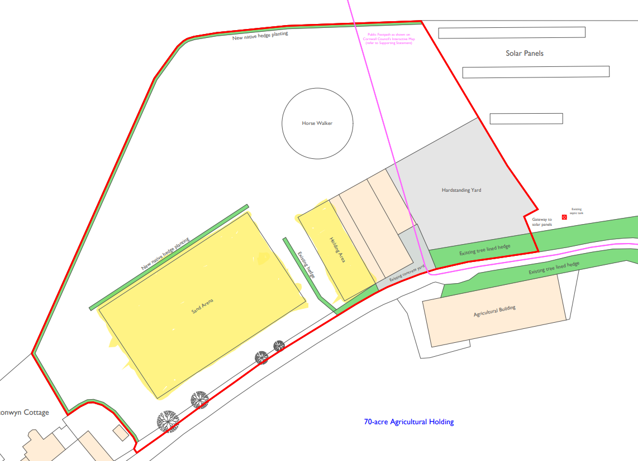

1. Construction of New sand school arena and associated works
2. Install new access roadway from existing tarmac lane to allow lorry's into new site for construction of horse sand school arena strip topsoil to create access road lay 150-200mm of hardcore to create access road.
3. Excavations for new sand school arena (50m x 30m) by stripping

turf from existing grass field strip topsoil reduce dig area to required levels batter side profiles all spoil to be moved to pile next to arena.

1. Construction of new sand school arena (50m x 30m)
2. excavate and grade area to exact levels required install 5 drainage runs across area using 100mm perforated pipe and back filling with 40mm clean stone (drainage outlet to be confirmed)
3. supply and install geo textile membrane (layer 1)
4. supply and lay 100mm 505b clean stone and compact to create subbase for arena supply and install 9"x2" wood kick board around perimeter of new sand school
5. supply and install Horse arena grade geotextile (layer 2)
6. supply and lay 100mm of Cornish sea sand and level to create final finish.
7. Construction of New cooling down arena and associated works
8. Excavations for new cooling down sand school arena (15m x 30m) by stripping turf from existing grass field strip topsoil reduce dig area to required levels batter side profiles all spoil to be moved into pile next to arena.
9. Construction of new cooling down sand school arena (15m x 30m) excavate and grade area to exact levels required
   1. install 3 drainage runs across area using 100mm perforated pipe and back filling with 40mm clean stone (drainage outlet to be confirmed)
   2. supply and install geo textile membrane (layer 1)
   3. supply and lay 100mm 505b clean stone and compact to create subbase for arena
   4. supply and install 9"x2" wood kick board around perimeter of new sand school
   5. supply and install Horse arena grade geotextile (layer 2)
   6. supply and lay 100mm of Cornish sea sand and level to create final finish. (Fencing of cooling down arena to be confirmed)

4**. Budget**

The total maximum budget available for this commission is £60,000 (exc VAT) but inclusive of all expenses.

**Tenders that exceed the total budget will not be considered.**

The budget will be reviewed as part of the tender evaluation detailed in Section 10 and will reflect the degree to which there is a saving on the maximum budget

# 5. Tender and commission timetable

The timescale of the programme is from the date of signing the contract until the 31 December 2024. The timetable for submission of the Tender, completion of the programme are set out below:

|  |  |
| --- | --- |
| **Milestone** | **Date** |
| Date ITT available on Contracts Finder | 18 October 2024 |
| Site visit can be arranged by email with matthew.bain@stewe.co.uk | 18 – 25 October 2024 |
| Last date for raising queries | 1700: 25 October 2024 |
| Last date for clarifications to queries | 1700: 28 October 2024 |
| Deadline to return ITT | **1200: 8 November 2024** |
| Evaluation of ITT | 11-12 November 2024 |
| Award of Contract | 13 November 2024 |
| Contract Start | 18 November 2024 |
| Contract complete | 31 December 2024 |

# 6. Tender submission requirements

Please include the following information in your Tender submission.

6.1 Covering letter (two sides of A4 maximum) to include:

1. A single point of contact for all contact between the tenderer and RC & CM Tonks during the tender selection process, and for further correspondence.
2. Confirmation that the tenderer has the resources available to meet the requirements outlined in this brief and its timelines
3. Confirmation that the tenderer holds current valid insurance policies as set out below and, if successful, supporting documentation will be provided as evidence:
4. Professional Indemnity Insurance with a limit of indemnity of not less than one million (£1,000,000),
5. Employers Liability Insurance with a limit of indemnity of not less than one million (£1,000,000)
6. Public Liability Insurance with a limit of indemnity of not less than one million (£1,000,000).
7. Conflict of interest statement
8. Please confirm you can meet or exceed the specification detailed in Section 3 and in particular Cornish Sand

6.2 Details of 3 projects of similar value and size of which at least one must be related to the construction/renovation of equestrian facilities. Each Example should be no more than 2 sides of A4 not including any photographs, but these can only have titles and no text. Links to websites will not be viewed.

6.3 Budget

**7. Sub-contracting**

Tenderers should note that a consortia can submit a tender but the sub-contracting of aspects of this commission after appointment will only be allowed by prior agreement with RC & CM Tonks.

**8. Conflicts of Interest**

Tenderers must provide a clear statement with regard to potential conflicts of interests. Therefore, **please confirm within your tender submission** whether, to the best of your knowledge, there is any conflict of interest between your organisation and RC & CM Tonks or its programme team that is likely to influence the outcome of this procurement either directly or indirectly through financial, economic or other personal interest which might be perceived to compromise the impartiality and independence of any party in the context of this procurement procedure.

Receipt of this statement will permit RC & CM Tonks to ensure that, in the event of a conflict of interest being notified or noticed, appropriate steps are taken to ensure that the evaluation of any submission will be undertaken by an independent and impartial panel.

# 9. Tender clarifications

Any clarification queries arising from this Invitation to Tender which may have a bearing on the offer should be raised by email to:

[matthew.bain@stewe.co.uk](mailto:matthew.bain@stewe.co.uk)

in accordance with the Tender and Commission Timetable in section 5.

writing and duly signed by a Director/Partner of the tenderer. All such correspondence shall be returned with the Tender Documents and shall form part of the contract.

# 10. Tender evaluation methodology

Each Tender will be checked for completeness and compliance with all requirements of the ITT. Tenders will be evaluated to determine the most economically advantageous offer taking into consideration the award criteria.

**Tender returns will be assessed on the basis of the following tender award criteria**

|  |  |
| --- | --- |
| Ref 6.1 Covering Letter |  |
| Acceptable covering letter including confirmation of the requirements detailed at 6.1 | Pass/ Fail |
| Ref 6.2 Previous examples | 30 |
| Details of 3 projects of similar value and size of which at least one must be related to the construction/renovation of equestrian facilities. Each Example should be no more than 2 sides of A4 not including any photographs, but these can only have titles and no text. Links to websites will not be viewed. |  |
| Ref 6.3 Budget | 70 |
| A **fixed fee** for this work (exc VAT) including travel and other expenses  The lowest bid will be awarded the full xx marks. Other bids will be awarded a mark that is proportionate to the level of their bid in comparison to the lowest bid i.e. Marks awarded = 70 x lowest bid / bid |  |

11**. Assessment of the Tender**

The reviewer will award the marks depending upon their assessment of the applicant’s tender submission using the following scoring to assess the response:

|  |  |  |
| --- | --- | --- |
| **Scoring Matrix for Award Criteria** | | |
| Score | Judgement | Interpretation |
| 100% | Excellent | Exceptional demonstration of the relevant ability, understanding, experience, skills, resource and/or quality measures required to provide the goods/works/services. Full evidence provided where required to support the response. |
| 80% | Good | Above average demonstration of the relevant ability, understanding, experience, skills, resource and/or quality measures required to provide the goods/works/services. Majority evidence provided to support the response. |
| 60% | Acceptable | Demonstration of the relevant ability, understanding, experience, skills, resource and/or quality measures required to provide the goods/works/services, with some evidence to support the response. |
| 40% | Minor Reservations | Some minor reservations of the relevant ability, understanding, experience, skills, resource and/or quality measures required to provide the goods/works/services, with little or no evidence to support the response. |
| 20% | Serious Reservations | Considerable reservations of the relevant ability, understanding, experience, skills, resource and/or quality measures required to provide the goods/works/services, with little or no evidence to support the response. |
| 0% | Unacceptable | Does not comply and/or insufficient information provided to demonstrate that there is the ability, understanding, experience, skills, resource and/or quality measures required to provide the goods/works/services, with little or no evidence to support the response. |

During the tender assessment period, RC & CM Tonks reserves the right to seek clarification in writing from the tenderers, to assist it in its consideration of the tender. Tenders will be evaluated to determine the most economically advantageous offer taking into consideration the award criteria weightings in the table above.

RC & CM Tonks is not bound to accept the lowest price or any tender. RC & CM Tonks will not reimburse any expense incurred in preparing tender responses. Any contract award will be conditional on the Contract being approved in accordance with RC & CM Tonks’s internal procedures and RC & CM Tonks being able to proceed.

13**. Tender Award**

Any contract awarded as a result of this tender process will be in accordance with this ITT and the supplier’s response.

# 14. Tender returns

Tenders are to be returned by email.

Tenders are to be returned in accordance with Section 5

Latest date to be returned: As per Section 5

Latest time to be returned: 17:00

Emailed tenders should be sent electronically to

[matthew.bain@stewe.co.uk](mailto:matthew.bain@stewe.co.uk)

with the following message clearly noted in the Subject box;

‘RUR 1051 Tender Response’

**Tenderers are advised to request an acknowledgement of receipt of their email.**

# 15. Disclaimer

The issue of this documentation does not commit RC & CM Tonks to award any contract pursuant to the tender process or enter into a contractual relationship with any provider of the service. Nothing in the documentation or in any other communications made between RC & CM Tonks or its agents and any other party, or any part thereof, shall be taken as constituting a contract, agreement or representation between RC & CM Tonks and any other party (save for a formal award of contract made in writing by RC & CM Tonks or on behalf of RC & CM Tonks).

Tenderers must obtain for themselves, at their own responsibility and expense, all information necessary for the preparation of their tender responses. Information supplied to the tenderers by RC & CM Tonks or any information contained in RC & CM Tonks’s publications is supplied only for general guidance in the preparation of the tender response. Tenderers must satisfy themselves by their own investigations as to the accuracy of any such information and no responsibility is accepted by RC & CM Tonks for any loss or damage of whatever kind and howsoever caused arising from the use by tenderers of such information.

RC & CM Tonks reserves the right to vary or change all or any part of the basis of the procedures for the procurement process at any time or not to proceed with the proposed procurement at all.

Cancellation of the procurement process (at any time) under any circumstances will not render RC & CM Tonks liable for any costs or expenses incurred by tenderers during the procurement process.