In **Lot 1** the price weighting is **30%**. The maximum score available in Lot 1 is **30**.

The 30% Price weighting is sub-weighted as follows:

|  |  |  |  |
| --- | --- | --- | --- |
| **Grouping** | **Evaluated Prices** | **Sub-Weighting** | **Maximum score available** |
| **Groups 1 - 10**: Part A & Part C - UK POS Business Travel | Booking /Transaction on Basket Tier 1 | 17.5% | 5.25 |
| Booking /Transaction on Basket Tier 2 | 10% | 3.00 |
| Booking /Transaction on Basket Tier 3 | 5% | 1.50 |
| **Group 11:** Management Fee Model | Management Fee Model | 14% | 4.20 |
| **Group 12:** Negotiated Programmes | Negotiated Programme Total | 7% | 2.10 |
| **Groups 14 - 19:** Related Charges & Additional Services | Additional Services | 2% | 0.60 |
| **Groups 20 - 23** Part B Civilian Programmes | Total Core Services (Commision Retained & Shared) | 2% | 0.60 |
| Total Optional Services (Commission Retained & Shared) | 2% | 0.60 |
| Total Management Service Fee (Commission Retained & Shared) | 20.5% | 6.15 |
| **Hub Pricing Groups 1 - 11** | Hub Pricing - Booking /Transaction on Basket Tier 1 | 9% | 2.70 |
| Hub Pricing - Booking /Transaction on Basket Tier 2 | 4.5% | 1.35 |
| Hub Pricing - Booking /Transaction on Basket Tier 3 | 4.5% | 1.35 |
| Groups 10 & 11 (Additional Solutions & Payment Services) | 2% | 0.60 |

* The Bidder with the lowest price for Total "basket" price for ‘UK Price: Total Booking/Transactions Fee Basket Price Tier 1’ will be awarded the maximum mark available (a price score of **5.25**).
* The Bidder with the lowest price for Total “basket” price for ‘UK Price: Total Booking/Transactions Fees Basket Price Tier 2’ will be awarded the maximum mark available (a price score of **3.00**).
* The Bidder with the lowest price for Total “basket” price for ‘UK Price: Total Booking/Transactions Fees Basket Price Tier 3’ will be awarded the maximum mark available (a price score of **1.50**).
* The Bidder with the lowest price for Total “basket” price for ‘**Group 11:** Management Fee Model’ will be awarded the maximum mark available (a price score of **4.20**).
* The Bidder with the lowest price for Total “basket” price for ‘**Group 12:** Negotiated Programmes’ will be awarded the maximum mark available (a price score of **2.10**).
* The Bidder with the lowest price for Total “basket” price for ‘**Groups 14 - 19:** Related Charges & Additional Services’ will be awarded the maximum mark available (a price score of **0.60**).
* The Bidder with the lowest price for Total “basket” price for ‘**Groups 20 - 23** Part B Civilian Programmes - Total Core Services (Commision Retained & Shared)’ will be awarded the maximum mark available (a price score of **0.60**).
* The Bidder with the lowest price for Total “basket” price for ‘**Groups 20 - 23** Part B Civilian Programmes - Total Optional Services (Commission Retained & Shared)’ will be awarded the maximum mark available (a price score of **0.60**).
* The Bidder with the lowest price for Total “basket” price for ‘**Groups 20 - 23** Part B Civilian Programmes - Total Management Service Fee (Commission Retained & Shared) will be awarded the maximum mark available (a price score of **6.15**)
* The Bidder with the lowest price for “Total “basket” price for ‘**Hub Pricing Groups 1 - 11** on Basket Tier 1’ will be awarded the maximum mark available (a price score of **2.70**).
* The Bidder with the lowest price for “Total “basket” price for ‘**Hub Pricing Groups 1 - 11** on Basket Tier 2’ will be awarded the maximum mark available (a price score of **1.35**).
* The Bidder with the lowest price for “Total “basket” price for ‘**Hub Pricing Groups 1 - 11** on Basket Tier 3’ will be awarded the maximum mark available (a price score of **1.35**).
* The Bidder with the lowest price for **Hub Pricing Groups 1 - 11 -** ‘Groups 10 & 11 (Additional Solutions & Payment Services)’ will be awarded the maximum mark available (a price score of **0.60**).

All Other Bidders will get a score price relative to the lowest total basket price.

Bidders' scores for all price baskets will be combined to provide their total price score for Lot 1 up to a total maximum available mark of **30**.

**Example**

The calculation we will use to evaluate your total basket price, for each Price element, is as follows:

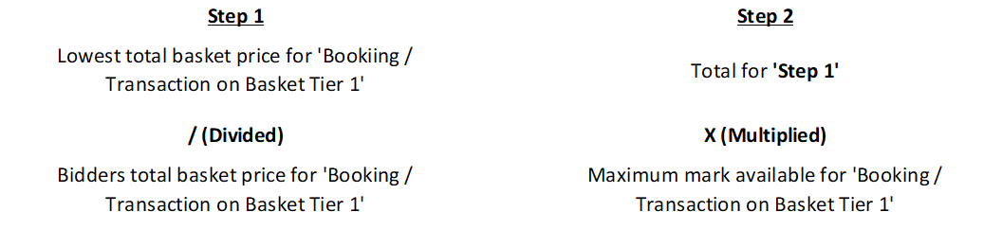

The same calculation will apply for all basket prices as per the table above.

|  |  |  |  |
| --- | --- | --- | --- |
| Bidders Fees Booking Transaction Basket Tier 1 | | | Maximum **17.5** |
| Potential  Provider | Bidder Fees | Raw Score (0-  100) | Question  Weighted Score |
| Bidder A | 15,000,000 | 100 | 17.50 |
| Bidder B | 20,000,000 | 75 | 13.13 |
| Bidder C | 25,000,000 | 60 | 10.50 |

The same example can be applied to Total Basket Price for each Price element. Bidder’s scores for all Price baskets will be combined to provide their total price score for Lot 1 up to a total maximum available mark of **17.5.**

In **Lot 2** the price weighting is 30%. The maximum score available in Lot 2 is 30.

The 30% Price weighting is sub-weighted as follows:

|  |  |  |
| --- | --- | --- |
| Evaluated Prices | Sub-Weighting | Maximum score available |
| **Groups 1 - 7** Booking /Transaction on Basket Tier 1 | 55% | 16.50 |
| **Groups 1 - 7** Booking /Transaction on Basket Tier 2 | 15% | 4.50 |
| **Groups 1 - 7** Booking /Transaction on Basket Tier 3 | 8% | 2.40 |
| **Group 9** - Negotiated Programme Total | 12% | 3.60 |
| **Group 11** - Implant Fee | 4% | 1.20 |
| **Group 12** - Payment Services (%) | 2% | 0.60 |
| **Groups 13, 14 & 15** Management Information, Rail printers, software licences | 4% | 1.20 |

* The Bidder with the lowest price for Total "basket" price for ‘**Groups 1 - 7** Booking/Transactions Fee Basket Price Tier 1’ will be awarded the maximum mark available (a price score of **16.50**).
* The Bidder with the lowest price for Total “basket” price for ‘**Groups 1 - 7** Booking/Transactions Fees Basket Price Tier 2’ will be awarded the maximum mark available (a price score of **4.50**).
* The Bidder with the lowest price for Total “basket” price for ‘**Groups 1 - 7** Booking/Transactions Fees Basket Price Tier 3’ will be awarded the maximum mark available (a price score of **2.40**).
* The Bidder with the lowest price for Total “basket” price for ‘**Group 9** - Negotiated Programme Total’ will be awarded the maximum mark available (a price score of **3.60**).
* The Bidder with the lowest price for Total “basket” price for ‘**Group 11** - Implant Fee’ will be awarded the maximum mark available (a price score of **1.20**).
* The Bidder with the lowest price for Total “basket” price for ‘**Group 12 -** Payment Services (%)’ will be awarded the maximum mark available (a price score of **0.6**).
* The Bidder with the lowest price for “Total “basket” price for ‘**Groups 13, 14 & 15** Management Information, Rail Printers, Software Licences, - ’ will be awarded the maximum mark available (a price score of **1.20**)

All Other Bidders will get a score price relative to the lowest total basket price.

Bidders score for all price baskets will be combined to provide their total price score for Lot 2 up to a total maximum available mark of 30.

**Example**

The calculation we will use to evaluate your total basket price, for each Price element, is as follows:

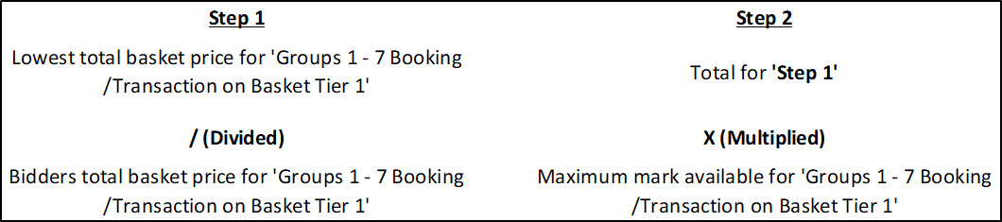

The same calculation will apply for all basket prices.

|  |  |  |  |
| --- | --- | --- | --- |
| **Groups 1 - 7** Booking /Transaction on Basket Tier 1 | | | Maximum **16.5** |
| Potential  Provider | Bidder Fees | Raw Score (0-  100) | Question  Weighted Score |
| Bidder A | 15,000,000 | 100 | 16.5 |
| Bidder B | 20,000,000 | 75 | 12.38 |
| Bidder C | 25,000,000 | 60 | 9.9 |

The same example can be applied to Total Basket Price for each Price element. Bidder’s scores for all Price baskets will be combined to provide their total price score for Lot 2 up to a total maximum available mark of **30**.

In Lot 3 the price weighting is 30%. The maximum score available in Lot 3 is 30.

The 30% Price weighting is sub-weighted as follows:

|  |  |  |
| --- | --- | --- |
| Evaluated Prices | Sub-Weighting | Maximum score available |
| Booking /Transaction on Basket Tier 1 | 60% | 18.00 |
| Booking /Transaction on Basket Tier 2 | 15% | 4.50 |
| Booking /Transaction on Basket Tier 3 | 10% | 3.00 |
| Group 4 - Negotiated Programmes | 12.5% | 3.75 |
| Groups 5 & 6 - Additional Services | 2.5% | 0.75 |

* The Bidder with the lowest price for Total "basket" price for ‘UK Price: Total Booking/Transactions Fee Basket Price Tier 1’ will be awarded the maximum mark available (a price score of **18.00**).
* The Bidder with the lowest price for Total “basket” price for ‘UK Price: Total Booking/Transactions Fees Basket Price Tier 2’ will be awarded the maximum mark available (a price score of **4.50**).
* The Bidder with the lowest price for Total “basket” price for ‘UK Price: Total Booking/Transactions Fees Basket Price Tier 3’ will be awarded the maximum mark available (a price score of **3.00**).
* The Bidder with the lowest price for Total “basket” price for ‘Group 4 - Negotiated Programmes Fee’ will be awarded the maximum mark available (a price score of **3.75**).
* The Bidder with the lowest price for Total “basket” price for ‘Groups 5 & 6 - Negotiated Programmes’ will be awarded the maximum mark available (a price score of **0.75**).

All Other Bidders will get a score price relative to the lowest total basket price.

Bidders score for all price baskets will be combined to provide their total price score for Lot 3 up to a total maximum available mark of 30.

**Example**

The calculation we will use to evaluate your total basket price, for each Price element, is as follows:

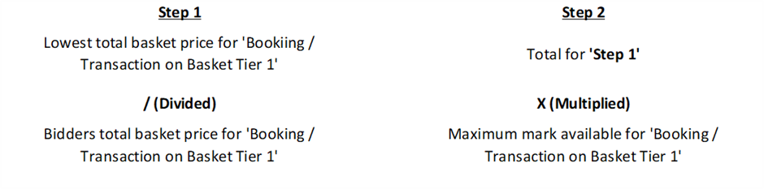

The same calculation will apply for all basket prices.

|  |  |  |  |
| --- | --- | --- | --- |
| Bidders Fees Booking / Transaction Basket Tier 1 | | | Maximum **18** |
| Potential  Provider | Bidder Fees | Raw Score (0-  100) | Question  Weighted Score |
| Bidder A | 15,000,000 | 100 | 18 |
| Bidder B | 20,000,000 | 75 | 13.5 |
| Bidder C | 25,000,000 | 60 | 10.80 |

The same example can be applied to Total Basket Price for each Price element. Bidder’s scores for all Price baskets will be combined to provide their total price score for Lot 3 up to a total maximum available mark of **30**.

In **Lot 4** the price weighting is 30%. The maximum score available in Lot 4 is 30.

The 30% Price weighting is sub-weighted as follows:

|  |  |  |  |
| --- | --- | --- | --- |
| **Grouping** | **Evaluated Prices** | **Sub-Weighting** | **Maximum score available** |
| **Groups 20 - 23** Part B Civilian Programmes | Total Core Services (Commision Retained & Shared) | 8.00% | 2.40 |
| Total Optional Services (Commission Retained & Shared) | 8.00% | 2.40 |
| Total Management Service Fee (Commission Retained & Shared) | 84.00% | 25.20 |

* The Bidder with the lowest price for Total "basket" price for ‘**Groups 20 - 23** Part B Civilian Programmes: Total Core Services (Commision Retained & Shared)’ will be awarded the maximum mark available (a price score of **2.40**).
* The Bidder with the lowest price for Total “basket” price for ‘**Groups 20 - 23** Part B Civilian Programmes: Total Optional Services (Commission Retained & Shared)’ will be awarded the maximum mark available (a price score of **2.40**).
* The Bidder with the lowest price for Total “basket” price for ‘**Groups 20 - 23** Part B Civilian Programmes: Total Management Service Fee (Commission Retained & Shared)’ will be awarded the maximum mark available (a price score of **25.20**).

All Other Bidders will get a score price relative to the lowest total basket price.

Bidders score for all price baskets will be combined to provide their total price score for Lot 4 up to a total maximum available mark of 30.

**Example**

The calculation we will use to evaluate your total basket price, for each Price element, is as follows:

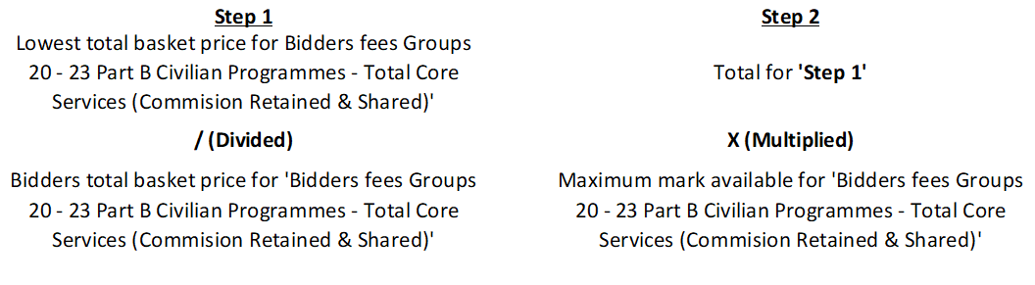

The same calculation will apply for all basket prices.

|  |  |  |  |
| --- | --- | --- | --- |
| **Bidders fees Groups 20 - 23** Part B Civilian Programmes - Total Core Services (Commision Retained & Shared) | | | Maximum **2.4** |
| Potential  Provider | Bidder Fees | Raw Score (0-  100) | Question  Weighted Score |
| Bidder A | 15,000,000 | 100 | 2.40 |
| Bidder B | 20,000,000 | 75 | 1.80 |
| Bidder C | 25,000,000 | 60 | 1.44 |

The same example can be applied to Total Basket Price for each Price element. Bidder’s scores for all Price baskets will be combined to provide their total price score for Lot 4 up to a total maximum available mark of **30**.