

# Digital Outcomes and Specialists 5 (RM1043.7)

# Framework Schedule 6 (Order Form)

Version 2

Crown Copyright 2020

## Framework Schedule 6 (Order Form Template, Statement of Work Template and Call-Off Schedules)

### Order Form

|  |  |
| --- | --- |
| **Call-Off Reference:** | PS/22/89 |
| **Call-Off Title:** | Provision of Software Engineering Services |
| **Call-Off Contract Description:** | DVLA requires a supplier to provide a flexible delivery of highly skilled Engineering developers/support services to aid in the design, development, and support of transformation solutions, working closely with our Development Teams and be able to solve complex problems, via a call off agreement to:  Deliver migration of legacy services to cloud-based environments;  Develop new internal and external facing services;  Support DVLAs digital strategy by creating online services and digital channels to improve overall customer service.  Capability provided under SOWs will need to work closely with the current DVLA product teams.  The supplier will also be required to support the components developed under the transformation programme of work. This would cover 4th line support (primarily investigation and code changes) in-hours (between 9am and 6pm Monday to Friday) with potential for out-of-hours  Deliverables must be in line with DVLA solutions. The appointed supplier shall have the ability to deliver a mix of engineering services in line with outcome-based deliverables, as set out in the individual Statements of Work as well as having the ability to interact and give guidance on best practice and react to technical challenges.  DVLA is responsible for the overall business requirements and solution architecture. |
| **The Buyer:** | Driver and Vehicle Licensing Agency |
| **Buyer Address:** | Longview Road  Morriston  Swansea  SA6 7JL |
| **The Supplier:** | Made Tech Ltd |
| **Supplier Address:** | Made Tech Ltd  4 O’Meara Street  London  SE1 1TE |
| **Registration Number:** (Insert registration number (if registered)) | XXXXXX “redacted under FOIA section No 40 – Personal Information |
| **DUNS Number:** (Insert if known) | XXXXXX “redacted under FOIA section No 40 – Personal Information |
| **SID4GOV ID**: |  |

#### Applicable Framework Contract

This Order Form is for the provision of the Call-Off Deliverables and dated 1st February 2023. It’s issued under the Framework Contract with the reference number RM1043.7 for the provision of Digital Outcomes and Specialists Deliverables.

The Parties intend that this Call-Off Contract will not, except for the first Statement of Work which shall be executed at the same time that the Call-Off Contract is executed, oblige the Buyer to buy or the Supplier to supply Deliverables.

The Parties agree that when a Buyer seeks further Deliverables from the Supplier under the Call-Off Contract, the Buyer and Supplier will agree and execute a further Statement of Work (in the form of the template set out in Annex 1 to this Framework Schedule 6 (Order Form Template, Statement of Work Template and Call-Off Schedules).

Upon the execution of each Statement of Work it shall become incorporated into the Buyer and Supplier’s Call-Off Contract.

#### Call-Off Lot

# Digital Outcomes and Specialists framework (Outcomes based requirement)

#### Call-Off Incorporated Terms

The following documents are incorporated into this Call-Off Contract. Where numbers are missing we are not using those schedules. If the documents conflict, the following order of precedence applies:

1. This Order Form including the Call-Off Special Terms and Call-Off Special Schedules.
2. Joint Schedule 1 (Definitions) RM1043.7
3. Framework Special Terms
4. The following Schedules in equal order of precedence:

* Joint Schedules for RM1043.7
  + Joint Schedule 2 (Variation Form)
  + Joint Schedule 3 (Insurance Requirements)
  + Joint Schedule 4 (Commercially Sensitive Information)
  + Joint Schedule 6 (Key Subcontractors)
  + Joint Schedule 7 (Financial Difficulties)
  + Joint Schedule 10 (Rectification Plan)
  + Joint Schedule 11 (Processing Data) RM1043.7
  + Joint Schedule 12 (Supply Chain Visibility)
* Call-Off Schedules for RM1043.7
  + Call-Off Schedule 1 (Transparency Reports)
  + Call-Off Schedule 2 (Staff Transfer)
  + Call-Off Schedule 3 (Continuous Improvement)
  + Call-Off Schedule 5 (Pricing Details and Expenses Policy)
  + Call-Off Schedule 6 (Intellectual Property Rights and Additional Terms on Digital Deliverables)
  + Call-Off Schedule 7 (Key Supplier Staff)
  + Call-Off Schedule 8 (Business Continuity and Disaster Recovery)
  + Call-Off Schedule 9 (Security)
  + Call-Off Schedule 10 (Exit Management)
  + Call-Off Schedule 14 (Service Levels and Balanced Scorecard)
  + Call-Off Schedule 15 (Call-Off Contract Management)
  + Call-Off Schedule 16 (Benchmarking)
  + Call-Off Schedule 18 (Background Checks)
  + Call-Off Schedule 20 (Call-Off Specification)
  + Call-Off Schedule 25 (Ethical Walls Agreement)
  + Call-Off Schedule 26 (Cyber Essentials Scheme)

1. CCS Core Terms (version 3.0.9)
2. Joint Schedule 5 (Corporate Social Responsibility) RM1043.7
3. Call-Off Schedule 4 (Call-Off Tender) as long as any parts of the Call-Off Tender that offer a better commercial position for the Buyer (as decided by the Buyer) take precedence over the documents above.

No other Supplier terms are part of the Call-Off Contract. That includes any terms written on the back of, added to this Order Form, or presented at the time of delivery.

#### Call-Off Special Terms

The following Special Terms are incorporated into this Call-Off Contract:

|  |  |
| --- | --- |
| **Call-Off Start Date:** | 01/02/2023 |
| **Call-Off Expiry Date:** | 31/01/2025 |
| **Call-Off Initial Period:** | 24 months |
| **Call-Off Optional Extension Period:** | 25% of the full term (if required) |
| **Call-Off Contract Value:** | Estimated up-to value £14 million.  Commercial commitment from DVLA will be provided in the form of discrete work packages and signed off as individual Statements of Work (SOW’s).  This process will be adopted to manage the clarity of service throughout the life of the contract. |

#### Call-Off Deliverables

See details in Call-Off Schedule 20 (Call-Off Specification)]

#### Buyer’s Standards

From the Start Date of this Call-Off Contract, the Supplier shall comply with the relevant (and current as of the Call-Off Start Date) Standards referred to in Framework Schedule 1 (Specification).

#### Cyber Essentials Scheme

The Buyer requires the Supplier, in accordance with Call-Off Schedule 26 [Cyber Essentials Plus Certificate] prior to commencing the provision of any Deliverables under this Call-Off Contract.

The Supplier Staff shall adhere to the Cyber Security standards, protocols & ISO/IEC27001 – Information Security Management

<https://www.gov.uk/government/publications/the-minimum-cyber-security-standard>

<https://www.ncsc.gov.uk/collection/cloud-security/implementing-the-cloud-security-principles>

<https://www.ncsc.gov.uk/cyberessentials/overview>

#### Maximum Liability

The limitation of liability for this Call-Off Contract is stated in Clause 11.2 of the Core Terms as amended by the Framework Award Form Special Terms.

#### Call-Off Charges

1. Time and Materials (T&M)

The Deliverables under this Call-Off Contract, the applicable rate card(s) shall be incorporated into Call-Off Schedule 5 (Pricing Details and Expenses Policy) and the Supplier shall, under each SOW, charge the Buyer a rate no greater than those set out in the applicable rate card for the Supplier Staff undertaking that element of work on the Deliverables.

#### Reimbursable Expenses

Not applicable - T&S included in day rates as stated in the Pricing Schedule.

#### Payment Method

Invoiced monthly in arrears / Day Rate

#### Buyer’s Invoice Address

|  |  |
| --- | --- |
| **Name** | Shared Services Arvato (SSa) |
| **Address** | 5 Sandringham Park  Swansea Vale  Swansea  SA7 0EA |
| **Invoicing Procedures** | The Supplier shall issue a single paper invoice monthly in arrears. The Buyer shall pay the Supplier within thirty (30) calendar days of receipt of a valid invoice. The Purchase Order number must be included on the Suppliers invoice.  Or alternatively electronic invoices can be issued to:  [ssa.invoice@sharedservicesarvato.co.uk](mailto:ssa.invoice@sharedservicesarvato.co.uk)  Please see embedded document below for invoicing procedures: |

#### Buyer’s Authorised Representative

|  |  |
| --- | --- |
| **Name** | XXXXXX “redacted under FOIA section No 40 – Personal Information |
| **Role** | XXXXXX “redacted under FOIA section No 40 – Personal Information |
| **Email address** | XXXXXX “redacted under FOIA section No 40 – Personal Information |
| **Address** | DVLA  Longview Road  Swansea  SA6 7JL |

#### Buyer’s Environmental Policy

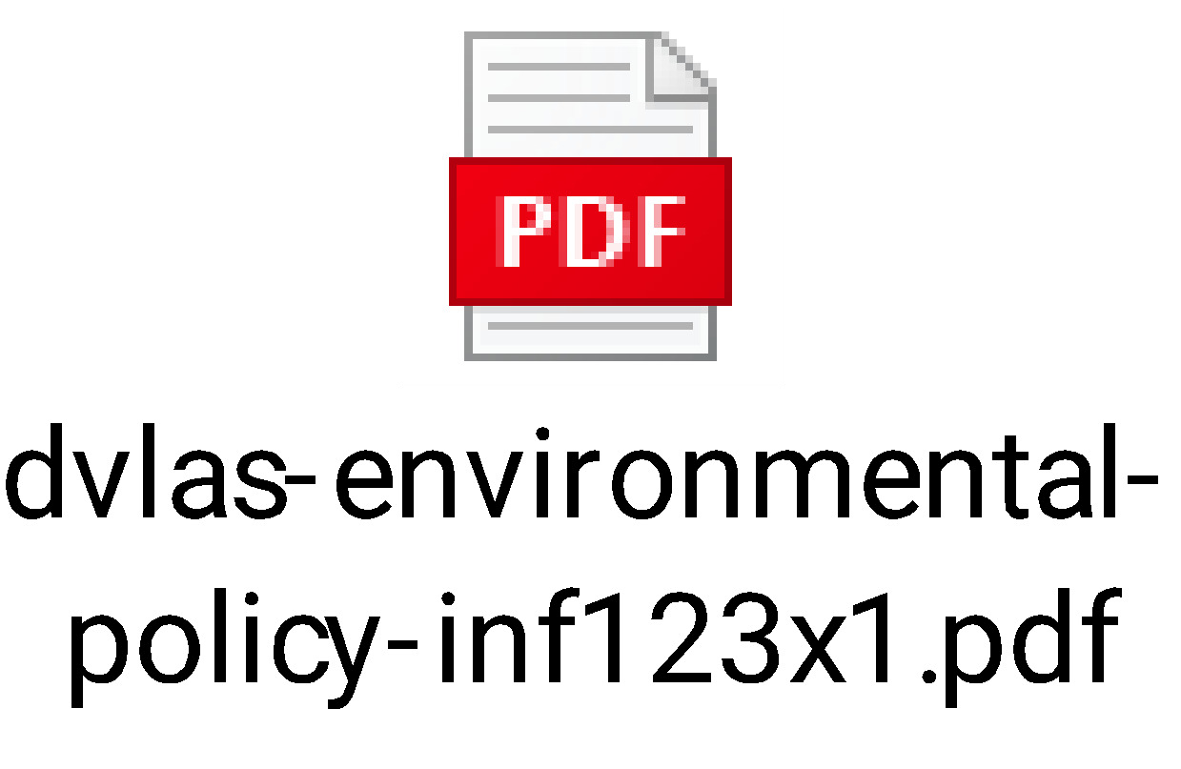

Buyer’s Security Policy

The Supplier and Staff shall abide by the Buyer Security Policy.

#### Supplier’s Authorised Representative

|  |  |
| --- | --- |
| **Insert name** | XXXXXX “redacted under FOIA section No 40 – Personal Information |
| **Insert role** | XXXXXX “redacted under FOIA section No 40 – Personal Information |
| **Insert phone** | XXXXXX “redacted under FOIA section No 40 – Personal Information |
| **Insert email address** | XXXXXX “redacted under FOIA section No 40 – Personal Information |
| **Insert address** | XXXXXX “redacted under FOIA section No 40 – Personal Information |

#### Supplier’s Contract Manager

As above

#### Progress Report Frequency

On the first Working Day of each calendar month

#### Progress Meeting Frequency

Monthly

#### Key Staff

|  |  |  |  |  |  |
| --- | --- | --- | --- | --- | --- |
| **Name** | **Role** | **Email Address** | **Address** | **Contact Details** | **Worker Engagement Route** (including whether inside or outside IR35 and whether there is a requirement to issue a Status Determination Statement) |
| XXXXXX “redacted under FOIA section No 40 – Personal Information | XXXXXX “redacted under FOIA section No 40 – Personal Information | XXXXXX “redacted under FOIA section No 40 – Personal Information | XXXXXX “redacted under FOIA section No 40 – Personal Information | XXXXXX “redacted under FOIA section No 40 – Personal Information | XXXXXX “redacted under FOIA section No 40 – Personal Information |
| XXXXXX “redacted under FOIA section No 40 – Personal Information | XXXXXX “redacted under FOIA section No 40 – Personal Information | XXXXXX “redacted under FOIA section No 40 – Personal Information | XXXXXX “redacted under FOIA section No 40 – Personal Information | XXXXXX “redacted under FOIA section No 40 – Personal Information | XXXXXX “redacted under FOIA section No 40 – Personal Information |

#### Key Subcontractor(s)

Not applicable – any changes to be agreed via variation with DVLA.

#### Commercially Sensitive Information

#### XXXXXX “redacted under FOIA section No 40 – Personal Information

#### Balanced Scorecard

See Call-Off Schedule 14 (Service Levels and Balanced Scorecard)

#### Material KPIs

The following Material KPIs shall apply to this Call-Off Contract in accordance with Call-Off Schedule 14 (Service Levels and Balanced Scorecard):

|  |  |  |
| --- | --- | --- |
| **Material KPIs** | **Target** | **Measured by** |
| Performance to Pay Process | Green RAG status | Balanced Scorecard |
| Partnering Behaviour and Added Value | Green RAG status | Balanced Scorecard |
| People (Resourcing) | Green RAG status | Balanced Scorecard |
| People in Place (Delivery) | Green RAG status | Balanced Scorecard |
| Social Value | Green RAG status | Balanced Scorecard |
| Social Value | Green RAG status | Balanced Scorecard |

#### Additional Insurances

Additional insurances not applicable, for insurance required as a minimum, please see

Joint Schedule 3 (Insurance Requirements)

#### Guarantee

Not applicable

#### Social Value Commitment

The Supplier agrees, in providing the Deliverables and performing its obligations under the Call-Off Contract, that it will comply with the social value commitments in Call-Off Schedule 4 (Call-Off Tender)]

#### Statement of Works

During the Call-Off Contract Period, the Buyer and Supplier may agree and execute completed Statement of Works. Upon execution of a Statement of Work the provisions detailed therein shall be incorporated into the Call-Off Contract to which this Order Form relates.

**For and on behalf of MadeTech Ltd:**

|  |
| --- |
| XXXXXX “redacted under FOIA section No 40 – Personal Information |
| XXXXXX “redacted under FOIA section No 40 – Personal Information |
| XXXXXX “redacted under FOIA section No 40 – Personal Information |
| XXXXXX “redacted under FOIA section No 40 – Personal Information |

**For and on behalf of DVLA:**

|  |
| --- |
| XXXXXX “redacted under FOIA section No 40 – Personal Information |
| XXXXXX “redacted under FOIA section No 40 – Personal Information |
| XXXXXX “redacted under FOIA section No 40 – Personal Information |
| XXXXXX “redacted under FOIA section No 40 – Personal Information |

### Appendix 1

The first Statement(s) of Works shall be inserted into this Appendix 1 as part of the executed Order Form. Thereafter, the Buyer and Supplier shall complete and execute Statement of Works (in the form of the template Statement of Work in Annex 1 to the template Order Form in Framework Schedule 6 (Order Form Template, Statement of Work Template and Call-Off Schedules).

**Annex 1 of Framework Schedule 6 Order Form**

**Statement of Works (SOW)**

**PS/22/89 - Provision of a Software Engineering**

Upon execution, this SOW forms part of the Call-Off Contract (reference below).

The Parties will execute a SOW for each set of Buyer Deliverables required. Any ad-hoc Deliverables requirements are to be treated as individual requirements in their own right and the Parties should execute a separate SOW in respect of each, or alternatively agree a Variation to an existing SOW.

All SOWs must fall within the Specification and provisions of the Call-Off Contact.

The details set out within this SOW apply only in relation to the Deliverables detailed herein and will not apply to any other SOWs executed or to be executed under this Call-Off Contract, unless otherwise agreed by the Parties in writing.

XXXXXX “redacted under FOIA section No 40 – Personal Information

### Annex 1 (Template Statement of Work)

**Any additional Statement of Work documents following thereafter, will form part of the call-off contract.**

**Annex 1 of Framework Schedule 6 Order Form**

**Statement of Works (SOW)**

**PS/XX/XX………………………………………………………………..**

Upon execution, this SOW forms part of the Call-Off Contract (reference below).

The Parties will execute a SOW for each set of Buyer Deliverables required. Any ad-hoc Deliverables requirements are to be treated as individual requirements in their own right and the Parties should execute a separate SOW in respect of each, or alternatively agree a Variation to an existing SOW.

All SOWs must fall within the Specification and provisions of the Call-Off Contact.

The details set out within this SOW apply only in relation to the Deliverables detailed herein and will not apply to any other SOWs executed or to be executed under this Call-Off Contract, unless otherwise agreed by the Parties in writing.