Invitation to Tender
for

Contract for production of Forest Nursery stillage

Contract No: FEE/0342

Introduction
The Forestry Commission’s (FC) mission is to protect and expand Britain's forests and woodlands and increase their value to society and the environment.

We take the lead in the development and promotion of sustainable forest management. We deliver the distinct forestry policies of England and Scotland through specific objectives drawn from the country forestry strategies.

We the FC will always consider equality when conducting our procurement activities. We require you to meet your duties under the Equality Act 2010 and may ask for evidence that you are aware of and operate in accordance with those requirements.

More information is available on our website at www.forestry.gov.uk

Specification of Requirements
We will be awarding a contract for the production of stillages for Forest Nurseries based at Delamere in Cheshire and Wykeham in North Yorkshire. Tree stillage allows for the safe and efficient handling of trees and provide a means of transporting trees across the UK.

Our intention is to award this contract for a period of 3 years, from 1st April 2017 to 31st March 2020.

There will be an option to extend the contract at the end of this period by 1 year based on budget availability and demand, making a total of 4 years if the extension option is used.

The total value of this contract over the entire period, including any extension options, will be in the region of £45,000. The total value of this contract annually will be in the region of £15,000 of which we are looking to receive approximately 150 stillage annually.

There are two specifications of stillage for each of the two forest nurseries, of similar construction but different dimensions. Production of each stillage specification will alternate annually, supplying Delamere Forest Nursery for the first year and Wykeham Forest Nursery in the second year and so forth. Stillages must be manufactured and delivered to the relevant site by 31st August annually.

Background Information

Due to current ageing stock, the FC is looking to replace its current stillages.

Section 1

Essential requirements:

- For both stillage specifications, dimensions and safety features must remain the same as the existing stillage, see diagrams and photos below.
- For Wykeham specification, two thick steel fork lift tine guides must be placed underneath stillage to provide two-way fork lift access from the gated ends, to add stability when lifting. For Delamere specification, four thick steel fork lift tine guides must be placed underneath stillage to provide four-way fork lift access.
- The total weight of each stillage should be less than 80kg.

Note drawings are not to scale, it is recommended that the successful bidder checks all stillage dimensions at the FC site.
Delamere:

Stillage front view:
1190mm overall width (including feet)

1120mm total width (excluding feet)
50mm x 50mm
1020mm inside edge

65mm

467mm
1270mm total height from floor
50mm x 50mm

1210 mm height from top of feet

20mm x 20mm
510mm

75mm
45mm

228mm
407mm centre to centre on tine guides

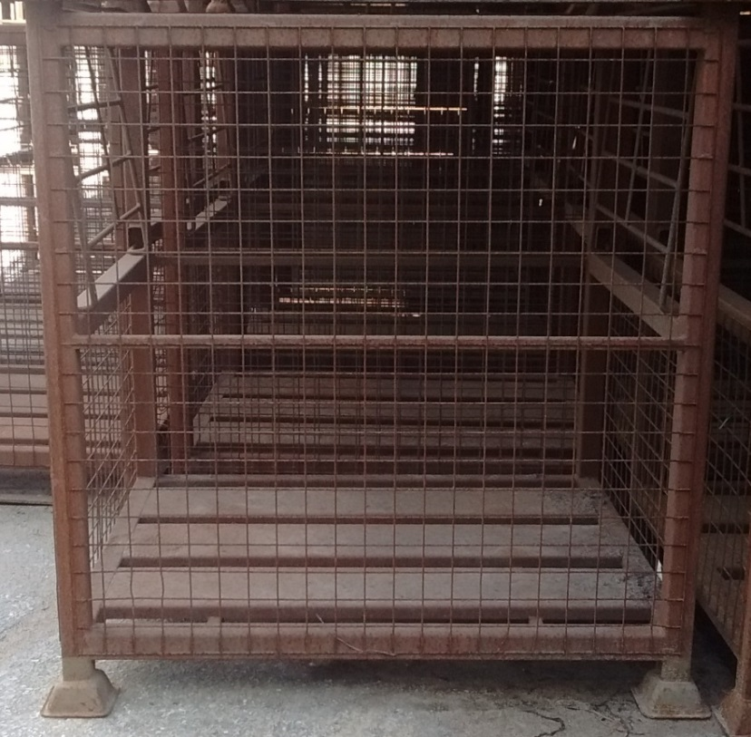

Stillage edge view:
992mm overall width (including feet)
50mm x 50mm
915mm total width (excluding feet)
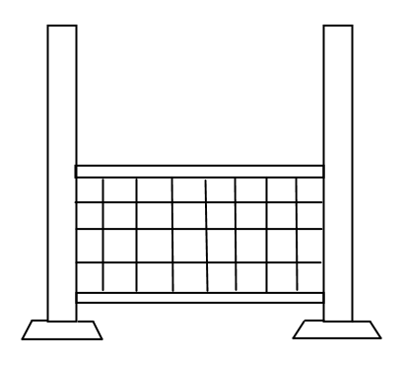

Gate attaches here

50mm x 50mm
1270mm total height from floor
815mm (inside edge)

1210mm height from top of feet
500 mm from bottom to top bar

45mm
75mm

228mm
407mm centre to centre on tine guides

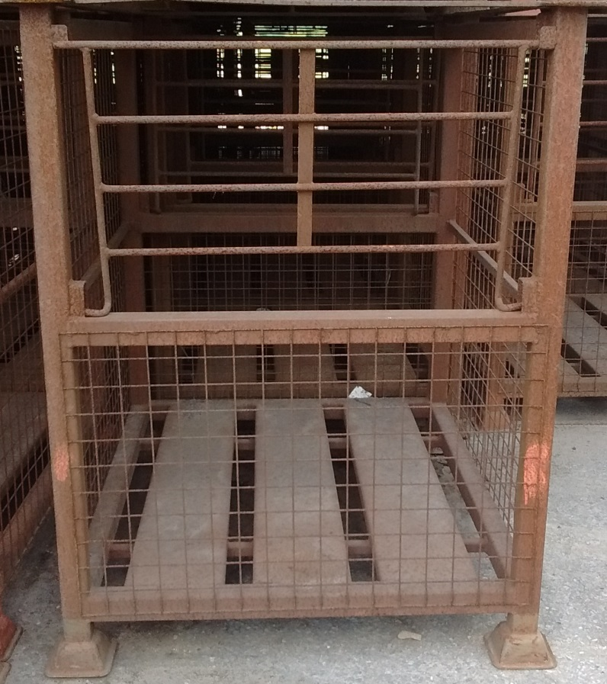

Mesh:

48.5mm
x 3mm

48.5mm x 3mm

Gate:
10mm x 10mm
810mm
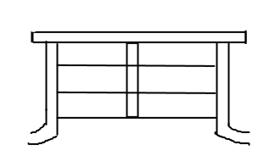

100mm

358mm
468mm total height

693mm

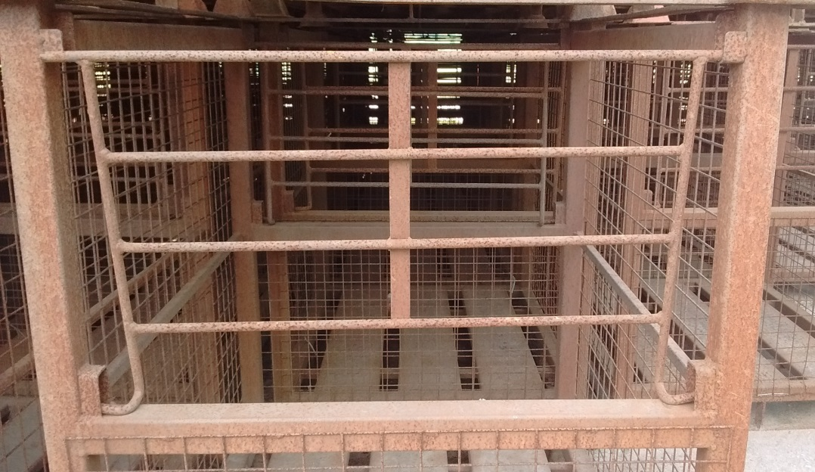

Stillage bottom from bird’s eye view:

915mm (total width)

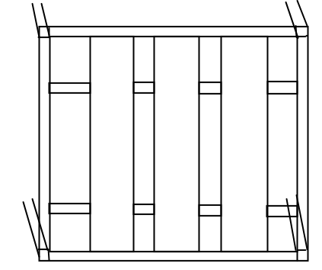
815mm (inside edge)
50mm x 50mm

200mm

25mm x 25mm

1020mm (inside edge)
1120mm
(total length)
570mm

Two steel bars extend whole width of stillage underneath 3 larger steel planks
200mm

56mm
61mm
194mm
x 24mm
61mm
56mm

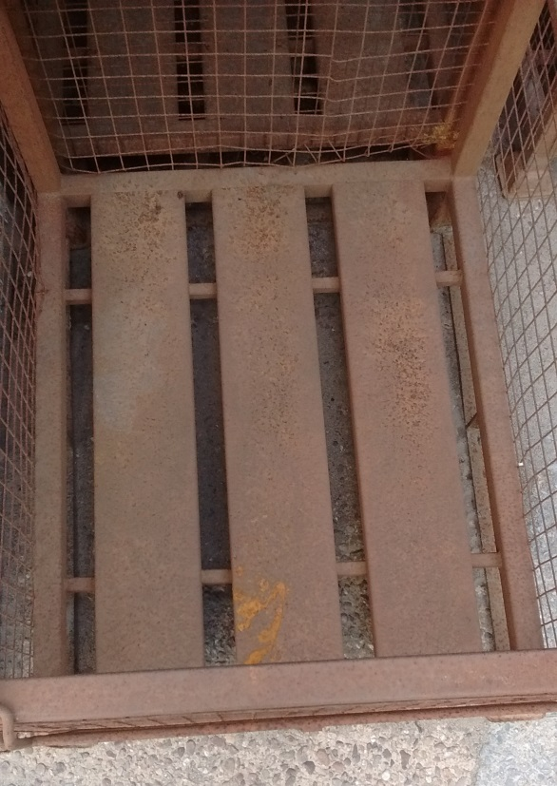

Wykeham:

Stillage front view:
1215mm overall width (including feet)
1140mm overall width (excluding feet)
50mm x 50mm

65mm
1040mm (inside edge)
1200mm height from top of feet

473mm
1260mm total height from floor

50mm x 50mm
20mm x 20mm

500mm

47mm

Stillage edge view:
1215mm overall width (including feet)

1140mm overall width (excluding feet)

50mm x 50mm
1040mm (inside edge)

Gate attaches here

1260mm total height from floor
1200mm height from top of feet

500mm from bottom to top bar
50mm x 50mm

47mm
75mm
200mm

640mm centre to centre on tine guides

Gate:

1035mm
10mm x 10mm

468mm total height
358mm

Mesh:

48.5mm
x 3mm

48.5mm x 3mm

Stillage bottom from bird’s eye view:

1140mm (total width)

1040mm (inside edge)
50mm x 50mm

25mm

1140mm
(total length)
1040mm (inside edge)

Two steel bars extend whole width of stillage underneath 3 larger steel planks

193mm
x 24mm

Section 2:

The following requirements will be assessed in section 4.8.1:
- The same dimensions of stillage feet must be used as the existing stock, outlined below.
- The material used for the stillage feet must be long-lasting and hard wearing. Stillage are stacked four-high therefore the design must be robust enough for the intended use. Current cage feet are welded on, however a removable cage foot or similar should be incorporated into the design to allow feet to be easily replaced.
- The type of steel used must be robust and long-lasting and a method of galvanisation should be used.

Stillage feet current specification:
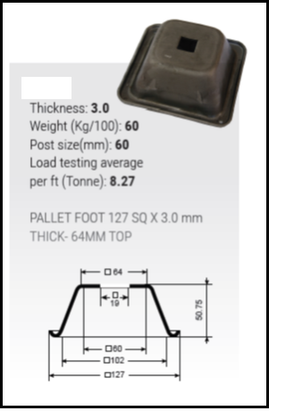

Geographical Area

The stillage will be delivered to Forestry Commission nurseries at Delamere, Cheshire, CW8 2JD and Wykeham, North Yorkshire, YO13 9EB.

Note: Tenderers must include details of any areas where they will not be able to comply with these requirements. If your Tender does not meet these requirements we reserve the right to reject it completely.

Notes for Completion and Conditions

Definitions and purpose
The “authority” or “we” means the Forestry Commission, or anyone acting on behalf of the Forestry Commission, that is seeking to invite suitable Suppliers to participate in this procurement process.

“You”/”Your” or “Supplier” or “Bidder” means the body responding to this Invitation to Tender (ITT) i.e. the legal entity submitting a tender. The ‘Supplier’ or ‘Bidder’ is intended to cover any economic operator as defined by the Public Contracts Regulations 2015 and could be a registered company; charitable organisation; Voluntary Community and Social Enterprise (VCSE); Special Purpose Vehicle; or other form of entity.

This Invitation to Tender (ITT) has been designed to assess both the suitability of a Supplier to deliver the authority’s contract requirement(s); and to determine of those suitable, which supplier(s) have provided the most economically advantageous tender.

Timetable
Set out below is the procurement timetable. While we do not intend to depart from the timetable, we reserve the right to do so and if this is required, we will inform Suppliers in writing of any changes.

Stages | Dates
Closing date for expressing interest and time for further questions | Monday 21st November 2016
Closing Date and Time for Tender Returns | Monday 28th November 2016 at 12:00
Expected Notification of Award | Monday 5th December 2016
Expected Start Date | 3rd April 2017

Enquiries
Please send all enquiries by email, by the deadline stated at Section 3.2 quoting the reference number printed at the front of this document to:
FAO Bethany Cambridge
Delamere Nursery
Forestry Commission
Linmere
Delamere
Northwich
CW8 2JD

bethany.cambridge@forestry.gsi.gov.uk

If we consider any question or request for clarification is relevant to all interested parties, we will circulate both the query and the response to all prospective bidders, although your identity will remain confidential.

If you want to tender, and have not yet registered interest in the contract, you must do so before the closing date for expressing interest to make sure you are told about any questions and answers.

Responses and supporting documents
Please ensure that all questions are completed in full, and in the format requested. Failure to do so may result in your submission being disqualified. If the question does not apply to you, please state clearly ‘N/A’.
Should you need to provide additional Appendices in response to the questions, these should be numbered clearly and listed as part of you declaration. A template for providing additional information is provided at the end of this document, which should be used unless, due to formatting, this is not possible.

To make the process straightforward, you do not need to provide supporting documents with your tender unless specifically requested to do so. However, we may ask you for this later.

Your organisation will only be evaluated based on the information in your tender. If you do not mention any applicable previous experience of working with us in your reply we cannot take this into account.

Please do not send any information that is general company or promotional literature, as this will not form part of our evaluation. Any additional documents you provide must refer to a question within the ITT and be easily identifiable as the answer.

Return arrangements
Please return your completed tender submission inclusive of any relevant appendices as:
- Two paper copies by post or hand delivered, and
- One copy on disk or USB type storage device in a read only format

Please note that we do not accept fax or email copies. We must receive your completed tender before the closing date and time shown in the Timetable at section 3.2. We will keep tenders received before this deadline unopened until after this time. We reserve the right to not consider any tenders received after the deadline. Please be aware that tenders may be copied for our use.
Mark your envelopes with the words ‘Tender for Contract for production of Forest Nursery stillage ref no FEE/0342 – Not to be opened until 12:00 on Monday 28th November 2016.’
Submissions may be excluded if you do not mark the envelope in this way.

Send completed tender documents to the following address:

FAO Bethany Cambridge
Delamere Nursery
Forestry Commission
Linmere
Delamere
Northwich
CW8 2JD

Clarification
During our evaluation process, we may need to seek clarification on aspects of your tender return. If required we will contact you using the contact details you have provided. Clarification may require you to submit, supplement, clarify or complete the relevant information or documentation within an appropriate time limit. The purpose of any such clarification is to provide us with the information we require to score your submission; it will not be an opportunity for you to improve or substantially change the information you have already submitted.

Verification of information provided
Whilst reserving the right to request information at any time throughout the procurement process, the authority may enable the Supplier to self-certify that there are no mandatory/discretionary grounds for excluding their organisation. When requesting evidence that the Supplier can meet the specified requirements (such as the questions within the sub-sections of 4.7 of this ITT relating to Technical and Professional Ability) the authority may only obtain such evidence after the final tender evaluation decision i.e. from the winning Supplier only.

Sub-contracting arrangements
Where the supplier proposes to use one or more sub-contractors to deliver some or all of the requirements, a separate Appendix should be used to provide details of the proposed bidding model that includes members of the supply chain, the percentage of work being delivered by each sub-contractor and the key deliverables each sub-contractor will be responsible for.

The authority recognises that arrangements in relation to sub-contracting may be subject to future change, and may not be finalised until a later date. However Suppliers should be aware that where information provided to the authority indicates that sub-contractors are to play a significant role in delivering key requirements, any changes to those sub-contracting arrangements may affect the ability of the Supplier to proceed with the procurement process or to provide the supplies and/or services required. Suppliers should therefore notify the authority immediately of any change in the proposed sub-contractor arrangements. The authority reserves the right to deselect the Supplier prior to any award, based on an assessment of the updated information.

Consortia arrangements
If the Supplier completing this ITT is doing so as part of a proposed consortium, the following information must be provided:-

- Names of all consortium members;
- The lead member of the consortium who will be contractually responsible for delivery of the contract (if a separate legal entity is not being created); and
- If the consortium is not proposing to form a legal entity, full details of proposed arrangements within a separate Appendix.

Please note that the authority may require the consortium to assume a specific legal form if awarded the work, to the extent that a specific legal form is deemed by the authority as being necessary for the satisfactory performance of the contract.

All members of the consortium will be required to provide the information required in all sections of the ITT as part of a single composite response to the authority i.e. each member of the consortium is required to complete the form.

Where you are proposing to create a separate legal entity, such as a Special Purpose Vehicle (SPV), you should provide details of the actual or proposed percentage shareholding of the constituent members within the new legal entity in a separate Appendix.

The authority recognises that arrangements in relation to a consortium bid may be subject to future change. Suppliers should therefore respond on the basis of the arrangements as currently envisaged. Suppliers are reminded that the authority must be immediately notified of any changes, or proposed changes, in relation to the bidding model so that a further assessment can be carried out by applying the selection criteria to the new information provided. The authority reserves the right to deselect the Supplier prior to any award of contract, based on an assessment of the updated information.

Confidentiality
When providing details of contracts in answering section 4.6 of this ITT (Technical and Professional Ability), the Supplier agrees to waive any contractual or other confidentiality rights and obligations associated with these contracts.

The authority reserves the right to contact the named customer contact in section 4.6 regarding the contracts included in section 4.6. The named customer contact does not owe the authority any duty of care or have any legal liability, except for any deceitful or maliciously false statements of fact.

The authority confirms that it will keep confidential and will not disclose to any third parties any information obtained from a named customer contact, other than to the Cabinet Office and/or contracting authorities defined by the Public Contracts Regulations.

The Supplier must treat all information supplied to it by the authority in confidence and must not disclose it to third parties other than to obtain sureties or quotations for submitting its response.

As part of the tendering process, the Supplier must identify any parts of its tender submission which it designates as confidential and would not want published; such information may include technical or trade secrets or other confidential information. The authority will then assess this information (along with the rest of the contract), taking account of Regulation 21 of the Public Contracts Regulations, when considering which contractual information should or should not be published or released on request.

Tender validity
All details of the tender, including prices and rates, must be valid for 90 days from receipt of tender.

Language
The completed tender and all accompanying documents must be in English.

Applicable Law
Any contract concluded as a result of this ITT will be governed by English law.

Pricing
All prices will be in sterling and exclusive of VAT.

Additional costs
Once we have awarded the contract, we will not pay any additional costs incurred which are not reflected in your tender submission.

Evaluation
A Tender Panel will evaluate responses to the tender objectively using the criteria and evaluation matrix’ defined within Section 4.

Gateways
Some questions in the tender are known as gateways and are fundamental requirements of the contract. These are marked on a ‘pass/fail’ basis and if you do not answer these sections appropriately, we may reject your submission in full and cease to evaluate any more questions.

Weighted questions
Some sections of this ITT include questions that are weighted. The weightings applied to each question ensure the relative importance of each is correctly reflected in the overall scores applied.
For these questions, the marks out of 4 that are achieved for each question will be subsequently weighted to provide a total number of marks out of 100.

Award
Once we have carried out the evaluation and identified the successful tenderer(s), we will tell all tenderers in writing by email of our award decision.

Debriefing
We will give all bidders the opportunity of a debriefing. Please tell us in writing as soon as possible if you want a debriefing.

Contract management
If we award a contract, you will have to co-operate in managing it and comply with the contract management requirements, as detailed in the Specification of Requirements at Section 2.

Costs
Unless otherwise stated in this ITT, all costs associated with taking part in this process remain your responsibility and we will not return any part of your completed tender to you.

Right to cancel or vary the process
We reserve the right to cancel or withdraw from the tendering process at any stage.

Inducements
Offering an inducement of any kind in relation to obtaining this or any other contract with us will disqualify you from being considered and may constitute a criminal offence.

Disclaimer
While the information in this ITT and supporting documents has been prepared in good faith by us, it may not be comprehensive nor has it been independently verified.
Neither the FC, nor their advisors, nor their respective directors, officers, members, partners, employees, other staff or agents:
- makes any representation or warranty (express or implied) as to the accuracy, reasonableness or completeness of this ITT; or
- accepts any responsibility for the information contained in the ITT or for the fairness, accuracy or completeness of that information nor shall any of them be liable for any loss or damage (other than in respect of fraudulent misrepresentation) arising as a result of relying on such information or any subsequent communication.

Your response
In order to submit a tender for this requirement you must complete and return the relevant sections, detailed in the table below, in compliance with Section 3 above. If we have decided that certain sections are not relevant for this particular ITT, we have indicated this by stating ‘N/A’ next to the title heading at the relevant section and by indicating ‘Not Applicable’ within the table below. Unless otherwise indicated in this way, all sections must be completed and returned.

The table below provides a summary of the evaluation method for each section, however full details of how we will evaluate your submission can be found in the individual Evaluation Matrix’ within each section.

Section | Title | Evaluation Method
4.1 | Supplier Information | For information only but must be completed
4.2 | Grounds for mandatory exclusion | Pass / Fail
4.3 | Grounds for discretionary exclusion – Part 1 | Pass / Fail
4.4 | Grounds for discretionary exclusion – Part 2 | Not applicable
Selection Criteria
4.5 | Economic and Financial Standing | Not Applicable
4.6 | Technical and Professional Ability | Pass/Fail
4.7 | Additional Selection Modules
4.7.1 | Project Specific Questions to assess Technical and Professional Ability | Pass/Fail
4.7.2 | Insurance | Pass / Fail
4.7.3 | Compliance with equality legislation | Not Applicable
4.7.4 | Environmental Management | Not Applicable
4.7.5 | Health and Safety | Not Applicable
Award Criteria
4.8 | Requirement Specific Questions | Scored and Weighted
4.9 | Pricing Schedule | Scored and Weighted
4.10 | ITT Template Appendices | Template Only – Use where required
4.11 | Terms and Conditions of Contract | Pass/Fail
4.12 | Declaration | Pass/Fail

4.1 Supplier Information
Supplier details |  | Answer
Full name of the Supplier completing the ITT
Registered company address
Registered company number
Registered charity number

Registered VAT number
Name of immediate parent company
Name of ultimate parent company
Please mark ‘X’ in the relevant box to indicate your trading status |  | i) a public limited company
 |  | ii) a limited company
 |  | iii) a limited liability partnership
 |  | iv) other partnership
 |  | v) sole trader
 |  | vi) other (please specify)
Please mark ‘X’ in the relevant boxes to indicate whether any of the following classifications apply to you |  | i)Voluntary, Community and Social Enterprise (VCSE)
 |  | ii) Small or Medium Enterprise (SME)
 |  | iii) Sheltered workshop
 |  | iv) Public service mutual
Bidding model
Please mark ‘X’ in the relevant box to indicate whether you are:
a) Bidding as a Prime Contractor and will deliver 100% of the key contract deliverables yourself
b) Bidding as a Prime Contractor and will use third parties to deliver some of the services

If yes, please provide details of your proposed bidding model that includes members of the supply chain, the percentage of work being delivered by each sub-contractor and the key contract deliverables each sub-contractor will be responsible for.
c) Bidding as Prime Contractor but will operate as a Managing Agent and will use third parties to deliver all of the services

If yes, please provide details of your proposed bidding model that includes members of the supply chain, the percentage of work being delivered by each sub-contractor and the key contract deliverables each sub-contractor will be responsible for.
d) Bidding as a consortium but not proposing to create a new legal entity.  If yes, please include details of your consortium in the next column and use a separate Appendix to explain the alternative arrangements i.e. why a new legal entity is not being created.  Please note that the authority may require the consortium to assume a specific legal form if awarded the contract, to the extent that it is necessary for the satisfactory performance of the contract. |  |  | Consortium members:  Lead member:
e) Bidding as a consortium and intend to create a Special Purpose Vehicle (SPV).  If yes, please include details of your consortium, current lead member and intended SPV in the next column and provide full details of the bidding model using a separate Appendix. |  |  | Consortium members:  Current lead member:  Name of Special Purpose Vehicle:
Contact details
Supplier contact details for enquiries about this ITT
Name
Postal address
Country
Phone
Mobile
E-mail

Licensing and registration (please delete the option which doesn’t apply)
Registration with a professional body  If applicable, is your business registered with the appropriate trade or professional register(s) in the EU member state where it is established (as set out in Annex XI of directive 2014/24/EU) under the conditions laid down by that member state). | Yes / No  If Yes, please provide the registration number in this box.
Is it a legal requirement in the state where you are established for you to be licensed or a member of a relevant organisation in order to provide the requirement in this procurement? | Yes / No  If Yes, please provide additional details within this box of what is required and confirmation that you have complied with this.

Grounds for mandatory exclusion
You will be excluded from the procurement process if there is evidence of convictions relating to specific criminal offences including, but not limited to, bribery, corruption, conspiracy, terrorism, fraud and money laundering, or if you have been the subject of a binding legal decision which found a breach of legal obligations to pay tax or social security obligations (except where this is disproportionate e.g. only minor amounts involved).

If you have answered “yes” to question 4.2.2 on the non-payment of taxes or social security contributions, and have not paid or entered into a binding arrangement to pay the full amount, you may still avoid exclusion if only minor tax or social security contributions are unpaid or if you have not yet had time to fulfil your obligations since learning of the exact amount due. If your organisation is in that position please provide details using a separate Appendix. You may contact the authority for advice before completing this form.

4.2.1 Within the past five years, has your organisation (or any member of your proposed consortium, if applicable), Directors or partner or any other person who has powers of representation, decision or control been convicted of any of the following offences? | Please indicate your answer by marking ‘X’ in the relevant box.
 | Yes | No
- conspiracy within the meaning of section 1 or 1A of the Criminal Law Act 1977 or article 9 or 9A of the Criminal Attempts and Conspiracy (Northern Ireland) Order 1983 where that conspiracy relates to participation in a criminal organisation as defined in Article 2 of Council Framework Decision 2008/841/JHA on the fight against organised crime;
- corruption within the meaning of section 1(2) of the Public Bodies Corrupt Practices Act 1889 or section 1 of the Prevention of Corruption Act 1906;
- the common law offence of bribery;
- bribery within the meaning of sections 1, 2 or 6 of the Bribery Act 2010; or section 113 of the Representation of the People Act 1983;
- any of the following offences, where the offence relates to fraud affecting the European Communities’ financial interests as defined by Article 1 of the Convention on the protection of the financial interests of the European Communities:
(i) the offence of cheating the Revenue;
(ii) the offence of conspiracy to defraud;
(iii) fraud or theft within the meaning of the Theft Act 1968, the Theft Act (Northern Ireland) 1969, the Theft Act 1978 or the Theft (Northern Ireland) Order 1978;
(iv) fraudulent trading within the meaning of section 458 of the Companies Act 1985, article 451 of the Companies (Northern Ireland) Order 1986 or section 993 of the Companies Act 2006;
(v) fraudulent evasion within the meaning of section 170 of the Customs and Excise Management Act 1979 or section 72 of the Value Added Tax Act 1994;
(vi) an offence in connection with taxation in the European Union within the meaning of section 71 of the Criminal Justice Act 1993;
(vii) destroying, defacing or concealing of documents or procuring the execution of a valuable security within the meaning of section 20 of the Theft Act 1968 or section 19 of the Theft Act (Northern Ireland) 1969;
(viii) fraud within the meaning of section 2, 3 or 4 of the Fraud Act 2006; or
(ix) the possession of articles for use in frauds within the meaning of section 6 of the Fraud Act 2006, or the making, adapting, supplying or offering to supply articles for use in frauds within the meaning of section 7 of that Act;
- any offence listed—
(i) in section 41 of the Counter Terrorism Act 2008; or
(ii) in Schedule 2 to that Act where the court has determined that there is a terrorist connection;
- any offence under sections 44 to 46 of the Serious Crime Act 2007 which relates to an offence covered by subparagraph (f);
- money laundering within the meaning of sections 340(11) and 415 of the Proceeds of Crime Act 2002;
- an offence in connection with the proceeds of criminal conduct within the meaning of section 93A, 93B or 93C of the Criminal Justice Act 1988 or article 45, 46 or 47 of the Proceeds of Crime (Northern Ireland) Order 1996;
- an offence under section 4 of the Asylum and Immigration (Treatment of Claimants etc.) Act 2004;
- an offence under section 59A of the Sexual Offences Act 2003;
- an offence under section 71 of the Coroners and Justice Act 2009
- an offence in connection with the proceeds of drug trafficking within the meaning of section 49, 50 or 51 of the Drug Trafficking Act 1994; or
- any other offence within the meaning of Article 57(1) of the Public Contracts Directive—
(i) as defined by the law of any jurisdiction outside England and Wales and Northern Ireland; or
(ii) created, after the day on which these Regulations were made, in the law of England and Wales or Northern Ireland.
Non-payment of taxes

4.2.2 Has it been established by a judicial or administrative decision having final and binding effect in accordance with the legal provisions of any part of the United Kingdom or the legal provisions of the country in which your organisation is established (if outside the UK), that your organisation is in breach of obligations related to the payment of tax or social security contributions?

If you have answered Yes to this question, please use a separate Appendix to provide further details. Please also use this Appendix to confirm whether you have paid, or have entered into a binding arrangement with a view to paying, including, where applicable, any accrued interest and/or fines?

Grounds for discretionary exclusion – Part 1
The authority may exclude any Supplier who answers ‘Yes’ in any of the following situations set out in paragraphs (a) to (i);

4.3.1 Within the past three years, please indicate if any of the following situations have applied, or currently apply, to your organisation. | Please indicate your answer by marking ‘X’ in the relevant box.
 | Yes | No
- your organisation has violated applicable obligations referred to in regulation 56 (2) of the Public Contracts Regulations 2015 in the fields of environmental, social and labour law established by EU law, national law, collective agreements or by the international environmental, social and labour law provisions listed in Annex X to the Public Contracts Directive as amended from time to time;
- your organisation is bankrupt or is the subject of insolvency or winding-up proceedings, where your assets are being administered by a liquidator or by the court, where it is in an arrangement with creditors, where its business activities are suspended or it is in any analogous situation arising from a similar procedure under the laws and regulations of any State;
- your organisation is guilty of grave professional misconduct, which renders its integrity questionable;
- your organisation has entered into agreements with other economic operators aimed at distorting competition;
- *your organisation has a conflict of interest within the meaning of regulation 24 of the Public Contracts Regulations 2015 that cannot be effectively remedied by other, less intrusive, measures;
- the prior involvement of your organisation in the preparation of the procurement procedure has resulted in a distortion of competition, as referred to in regulation 41, that cannot be remedied by other, less intrusive, measures;
- **your organisation has shown significant or persistent deficiencies in the performance of a substantive requirement under a prior public contract, a prior contract with a contracting entity, or a prior concession contract, which led to early termination of that prior contract, damages or other comparable sanctions;
- Your organisation –
- has been guilty of serious misrepresentation in supplying the information required for the verification of the absence of grounds for exclusion or the fulfilment of the selection criteria; or
- has withheld such information or is not able to submit supporting documents required under regulation 59 of the Public Contracts Regulations 2015; or
- your organisation has undertaken to
(aa) unduly influence the decision-making process of the contracting authority, or
(bb) obtain confidential information that may confer upon your organisation undue advantages in the procurement procedure; or
- your organisation has negligently provided misleading information that may have a material influence on decisions concerning exclusion, selection or award.

* Conflicts of interest

In accordance with question 4.3.1 (e), the authority may exclude the Supplier if there is a conflict of interest which cannot be effectively remedied. The concept of a conflict of interest includes any situation where relevant staff members have, directly or indirectly, a financial, economic or other personal interest which might be perceived to compromise their impartiality and independence in the context of the procurement procedure.

Where there is any indication that a conflict of interest exists or may arise then it is the responsibility of the Supplier to inform the authority, detailing the conflict in a separate Appendix. Provided that it has been carried out in a transparent manner, routine pre-market engagement carried out by the authority should not represent a conflict of interest for the Supplier.

** Taking Account of Bidders’ Past Performance

In accordance with question (g), the authority may assess the past performance of a Supplier (through a Certificate of Performance provided by a Customer or other means of evidence). The authority may take into account any failure to discharge obligations under the previous principal relevant contracts of the Supplier completing this ITT. The authority may also assess whether specified minimum standards for reliability for such contracts are met.

In addition, the authority may re-assess reliability based on past performance at key stages in the procurement process (i.e. Supplier selection, tender evaluation, contract award stage etc.). Suppliers may also be asked to update the evidence they provide in this section to reflect more recent performance on new or existing contracts (or to confirm that nothing has changed).

‘Self-cleaning’

Any Supplier that answers ‘Yes’ to questions 4.2.1, 4.2.2 and 4.3.1 should provide sufficient evidence, in a separate Appendix, that provides a summary of the circumstances and any remedial action that has taken place subsequently and effectively “self cleans” the situation referred to in that question. The Supplier has to demonstrate it has taken such remedial action, to the satisfaction of the authority in each case.

If such evidence is considered by the authority (whose decision will be final) as sufficient, the economic operator concerned shall be allowed to continue in the procurement process.

In order for the evidence referred to above to be sufficient, the Supplier shall, as a minimum, prove that it has;
- paid or undertaken to pay compensation in respect of any damage caused by the criminal offence or misconduct;
- clarified the facts and circumstances in a comprehensive manner by actively collaborating with the investigating authorities; and
- taken concrete technical, organisational and personnel measures that are appropriate to prevent further criminal offences or misconduct.

The measures taken by the Supplier shall be evaluated taking into account the gravity and particular circumstances of the criminal offence or misconduct. Where the measures are considered by the authority to be insufficient, the Supplier shall be given a statement of the reasons for that decision.

Grounds for discretionary exclusion – Part 2 – N/A
Selection Criteria

Economic and Financial Standing N/A

Technical and Professional Ability

The Government has developed an approach to ensuring that previous poor performance by suppliers can be taken into account and robustly assessed prior to entering into certain new contracts (as described in “Procurement Policy Note 04/15 Taking Account of Suppliers’ Past Performance”. This will give the Government confidence, based on past performance, in the reliability of suppliers.

The policy is that, as part of any assessment of a supplier’s Technical and Professional ability, contracting authorities should ensure that any failure by the supplier to provide satisfactory performance of previous principal contracts is taken into account in the assessment of whether specified minimum standards for reliability for such contracts are met.

Evidence will be collected from suppliers to enable this assessment to be made (and a random sample of the evidence collected may be verified).

In addition, under the policy, authorities will re-assess reliability based on past performance before key points in the procurement process (i.e. short listing, preferred bidder status, conclusion of contract etc). Suppliers will accordingly be asked to update the evidence they provide in relation to past performance to reflect more recent performance on new or existing contracts (or to confirm that nothing has changed).

4.6 | Relevant experience and contract examples
4.6 | Please provide details of up to three contracts, in any combination from either the public or private sector, that are relevant to the authority’s requirement. Contracts for supplies or services should have been performed during the past three years. Works contracts may be from the past five years, and VCSEs may include samples of grant funded work.  The named customer contact provided should be prepared to provide written evidence to the authority to confirm the accuracy of the information provided below.  Consortia bids should provide relevant examples of where the consortium has delivered similar requirements; if this is not possible (e.g. the consortium is newly formed or a Special Purpose Vehicle will be created for this contract) then three separate examples should be provided between the principal member(s) of the proposed consortium or Special Purpose Vehicle (three examples are not required from each member).  Where the Supplier is a Special Purpose Vehicle, or a managing agent not intending to be the main provider of the supplies or services, the information requested should be provided in respect of the principal intended provider(s) or sub-contractor(s) who will deliver the supplies and services. (If required you may provide this information in the form of a referenced Appendix).
 |  | Contract 1 | Contract 2 | Contract 3
4.6.1 | Name of customer organisation
4.6.2 | Point of contact in customer organisation  Position in the organisation  E-mail address
4.6.3 | Contract start date  Contract completion date  Estimated Contract Value
4.6.4 | In no more than 500 words, please provide a brief description of the contract delivered including evidence as to your technical capability in this market.
4.6.5 If you cannot provide at least one example for questions 4.6.1 to 4.6.4, in no more than 500 words please provide an explanation for this e.g. your organisation is a new start-up.

Evaluation Matrix for Section 4.6
Responses to the questions in this section will be scored on the basis of the marking criteria detailed in the table below.
Weight | Agreed Marking Criteria
Pass/Fail | Pass – Three references relevant to the subject matter of this ITT have been provided and the authority is content that the minimum standards for reliability have been met. We will consider accepting a lower number of references depending on how long you have been in business.  Fail – References are not relevant OR a satisfactory number of references have not been provided OR the authority has evidence of the suppliers’ failure to discharge their obligations under previous principal relevant contract(s) which may include minimum standards for reliability in performing such contracts having not been met.

Additional Selection modules

Suppliers who self-certify that they meet the requirements for these additional modules will be required to provide evidence of this if they are successful at award stage.

Project specific questions to assess Technical and Professional Ability -

No. | Question | Pass / Fail
4.7.1 | Does your proposal meet the requirements in Section 1 under Specification of Requirements?
Answer:

Insurance

Please self-certify (by deleting the option which doesn’t apply) whether you already have, or can commit to obtain, prior to the commencement of the contract, the levels of insurance cover indicated below.  Employer’s (Compulsory) Liability Insurance = £5million  Note: It is a legal requirement that all companies hold Employer’s (Compulsory) Liability Insurance of £5 million as a minimum. Please note this requirement is not applicable to Sole Traders.  Public Liability Insurance = £5 million  Product Liability Insurance = £2 million | Yes / No

Evaluation Matrix for Section 4.7.2
Responses to the questions in this section will be scored on the basis of the marking criteria detailed in the table below.
Weight | Agreed Marking Criteria
Pass/Fail | Pass – You must either confirm that you have the required levels of insurance in place for each and every claim rather than on an aggregate basis or, alternatively, undertake that should you be successful, that such levels of insurance will be available to you and that you undertake to maintain these levels of insurance for the duration of the requirement.  Fail – If you cannot make such a commitment, your bid will fail in its entirety.

Equality legislation - N/A

Environmental management - N/A

Health and Safety - N/A

Award Criteria

Requirement Specific Questions
No. | Question | Weight %
4.8.1 | Provide details of your proposed design to the work described in Section 2 – Specification of Requirements. This includes:  - Type of steel used to construct stillage  - Method of galvanisation used  - Cage foot material and design  Your response should explain your proposed approach or methodology for the manufacturing of stillage, and should incorporate a work program identifying the timescales and various steps involved.  We request that your proposal meets our criteria in Section 2 of the Specification of Requirements. | 40
Response:

No. | Question | Weight %
4.8.2 | What contingencies will be in place to reinforce the core team should fluctuations in work arise? | 10
Response:

Evaluation Matrix for Section 4.8
Responses to the questions in this section will be scored on the basis of the marking criteria detailed in the table below.

No. | Weighting | Marking Criteria
4.8.1  4.8.2 | 40  10 | The following evaluation system will be applied to this section:  0 – No response or totally inadequate  No response or an inadequate response.  1 – Major Reservations / Constraints  The response simply states that the supplier can meet some of the requirements set out in the question or Specification of Requirements, but have not given information or detail on how they will do this.  2 – Some Reservations/Constraints  Bidder has provided some information about how they propose to meet most of the requirements as set out in the question or Specification of Requirements. There is some doubt in their ability to consistently meet the full range of requirements.  3 – Fully Compliant  Bidder has provided detailed information covering all elements of the question, detailing how they propose to meet all the requirements as set out in the question or Specification of Requirements. This gives full confidence in their ability to meet the full range of our requirements.  4 – Exceeds Requirements  Bidder meets the required standard in all respects and exceeds some or all of the major requirements, which in turn leads to added value within the contract.

Pricing Schedule

 | Weight %
Please provide details of your pricing in the schedule provided below. If you have proposed more than one design for stillage please provide details of your pricing for these in the blank boxes below. | 50

Ref | Description | Price  (£)
1 | Price per stillage based on Delamere specification inclusive of delivery to site
2 | Price per stillage based on Wykeham specification inclusive of delivery to site

Evaluation Matrix for Section 4.9
Responses to this section will be scored on the basis of the marking criteria detailed in the table below.

Weight | Agreed Marking Criteria
% | Price will be evaluated using the ‘standard differential method’ – each bidder receives 100% of the available marks less the percentage by which their tender is more expensive than the lowest; with 4 being the maximum score achievable.

ITT – Template for Appendices
Please use the following form for each appendix you are providing. If, for formatting purposes you are not able to use this appendix form, please ensure you clearly number the appendix, along with the section and question it relates to.

Appendix Number -
ITT Section -
Question Number -

Terms and Conditions
This ITT, and any contract arising from it, will be subject to the latest version our terms and conditions for ‘Goods (and any related services)’.
The successful Tenderer’s usual terms and conditions are not, and will not, become terms and conditions of any contract that we may award as a result of this ITT.

a) | Do you accept the FC’s Terms and Conditions of Contract as detailed above? (delete the option that doesn’t apply) | Yes / No
b) | If no, please provide details of any specific areas that you have an issue with. Please note that failure to agree to our Terms and Conditions of Contract may invalidate your tender submission.

Evaluation Matrix for Section 4.11
Responses to the questions in this section will be scored on the basis of the marking criteria detailed in the table below.
Weight | Agreed Marking Criteria
Pass/Fail | Pass: Terms and Conditions have been accepted without any exceptions, or exceptions are minor and can be accommodated.  Fail: Exceptions noted have been discussed and are unable to be accommodated.

Declaration
I declare that to the best of my knowledge the answers submitted to these questions are correct. I understand that the information will be used in the selection and evaluation process to assess my organisation’s suitability to participate in this procurement, and to determine which supplier(s) provide the most economically advantageous tender in accordance with the criteria set out in this ITT. I am signing on behalf of ………………………………………………………………… (insert name of supplier).

I understand that the authority may reject my submission if there is a failure to answer all relevant questions fully or if I provide false/misleading information. I have provided a full list of any Appendices used to provide additional information in response to questions.

The essence of selective tendering is that the authority will receive bona fide competitive tenders from all those tendering. In recognition of this principle, I certify that this is a bona fide tender, intended to be competitive, and that ‘we’ (I or any other person acting for on behalf of my organisation) have not fixed or adjusted the amount of the tender by or under or in accordance with any agreement or arrangement with any other person. I also certify that we have not done and we undertake that we will not do so at any time before the hour and date specified for the return of this tender any of the following acts:
- communicate to a person other than the person calling for those tenders the amount or approximate amount of the proposed tender, except where the disclosure, in confidence, of the approximate amount of the tender was necessary to obtain premium insurance quotations required for preparing the tender;
- enter any agreement with any other person whereby they will refrain from tendering or as to the amount of any tender to be submitted;
- offer or pay or give or agree to pay any sum of money or valuable consideration directly or indirectly to any person for doing or having done or causing or having caused to be done in relation to any other tender or proposed tender for this work any act or thing of the sort described above.

In this certificate, the word “’person” includes any individual, partnership, association, or body either corporate or unincorporated; and “’any agreement or arrangement” includes any such transaction, formal or informal, and whether legally binding or not.

I also declare that there is no conflict of interest in relation to the authority’s requirement.

The following appendices form part of our submission;

Section of ITT | Appendix Number

ITT COMPLETED BY
Name:

Role in Organisation:

Date:

Signature:

Evaluation Matrix for Section 4.12
Responses to this section will be evaluated on the basis of the marking criteria detailed in the table below.
Weight | Agreed Marking Criteria
Pass/Fail | Pass: Completed, signed declaration has been provided with all relevant appendices listed.  Fail: Declaration has not been signed or provided, or exceptions have been noted which cannot be accepted.

See EU definition of SME: http://ec.europa.eu/enterprise/policies/sme/facts-figures-analysis/sme-definition/

