

NHS BRENT CCG
URGENT CARE CENTRE
CENTRAL MIDDLSEX HOSPITAL

MEMORANDUM OF INFORMATION
VERSION 1

Part 1: Introduction

Following a review of integrated urgent care, Brent Clinical Commission Group is undertaking a process to improve and optimise the Urgent Care system across the borough, the Urgent Care Centre that is based at Central Middlesex hospital is an integral part of this system As a result of this review a new service specification being developed. The CCG is now looking to appoint a suitably qualified provider to deliver this service. The Urgent Care Centre will be available to any patients that attend irrespective of the borough the patient resides in; this includes registered, non-registered and overseas patients.

This new service specification reflects a renewed focus of integrated working and will incorporate the integrated urgent care strategies across North West London and the new Commissioning Standards for Integrated Care that take effect from April 2017.

The North West London Collaboration of Clinical Commissioning Groups is working to re-shape the NHS 111, GP Out of Hours and wider urgent care services with the aim of commissioning a functionally integrated urgent care system. This will provide a single entry point for patients with an urgent care need, and through NHS 111 and a Clinical Hub be able to access a networked system of integrated care services where organisations collaborate to deliver, organise and facilitate high quality, clinical triage, advice and treatment.

Patients with an urgent healthcare requirement will predominantly access urgent care services outside of their core GP opening hours. Access to integrated urgent care services should be via calling NHS 111. Access to NHS 111 and the Clinical Hub) will be available 24 hours per day, 365 days per year.

The Clinical Hub will offer patients who require it access to a range of clinicians, both experienced generalists and specialists. The Clinical Hub will provide support directly to patients who access the North West London NHS 111 service by receiving appropriate calls directly from NHS 111. The service will also be accessible for health professionals in the community and within the acute sector (if required) so that clinical decisions do not need to be taken in isolation.

Key deliverables for the Urgent Care Centre are:

- Develop and agree a new model of care to support need and national requirements with robust service specification and payment system which meet the CCG strategy, local priorities and financial envelope
- Support the CCG objectives to ensure the most appropriate use of urgent care facilities the right care delivered at the right place, first time.
- Service commencement from April 2018

The Key stakeholders include:

- Patients/Carers/Public (Service Users)
- Primary Care (GP Practices)
- GP Access Hubs
- Community Services
- Social Care
- Intermediate Care
- Hospital Trusts and secondary care
- Local Authorities
- Voluntary and third sector organisations

Current Urgent Care Services in Brent
The Urgent Care Centre (UCC) can be found at Central Middlesex Hospital and is currently provided by Care UK.
The UCC is the first point of contact for patients who choose to attend by walking in. The UCC clinically assesses patients and provides treatment for non-life threatening illnesses or injuries, those which are life threatening would be directed into the emergency department located at Northwick Park Hospital or St Marys Hospital. The UCC provides services and treatment for urgent minor illness and injuries.
A similar process will apply for patients that arrive via the London Ambulance Service with patients that do not require the services of the Emergency Department.
Access to the UCC via NHS 111
The NHS 111 service is staffed by Health Advisors who are non-clinicians and Clinical Advisers who are clinicians, the service provides healthcare advice and referral to another service as per NHS 111 and the Directory of Services instructions. The UCC will be a service available for NHS 111 to refer to as appropriate.

Historic Activity

Key Demographics

The Case for Change

The existing unscheduled care services are fragmented, and, at times, pathways are not sufficiently clear for patients to easily know how and when to access services (patients not being seen by the right service, at the right time, in the right place first time) the current system also contains various levels of clinical and operational duplication

The strategy for integrated urgent care is to redirect patients with non-urgent primary care type conditions from UCC and A&E back to GP practices or other appropriate services within the community localities. Studies suggest that patients choose the urgent care setting based largely on convenience and more timely care and not urgent necessity. Around 13% of people who attend A&E are discharged without requiring treatment, and a further 35% receive guidance or advice only (HSCIC 2016)

There are many opportunities for innovation and for commissioning at a scale to enable efficiencies and services improvements through a functionally integrated system.

Part 2: Scope of Service

The service will include the provision of a functionally Integrated Urgent Care Centre which will comprise of some key areas:

Urgent Care Assessment Centre (triage)

Urgent Care Treatment Centre to include a minor injuries

The service and UCC model is expected to evolve throughout the life of the contract; as such commissioners will be looking for an adaptable and flexible provider who is open to work with them to achieve innovative healthcare solutions and pathways. The new model will work towards safely redirecting non-acutely unwell patients away from the hospital site and to more appropriate services.
There are three major points of intervention where patients can be redirected or treated within the integrated urgent care model:

NHS 111
NHS 111 has a very comprehensive system to deliver care advice covering a range of different situations and clinical conditions
- Advice on managing symptoms entirely, with no involvement of other services. This is known as self-care or home care advice
- Advice on managing symptoms until another service can be accessed e.g. until a routine GP appointment can be made if the symptoms do not clear. This is classed as a referral to primary care
- Advice to visit a pharmacist for medication advice and minor ailments
Clinical Hub
The Clinical Hub will assist patients by offering advice and ensuring that the most appropriate service is available and arranged according to the patient’s clinical condition by:
- Providing access to a single clinical telephone assessment
- Providing advice to support patients to self-care
- Providing clinical navigation to appropriate services
- Receiving calls from the NHS 111 service for patients who need to speak with a clinician
- Receiving warm transfers of urgent calls from NHS 111
- Receive calls to support Health Professionals
- Direct patients to primary care services, facilitating appointments where required
- Provide information for how patient scan register with a GP
- Health promotion and self-care and condition management
- Direct patients to the Emergency Department or UCC
- Facilitate attendance at a GP Access Hub or Walk in Centre
- Refer patients to or access a hospital specialty or department
- Work with primary care services to facilitate access to GP practice appointments
- Facilitate seamless pathways for patients
- Reduce duplication and transfers of clinical accountability
- Assisting providers with access to services and pathways

Urgent Care Assessment Centre
The Urgent Care Centre will undertake a brief clinical assessment (triage) of patients that self-present to the UCC without first accessing another service. This is to ensure that patients with urgent and emergency clinical requirements are identified and treated with the UCC or directed to an ED. Patients who do not have an urgent or emergency requirement will also receive a triage assessment and where appropriate will be redirected to the most appropriate pathway, service or health professional, alternatively the patient may be supported by being given advice on how to self-care.
Approaches to triage and potential positive re-direction back into Primary Care must be consistent across all Urgent Care providers in Brent, including GP practices, GP Access Hubs / Centre and the Clinical Hub. Providers are required to work with the other service providers within the local health economy to ensure that a common and integrated re-direction protocol is developed.
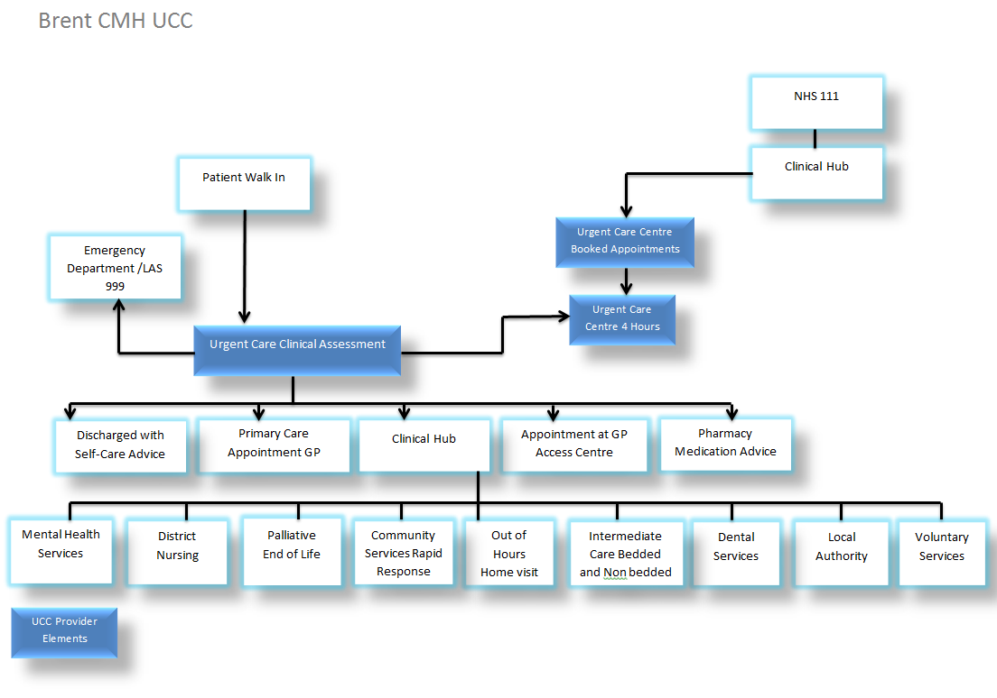Figure 1: Pathways in and out of the UCC

