**Health & Justice Clinical Healthcare Services Market Management Strategy Review, Market Assessment Questionnaire for:**

**INTEGRATED HEALTHCARE – PRISONS AND IMMIGRATION REMOVAL CENTRES (IRCs)**

**Introduction**

NHS Arden and Greater East Midlands Commissioning Support Unit (AGCSU) is working on a regional Market Management Strategy for healthcare services commissioned by NHS England & NHS Improvement Midlands (NHSE & NHSI).

As part of this project AGCSU wants to engage with relevant organisations within the Health and Justice Healthcare market, the initial stage is via questionnaires. In order to understand the interest and gain market input we have produced 3 questionnaires with identical questions categorised under the below service areas:

1. Integrated Healthcare – Prisons and Immigration Removal Centres (IRCs)
2. Sexual Assault Referral Centre Services (SARC)
3. Secure Children’s Homes and Training Centres

Please complete the relevant questionnaire(s) that best fits your market profile, where this applies to all three categories listed above attempt to complete them all. Where some questions may require duplication of a response as stated on a previous question, either reference the previous question or duplicate the response.

**Message from the NHSE & NHSI Head of Commissioning:**

*‘NHS England and NHS Improvement Midlands (NHSE & NHSI) area are keen to engage with organisations operating within or interested in the Health & Justice healthcare sector. We would appreciate you supporting NHS Arden & Greater East Midlands Commissioning Support Unit (AGCSU) who are working on our behalf by completing this questionnaire. Our objective is to gain your views to help develop NHSE & NHSI Midlands future commissioning strategies which can break down barriers to participating in future procurement processes.’*

*Sarah Forrest & Anthony Nichols - Head of Commissioning - Health & Justice NHSE & NHSI Midlands*

**NHSE & NHSI Midlands covers:**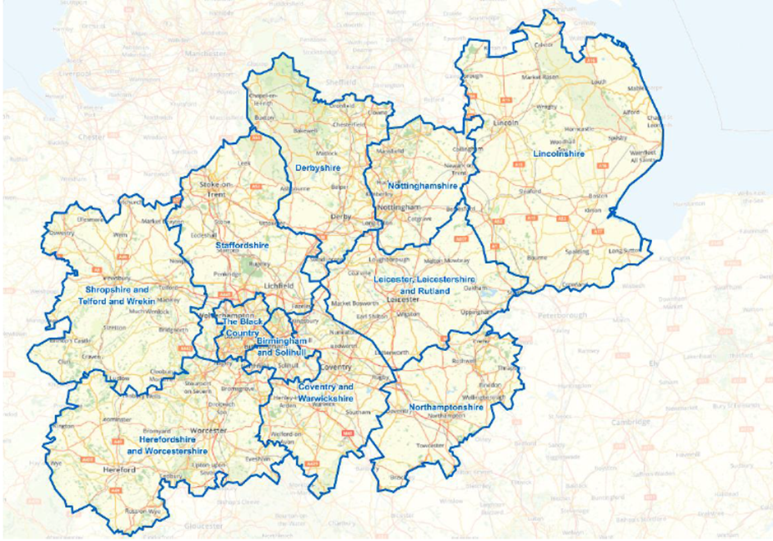

Please complete the table sections highlighted in the light grey response boxes, there is no word limit imposed on the questions and where necessary expand each box to meet your need, where your response refers to specific service please make this clear within each question. Try to complete as many questions as possible, the Commissioners are keen to gain as much market input as possible.

**1. Name of organisation:**

|  |  |
| --- | --- |
| Organisational Name: | *(Response)* |
| Registered Address: | *(Response)* |
| Trading Status (Public limited company; Limited company; Limited liability partnership; Other partnership; Sole trader or Other, please specify): | *(Response)* |
| Company Classification (VCSE; Small or Medium Enterprise (SME); Sheltered Workshop; Public service mutual or None of these): | *(Response)* |

**2. Contact details:**

|  |  |
| --- | --- |
| Name of individual completing the questionnaire: | *(Response)* |
| Position within organisation: | *(Response)* |
| Contact email: | *(Response)* |
| Contact telephone number: | *(Response)* |

**3. Provider’s current service provision and market positioning**

|  |  |  |  |  |  |  |  |  |  |  |  |  |  |  |  |  |
| --- | --- | --- | --- | --- | --- | --- | --- | --- | --- | --- | --- | --- | --- | --- | --- | --- |
| 3.1 Which Health and Justice (H&J) healthcare service area(s) best describe your market interest and positioning | *Please tick area(s) of interest:*   |  |  | | --- | --- | | Integrated Healthcare – Prisons and IRCs |  | | Sexual Assault Referral Centres (SARC) |  | | Liaison and Diversion |  | | Secure Children’s Homes and Training Centres |  | | Substance Misuse – Prisons |  | | Dental - Prison |  | | Other clinical services |  |   If other clinical services, please provide further details:   |  | | --- | |  | |
| 3.2 Please detail how many contracts you currently hold for Integrated Healthcare – Prisons and IRCs service and within which areas of England | *(Response)* |
| 3.3 Please detail how many contracts you currently hold for other Health and Justice healthcare services and within which areas of England. Please state what the other services are | *(Response)* |
| 3.4 How would you describe yourself in the Health & Justice healthcare market | *Please tick:*   |  |  | | --- | --- | | New/potential entrant |  | | Established provider with low market share |  | | Market leader |  | | Aspirational |  | | Market provider with a declining interest or looking to exit the Health & Justice market |  | |
| 3.5 Please provide a summary why you have selected the answer to section 3.4 above | *(Response)* |
| 3.6 What are your organisation’s key reasons for operating or having an interest in the health and justice healthcare market | *(Response)* |

**4. Market Feedback**

| **No.** | **Question** |
| --- | --- |
| Note | The commissioners are very keen to understand reasons why organisations are not responding with bids for contract opportunities within Integrated Healthcare – Prisons and IRCs. |
| 4.1a | What do you consider are the key barriers/constraints in bidding for Integrated Healthcare – Prisons and IRCs service contracts |
|  | *(Response)* |
| 4.1b | Is there any recent Integrated Healthcare – Prisons and IRCs tenders advertised where you have decided not to bid? If so, please detail these and provide a summary of the reasons why |
|  | *(Response)* |
| 4.1c | What key issues and problems have you faced when responding to tenders within Integrated Healthcare – Prisons and IRCs |
|  | *(Response)* |
| 4.1d | What additional early market engagement steps can the commissioners undertake to help both the market understand the potential opportunity and the Commissioners to understand the opportunities/threats the providers and wider market face |
|  | *(Response)* |
| 4.1e | What key internal issues do you face when responding to tenders for Integrated Healthcare – Prisons and IRCs procurement opportunities |
|  | *(Response)* |
| 4.2 | What do you consider to be the optimal contract length to enable you to deliver a high-quality service for Integrated Health Care in Prisons and or IRCs, please detail the reasons why |
|  | *(Response)* |
| 4.3 | What do you see to be the drawbacks or impact on the services from a reduced shorter contract length than the one you suggested |
|  | *(Response)* |
| 4.4 | What would your organisation look for in Integrated Healthcare – Prisons and IRCs tender opportunities that encourages a bid submission? |
|  | *(Response)* |
| 4.5 | How can we support you as market providers in helping to improve the procurement and tender process for Integrated Healthcare – Prisons and IRCs contracts |
|  | *(Response)* |
| 4.6 | What do you believe is the most suitable time period for contract mobilisation following the contract award for Integrated Healthcare – Prisons and IRCs contracts to ensure the awarded provider has enough time for full implementation |
|  | *(Response)* |
| Note | The commissioners are very keen to understand why potential market providers are not responding with bids to other Health & Justice Clinical Healthcare areas |
| 4.7a | Would you be interested in tendering for the other Health & Justice services:  Sexual Reference Centre Services;  Liaison and Diversion;  Secure Children’s Homes and Training Centres;  Dental - Prison  if so, please state which ones? |
|  | *(Response):* |
| 4.7b | If not, please explain why not: |
|  | *(Response):* |
| 4.8 | Would you be interested in attending a Market assessment workshop to discuss further feedback both with other providers and with the Commissioners to understand the Commissioning intentions of NHSE & NHSI Midlands |
|  | *(Response):* |
| 4.9 | Would you be interested in having a 1:1 meeting with the Commissioner to discuss further your responses to this questionnaire |
|  | *(Response):* |

**5 Response instructions**

We would like to thank you for the time you have taken to respond to this questionnaire. The Commissioners really welcome your feedback which will hopefully prove to be valuable in determining the future Commissioning and procurement strategies for the Health and Justice Clinical Services.

Please forward completed questionnaires as soon as you can to [agem.marketmanagement@nhs.net](mailto:agem.marketmanagement@nhs.net) email address and by close of 10th September 2019, earlier responses will be appreciated. Should you require further information please contact: Surinder Kahlon via the above email address.

**6 Next steps**

Further engagement may be necessary and is likely to be conducted on a direct basis with identified organisations.