OPEN TENDER

RSSB INVITATION TO TENDER FOR THE PROVISION OF: RSSB2630 - T1127 Creating a common framework of how rail can measure and understand its social impact value as a system

Deadline: Friday 15th September 2017

ITT Reference: RSSB2630 - T1127 Creating a common framework of how rail can measure and understand its social impact value as a system

- TENDER DOCUMENTS

1.1 Tenders shall be submitted in accordance with the following instructions. It is important that all the information requested is provided in the format and order specified. If the Tenderer does not provide all of the information RSSB has requested within the tender pack, RSSB may reject the tender as non-compliant.

1.2 Tenderers must obtain for themselves, at their own responsibility and expense, all information necessary for the preparation of their tender. Tenderers are solely responsible for any costs and expenses in connection with the preparation and submission of their Tender, and all other stages of the selection and evaluation process. Under no circumstances will RSSB, or its advisors, be liable for any costs or expenses Tenderers, their sub-contractors, suppliers or advisors incur in this process, including if this tendering process is terminated or amended by RSSB.

1.3 Tenderers are solely responsible for obtaining the information that they consider is necessary in order to prepare the content of their tender and to undertake any investigations they consider necessary in order to verify any information RSSB provides during the procurement process.

1.4 All pages of the tender submission must be sequentially numbered (including any forms to be completed and returned).

1.5 All specifications, plans, drawings, samples and patterns and anything else that RSSB issues in connection with this ITT, remains the property of RSSB and are to be used solely for the purpose of tendering.
1.6 At any time prior to the deadline for receipt of questions, RSSB may modify the tender documents by amendments in writing.

1.7 RSSB (at its sole discretion) may extend the deadline for receipt of Tenders.
RSSB reserves the right to modify or to discontinue the whole of, or any part of, this tendering process at any time and accepts no obligation whatsoever to award a contract.

- GENERAL, LEGAL & COMPLIANCE
2.1 RSSB will check each tender for completeness and compliance with the tender instructions. RSSB reserves the right to reject any tenders it considers substantially incomplete, or non-compliant (each tender will be assessed on its own merit, according to the level/importance of omitted or non-compliant content).

2.2 The Tenderer will be excluded should any of the grounds for mandatory rejection or discretionary rejection be triggered. Mandatory requirements can be viewed within the Public Contracts Regulations 2015.

2.3 Tenderers are required to confirm in their tender response, they are able to meet all mandatory and discretionary requirements.
2.4 The Tenderer will be excluded should it be assessed that it has a high risk of:
  - Insolvency over the lifetime of the contract; e.g. the Tenderer may be excluded if its current assets to current liabilities ratio is less than 1;
  - Insufficient financial capacity to deliver the services effectively; or
  - Over-dependence on RSSB (e.g. the Tenderer may be excluded if its turnover is less than £ [no more than2x the contract value]

3.0 TENDER INSTRUCTIONS

3.1 “RSSB” means the contracting authority, seeking to invite suppliers to participate in the procurement process.

“You” or “Supplier” means the legal entity completing these questions, seeking to be invited to the next step of the procurement process Invitation to Tender (ITT)

3.2 Please ensure all questions are completed in full and in the format requested. Failure to do so may result in your submission being disqualified. If the question does not apply you need to clearly state N/A.

3.3 If it is necessary for you to provide additional information this should be provided as an appendix and clearly referenced as part of your declaration.

3.4 RSSB REPRESENTATIVE
Your main point of contact is: shareditt@rssb.co.uk
RSSB OVERVIEW
If you wish to find out more about RSSB, please visit our website at www.rssb.co.uk
Timetable

The timetable for this procurement follows. This is intended as a guide and whilst RSSB does not intend to depart from the timetable, it reserves the right to do so at any stage.
The expected milestones are set out below:
 | Start Date
Expression of interest meeting | 4 August 2017
RFP issued | 18 August 2017
Supplier clarification questions deadline | 08 September 2017; 17:00 hours
Deadline for Submitting Tenders | 15 September 2017; 17:00 hours
Post Tender Clarification and Evaluation | W/C 18 September 2017
Estimated notification of award decision | W/C 02 October 2017
Target contract commencement date | w/c 30 October 2017

Note: RSSB reserves the right to amend these dates as business requirements demand and will communicate any changes to tenderers.

3.5 QUESTIONS
Should you have any questions relating to the project, please email these before the deadlines detailed in the project timeline above to ensure that these questions can be effectively addressed? To ensure equal and fair treatment to all potential suppliers, RSSB will circulate all questions and responses anonymously.
Questions should be emailed to: shareditt@rssb.co.uk

4.0 Evaluation Information
4.1 In the interests of an open, fair and transparent assessment, this document sets out how RSSB intends to evaluate tender responses. It outlines the evaluation criteria and respective weightings, as well as the evaluation methodology to be applied.

4.2 Verification of Information Provided

Whilst reserving the right to request information at any time throughout the procurement process. RSSB may enable the Supplier to self- certify that there are no mandatory/ discretionary grounds for excluding their organisation. When requesting evidence that the supplier can meet the specified questions relating to Technical and Professional Ability RSSB may only obtain such evidence after the final tender evaluation decision and only from the winning Supplier only.

4.3 Please self-certify whether you already have, or can commit to obtain, prior to the commencement of the contract, the levels of insurance cover indicated below:
- Employer’s (Compulsory) Liability Insurance = £2M
- Public Liability Insurance = £1M
- Professional Indemnity Insurance = £1M

4.4 Sub- contracting Arrangements

Where the Supplier proposes to use one or more sub- contractors to deliver some or all of the contract requirements, a separate Appendix should be used to provide details of the proposed delivery model that includes members of the supply chain and percentage of work being delivered by each sub -contractor and the key deliverables that each sub- contractor will be responsible for.

RSSB recognises that sub- contracting arrangements may be subject to change and not finalised until a later date. However, Suppliers should be aware that where information provided to RSSB indicates that sub- contractors are to play a significant role in delivering the key requirements and any changes to those sub- contracting arrangements significantly affect the ability of the supplier to deliver key requirements the Supplier should notify RSSB immediately of any changes in the proposed supplier sub-contractor arrangements. RSSB reserves the right to deselect the Supplier prior to any award of contract based on an assessment of the updated information.

4.5 Consortia Arrangement

If the Supplier completing this tender submission is doing so as part of a proposed consortium the following information must be provided:

- Names of all consortium members;
- The lead member of the consortium who will be contractually responsible for delivery of the contract (if a separate legal entity is not being created); and
- If the consortium is proposing to form a legal entity, full details of the proposal should be submitted as an Appendix with this Tender.
- RSSB may require the consortium to assume a specific legal form if awarded the contract. If it is deemed that a legal incorporation is necessary for the satisfactory performance of the contract.
- All members of the consortium will be required to provide the information required in all sections of the Tender as part of a single composite response to RSSB i.e. each member of the consortium is required to contribute to completing the response document.

4.6 Confidentiality

RSSB reserves the right to contact the named customer contact and the nominated customer does not owe RSSB any duty of care or have any legal liability, except for any deceitful or maliciously false statements of fact.
RSSB confirms that it will keep confidential and will not disclose to any third parties for any information obtained from the named customer contact, other than to the Crown Commercial Services and or contracting authorities defined by the Public Contract Regulations.

5.0 Evaluation Process
5.1 The process that will be used to select an appropriate Tenderer and award the contract for this procurement is available in more detail in the Evaluation Criteria.
The open procedure is a single stage process.
5.2 Marking for Award Criteria
An evaluation panel consisting of representatives of key stakeholders within RSSB will carry out the evaluation. The procurement team will only act as moderator during the assessment phases of the evaluation.
Each evaluation area is weighted to show the relative importance significance of the criteria specific area’s for assessment.

6.0 PROCESS AND PREPARATION OF RESPONSES

6.1 The Supplier shall not enter in any agreement or arrangement with any third party which would in any way cause RSSB or its members to incur any financial obligations to the Supplier or any third party.

6.2 The Supplier shall not approach any Customer employee, the Customer’s Representative or its agents to discuss any aspects of the Tender. All communication should be conducted via the Customers Representative.

6.3 The Supplier shall not canvass support for the award of the contract by approaching any employee of RSSB, its Representative or its agents.

6.4 The documents as enclosed are to be accepted in their entirety. No alteration Representative before the date stated for the receipt of tenders. If any alteration is made or these instructions to Suppliers are not fully complied with the tender may be invalidated.

6.5 The conditions of contract included in this Invitation to tender apply. The Suppliers standard terms of business or trade will not be accepted.

6.6 Any requested changes to the conditions of contract must be detailed on the Contract Issues Memo document included for consideration. If this is not completed, it is assumed that the Supplier has accepted all terms and conditions detailed and no further changes will be accepted.

6.7 The Supplier shall be deemed to have satisfied itself as to the nature, extent and the content of the goods, services or works to be provided, the extent of staff required and all other matters, which may affect the tender.

6.8 All prices quoted to be GBP (unless otherwise requested in the Invitation to Tender) exclusive Value Added Tax and firm.
It is the Suppliers responsibility to ensure the tender is correct at the time of submission. No amendment to the tender will be allowed after the due date.

6.9 Any questions must be emailed to the main point of contact no less than five days before the return date. Note: questions/responses will be circulated anonymously to all Suppliers invited to tender. Tenders received after the closing date and time will not be considered.

6.10 The Customers Representative reserves the right to correct any omissions or inaccuracies in the Invitation to Tender and to clarify and/or amend any of the Customers’ requirements, up to seven days before the return of tenders.

6.11 All information supplied by RSSB must be treated in confidence and not disclosed to third parties except insofar as this is necessary to obtain sureties or tenders required during the preparation of the Tender. All information provided by Suppliers will be treated in confidence except in stances where references may be sought.

6.12 RSSB reserves the right to cancel this Tender at any point and any cost incurred in the preparation of this Tender is at the Bidder’s expense.

6.13 Tenders must remain open for acceptance for a period of 180 calendar days from the submission date.

6.14 The tenderer should include the following information as part of their tender response:

Legal entity name of Tenderer

Contact person's name, email address, telephone number and postal address for enquiries relating to this procurement
Name:

Postal address:

Telephone number:

Email address:

Tenderer’s registered address

Tenderer’s website address (if available)

Please tick the box for the legal form of the Tenderer
- Sole Trader ☐
- Partnership ☐
- Limited Liability Partnership ☐
- Private Limited Company ☐
- Public Limited Company ☐
- Local Council ☐
- Voluntary/ charitable/ not for profit organisation ☐
- Other (please specify below) ☐

If ‘Other’ has been selected from the question above please provide details.

If your business is a registered company, charity or any other registered organisation (including limited, non-limited or Industrial and Provident Society), please state your registration number. This must be the registration number of the Tenderer, providing the country and date of incorporation / registration if other than the UK.

Name of ultimate parent company (if this applies)

Companies House Registration number of ultimate parent company (if this applies)

Additional Notes
- Fully answer the question given and consider the weighting for the section
- Explain how you will meet the criteria and provide evidence to support your response.
- Further reading on how to complete the tender is available in section 10

7.0 TENDER EVALUATION (SELECTION CRITERIA
Heading | Specific question(s) | Evaluation Criteria
S1 Supplier’s organisational experience delivering assessments of social value on business and systems within an organisation/sector/project | The tenderer should provide a short description (in no more than two pages) of at least two projects, completed within the last three years that delivered an assessment of the social value of business and systems within an organisation/sector/project. | Pass: The tenderer provides RSSB with a strong degree of confidence in its experience delivering assessments of social value on business and systems within an organisation/sector/project.  Fail: The tenderer either fails to provide evidence of at least two examples or fails to provide RSSB with sufficient confidence in its experience delivering assessments of social value on business and systems within an organisation/sector/project.
S2 Supplier’s organisational experience developing common frameworks and guidance | The tenderer should provide a short description (in no more than two pages) of at least one project, completed within the last three years that involved the development of a framework and associated guidance. | Pass: The tenderer provides RSSB with a strong degree of confidence in its experience developing common frameworks and associated guidance.  Fail: The tenderer either fails to provide evidence of at least one example or fails to provide RSSB with sufficient confidence in its experience developing common frameworks and associated guidance.

8.0 TENDER EVALUATION (AWARD CRITERIA)
8.1 ITT Assessment
The Contract Award decision is solely based on the basis of Tenderer proposal and price offering.

8.2 RSSB uses the following quality / price ratio to determine the outcome of the evaluation where quality (technical evaluation) and price are weighted and scored individually before being combined.
Quality 70%: Price 30%

8.3 Technical criteria are weighted and scored as a percentage of the maximum score available with a minimum quality threshold set.

Technical Evaluation
8.4 Tenders are assessed on how well they satisfy the technical evaluation criteria.
The relative importance of each criterion is established by giving it a percentage weighting so that all the weightings equal 100%. The Evaluation Matrix provides details of the weightings that RSSB will use in assessing Tenderer proposals.

The Technical Evaluation will be carried out using Tenderer responses to the tender specification using the scoring scheme (identified in Table below).

8.5 The scored responses are generally assessed out of a maximum of five (5). The Evaluation Panel will not be allowed to give partial scores (for example 3.5); however, once all scores are aggregated, the technical scores will be rounded to two decimal places prior to consolidating with the price evaluation.

8.6 The following shall constitute a failure to evidence satisfactory delivery of the requirement(s) of the procurement and will automatically disqualify the Tenderer:

- A grade of zero (0) in any of the evaluated technical/quality questions in Section D of Schedule One (a) of Part B of the ITT before the weightings are applied; or

- a grade of one (1) in more than one of the evaluated technical/quality questions in Section D of Schedule One (a) of Part B of the ITT before the weightings are applied

8.7 Those Tender Responses which fail to demonstrate satisfactory delivery of the requirement(s) of the procurement by reason of failing to achieve these minimum thresholds will be set aside and not considered further.

Grade | Definition of grade
5 | A wholly excellent Tender Response that (where applicable):  - Addresses all aspects of the question in an informed and comprehensive manner;  - Demonstrates a thorough understanding of what is being asked for;  - Provides evidence of how that understanding can be applied in practice;  - Offers full confidence that the Tenderer will deliver the service in full;  - Addresses the majority of areas of doubt and uncertainty; and  - Provides certain, unambiguous commitments or statements of intent that permit reliance through translation into contractual terms
4 | - A good Tender Response that (where applicable):  - Addresses all aspects of the question and is generally of a good standard;  - Demonstrates a good understanding of what is being asked for;  - Provides a worked-up methodical approach;  - Offers confidence that the Tenderer will deliver the service in full with limited areas of doubt or uncertainty;  - Addresses key areas of doubt and uncertainty; and  - Provides commitments that can be translated well into contractual terms
3 | A satisfactory Tender Response that (where applicable):  - Addresses the majority of the question and is generally of a good standard but lacks substance or detail in some areas;  - Demonstrates an understanding of what is being asked for;  - Provides a satisfactory approach;  - Offers a general level of confidence that the Tenderer will deliver the service (but with room for doubt in some areas);  - Address some areas of doubt and uncertainty; and  - Provides some commitments that can be translated well into contractual terms.
2 | A Tender Response that (where applicable):  - Addresses some of the question but either lacks relevant information and detail or lacks substance in a manner that would suggest the response is a “model answer”;  - Demonstrates some understanding but with a lack of clarity in key areas;  - Provides an approach which is not wholly appropriate or viable or lacks evidence;  - Shows that the level of confidence that the supplier can deliver does not outweigh the doubt;  - Does not address many areas of doubt and uncertainty; and  - Does not offer sufficient commitment (with doubt as to the extent to which would translate into contractual terms)
1 | A generally unsatisfactory Tenderer response that (where applicable):  - Does not address the question or has omissions;  - Lacks understanding in significant areas:  - Provides an approach which has gaps or creates concerns;  - Shows that the level of confidence that the supplier can deliver is low;  - Creates uncertainty; and  - Displays significant lack of commitment (with doubt as to the extent to which would translate into contractual terms)
0 | A wholly unsatisfactory Tenderer response that (where applicable):  - Provides no response or omissions/oversights that prevent scoring;  - Refuses to deliver the requirement; and  - Creates concerns so significant that the response would be detrimental to the interests of RSSB

9.0 ITT Evaluation Matrix (Award Criteria)

Heading | Specific question(s) | Evaluation Criteria | Weight
WA1 Supplier’s technical competence in delivering assessments of social value on business and systems within an organisation/sector/project | The tenderer should provide evidence of their resource’s technical competence in delivering assessments of the social value of business and systems within an organisation/sector/project. | The tenderer provides clear evidence (in no more than two pages) of their resource’s technical competence to deliver assessments of social value on business and systems within an organisation/sector/project.  The tenderers response provides RSSB with a strong degree of confidence in their technical competences in delivering assessments of social value  The tenderers response demonstrates that the tenderers has a high degree of quality in technical competence in delivering assessments of social value. | 10%
WA2 Supplier’s technical competence in developing common frameworks and guidance | The tenderer should provide evidence of their resource’s technical competence in developing frameworks and associated guidance. | The tenderer provides clear evidence (in no more than two pages) of their resource’s technical competence to develop common frameworks and associated guidance.  The tenderers response provides RSSB with a strong degree of confidence in their resource’s technical competence in developing frameworks and associated guidance.  The tenderers response demonstrates that the tenderers has a high degree of quality in their resource’s technical competence in developing frameworks and associated guidance. | 10%
WA3 Method statement – ability to meet deliverables | Tenderers should provide a method statement detailing how it is proposed to fulfil RSSB requirements as described in the specification (‘work package objectives’, ‘scope’, and ‘deliverables’). | The Tenderer’s response (in no more than five pages):  - Explains how they would apply their expertise to meet the specification, including how they would conduct the study;  - Demonstrates their understanding of the objectives and provide a coherent and systematic approach to meet these objectives.  - The tenderers method statement provides RSSB with a high degree of confidence in the tenderers ability to fulfil RSSB’s requirements as described in the specification.  - The tenderers proposes a high quality proposal, in terms of fulfilling RSSB requirements as described in the specification. | 20%
WA4 Project management: resource, quality, time and risk management | Tenderers should outline the processes and resources it proposes to use in order to fulfil RSSB requirements.  Tenderers should:  - Clearly identify each team member’s role;  - Provide adequate allocation of appropriate resources against deliverables;  - Demonstrate how they would work with RSSB and communicate and engage with relevant industry stakeholders to ensure that the quality and content of the deliverables are fit for purpose;  - Explain how they would meet the critical success factors for this piece of research;  - Demonstrate how they would manage any identified and unforeseen risks to delivering the project. | The tenderer’s response shows (in no more than ten pages) that it:  - Has identified relevant individuals to deliver the work;  - Has provided a credible plan for delivering successful outcomes to time, quality and cost;  - Has identified appropriate ways to engage with RSSB and relevant stakeholders;  - Has identified suitable ways to address the project’s critical success factors;  - Has identified risks and proposed effective management and mitigations. | 30%
WA5 Cost of project | Tenderers should:  - Provide a fixed cost for the project and the associated cost break down. | - The tender with the lowest total cost will receive 100% of the available weighted score (30%).  - Other Tenderer’s tenders will receive a pro-rated relative to the lowest cost according to the following formula:  - Score of other tender = lowest tender total cost / other tender total cost x 100%. | 30%

10.0 PRICE EVALUATION
10.1 All prices quoted shall be in sterling (unless otherwise requested in the Tender Documents), exclusive of Value Added Tax and shall be firm.
10.2 A full and comprehensive breakdown of all costs and expenses to provide the goods, services or works requested in this invitation to tender must be provided and all assumptions must be clearly stated.
10.3 Failure to provide adequate detail may cause your tender to be judged non-compliant.
10.4 The construction of the price must be clear and easy to understand. Where appropriate the use of tables to show pricing is preferred. We require the following information:
    - A breakdown by grade and named individual, indicating the number of days to be worked on each task and the daily rate to be charged.
    - A list of sub-contracts with prices and copies of quotations where available (a similar breakdown by grade, named individuals and rates, as above, is required where the sub-contract is for manpower).
    - Details of any other costs, such as hire charges for equipment.
    - Details of travel and subsistence and all expenses to be incurred. Mileage reclaim will be linked to maximum levels set by HMRC.
    - The above breakdowns should be further broken down into individual work packages.

11.0 TENDER EVALUATION CRITERIA AND MINIMUM REQUIREMENTS
11.1 In evaluating tenders, the most economically advantageous tender(s) will be sought. This will be using the evaluation criteria and weightings detailed in ITT Evaluation Matrix Award Criteria.
11.2 The evaluation criteria detail the minimum requirements. Therefore, any tender which cannot demonstrate that it meets any of the minimum requirements will not be marked and will automatically score zero.
Tenderers are advised to carefully consider the attached specifications, ask clarification questions to ensure these are understood.

12.0 CONDITIONS OF CONTRACT

The terms and conditions of the contract are contained with a separate document.
Qualification of the Contract
Where Tenderers have any queries or concerns with any specific condition of the terms and conditions of the contract, these should be submitted in writing to shareditt@rssb.co.uk as soon as possible, and in any case no later than 10 days prior to the deadline for submission of tenders. Please ensure the specific condition(s) and proposed amendment(s) are provided. These will be reviewed by RSSB on a case by case basis, and, if accepted, revised terms and conditions will be issued to all Tenderers. Failure to accept the terms and conditions of the contract or to qualify the tender in any way, may result in the tender being rejected by RSSB.

13.0 RSSB Company Information

Introduction

RSSB was established in April 2003. The Company’s primary objective is to facilitate the railway industry’s work to achieve continuous improvement in the health and safety performance of the railways in Great Britain, and thus to facilitate the reduction of risk to passengers, employees and the affected public. The railway is a complex system with multiple interfaces delivered by many different organisations. At RSSB we bring these different organisations together to make collective decisions. We help the rail industry carry out research, understand risk, set standards and improve performance. We provide a constant point of reference in a changing environment.

We support rail in the areas of safety standards, knowledge and innovation and a wide range of cross- industry schemes requiring our knowledge and independence. Our work involves close collaboration, but as technical experts we also appoint suppliers in the wider market to provide an informed view.

Key elements of the company’s remit are to:
- Manage Railway Group Standards on behalf of the industry
- Lead the development of long-term safety strategy for the industry, including the publication of annual Railway Strategic Safety Plans
- Propose change through facilitation of the research and development programme, education and awareness
- Measure, report and inform on health and safety performance, safety intelligence, trends, data and risk
- Support cross-industry groups in national programmes which address major areas of safety concern
- Facilitate the effective representation of the UK rail industry in the development of European legislation and standards that impact on the rail system
RSSB is a not-for-profit company owned by major industry stakeholders. The company is limited by guarantee and is governed by its members, a board and an advisory committee. It is independent of any single railway company and of their commercial interests.

Background
RSSB Overview
RSSB is a membership organisation in the railway that helps industry by understanding risk, guiding standards and managing research. The rail industry in Britain is made up of many different organisations, but they all form a system and share a common purpose, to move people and freight safely and efficiently by rail. RSSB brings all parts of this system together to make collective decisions, products and services, to help industry drive out unnecessary cost, improve business performance and develop long-term strategies.
RSSB’s activities include:
- Understanding risk – Using safety intelligence from across the rail industry and elsewhere with the latest risk modelling to inform members and support safe decision making.
- Guiding standards – Creating, reviewing and simplifying GB standards to align with European requirements; managing the Rule Book and making it easier for the railway to deliver efficiently and safely.
- Managing research, development and innovation – Undertaking, commissioning and managing research and innovation programmes to address current needs, provide knowledge for decision making now and for the future, and promoting step changes to deliver the Rail Technical Strategy.
- Collaborating to improve – As an independent cross-industry body with a critical mass of technical expertise, supporting activities which require collaboration. These range from supplier assurance schemes (RISQS, RISAS) to confidential reporting (CIRAS), from health and wellbeing strategies to sustainability principles.

Specification

Specification for research project

Creating a social value measurement framework for rail

T1127-02 (Work package 2 of 2)

Procurement ID number | RSSB2630
Procurement Manager
Version | 0.7
Date | August 2017

- Background
- RSSB Overview
RSSB is a membership organisation that supports the railway industry by understanding risk, guiding standards and managing research. The rail industry in Britain is made up of many different organisations, but they all form a system and share a common purpose, to move people and freight safely and efficiently by rail. RSSB brings all parts of this system together to make collective decisions, products and services, to help industry drive out unnecessary cost, improve business performance and develop long-term strategies.
RSSB’s activities include
- Understanding risk – Using safety intelligence from across the rail industry and elsewhere with the latest risk modelling to inform members and support safe decision making.
- Guiding standards – Creating, reviewing and simplifying GB standards to align with European requirements; managing the Rule Book and making it easier for the railway to deliver efficiently and safely.
- Managing research, development and innovation – Undertaking, commissioning and managing research and innovation programmes to address current needs, provide knowledge for decision making now and for the future, and promoting step changes to deliver the Rail Technical Strategy.
- Collaborating to improve – As an independent cross-industry body with a critical mass of technical expertise, supporting activities which require collaboration. These range from supplier assurance schemes (RISQS, RISAS) to confidential reporting (CIRAS), from health and wellbeing strategies to sustainability principles.

- Creating a social value measurement framework for rail
The GB rail industry has robust means to measure the economic value of rail, however, social sustainability still relies largely on narrative explanations and limited metrics. While there has been much progress on understanding and targeting the social value of rail projects, the absence of a robust methodology and baseline to measure, monitor and evaluate social impacts has resulted in inconsistencies across industry and little trust in existing metrics. This has made it challenging to assess the social return on investment (SROI) within the investment optioneering, planning and delivery of the railway.
Sustainability is becoming increasingly embedded within industry, as such, there is an increasing need to consistently and proportionally measure and monitor social impacts across the rail system. Recent examples of social impact expectations include
- South Western franchise Invitation to Tender (ITT) – Bidders required to ‘develop a dashboard of metrics for Stations or groups of Stations that … evidence improvements to ... meeting the community’s needs’;
- East Midlands Franchise Prospectus – Franchisees ‘required to proactively develop meaningful relationships with the communities the franchise serves, working with stakeholders across the region to encourage greater social inclusion’;
- Thameslink and Crossrail - Network Rail teams have been challenged to report on the social value delivered through the life of projects;
- Upcoming major infrastructure projects such as Crossrail 2, Brighton Main Line Upgrade Programme (BMUP) and TransPennine Route Upgrade (TRU) - Requirements for clear planning on incorporation of social value within the design and delivery, including improved measurement of benefits analysis;
- Network Rail - Setting contractor requirements around delivery of social benefits as part of the wider environment and social contract requirement updates. However, measurement of benefits delivered is an ongoing challenge;
- Edge Hill station (Liverpool) – Network Rail challenged to report on the social value of the station’s transformation into a vibrant arts centre, with studio and performance space and offices for a local arts organisation.
This project will develop a common framework and guidance to understand and measure social value impacts across GB rail industry organisations, projects and programmes. The proposed outputs will provide industry with greater consistency and quality assurance and support the Rail Sustainable Development Principles by enabling industry to have ‘an in-depth understanding of the issues and needs in a local area’. The project outputs will help inform the development of rail organisations’ social assessment tools, enabling industry to collect metrics and set social performance goals. Successful implementation could contribute towards government’s expectations on economic and social policy, for example securing ‘wider social, economic and environmental benefits’ as outlined in the Public Services (Social Value) Act.
This project is structured in two work packages as follows
- T1127-01 RSSB development costs
- T1127-02 Development of a common framework
T1127-01 covers the internal costs incurred by RSSB in the development of the project specification and business case.

- Work package objectives
This work package sets out to develop a common framework for understanding and measuring social value impacts across GB rail industry organisations, projects and programmes. The common framework will
- Build upon existing research to reduce the risk of duplicating existing work;
- Be applicable across the whole life of franchises, projects and programmes;
- Be scalable and useable across the GB rail industry.

In order to achieve this aim, this work package will
- Undertake a literature review on existing frameworks to assess social value impacts, to include a mapping of
- WebTAG
- Olympic Delivery Authority (ODA) Balanced Scorecard
- Global Reporting Initiative (GRI) Index
- United Nations Millennium Development Goals
- Crossrail Sustainability Programme
- T1074 Developing a sustainable stations framework;
- Collate and analyse social impact data (metrics) from rail and other industries;
- Review social value monetisation frameworks, tools and techniques used in other industries.
- Develop (and trial) a framework that includes
- List of relevant metrics for rail with appropriate measures/monetisation
- Benchmarks of good practice
- Guidance on decision making on metrics, implementation and measurement/monitoring

- Scope
In scope | Out of scope
- Social impact data (benefits and disbenefits) from rail and other industries, to include consideration of social benefits such as  - Health and wellbeing  - Diversity and inclusion  - Community cohesion  - Community safety, including suicide prevention and anti-social behaviour  - Employment and skills (including local recruitment)  - Local and sustainable procurement (including SMEs and social enterprises)  - Employee engagement  - Customer satisfaction  Consideration should also be given to the industry specific drivers of social value, to include (but by no means limited to)  - Accessibility (i.e. in relation to design and operations)  - Community use of railway assets (including rail heritage, community rail partnerships and community rail volunteering)  - Travel and tourism  - Polycentric development  - Gentrification  - Social value monetisation frameworks, tools and techniques used in other industries, to include  - Housing Associations' Charitable Trust (HACT) Social Value Calculator  - Differentiation between construction and operational phases (regeneration benefits)  - Standardisation of quantitative values (including weighting factors)  - Scalability (to account for geographical/regional, project/programme, organisation and stakeholder types)  - To include Index of Multiple Deprivation  - Qualitative factors (to ensure that the framework is not quantitatively dominant)  - Assessment of benefits timeframe (i.e. to assess at what point social benefits are transferred)  - Additionality/deadweight (to reduce risk of double counting of benefits)  - Regeneration of local areas (e.g. the influence of train stations on town centres)  - Alignment of social benefits with local government policy (e.g. Section 106) | - Development of a social assessment tool with common monetisation methodology (noting that organisations may develop their own)  - Proposal of targets and indicators of progress for the GB rail industry to measure and understand its social impact/value as a system  - Quantifying the total socio-economic impact of rail on Great Britain  - Environmental sustainability/natural impact (carbon impact, etc.)

- Methodology
Suppliers are expected to explain the methodology that they are intending to use to successful meet the project objectives and cover the scope.

- Deliverables
Deliverable Name | Type
Creating a social value measurement framework for rail – Social value monetisation frameworks, tools and techniques | Report
Description
The report will incorporate the following
- A literature review that identifies existing frameworks to assess social value impacts, this should include a mapping of WebTAG, a review of the Olympic Delivery Authority (ODA) Balanced Scorecard, Global Reporting Initiative (GRI) Index, United Nations Millennium Development Goals, Crossrail Sustainability Programme and T1074 Developing a sustainable stations framework;
- A collation and assessment of social value monetisation frameworks, tools and techniques used in other industries.
The report will be reviewed by the project steering group, Sustainable Development Steering Group and RSSB and will feed into the common framework. The report will be produced in a RSSB template and will be made available on SPARK (a free-to-access interactive web library) to RSSB members.

Deliverable Name | Type
Creating a social value measurement framework for rail - Common framework | Framework
Description
A practical common framework will be developed to understand and measure social value impacts across GB rail industry organisations, projects and programmes. The framework should apply the findings of the report and include a list of relevant metrics for rail with appropriate measures/monetisation; and benchmarks of good practice. The framework should be interactive and user-friendly for non-experts; the framework should be scalable by region, organisation, project and programme types and should incorporate guidance on decision making for metrics, implementation and measurement/monitoring.
The framework will be reviewed by the project steering group, Sustainable Development Steering Group and RSSB and will be made available on SPARK to all users. The framework will be produced in a RSSB template.

Deliverable Name | Type
Creating a social value measurement framework for rail - Draft Research in Brief | Research in Brief
Description
The research in brief will summarise the aim, findings, impacts and benefits, background and methodology of the project. The document should identify indicative ownerships of recommendations and next steps which are realistic and indicatively accepted (if achievable).
The deliverable will be reviewed and finalised by RSSB and will be made available on SPARK and RSSB’s websites. The draft research in brief will be produced in a RSSB template, no more than four pages in length.

- Stakeholders roles and responsibilities
Stakeholder(s) | General role in project | Specific role in acceptance of deliverables
RSSB Delivery Manager | The RSSB Delivery Manager is the first point of contact during project delivery and is responsible for the detailed project management including project schedules, cost reporting and other relevant project management tasks.  The Delivery Manager leads the project in organising meetings, etc and ensures timely and effective delivery towards project objectives. | Facilitates technical review and acceptance processes, identifies and monitors corrective actions where needed, including facilitating decision making.
RSSB Technical Lead | Throughout the project, the RSSB Technical Lead ensures that technical aspects are reflected accurately.  Technical aspects can refer to specific issues around railway signalling, track engineering, safety relevant operations or any other specialist field. | Reviews emerging outputs from a technical perspective.
Industry sponsor and RSSB sponsor | The industry and RSSB sponsors act as a figurehead for the research, championing its importance and its outputs.  Their key role is to provide steer to the research as it progresses and exert pressure on the industry to make use of its findings. | Formally accepts deliverables
Project supporters | The project supporters represent parts of industry complementary to the industry sponsor’s organisation. They offer expertise for effective project delivery and support the implementation of findings led by the industry sponsor through networking, advice and other support. | Formally accepts deliverables
Project steering group | The project steering group ensures the project delivers to industry needs.  As such, it helps formulate specifications, assesses tenders, reviews draft and final outputs and other relevant tasks. | Formally accepts deliverables

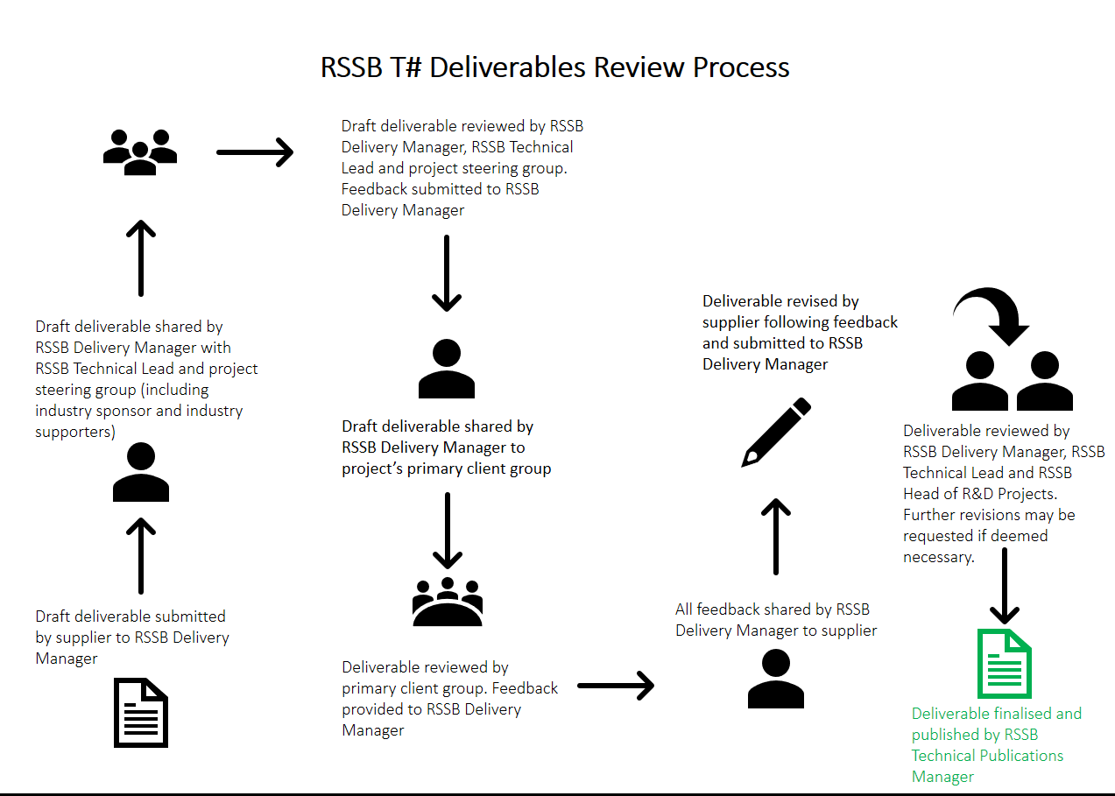
Two diagrams are included below to outline RSSB’s governance process for reviewing and publishing T# deliverables and Research in Briefs

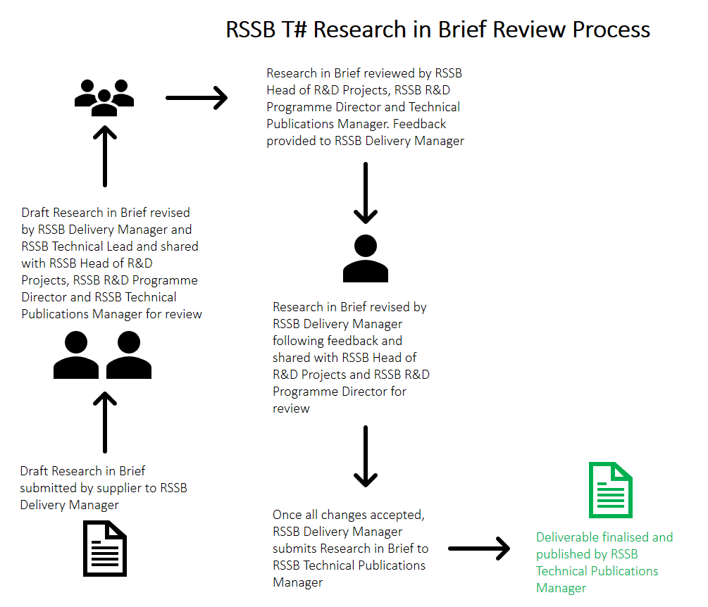

- Budget and timescales
The budget for this work is up to £75,000. Any bid above this value will need to provide detailed explanation on why the supplier doesn’t feel that the budget is adequate and in such case, we strongly encourage suppliers to provide costed options for RSSB to consider.

The work is expected to start in October 2017 and be completed by June 2018. These are indicative dates and RSSB is prepared to consider bids that vary from these expectations if they have a robust and realistic project plan, and an explanation of changes to the proposed start and end dates.

- Critical success factors and risk management
The following critical success factors/risks have been identified to help ensure successful delivery of the project and increased likelihood of industry acceptance/implementation
- Stakeholder engagement and buy-in
- Access to social impact data
- Mitigation of potential Intellectual Property Right (IPR) issues
- Industry consensus on weighting factors
- Framework useable (intuitive) for non-specialists
- Ability to identify single set of indicators at industry level

A detailed risk assessment/register and assumptions register should be provided highlighting areas where greater attention may be required to ensure success of the project.

Appendix X Form of Tender

This section outlines how the offer from the Tenderer is to be constructed. Please return this Tender Declaration along with your Tender and retain a copy for your records.

Having examined the ITT email, the Instructions to Tenderers, the Information Required From Tenderers, the Conditions of Contract, the Specification and this Form of Tender (the “Tender Documents”), we offer to supply all/part of (delete as applicable) the goods, services or works specified in these Tender Documents.
We undertake if selected, to perform the contract in accordance with the Tender Documents, including the Conditions of Contract contained herein.
We agree that this tender shall remain open for acceptance by the Customer for 180 days from the date stipulated for the return of tenders.
We understand that you are not bound to accept the lowest, or any tender you may receive.
We certify that this is a bona fide tender, and that we have not fixed or adjusted the amount of the tender by or under or in accordance with any agreement or arrangement with any other person. We also certify that we have not done and we undertake that we will not do, at any time before the hour and date specified for the return of this tender, any of the following acts:
- Communicate to a person, other than the person calling for the tenders, the amount or approximate amount of the proposed tender. Except where the disclosure, in confidence, of the approximate amount of the tender was necessary to obtain insurance premium quotations required for the preparation of the tender.
- Enter into an agreement or arrangement with any other person that he shall refrain from tendering or as to the amount of any tender to be submitted.
- Offer or pay or give or agree to pay or give, any sum of money or valuable consideration directly or indirectly to any person, for doing or having done or causing or having caused to be done, in relation to any other tender or proposed tender for the said goods, services or works, any act or thing of the sort described herein.
We recognise that the Customer reserves the right to clarify details of our offer prior to the award of any contract.
We hereby undertake that the period during which this tender remains open for acceptance not to divulge to any persons, other than the persons to whom the tender is to be submitted, any information relating to the submission of this tender or the details contained therein except where such is necessary for the purpose of submission of this tender.

Appendix X Subcontractors

All suppliers to RSSB are asked to provide details of all sub-contractors that will be used to perform the contract.

Name & Address of Sub-Contractor |  | Service performed for Contractor | Provide details of staff numbers | Provide latest year’s turnover
Name:
Address:

Name:
Address:

Name:
Address:

Appendix X Conflicts of Interest

Tenderers have a continuing duty to disclose actual or potential conflicts of interest in respect of itself, its named sub-contractors and / or consortia members.

Please describe any (potential) conflicts of interest that the Tenderer has identified and how these will be managed*:

If you DO NOT have any conflicts to declare, please tick this box:

Tenderers are reminded that failure to identify material conflicts of interest may lead to rejection of its tender response.
Guidance to Tenderers:
Tenderers should describe in the detail the perceived conflict (how it could be perceived in the context of this procurement) and the measures it will take to mitigate the conflict through the procurement life-cycle and service delivery

Social sustainability is defined as ‘identifying and managing business impacts, both positive and negative, on people, be they employees, suppliers, rail users, communities or other groups affected by the rail industry’s physical and socio-economic presence.’
Social value includes consideration of social benefits such as - Health and wellbeing - Diversity and inclusion - Community cohesion - Community safety, including suicide prevention and anti-social behaviour - Employment and skills (including local recruitment) - Local and sustainable procurement (including SMEs and social enterprises) - Employee engagement - Customer satisfaction Industry specific drivers of social value include (but are by no means limited to) - Accessibility (i.e. in relation to design and operations) - Community use of railway assets (including rail heritage, community rail partnerships and community rail volunteering) - Travel and tourism - Polycentric development - Gentrification
Further to this, a review should be undertaken of the DfT’s 2010 report ‘Station Usage and Demand Forecasts for Newly Opened Railway Lines and Stations’
The review should, in part, include RDG’s report ‘Community Stations: Innovative community uses for railway stations and land’
This is the average annual numbers of both staff and managerial staff employed over the last trading year

