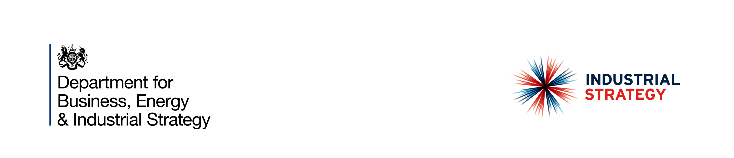

Offshore Energy Strategic Environmental Assessment (SEA) – Project Management for the maintenance of SEAs, including the provision of a new SEA

# Market Engagement Questionnaire

**Submission Date – 26/09/2022**

# Market Engagement Questionnaire

Please complete all the below questions and submit via the Jagger Procurement Portal by 26/09/22

|  |  |
| --- | --- |
| Name |  |
| Address |  |
| Contact Email |  |
| Company Number |  |
| Please provide details of your expertise in undertaking Strategic Environmental Assessments and Habitat Regulations Assessments. |  |
| Please provide details of your expertise in project management of a large programme of work. |  |
| Please provide details of your experience of sub-contracting and management of a research programme. |  |
| What are the key points you would like us to address in the specification, to enable you to produce a quality bid? |  |
| Which of the following Social Value themes do you think is most relevant to this future contract? (The examples provided are not prescriptive but are to give you an idea of activities which may be suitable under each theme)   * Supporting Covid-19 recovery * Tackling economic inequality (creating new businesses, new jobs and new skills) * Fighting climate change including how you would assist BEIS in reaching their Net Zero target * Providing equal opportunities (e.g. tackling workforce inequality or reducing disability employment gap) * Improving wellbeing (e.g. improving health and wellbeing, improving community integration |  |