GO-EV SMart Project
Specification for
Telemetry Development
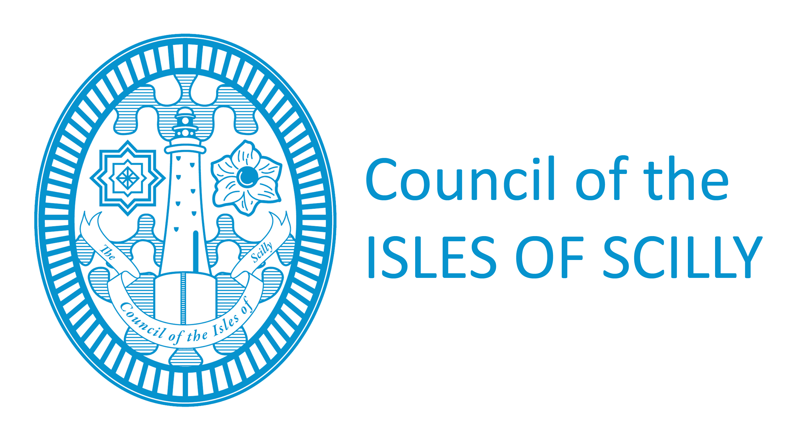
July 2026

Contents

- Background
- Specification of works
- Variations from the Specification (Variant Bids)

Background

- The Council of the Isles of Scilly is managing a project to develop an alternative fuelling network, multi modal travel hubs and mobility platform to encourage adoption of ultra-low carbon transport. The project is IOS GO-EV SMart project (“GO-EV) with ERDF reference 05R17PO1761. It will be trialling innovative ‘vehicle-to-grid’ (V2G) technology. The project is being funded by the European Regional Development Fund (ERDF) and the central government Local Growth Fund (administered by the Cornwall and Isles of Scilly Local Enterprise Partnership).
- The GO-EV project has been delivered in 3 work streams:
  - WS1 – the installation of a charge point network, solar canopies and provision of 10 electric vehicles. This included 2 multi modal hubs at the Airport and one at the Mermaid car park (as close to St Mary’s Quay as it was physically possible to install a hub). A number of charging sites have been created on St Mary’s and each of the off-islands of Bryher, St Agnes, Tresco and St Martin’s offering dedicated charge points for car share vehicles as well as charge points for people with their own electric vehicles to charge from. Each site has a different configuration based on site constraints and demand for vehicle charging. It was not possible to install solar canopies at each site but alternatives where possible were utilised including connection to existing solar, new ground mounted solar and building mounted solar. Due to tight budget management, it has been possible to purchase 12 rather than 10 electric vehicles with 4 no. Nissan Leaf cars, 4 no. 7-seater combi vans (one of which was converted for wheelchair access) and 4 no. commercial panel vans. These offer a range of options for public and business to rent a vehicle for a multitude of uses including tip runs to the local waste site, mainland contractors visiting the islands, by the Council as part of its fleet, the delivery of meals on wheels, by the coast guard when their vehicle was off the road and numerous other examples. The car share scheme has proved very popular and successful and helped drive the business case to purchase a further two vehicles above the original planned 10. Ten of the network of charge points come with vehicle-to-grid technology allowing the vehicles to charge as well as discharge to the grid supporting some of the aspects of WS2.
  - WS2 is divided into two parts which together deliver the ICT and innovation aspects of the project:
    - Firstly, a car share platform allowing for the management of the car share scheme. This includes a mobile phone app allowing for members to search for, book and pay for car share vehicle rentals. The mobile phone app was also used to open and close the vehicles linked with on board units connected to the vehicles locking mechanism. A back-office function allows for the management of the car share scheme by the operator including validating new customers into the system. An initial white label car share platform was deployed but early testing proved there were too many teething problems with the system which although it worked well, suffered in areas where there was poor mobile signal. With budget and time available, the project was able to pivot and build a dedicated car share platform and in car hardware from scratch. As this new system is bult on open-source software, it has been published so that other community groups wanting to create a car share scheme can benefit.
    - Secondly an ICT platform for controlling the flow of energy was created by Hitachi and built on the previous Smart Energy Islands project. An API from the car share platform allows for information on the state of charge of the vehicle and any upcoming bookings to be fed into the ICT platform which is turn then talks to the charger to tell it when to charge (or discharge) the vehicle. This has enabled the optimisation of solar charging, optimising the best times to discharge the vehicles to the grid and optimising the time vehicles are charged using grid electricity based on different tariff prices and different times. Each type of optimisation was set to ensure that each car share booking had enough charge in the vehicle to fulfil the journey.
  - WS3 involved the creation of a business case for both the legacy operation of the car share scheme on the Isles of Scilly and the wider deployment of the energy optimisation learnings across the UK and Europe. A business case for the legacy operation of the car share scheme by the Isles of Scilly Community Venture was developed and taken for approval at Full Council by Members. As laid out in the application, the assets will in due course transfer to the Community Venture. Additional State Aid/subsidy Control advice has been sought before the transfer takes place as the original advice at the beginning of the project is potentially now out of date.
- While background information is provided for WS1 and WS3, this tender is mainly related to WS2 element and specifically telemetry development of the car share platform detailed above.

Specification of services

- The Council of the Isles of Scilly is seeking a suitably experienced consultant or agency to carry out and test enhancements to our open source in-vehicle-telemetry system for the GO-EV car share project. This will encompass updating PCB designs, device firmware and case design. The modifications required are detailed below, and should build upon our existing Open Source hardware/firmware design available at https://github.com/ios-cv/maxbox
- The specific outputs required from the supplier are listed below. Suppliers will be expected to deliver all of the outputs in full and are required to address their capability to deliver the outputs in the quality criteria of the tender assessment:
  - Addition of LoRaWAN module and necessary ancillary components and antennas to existing PCB design to enable sending of telemetry data over LoRaWAN
  - Addition of 4G module and necessary ancillary components and antennas to existing PCB design to enable sending of telemetry data over 4G
  - Addition of GPS module and necessary ancillary components and antennas to existing PCB design to enable GPS coordinates to be collected and transmitted with telemetry data
  - Redesign/relocation of 6-pin picoblade connector strain relief to make it fit for purpose by following appropriate standards and/or best practices
  - Basic integration of existing firmware with the new 4G/LoRaWAN/GPS modules to demonstrate new modules are fully functional and compatible at a hardware and firmware level with the system
  - Additional telemetry readings to be added to the firmware from vehicle CAN BUS data relating to faults and vehicle health, to include at a minimum: tyre pressure sensor readings. Compatibility required with Nissan Leaf ZE1 and Nissan eNV200 vehicles.
  - Enhancements to the LED-based user-feedback mechanism to allow for more flexible and ergonomic communication of success/error states.
  - Intermediate test/release candidate PCB production as required (at supplier’s expense) to verify and demonstrate functionality of the system including all existing functionality and the enhancements described in this specification. User Acceptance Testing to be conducted on the Isles of Scilly by GO-EV project team supported in person or remotely by supplier.
  - Access to test vehicles (Leaf ZE1 / eNV-200) can be provided to supplier at no charge on the Isles of Scilly. Elsewhere, access to such vehicles will be at supplier’s expense.
  - If necessitated by any change in form factor of the PCB, updated STL files to be provided for a new case design compatible with the new PCB which is suitable for 3D printing.
  - Preparation of all necessary files for final version PCB production and assistance to customer in submitting the final production PCB order (production PCBs to be purchased at customer’s expense).
  - All software source code, PCB design files, and case/enclosure design files produced under this contract should be provided under the same open source licences as the existing code base in the form of commits or pull requests to our git repository at https://github.com/ios-cv/maxbox
  - Supplier warrants that all outputs produced under this specification are compatible with the Open Source licences adopted in the above repository.
  - Supplier to provide support to customer for a period of 1 year after the completion of the contract. Support to include assistance in identifying, debugging and remediating any issues with the final production version of the PCB, firmware and case.
- It is expected that the supplier will complete all the outputs by 31st May 2023.

Variations from the Specification (Variant Bids)

The Council will not accept variant bids relating to this procurement.

