

**Request for Information – ROM Costs**

Provision of Card Spending Data

1. **Project Primary Objectives & Requirements**

**Request for Information (RFI) – Provision of Card Spending Data, Rough Order of Magnitude (ROM) costs**

ONS would like to obtain estimated ROM costs to provide the data detailed at Annex A (Required variables). If you are interested in this opportunity and are able to provide the required variables detailed in Annex A, please complete the ROM cost table under Section 2 and provide responses to the questions in Section 3. Please submit your completed document via InTend by end of day 10/01/2025. Instructions on how to submit via InTend are included in Section 3. We will look to follow up with a one-to-one conversation to discuss submissions further.

**Purpose**

The Office for National Statistics (ONS) have been developing card spending data for the public good in partnership with data providers in the payment industry since 2019. The work so far, in conjunction with similar work undertaken by other National Statistical Institutes, has demonstrated the clear potentials of card spending data as new data sources for Official Statistics production as well as for providing granular, timely insights into the national and local economies.

In the next phase of our statistical development, ONS are seeking to work collaboratively with a UK data provider with high coverage and data granularity to jointly develop economic and statistical applications for ONS and wider UK Government based on card spending data. We expect working together on a cost-recovery basis, i.e. contract costs being proportionate to the actual costs incurred, in a value-exchange model. For example, when developing new data and insights for ONS’ purposes, data scientists from both organisations may work together to solve technical issues that bring additional value to the data provider beyond the partnership. Similarly, the data provider may benefit from ONS publications and statistical improvements based on their data through an enhanced corporate reputation. We expect to build a strong partnership with the data provider, that goes beyond a transactional commercial arrangement, in maximising the public value of large transactional data.

As part of the partnership, ONS would like to develop card spending data into new economic data that can improve National Accounts measurement and produce insights on consumer behaviour to:

1. understand retail performance of high streets and towns,

2. understand spend by merchant location,

3. understand spend by origin & channel.

Further requirements include permissions for ONS to regularly publish articles and aggregated insights/datasets such as this [recent publication on card spending flows across UK regions](https://www.ons.gov.uk/economy/economicoutputandproductivity/output/articles/consumercardspendingflowofspendingacrosstheuk/2019to2023), and to enable cross-government access to the data through a secure data platform (such as the Integrated Data Service) to link to other government key data assets to produce further innovative, cross-cutting insights, as this recent [joint publication by the Competition and Markets Authority and ONS](https://www.gov.uk/government/publications/estimating-geographical-retail-markets-from-card-spending-data).

ONS require the following information, in the form of 3 data tables.

* Retail Performance of High Streets and Town
* Spend by merchant location
* Spend by origin and destination

The full details of the variables required within each of the tables are included in Section 2.

The data tables will be aggregated to monthly totals (or more granular, subject to statistical disclosure control not affecting the utility of the data) and provided to ONS a monthly or quarterly basis.

1. **Annex A: Required variables.**

**Table 1: Retail Performance of High Streets and Town**

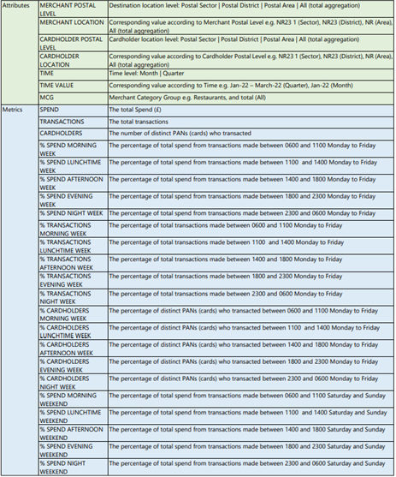

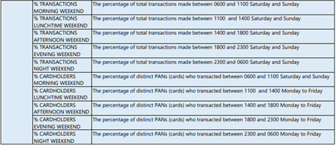

**Table 2: Spend by merchant location**

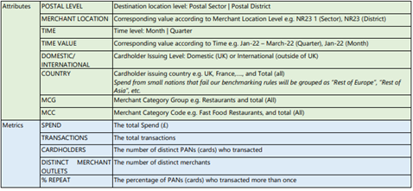

**Table 3: Spend by origin and destination**

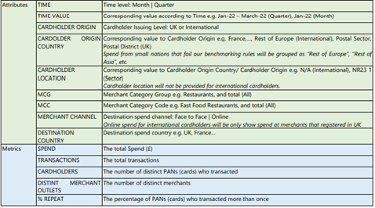

Please provide ROM costs for the below:

|  |  |
| --- | --- |
| **Deliverable** | **Approx Annual Costs** |
| Aggregated monthly totals of the variables detailed in Annex A delivered monthly. |  |
| Aggregated monthly totals of the variables detailed in Annex A delivered quarterly. |  |

1. **Questions**
2. Can you provide all the variables detailed in Annex A?
3. Can you provide aggregated monthly totals of the variables detailed in Annex A?
4. Would you be willing to work with ONS collaboratively in developing these data and related insights?
5. Would you permit ONS to publish articles and aggregated insights/datasets?
6. Would you permit ONS to share the data across government through a secure data platform, such as the Integrated Data Service? (Any potential publications by other government departments will adhere to the same process as ONS publications)
7. What coverage of UK card transactions can you provide that ensure any output would accurately reflect economic trends at both the national and local levels?

If you would like to assist with this information, please register on the ONS e-tendering portal <https://in-tendhost.co.uk/ons> and use the "express an interest" function against the project title ‘Provision of Card Spending Data’. You will then need to ‘Opt In’ to submit your RFI.

This Exercise is NOT a pre-qualification or selection exercise and is NOT part of any pre-qualification or selection process that may apply to any future potential procurement. It is intended to act as an awareness and information gathering exercise offering an opportunity for suppliers to advise the extent to which they potentially can provide some or all the services that ONS may require, in order to help ONS with its future intentions.

Any future tenders may be conducted through ONS’s ‘DPS Data SaSiE’. If you would like to sign up for this in readiness to receive any future tender packs, please search for the DPS title on the e-tendering portal and ‘opt in’. This will take you through to the associated documentation for your organisation to apply.