

# RSPB

# ITT

# Compliant Visitor Toilets

# Pulborough Brooks

# Date 2nd May 2025

# Rev. 03-2171-PBTF-16.001



RSPB

Date: 2nd May 2025

Dear Sir or Madam,

TENDER FOR THE SUPPLY OF Compliant Visitor toilet block for the RSPB at Pulborough Brooks, Upperton Barns, Wigginholt, Pulborough, West Sussex, RH20 2EL

Period 2nd May 2025 to 28th May 2025

You are invited to tender in competition with others to provide the goods and/or services specified above to the RSPB.

The following documents are enclosed and must be, where applicable, completed and signed on behalf of the supplier.

|  |  |
| --- | --- |
| Document A | Instruction and Information |
| Document B | RSPB: A Brief Introduction |
| Document C | Specification of Goods / Services |
| Document D | Company Information |
| Document E | Form of Offer |
| Document F | Terms and Conditions |
| Document G | Certificate of Bona Fide Offer |

Your tender response should be emailed to [chris.goodman@rspb.org.uk](mailto:chris.goodman@rspb.org.uk) / 9th June 2025 1300Hrs

Only tenders submitted in accordance with the RSPB’s Terms and Conditions will be considered. Any tenders that are incomplete, or received after the time indicated, may be disregarded.

If you wish to discuss any aspect of this tender prior to tendering, please email [chris.goodman@rspb.org.uk](mailto:chris.goodman@rspb.org.uk)

If you do not wish to tender on this occasion please let us know.

Yours faithfully

Chris Goodman

Project Manager

RSPB

|  |  |
| --- | --- |
|  | **Document A**  **Instructions and information** |

1. This document is designed to be completed electronically. You are required to mark boxes, insert information or submit additional documentation in response to the questions herein. Whilst the text boxes should expand as you add text, if there is insufficient space for your response please attach a separate document clearly marked with the name of your Company, the reference number and the number(s) of the question(s) to which it relates. Please ‘sign’ this document by adding your name to the end of Document G.
2. If you are unable to comply with a request for information or provide documentation requested then a written account explaining the absence of the information must accompany the return of this tender. Please be aware that the failure to respond to any of the questions, without a written reason, may result in a negative evaluation of that element within the overall evaluation of this questionnaire.
3. The RSPB may require supplementary information or clarification or further evidence of the information given. The RSPB may wish to visit reference sites given as evidence of relevant experience.
4. The RSPB may request interviews with all or a selection of applicants or none. Applicants will be notified in due course. The ability of suppliers may also be determined by, amongst other factors, references, certification, site visits and ‘mystery shopping’.
5. Please answer the questions specifically for your company, NOT for the group if you are part of a group of companies. Please note the term “Company” refers to: Sole proprietor, partnership, incorporated company, co-operative, or voluntary organisation as appropriate.
6. During the term of this agreement and for 1 year thereafter, neither party shall solicit to work for it any person who is or was employed by the other party and who has been involved in the provision of the Services at any time during the preceding 12 months. For the avoidance of doubt, if a person who is or was employed by the other party at the relevant time responds to a publicly advertised recruitment campaign, the recruiting party shall not be deemed to have solicited that person from the other party. If either party is in breach of this it shall pay to the other party an amount equivalent to the gross salary paid by that other party to the relevant employee for the final 12 months of employment.
7. No charge will be made to the RSPB by applicants for any preparation costs accrued during the tender process, whether the applicant was successful or not.
8. You are invited to submit your best offer for the work as detailed below. The RSPB reserves the right to undertake post-tender negotiations.
9. If you require any further information or clarification regarding this tender please email chris.goodman@rspb.org.uk
10. It should be noted that in any contractual relationship that is subsequently entered into, reference will be made to the detailed information provided in the formal response to this tender document provided by the successful organisation. Thus answers and information given in your reply will become a binding part of the contractual obligations between yourselves and the RSPB.



1. Timetable

|  |  |
| --- | --- |
| Invitation to Tender document sent out | 8th May 2025 |
| Tender documents to be returned | 9th June 2025 1300Hrs |
| Presentations by shortlisted suppliers (where appropriate) | 16th June 2025 |
| Visits to shortlisted supplier sites (where appropriate) | 23rd June 2025 |
| Award of contract | 25th June 2025 |
| Commencement of services / orders for goods | 30th June 2025 |
| End of contract* | 1st Jan 2026 |

* Three-year contracts may be extended for a further year.

1. The RSPB does not bind itself to accept the lowest or any Tender, and reserves the right to accept part only of a Tender. RSPB reserves the right to procure individual elements of the required solution from one or more supplier as appropriate.

Whilst the RSPB aims to provide feedback on failed submissions this may not always be possible, and the RSPB is under no obligation to do so.

1. Tender Evaluation Process

Tenders that fail to meet essential requirements may be excluded from consideration.

Tenders that fulfil essential requirements will be evaluated on the basis of the most economically advantageous tender, weightings as detailed below.

|  |  |
| --- | --- |
| **Criterion** | **Weighting** |
| Service Delivery | 20 |
| Price | 40 |
| Relevant experience | 20 |
| Environmental considerations | 20 |

|  |  |
| --- | --- |
|  | **Document B**  **A Brief Introduction** |

**Introduction to the RSPB - who we are & what we do.**

The RSPB is the largest wildlife conservation charity in Europe with over one million members.

Our purpose is to advance the conservation of birds, other wildlife, and the natural world, by protecting and restoring habitats and landscapes, saving species and connecting people to nature. We carry out conservation work that you can see from space, built from the ground up. We believe that the planet is facing a nature and climate emergency and that we have a moral duty to pass on the natural world in a better state to future generations.

Our vision is a shared world where wildlife, wild places, and all people thrive. We believe we’re all connected by the wonder of nature. The health of the natural world is fundamental to the survival of all species and has the right to flourish. We know that birds, other wildlife and the habitats on which these depend are interconnected. We recognise that the health and resilience of individuals, our society and the economy is dependent on the health and sustainability of the planet’s ecosystems. We believe that we have the greatest impact when our strategy is informed both by our understanding of the state of species and ecosystems and our core beliefs.

To support our mission and vision we manage 226 nature reserves, supporting over 18,700 species covering more than 159,000 hectares. Our nature reserves encompass many of the UK’s important habitats including lowland wet grassland, reedbeds and estuaries. More about our mission can be found [here](https://www.rspb.org.uk/about-the-rspb/about-us/our-mission/).

For details on the RSPB’s challenges and achievements in the previous financial year please go to

[How the RSPB is Run | About Us - The RSPB](https://www.rspb.org.uk/about-the-rspb/about-us/how-the-rspb-is-run/)

For an overview of the RSPB please go to:

[About the RSPB - The RSPB](https://www.rspb.org.uk/about-the-rspb/)

|  |  |
| --- | --- |
|  | **Document C**  **Specification** |

**Introduction to Project**

This document outlines Pulborough Brooks Takes Flight (PBTF) requirements for a turnkey solution to provide a compliant visitor toilet block consisting of a Changing Places Toilet, an accessible toilet and four unisex toilets, plus a storage/welcome area at the RSPB Pulborough Brooks South Downs Reserve. This ITT will be sent to selected suppliers and made available via the Contracts Finder portal for a response. The requirements in this document create a minimum baseline of requirements and if a supplier can improve or beneficially adapt these requirements, they should do so outlining what the changes to the specification are and the reason for the change.

Any areas a supplier is unsure of or can suggest improvements can be discussed with the RSPB, but those questions and answers will be provided to all prospective suppliers, and the document will then be updated.

The RSPB anticipates the finished unit will consist of:

* 4 x standard Unisex toilets, internal measurement approx.,
  + 2379mm deep x 1245mm wide x 2450mm to 2600mm high depending on roof slope, measurements to be agreed.
* 1x Disability Discrimination Act (DDA) (Accessible) toilet to include baby/infant changing facilities, internal measurements approx.,
  + 2379mm deep x 1600mm wide x 2600mm high, measurements to be agreed.
* 1x Changing Places Toilet (CPT) Dimensions for the CPT are outlined in Document T and by the Changing Places org., the overall minimum dimensions are 3000mm x 4000mm, see Building Regs and Document T for all internal equipment location and dimensions.
* 1 x Welcome/store area approx. internal dimensions 3000mm x 2956mm
* Ground level access with no ramps to toilets.
* Supplier to complete all necessary groundworks for the unit, including all necessary utilities connections testing and certification.

Addendum C – Shows Photographs of area concerned.



The information below is a statement of minimum requirements and is not intended to limit creative or original thinking in the preparation of proposals.

1 Mandatory – Offer a turnkey solution

*Are you able to meet this specification in full? If so please give details below*

*If not please state any differences in service offered*

|  |
| --- |
| Specification met? Yes /Part met  / No (tick as appropriate)  Details:  Confirm if your company manufactures the building or uses a third party for fabrication.    Supply a turnkey solution for a prefabricated building including groundwork which meets all latest building and heat and ventilation requirements, see Addendum A to accommodate visitor toilets comprising of:   * 4 x standard Unisex toilets, internal measurement approx., 2379mm deep x 1245mm wide x 2450mm to 2600mm high depending on roof slope, measurements to be agreed. * 1x DDA (accessible) toilet to include baby/infant changing facilities, internal measurements approx.., 2379mm deep x 1600mm wide x 2600mm high, measurements to be agreed. * 1x CPT Dimensions for the CPT are outlined in document T and by the changing places Org., the overall minimum dimensions are 3m x 4m, see Building Regs and document T for all internal equipment location and dimensions. * 1 x Welcome area approx. internal dimensions 3000mm x 2956mm * Ground level access with no ramps to toilets. * If possible, a cleaning cupboard should be incorporated. * Complete all necessary groundwork. * With connections to all utilities (Water, sewage, electricity), connections to be tested confirmed working and meeting Building Regs 2010 and certified.   See Addendum B showing an indicative unit which can be changed. However, we are limited in positioning due to proximity to the car park. To be discussed at site survey |
|  |

2.      Mandatory – Drawings for planning consent plus example sites for reference

*Are you able to meet this specification in full? If so please give details below*

*If not please state any differences in service offered*

|  |
| --- |
| Specification met? Yes /Part met  / No (tick as appropriate)  Details:   * Provide detailed drawings that can be used for planning application * Provide at least three example sites along with references from previous installations |

3.      Mandatory – Detailed Pricing

*Are you able to meet this specification in full? If so please give details below*

*If not please state any differences in service offered*

|  |
| --- |
| Specification met? Yes /Part met  / No (tick as appropriate)  Details:   * Provide detailed pricing explaining what your solution includes and specifically what is not included * Lead time for delivery and installation! * Must provide a quote/s, for   + a pitched (butterfly roof)   + mono pitched roof   + a flat roof   + The unit clad in wood, Horizontal cladding stained black to match the existing building |
|  |

1. Mandatory – Building Structure

*Are you able to meet this specification in full? If so, please give details below*

*If not, please state any differences in service offered*

|  |
| --- |
| Specification met? Yes /Part met  / No (tick as appropriate)  Details:  The supplier should comply with Building Regs 2010 + Toilet Accommodation: Approved Document T – GOV.UK (Addendum A) or exceed these minimum requirements   * Individual aspects of building design and construction must comply in the interests of the health and safety of building users, of energy efficiency (for further information see paragraphs A12(d)–(f), A14(f)–(h), A22, A23, B2(c) and F24 in Volume 2 of the Manual to the Building Regulations), and of access to and use of buildings * The building must have a minimum life expectancy of 20 years, can you confirm your buildings last this long? How will you back up this life expectancy with a warranty and schedule maintenance work if required.   + Provide Maintenance schedules for warranty compliance! * The building base must be insulated prior to fitting the floor of the toilets and welcome area * Must supply detail on how adequate ventilation and airflow will be managed * The floor and walls including internal walls must be insulated and sound proofed, match or exceed Building Regs 2010 and Doc T * Sound proofing – should meet Approved Document E - Resistance to the passage of sound (2003 Edition incorporating 2004, 2010, 2013 and 2015 amendments) or higher * External walls to be clad in wood (Not cement resin boards) to be fixed horizontally and stained black to match the existing building * The SDNP is a no light zone, however for health and safety reason low level lighting will be required and should be activated in the presence of a human with an emergency override to manually turn lights on * The Supplier should provide specs and costs for a flat roof and double pitched roof, the roof should be subservient to the main building * Building to be rodent proof * All cabling and pipework where exposed to be rodent proofed * All pipework to be insulated * Building to be connected to services, mains electricity, hot & cold-water supply, sewage and if required a network connection * Building roof **must** be able to support the installation and usage of a hoist in the CPT * Specify how condensation of building is dealt with, specifically the building frame * If the prefabricated design is manufactured from mild steel, specify how it will be rust proofed and what maintenance schedule is required to be conducted to maintain warranty * The building can be screw mounted or mounted onto a concrete slab indicate your preference and why * Guttering – Rainwater discharge **must** run into a drainage system, please specify how this will be done * Each room in the building must have floor to ceiling walls * Must provide all relevant maintenance schedules for equipment contained in the building * Please supply full specifications of the building framework/structure, insulation/soundproofing used in construction of the block. Specify structure of internal walls and floors and insulation/soundproofing. Specify roof construction and materials used |

5.     Mandatory - Groundworks

*Are you able to meet this specification in full? If so, please give details below*

*If not, please state any differences in service offered*

|  |
| --- |
| Specification met? Yes /Part met  / No (tick as appropriate)  Details:   * A site survey must be conducted to ensure suppliers are happy with the location and can meet the criteria stipulated. Any deviation must be discussed and agreed upon prior to awarding contract and commencement of works * There **must** be level access to all toilets, ramps will not be accepted. If a slope is unavoidable then it should not exceed 1in 20 and be discussed at site survey * Access to the CPT and welcome area should be via tarmac pathway * There must be a 2-metre-wide tarmac path between the existing retail store and the toilet block to be confirmed and agreed during site survey * The path in Blue (Addendum B) from the café will need widening to 1.7M and run from Café to new path around Visitor toilets in Yellow (Addendum B) the Unisex and DDA toilets in front of the toilets it should be wide enough for two wheelchairs to pass each other. Location, length and width to be confirmed and agreed during site survey   + Path from Café to end of compliant toilet block approx., 22M long x 2M wide   + Path from courtyard to corner of unisex toilets approx., 8M long x 2M wide   Must complete all necessary groundwork to connect unit to Water, sewage, electricity. Test and certify all connections |

6.      Mandatory - Unisex Toilets

*Are you able to meet this specification in full? If so, please give details below*

*If not, please state any differences in service offered*

|  |
| --- |
| Specification met? Yes /Part met  / No (tick as appropriate)  Details:   * All toilet **floors including CPT and DDA** toilets to be tanked to a minimum 100mm up the wall from floor prior to tiling * Waterproof boarding to be applied onto sub floor of building and walls prior to any tiling * Ceramic Toilet with a dual adult/child seat, a proximity flush with manual override, to conform with Building Regs and Approved Document T * No visible pipework * All pipework to be insulated against freezing * Ceramic sink, no visible pipework, to conform with Building Regulation 2010 and Approved Document T * Must have mixer taps with proximity operation, ability to set maximum water temperature, must have a timed shut off. Faulty tap must fail shut so water is not wasted * Mirror to conform to Building and Approved Document T specifications * Paper towel dispenser and bin can be combined if suitable or separate * Toilet tissue dispenser wall mounted * Ceiling mounted heating panel with LED lights 5000K Heat output approx., 475 watts (at a minimum the heat panels must keep each room above the minimum stipulated with regard to health and safety to be discussed and agreed * Extractor fan in each toilet extracting to open air, should extract away from any visitor areas * WC and sink to be connected to water and sewage facility * Each toilet to be connected to mains electricity for heating and lighting and comply with the latest UK building and electrical regulations * Each toilet should have a mains electricity isolator switch in case of emergency situated just inside the entrance of each toilet at high level * Each toilet must have water isolation in case of emergency and sink and WC must have individual isolation valves as per building regs * Must have lighting and heating to work on proximity detector with an automatic low temperature override to avoid freezing – Alternative is for heating to work on a timer with ability to set a daytime temp and nighttime temperature and lighting to work on proximity * Floors and walls to be tiled, floor tiles must be non-slip, specify make and type of tile * Please supply full specifications of all equipment to be installed in unisex toilets, including but not limited to manufacturer, item name and model number |

7.      Mandatory – Changing Places Toilet (CPT)

*Are you able to meet this specification in full? If so, please give details below*

*If not, please state any differences in service offered*

|  |
| --- |
| Specification met? Yes /Part met  / No (tick as appropriate)  Details:   * Must meet the CPT Org specification along with Building Regulation 2010 and Doc T * If unsure of CPT specs the RSPB can supply CPT org contacts to discuss prior to any installation * Supplier **must** arrange for the inspection of the CPT by the CPT organisation and must pass that inspection and pass certification. This installation must be included into the Changing Places Org list of certified CPT’s prior to handover to the RSPB. If, the CPT fails inspection and is not certified as a CPT installation, the RSPB will not accept the Visitor toilet block as completed until the certification is achieved * Supplier to confirm if changing bed in CPT will be connected to drainage * A shower is not required for the CPT currently * Ensure Emergency pull cords are situated in suitable locations including low level * Emergency alarm for CPT and DDA will be monitored from two locations one being remote there must be a solution to monitor the alarm remotely and, in the Retail, area * Please supply full specifications of all equipment to be installed in the CPT, including but not limited to manufacturer, item name and model number * Ceiling mounted heating panel with LED lights 5000K Heat output approx., 475 watts (at a minimum the heat panels must keep each room above the minimum temperature as specified in the Health and Safety Executive, Temperature in the workplace |

8.    Mandatory – Accessible toilet (DDA)

*Are you able to meet this specification in full? If so, please give details below*

*If not, please state any differences in service offered*

|  |
| --- |
| Specification met? Yes /Part met  / No (tick as appropriate)  Details:   * In addition to the unisex toilet requirements * Must meet Building Regs and Doc T * It must contain baby changing facilities * Ensure Emergency pull cords are situated in suitable locations including low level * Emergency alarm for CPT and DDA will be monitored from two locations one being remote there must be a solution to monitor the alarm remotely in the Retail area * Supply full specifications of all equipment to be installed in the accessible (DDA) toilet, including but not limited to manufacturer, item name and model number * Ceiling mounted heating panel with LED lights 5000K Heat output approx., 475 watts (at a minimum the heat panels must keep each room above the minimum stipulated with regard to health and safety to be discussed and agreed |

9.       Mandatory – All Toilets and Welcome Area Doors

*Are you able to meet this specification in full? If so, please give details below*

*If not, please state any differences in service offered*

|  |
| --- |
| Specification met? Yes /Part met  / No (tick as appropriate)  Details:   * Doors must Open outwards * DDA toilet door should hang on the right-hand side when looking at door from the outside, for avoidance of doubt show on your drawings and will be agreed if contracted awarded * CPT Toilet door should hang on the left-hand side when looking at door from the outside, for avoidance of doubt show on your drawings and will be agreed if contracted awarded * Door closure mechanism must fully close door when empty * Door closure mechanism must meet Building Regulation 2010 and Doc T for CPT, DDA and frail and infirm use, the door closure mechanism must not make the door difficult to open but ensure it shuts fully * Vandal Proof door * All Toilet doors must be lockable internally with external occupancy indicator and must have an external override of the internal lock for emergency purposes * Be Lockable from the outside to control usage out of hours. Will consider mag locks with timers, otherwise all toilet doors including CPT and DDA must be lockable using the same key for all doors, avoiding multiple keys * Have a high-level frosted window with Unisex, CPT and DDA decals as appropriate. * Door handles to meet BS standards and stainless steel and be set to appropriate heights * CPT and DDA toilet doors to be operated via Radar key or equivalent during opening hours and then fully locked outside of opening hours * For the avoidance of doubt, all Toilet doors must be fully lockable outside of business hours * Welcome area to have steel shutters closing over doors for protection out of hours |

10.    Mandatory – Welcome/Storage Area

*Are you able to meet this specification in full? If so, please give details below*

*If not, please state any differences in service offered*

|  |
| --- |
| Specification met? Yes /Part met  / No (tick as appropriate)  Details:   * Ceiling mounted heating panel with LED lights 5000K Heat output 475w to be discussed and number of panels to be agreed * Entrance via double doors * Steel shutters to close over doors when not in use |

|  |  |  |  |
| --- | --- | --- | --- |
|  | | | **Document D**  **Company Information** |
| **1.0** | **General** | | |
|  |  | | |
| **1.1** | **Registered Name**    **Trading Name (if different)** | | |
|  |  | | |
| **1.2** | **Correspondence Details**  **Name of person applying on behalf of the company**    **Address:**    **Telephone:**    **Mobile:**    **Email:** | | |
|  | **Registered office Address (if different from above)** | | |
|  |  | | |
| **1.3** | **Company Registration No (if applicable)**    **VAT registration number (if applicable)** | | |
|  |  | | |
| **1.4** | **Date company was founded (if a limited company, date of incorporation)** | | |
|  |  | | |
| **1.5** | **Company structure and nature of company**  Please outline the nature of the company, whether it is a partnership, sole trader, plc etc.    Is the company proposed as party to the contract part of a larger organisation? If so, please explain the relationship between the various parts of the organisation, up to the ultimate holding company.    Current number of full-time equivalent staff currently employed by the company (not larger parent company) | | |
|  |  | | |
| **1.6** | **Accreditation by / Membership of Trade Association(s)**  **Is your Company registered with any industry accreditation body? YES  NO**  **If yes, please provide details:**    **Is your Company on any public sector Framework agreements? YES NO**  **If yes, please provide details:**    **Please state membership of any professional bodies/ other associations below:** | | |
| **1.7** | **Quality Assurance**  **Is all / part of your company ISO9001 Quality Assured? YES NO**  **Is all / part of your company ISO14001 Quality Assured? YES NO**  **If yes, please provide copy of certification**  **Do you have any other Quality Assurance? If yes, please summarise details below** | | |
|  |  | | |
| **1.8** | **Environmental Commitments**  **Is all / part of your company registered under Science Based Targets Is all / part of your company registered or signed up to Science Based Targets (**[**https://sciencebasedtargets.org/net-zero**](https://sciencebasedtargets.org/net-zero)**), SME Climate Hub (**[**https://smeclimatehub.org/uk/**](https://smeclimatehub.org/uk/)**),  ISO 14064, ISO 14067 or a similar scheme to calculate and reduce your impact on the climate?**  **YES NO**  **If yes, please summarise details below** | | |
|  |  | | |

|  |  |
| --- | --- |
| **2.0** | **Financial & Business Probity** |
|  |  |
|  |  |
|  |  |
| **2.1** | | **Judgements etc.**  **Are there any judgements, claims or suits pending or outstanding against your company?**  **Yes  No** If Yes, please provide full details  **Has your company ever failed to complete a contract?**  **Yes  No** If Yes, please provide full details |
| **2.2** | | Please answer all of the following questions as they apply to your Company’s circumstances. Please confirm that:  1) being a company, no resolution has been passed or Order of the Court made for the company’s winding up otherwise than for the purposes of bona fide reconstruction or amalgamation, nor has a receiver, manager or administrator on behalf of a creditor been appointed in respect of the company’s business or any part thereof, nor is it the subject of any proceedings for any of the above procedures, nor is it the subject of similar procedures under the law of any other state.  **Confirmed  Not confirmed  Non-applicable**  2) being a partnership, it has not granted a trust deed or become otherwise apparently insolvent, or it is not the subject of a petition presented for sequestration of its estate.  **Confirmed  Not confirmed  Non-applicable**  3) being an individual, you are not bankrupt, or have not had a receiving order or administration order made against you, or have not made a composition or arrangement or trust deed with or for the benefit of your creditors, or have not made any conveyance or assignment for the benefit of your creditors, or have not had a petition presented for sequestration of your estate or do not appear to be able to pay or to have no reasonable prospect of being able to pay a debt within the meaning of the Insolvency Act or any similar procedure under the law of any EC member state.  **Confirmed  Not confirmed  Non-applicable**  4) no Directors, Partners, Associates or the Company Secretary have been involved in any Company which has been liquidated or gone into receivership.  **Confirmed  Not confirmed  Non-applicable**  5) none of the Directors, Partners, Associates or the Company Secretary have been convicted of a criminal offence relating to the conduct of their business or profession.  **Confirmed  Not confirmed  Non-applicable**  6) neither the Company nor any of the Directors, Partners, Associates or Company Secretary has committed an act of grave misconduct in the course of their business or profession.  **Confirmed  Not confirmed  Non-applicable**  7) all obligations relating to the payment of taxes under the law of any part of the United Kingdom or the EC member state in which the Company is established has been fulfilled  **Confirmed  Not confirmed  Non-applicable**  8) all obligations relating to the payment of social security contributions under the law of any part of the United Kingdom or the EC member state in which the Company is established have been fulfilled.  **Confirmed  Not confirmed  Non-applicable**  If you have ticked **‘Not confirmed’** for any questions above, please give details here |

|  |  |
| --- | --- |
| **2.3** | Please list the names of any Director, Partner, Associate or Company Secretary who have been employed by the RSPB, giving department and dates.    Please give details of any Director, Partner, Associate or Company Secretary who have a relative who is employed by the RSPB at a senior level.    Please list the names of any Director, Partner, Associate or Company Secretary who have any involvement in other Companies who provide services to the RSPB    Is any work being undertaken or likely to be undertaken during the next three years by the Company or staff within it which could give rise to a conflict of interest through acting for third parties or otherwise? If yes, please explain the actual or likely circumstances and how such potential conflicts of interest would be handled. |

|  |  |  |  |  |  |
| --- | --- | --- | --- | --- | --- |
| **2.4** | **Insurances (a scanned copy of each certificate may be requested)** | | | | |
|  |  | **Insurer** | **Policy No** | **Value of Cover** | **Expiry Date** |
|  | Employers Liability |  |  |  |  |
|  | Public Liability |  |  |  |  |
|  | Prof. Indemnity |  |  |  |  |
|  | All Risks  (if applicable) |  |  |  |  |

|  |  |
| --- | --- |
| **2.5** | **Has your company (or any building/project you have undertaken) won any awards, accolades or recognition?**  **YES  NO** If yes please provide full details. |

|  |  |
| --- | --- |
| **3.0** | **Health & Safety and Environment** |
|  |  |
| **3.1** | Has your company been served with any enforcement or prohibition notices or been prosecuted in the past 5 years for breaches of health & safety legislation?  **YES**  **NO** If yes please provide full details. |
| **3.2** | Has your company been served with any enforcement or prohibition notices or been prosecuted in the past 5 years for breaches of environmental legislation?  **YES  NO** If yes please provide full details. |
| **3.3** | Has your company been served with any enforcement or prohibition notices or been prosecuted in the past 5 years for breaches of data protection legislation?  **YES  NO** If yes please provide full details. |
| **3.4** | Have any restrictive clauses in relation to your company’s Employer’s Liability, Public Liability or Professional Indemnity Insurance policies been enforced in the last 5 years due to past Health & Safety performance?  **YES**  **NO**  If yes please provide full details. |

|  |  |
| --- | --- |
|  | **Document E**  **Form of Offer** |

**Cost**

|  |  |
| --- | --- |
| Cost for providing goods/services, as outlined in specifications (Document C) | £      + VAT |

**Added Value**

As well as any charity rate that you may be able to offer, the RSPB is always open to corporate partnerships that deliver benefit to your organisation, the RSPB and nature. Working as part of your CSR agenda we can provide opportunities for fundraising, secondments, interns and volunteering, offering your staff both personal and career development opportunities. We also welcome all forms of gifts in kind as valuable contributions to our work.

Suppliers should provide details of any associated added value features/services/gifts in kind available to the RSPB under the terms of this Tender. (Attach separate document if needed).

Please note, added value donations will not be part of the criteria we use to decide on which supplier to choose.

**Management Information**

The supplier shall be required to provide regular management information to the RSPB. Suppliers are therefore required to submit within their Tender offer examples of management information available to the RSPB. (Attach separate document if needed)

**Proposed Project Team**

Please indicate personnel expected to carry out management and delivery of this contract with the RSPB and their areas of responsibility. Include summary CVs for the Partner/Director in overall charge of the commission and of your proposed team, including technical qualifications and details of experience. (Attach separate document if needed)

**Approach to the Project**

What would be your approach to this project (including methods, any management and control procedures, quality assurance, resources etc.)? (Attach separate document if needed)

**After sales service**

Please indicate details of any warranty period associated with the goods / service, and how any such work will be carried out. Include details of contingency planning in case of disaster (such as fire, strikes, flooding etc). (Attach separate document if needed). Indicate any maintenance schedules the RSPB need to adhere to for the warranty period and outline ongoing maintenance schedules to keep the building in good and serviceable order.

**References**

Suppliers are requested to provide details of three references from their existing clientele, supplying full name, address, telephone number, email address, contact name, period of Contract and the estimated annual value of the Contract. In supplying this information, Suppliers shall have granted the RSPB permission to seek such information as deemed necessary, in relation to the Suppliers performance with their nominated references.

Reference 1

|  |  |  |
| --- | --- | --- |
| Company Name |  | |
| Address |  | |
| Telephone No |  | Ext |
| Email |  | |
| Contact |  | Dates of work |
| Nature of work done |  | Value of contract |

Reference 2

|  |  |  |
| --- | --- | --- |
| Company Name |  | |
| Address |  | |
| Telephone No |  | Ext |
| Email |  | |
| Contact |  | Dates of work |
| Nature of work done |  | Value of contract |

Reference 3

|  |  |  |
| --- | --- | --- |
| Company Name |  | |
| Address |  | |
| Telephone No |  | Ext |
| Email |  | |
| Contact |  | Dates of Work |
| Nature of work done |  | Value of contract |

|  |  |
| --- | --- |
|  | **Document F**  **RSPB Terms and Conditions** |

The basis of the contractual agreement between RSPB and the applicant is detailed in the [‘RSPB Terms and Conditions of Purchase of Goods and Services’](https://www.rspb.org.uk/about-the-rspb/about-us/how-the-rspb-is-run/supplier-terms-and-conditions/) – please click on this link to download. In applying for this tender, you are explicitly agreeing to be bound by these Terms and Conditions for the duration of the contract. If you require any alterations to these Terms and Conditions please state your issues below. (Attach separate document if needed)

The RSPB expects that all suppliers it works with to adhere to certain ethical and environmental standards. Please download the [RSPB Ethical and Environmental Procurement Policy](https://www.rspb.org.uk/about-the-rspb/about-us/how-the-rspb-is-run/supplier-terms-and-conditions/) and tick this box if you agree to be bound by its terms and conditions 

|  |  |
| --- | --- |
|  | **Document G**  **Certificate of Bona Fide Offer** |

We certify that this offer is made in good faith, and that we have not fixed or adjusted the amount of the offer by or under or in accordance with any agreement of arrangement with any other person. We also certify that we have not, and we undertake that we will not:

1 a) communicate to any person other than the person inviting these offers the amount or approximate amount of the offer or proposed offer, except where the disclosure, in confidence, of the approximate amount of the offer was necessary to obtain insurance quotations required for the preparation of the offer;

b) enter into any agreement with any other person that s/he shall refrain from making an offer or as to the amount of any offer to be submitted;

2 pay, give or offer or agree to pay or to give any sum of money or other valuable consideration directly or indirectly to any person for doing or having done or causing or having caused to be done in relation to any offer or proposed offer for the goods/services any act or thing of the sort described in 1 a) or 1 b) above.

We acknowledge that if we acted or shall act in contravention of this certificate, the RSPB will be entitled to cancel the agreement and to recover from ourselves the amount of any loss and expense resulting from such cancellation.

I state that everything in this tender submission is truthful, that if found to be untruthful the RSPB can terminate any agreement between the RSPB and the company formed on the basis of this tender, and we will pay to the RSPB any loss or expenses the RSPB suffers as a result of such untruthfulness, whether an agreement is entered into or not.

In this certificate, the word “person” includes any persons and any body or association, corporate or unincorporated; “any agreement or arrangement” includes any transaction, formal or informal, and whether legally binding or not.

|  |  |
| --- | --- |
| Signed |  |
| On behalf of |  |
| Date |  |

**Please note: a name added in an electronic document is functionally equivalent to a signature.**

# Addendum A

## Reference Documents

[Toilet accommodation: Approved Document T](https://assets.publishing.service.gov.uk/media/67167c02d100972c0f4c9b38/ADT_2024.pdf)

[Approved Document M, vol 2 - Amendments](https://assets.publishing.service.gov.uk/media/66f6c59fe84ae1fd8592eac2/ADM__V2_Amendment_Booklet_2024.pdf)

[Inclusive Mobility. A Guide to Best Practice on Access to Pedestrian and Transport Infrastructure](https://assets.publishing.service.gov.uk/government/uploads/system/uploads/attachment_data/file/1044542/inclusive-mobility-a-guide-to-best-practice-on-access-to-pedestrian-and-transport-infrastructure.pdf)

## List of approved documents available

The Building Regulations 2010, Approved Documents are available from: RIBA Books Online: www.ribabooks.com Telephone: (0)207 307 5355 Email: sales@ribabooks.com

# Addendum B

## Drawing showing location and design of unit

## Diagram showing paths leading to and around visitor toilets

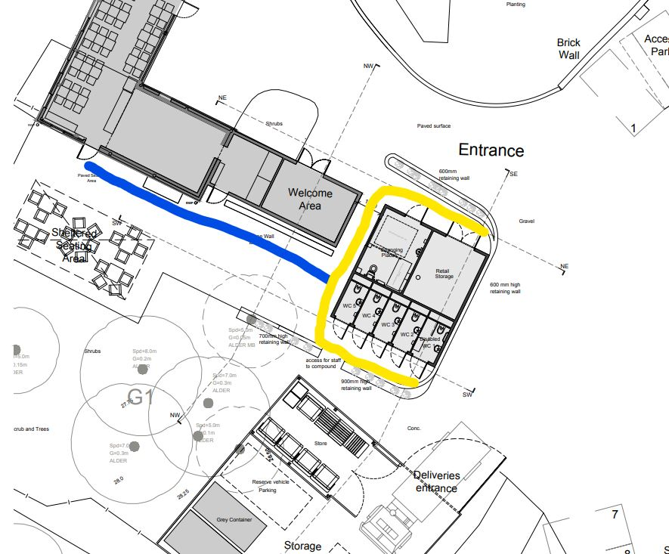

# Addendum C

## Photographs showing location

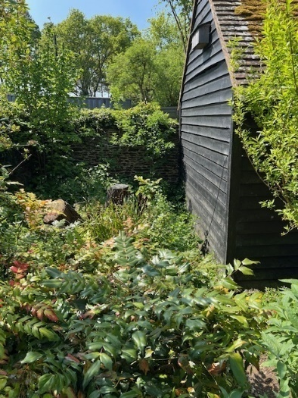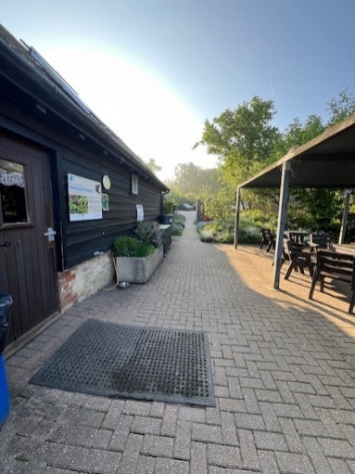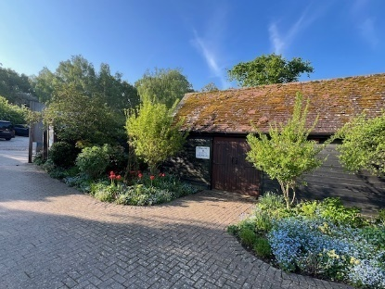

View from Visitor Centre to toilet location

End of existing retail barn

View from Café / Patio toward car Park, showing footpath

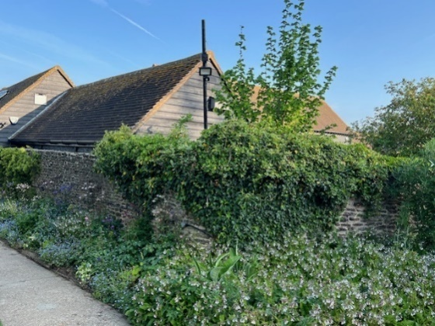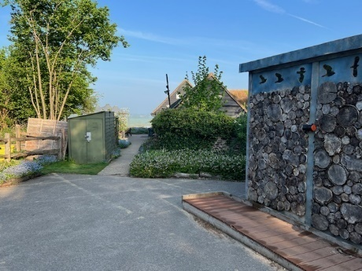

View from car park showing footpath from car park to café and end of retail barn store

View from car park showing location of visitor toilets and wall which will require partial dismantling