National Asset Delivery
Technical Surveys and Testing

Site Information for A1 Concrete Testing

Tinwell (A1/147.00) , Structure Key: 5336

Location Information

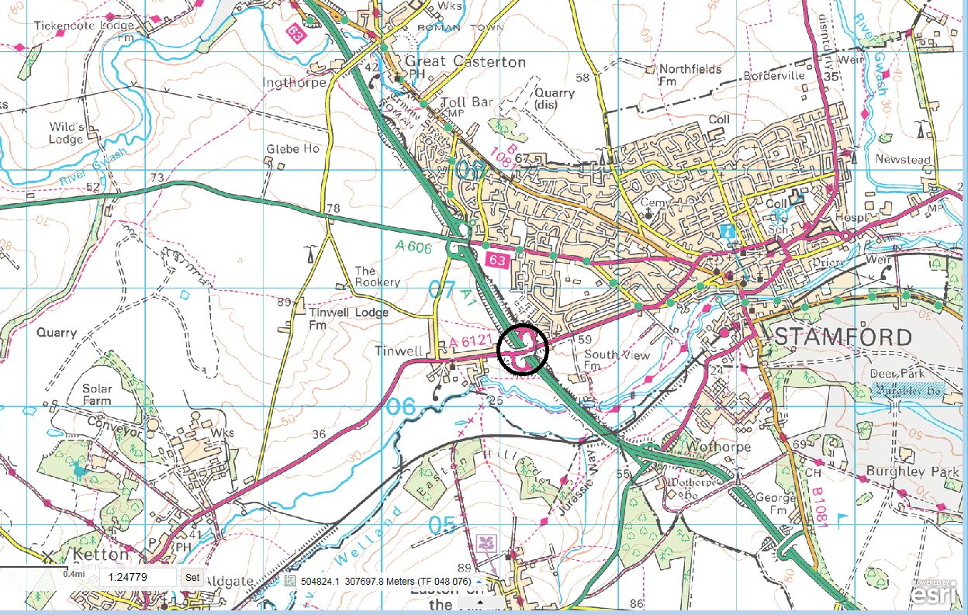
The bridge is located to the west of Stamford, Lincolnshire and carries the A6121 over the A1 trunk road and slips roads. Marker Post 44.3 - Grid Reference 501209/306502 - Lat: 52.646823, Long: -0.50551505. The nearest postcode is: PE9 3UB.
A1/147.10 Tinwell
Grid Reference:
501209, 306502

Location plan

Photographs of the site are included in section 1.3 below.

  - Access Restrictions

There are no overhead cables present at the site.

The Contractor will need to assess the access risks.

  - Existing photographs

West Pier:

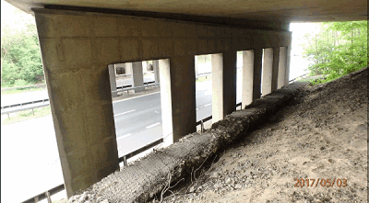

Centre Pier:

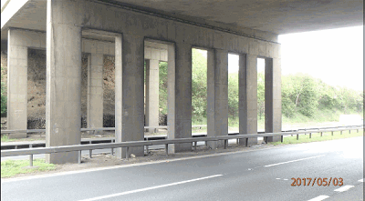

Northbound deck soffit:

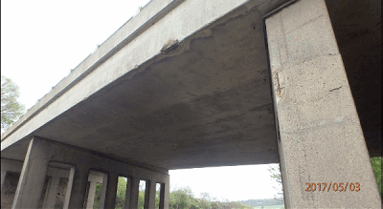

  - Environmental Considerations
The following constraints have been identified; see Appendix 3 for additional information:
Constraints Map |  |  |  | Date Produced: 20/08/18
Environmental Constraints table (Add rows as required)
Receptor | Location | Designation | Category/ Dataset |  | Record Date | Potential Impact
Otter | Appendix A, otter symbol | Statutory | EnvIS |  | 2003 & 2012 | None, due to distance of works from suitable habitat
White legged damselfly | Appendix A, insect symbol | Non-statutory | EnvIS |  | 2003 | Risk of damaging habitat through pollution.
Grass snake | Appendix A, reptile symbol | Statutory | EnvIS |  | 1998 | None, works confined to non-suitable habitat
Pipistrelle spp. | Appendix A, bat symbol | Statutory | EnvIS |  | 2005 | Potential to disturb a protected species.
Buzzard | Appendix A, bird symbol | Non-statutory | EnvIS |  | 2006 | None, due to limited work operations.
Ancient Woodland | Appendix A, brown zone | Non-statutory | Natural England |  |  | None, due to distance from works.
Enclosure | Appendix A, labelled orange zone | Non-statutory | EnvIS: CHAMP |  |  | None, no alterations to visual setting
Multiple ditch system | Appendix A, labelled orange cross hatch | Non-statutory | EnvIS: CHAMP |  |  | None, no alterations to visual setting. No excavation of undisturbed soils.
Rugby & Stamford Railway | Appendix A, orange cross hatch | Non-statutory | EnvIS: CHAMP
River Welland | Appendix A, blue line | Statutory | Environment Agency |  |  | Risk of polluting controlled waters through drainage system.
Flood Zone 3 | Appendix A, dark blue zone | Non-statutory | Environment Agency |  |  | No change to the incidence or severity of flooding.
Flood Zone 2 | Appendix A, light blue zone | Non-statutory | Environment Agency |  |  | No change to the incidence or severity of flooding.

The following additional risks are to be considered in the designers’ environmental risk assessment. These will form the basis of any future review of scheme related information.
Risk | Control | Action required
Structure with features which could be used by roosting bats. | Close proximity to heavy road traffic reduces suitability of structure for roosting bats.  Any bats present will be habituated to significant levels of noise and vibration.  No alterations to structural features will be undertaken. | Visually inspect crevices in work area prior to commencing.  If bats are observed within crevices or emerging from structure retreat immediately and contact environmental specialist immediately for further advice.
Pollution of controlled waters due to spillage on site. | Ensure surface water drainage is adequately protected from spillage. | Follow CIRIA C532 best practise guidance.  Spill kits to be available on site.
Disturbance of nocturnal mammals (badgers, bats) | Ensure lighting is controlled and restricted to works area. | Directional lighting to be used with hoods to prevent light pollution.
Causing noise nuisance to local residents. | Reduce noise from works activities where feasible.  Undertake noisier operations prior to midnight. | Apply best practise measures as outlined in BS5228 part 1.

Sidney Farm (A1/148.10), Structure Key: 5337
  - Location Information

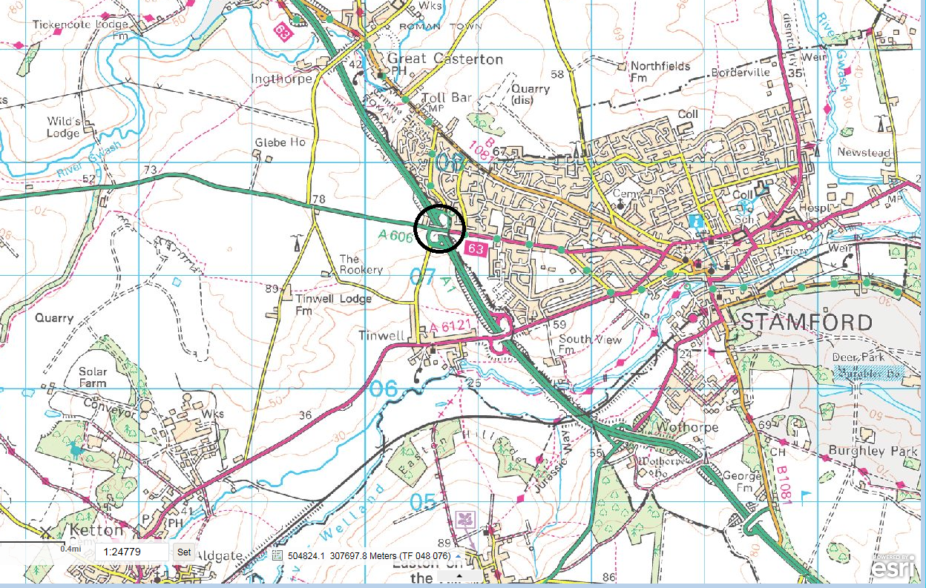
The bridge is located to the west of Stamford, Lincolnshire and carries the A606 over the A1 trunk road. Located at Marker Post 45.4. Grid Reference: 500663 / 307433. Lat: 52.655291, Long: -0.51329849. The nearest postcode is: PE9 2JY.
A1/148.10 Sidney Farm
Grid Reference:
500663, 307433

Location Plan

Photographs of the site are included in section 2.3 below.

  - Access Restrictions

There are no overhead cables present at the site.

The Contractor will need to assess the access risks.

  - Existing photographs

West Pier:

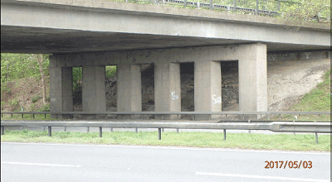

Centre Pier:

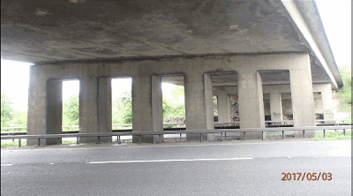

Northbound deck soffit:

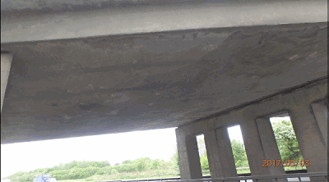

  - Environmental Considerations
The following constraints have been identified; see Appendix 3 for additional information:
Constraints Map |  |  | Date Produced: 18/08/18
Environmental Constraints table (Add rows as required)
Receptor | Location | Designation | Category/ Dataset | Record Date | Potential Impact
Badger | Appendix A, badger symbol | Statutory | EnvIS |  | Potential to disturb foraging. No risk of causing disturbance or damage of setts.
Buzzard | Appendix A, bird symbol | Statutory | EnvIS |  | None, due to scope of works.
SSSI: Great Casterton Road Banks | Appendix A, purple zone | Statutory | Natural England |  | None, no pollution pathways and no direct effect.
Enclosure features: Ridge & furrow, ditch | Appendix A, brown cross hatch zones | Non-statutory | EnvIS: CHAMP |  | None, no excavation.
Scheduled Monument: Ermine street section | Appendix A, red zone | Statutory | Historic England |  | None, due to distance from work area.
Buried material: Ermine Street Roman Road | Appendix A, blue line | Non-statutory | EnvIS: CHAMP |  | None, due to distance from works area.

The following additional risks are to be considered in the designers’ environmental risk assessment. These will form the basis of any future review of scheme related information.
Risk | Impact | Impact Type
Structure with features which could be used by roosting bats. | Close proximity to heavy road traffic reduces suitability of structure for roosting bats.  Any bats present will be habituated to significant levels of noise and vibration.  No alterations to structural features will be undertaken. | If bats are observed within crevices or emerging from structure retreat immediately and contact environmental specialist immediately for further advice.
Pollution of controlled waters due to spillage on site. | Ensure surface water drainage is adequately protected from spillage. | Follow CIRIA c532 best practise guidance.  Spill kits to be available on site.
Disturbance of nocturnal mammals (badgers, bats) | Ensure lighting is controlled and restricted to works area. | Directional lighting to be used with hoods to prevent light pollution.
Causing noise nuisance to local residents. | Reduce noise from works activities where feasible.  Undertake noisier operations prior to midnight. | Apply best practise measures as outlined in BS5228 part 1.

