
Foundation For Good’s Vision for lasting impact

Community Building Project
Scope of Works

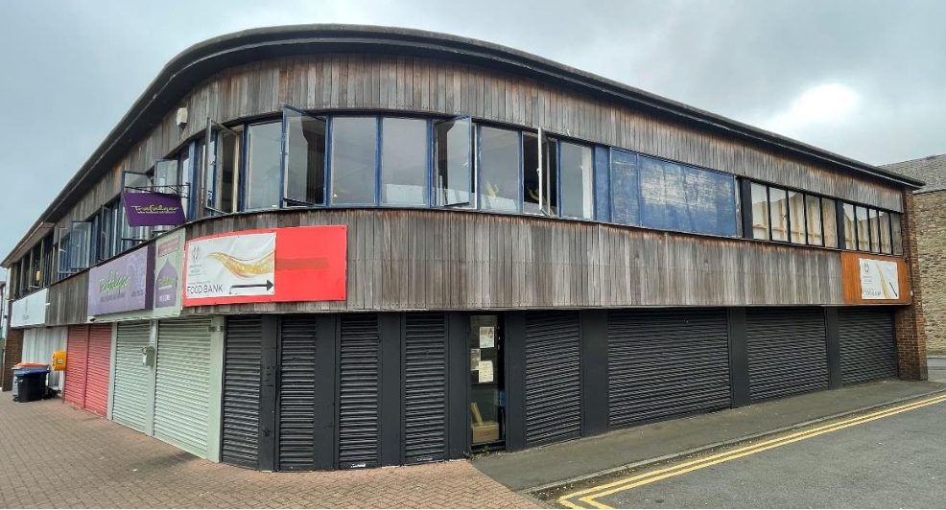

Index
General Overview - Page 3 - 10
Regulation and Considerations - Page 11 - 18
Project Phases - Page 19 - 21

Building Plans - Page 22 - 27

Detailed Room-by-Room Scope - Page 28 - 86

Annex - Page 87

1. Project Overview

Objective: The objective of this project is to refurbish the Foundation for Good’s community building to improve its facilities and services for the local community. This includes enhancing accessibility, upgrading facilities, integrating sustainable practices, and modernising the building to meet current and future needs.

Location and Access: The site is located at 11-19 Trafalgar Street, Consett, County Durham, DH8 5AP.

2. Detailed Scope of Work

2.1 Demolition and Removal
2.1.1 General Demolition:
- Remove Existing Interior Partitions:
  - Carefully remove all non-load-bearing interior partitions throughout the building, including those in the gym space, classrooms, and offices. This includes the removal of partition walls in rooms 4, 5, 19, 6, 23, 24, 25 and other specified areas as per the provided floor plans.
- Flooring Removal:
  - Remove all existing flooring materials, including worn carpets, tiles, and rubber flooring, particularly in the gym areas (Room 1), male and female changing rooms (Rooms 6 and 35), and hallways (Room 39). Care should be taken to minimise dust and debris, especially in areas where the building will remain operational.
- Ceiling Removal:
  - Demolish and remove all suspended ceiling systems and damaged ceiling tiles in designated areas, such as the executive meeting room (Room 3). Ensure that all electrical wiring and lighting fixtures are safely disconnected before removal.
2.1.2 Structural Demolition:
- Staircase Removal:
  - Remove the existing staircase in Room 1, including the associated door and any structural elements attached to it. The space left by the removed staircase should be prepared for the installation of new flooring and structural supports as detailed in the architectural plans.
- Brickwork Removal:
  - Carefully remove sections of existing brickwork to create new doorways and openings, particularly in areas where new access points to the wellbeing café (Room 2), and meeting rooms are required. All removed brickwork should be properly disposed of, and surrounding structures must be supported during the removal process to prevent damage.
- Loading Bay Demolition:
  - Brick up the existing loading bay on the rear elevation of the building, ensuring that the new brickwork matches the existing structure in appearance and integrity. This area should be prepped for the installation of new small black-tinted windows as specified.
2.1.3 Hazardous Materials Management:
- Asbestos Handling:
  - Before demolition begins, conduct a thorough asbestos survey across all areas to be demolished. If asbestos is found, it must be removed by a licensed contractor following all health and safety regulations. Document the removal process and provide all necessary certifications upon completion.
2.1.4 Waste Disposal:
- Waste Segregation and Disposal:
  - All demolition debris, including brick, metal, wood, and hazardous materials, must be sorted on-site and disposed of in accordance with local environmental regulations. Recyclable materials should be separated and sent to appropriate facilities. Any non-recyclable waste must be transported to licensed disposal sites.
- Environmental Compliance:
  - The contractor is responsible for ensuring that all demolition activities comply with environmental regulations, including dust suppression, noise control, and proper disposal of hazardous materials. A detailed waste management plan should be submitted and approved before demolition begins.
2.1.5 Site Preparation Post-Demolition:
- Site Clearing:
  - After demolition, all debris must be cleared from the site. The contractor must ensure that the site is left clean and ready for the next phase of construction, with all remaining structures stabilised and secured.
- Temporary Protection:
  - Install temporary protection (such as hoarding or tarpaulins) around open areas and newly created openings to safeguard against weather damage and unauthorised access.

2.2 Structural Work

Scope:

Construct new walls and partitions as per the architectural drawings.

Install mezzanine flooring in the gym area, supported by new structural beams.

Reinforce existing structures where necessary, following the structural engineer’s recommendations.

2.3 Mechanical, Electrical, and Plumbing (MEP) Works

Mechanical Systems:

Install new HVAC systems throughout the building, including 21 units for heating and cooling.

Integrate an air purification system with the HVAC units.

Electrical Systems:

Complete rewiring of the building, including new lighting fixtures, power outlets, and data cabling, CCTV.

Install energy-efficient LED lighting and PIR controls for energy savings.

Plumbing Systems:

Upgrade plumbing in all restrooms, including new fixtures and fittings.

Install water-saving devices in all toilets and wet rooms.

2.4 Interior Finishes

Flooring:

Install 20mm thick rubber flooring in the gym and other specified areas.

Lay new carpeting in classrooms, offices, and meeting rooms as per the interior design plan.

Wall Finishes:

Paint walls in a combination of black, gold, white, and grey, following the new colour scheme.

Apply washable wall coverings in high-traffic areas for easy maintenance.

Ceilings:

Replace damaged ceiling tiles and install new suspended ceilings where specified.

2.5 External Works

Facade:

Replace 111 windows with double-glazed, black-tinted aluminium windows.

Paint the entire exterior of the building black, following the design specifications.

Roof:

Install solar panels and a new air source heat pump system.

Repair minor leaks and install a lockable loft hatch with a retractable ladder.

3. Materials and Equipment Specifications

3.1 Materials Quality

All materials used must meet or exceed British Standards, particularly in terms of fire safety, durability, and environmental impact.

3.2 Equipment Installation

HVAC Units:

Install 21 energy-efficient HVAC units as specified, with integrated air purification systems.

Security Systems:

Install a new CCTV system with 32+ high quality cameras, controlled from offices 8 and 17.

Implement a comprehensive access control system for 30 doors.

4. Compliance Requirements

4.1 Building Codes and Standards

All work must comply with local, regional, and national building regulations, including those related to fire safety, electrical systems, and accessibility.

4.2 Health and Safety Regulations

Contractors are required to adhere to all health and safety regulations, including the creation of a site-specific health and safety plan. Regular safety briefings and the use of PPE are mandatory.

5. Detailed Room-by-Room Scope

5.1 Gym Area (Room 1)

Current Condition:

The gym currently features outdated equipment and poor lighting.

Modifications Required:

Install new rubber flooring and a professional prowler track.

Update lighting to industrial-style spotlights with gold/yellow tones.

Paint walls black, with specific design elements as per the plans.

Special Instructions:

Ensure that all installations do not interfere with the operation of the gym equipment, particularly in areas used for skipping and bag work.

5.2 Wellbeing Café (Room 2)

Current Condition:

The space is currently an open area requiring full fit-out.

Modifications Required:

Install wooden flooring, a new kitchen area, and seating.

Furnish the café with industrial-style furniture and install suspended warm lighting.

Special Instructions:

All equipment, such as the coffee machine and ovens, should be second-hand where possible to maintain cost-effectiveness.

6. Workmanship Standards

6.1 Quality Standards

All work must be carried out to the highest standards, with a focus on durability and aesthetic appeal. Paint finishes should be smooth with no visible defects, and all fixtures should be securely installed and properly aligned.

6.2 Inspection and Testing

Contractors must coordinate with the project manager for regular inspections and testing of all systems and installations. Detailed reports should be submitted after each inspection.

7. Coordination Requirements

7.1 Subcontractor Coordination

The primary contractor is responsible for coordinating all subcontractors, ensuring that work is carried out efficiently and without conflicts. Weekly coordination meetings are required.

7.2 Integration with Existing Systems

Contractors must carefully integrate new systems with existing ones, particularly for electrical and HVAC systems. Testing and commissioning are mandatory to ensure full compatibility.

8. Site-Specific Considerations

8.1 Site Constraints

Access to the site is restricted to the hours of:

Monday–Friday: 8 AM–6 PM

Saturday: 8 AM–1 PM

Sunday and bank holidays: Noisy work is prohibited

The site is located in a residential area, so noise and dust control measures must be in place at all times.

8.2 Storage and Laydown Areas

Limited storage is available on-site. Off-site storage should be arranged for materials that are not immediately needed.

9. Safety and Security Measures

9.1 Site Security

The site must be secured with fencing and lighting. Unauthorised access must be prevented, and security personnel may be required during off-hours.

9.2 Safety Protocols

Strict adherence to safety protocols is required, including working at heights, handling hazardous materials, and confined space entry.

10. Project Timeline

10.1 Project Phases

The project is divided into the following phases:

Phase 1: Demolition and Structural Works - 4th November 2024 to 2nd December 2024

This phase covers all preparatory activities, demolition, and the construction of new structural elements, including both internal and external modifications.

Phase 2: MEP Installations and External Finishes - 2nd December to 3rd January 2025

This phase focuses on the installation of mechanical, electrical, and plumbing systems, as well as completing all external finishes and enhancements to the building's facade.

Phase 3: Interior Finishes, Furnishing, and Handover - 3rd January 2025 to 14th February 2025

This final phase includes all interior finishing work, the installation of furnishings and equipment, and concludes with final inspections, staff training, and handover of the completed project.

10.2 Completion Dates

The overall project completion date is 14/02/25, with key milestones detailed in the project timeline.

11 Post-Completion Activities
We can add a section focused on post-completion activities such as final audits, user feedback, and continuous improvement.

Proposed Section: Post-Completion Activities
11.1 Final Audit:
- Inspection: A final audit will be conducted by the Project Manager in coordination with Foundation for Good representatives. This will include a thorough inspection of all completed work to ensure it meets the required standards.
- Deficiency List: Any deficiencies or issues identified during the final audit will be documented and rectified by the relevant contractors before final sign-off.
11.2 User Feedback:
- Feedback Collection: After the building is in use, feedback will be collected from staff and community members on the functionality and usability of the new facilities.
- Continuous Improvement: Based on feedback, a continuous improvement plan will be developed to address any areas of concern or potential enhancements.
11.3 Handover Documentation:
- Documentation: Contractors will provide detailed handover documentation, including operation manuals, warranties, and maintenance schedules for all installed systems.
- Training: Training sessions will be organised for Foundation for Good staff on how to operate and maintain the new systems and equipment.

12. Documentation Requirements

12.1 As-Built Drawings

Contractors must submit as-built drawings for all modifications, ensuring they reflect any changes made during construction.

12.2 Operation and Maintenance Manuals

Detailed manuals for all installed systems must be provided, including troubleshooting guides and maintenance schedules.

13. Communication Protocols

13.1 Site Meetings

Weekly site meetings are required to review progress, address issues, and plan upcoming work. Minutes from these meetings should be documented and distributed to all relevant parties.

13.2 Reporting

Progress reports must be submitted every weekly, detailing completed work, upcoming tasks, and any issues encountered.

14. Community Engagement
14.1 Minimising Disruption:
- Communication: Regular updates will be provided to the community regarding the progress of the refurbishment and any potential disruptions.
- Alternative Access: Where possible, alternative access points will be provided to ensure that community members can continue to use unaffected parts of the building.
14.2 Community Involvement:
- Stakeholder Meetings: Meetings will be held with community stakeholders to gather input and address any concerns related to the refurbishment.
- Feedback Channels: Open channels of communication will be established for community members to provide feedback and ask questions throughout the project.
14.3 Open House Events:
- Pre-Completion Tours: Once the refurbishment is near completion, open house events will be organised to allow community members to tour the new facilities and provide final feedback.
- Official Opening: An official opening event will be held to celebrate the completion of the project, with invitations extended to all community stakeholders.

1. Health and Safety Compliance
Objective: Ensure all renovations and installations comply with current health and safety regulations to safeguard workers, users, and visitors.
- Fire Safety: All new installations, including electrics, CCTV, and access control systems, must adhere to fire safety standards. This includes the installation of smoke alarms, fire extinguishers, and clearly marked fire exits. All materials used should be fire-retardant where applicable.
- Structural Integrity: Before commencing any significant structural changes, such as removing walls or installing mezzanine floors, a structural engineer must assess the building. The results of this assessment should be documented, and any necessary reinforcements should be included in the project.
- Worker Safety: All contractors and workers on-site must wear appropriate personal protective equipment (PPE) and follow safety protocols. Regular safety briefings should be conducted, and a first aid station should be set up on-site.

2. Sustainability and Energy Efficiency
Objective: Integrate sustainable practices and energy-efficient solutions into the refurbishment to reduce environmental impact and operating costs.
- Energy-Efficient Materials: Wherever possible, use eco-friendly and energy-efficient materials. This includes insulation, low-VOC (volatile organic compounds) paints, and energy-saving lighting fixtures like LED lights.
- Renewable Energy: Consider the installation of solar panels on the roof in relation to energy usage to provide a renewable energy source for the building. This can be supplemented by a battery storage system to optimise energy use.
- Water Conservation: Install water-saving fixtures in all toilets and wet rooms. Consider the use of rainwater harvesting systems for non-potable water uses, such as flushing toilets or irrigation.
- Waste Management: Implement a waste management plan that prioritises recycling and the responsible disposal of construction debris. Where possible, re-use materials from the deconstruction phase in the new construction.

3. Disability Access Compliance
Objective: Ensure the facility is fully accessible to all users, regardless of physical abilities.
- Entrances and Corridors: All entrances must be wheelchair accessible, with ramps and wide doorways. Corridors should be free of obstructions, with a minimum width to accommodate wheelchairs.
- Signage: Install clear and accessible signage throughout the building, including braille and tactile signs where appropriate. All signs should be positioned at a height accessible to wheelchair users.

4. Detailed Equipment Specifications
Objective: Ensure all equipment procured meets the needs of the users and adheres to quality and safety standards.
- Wellbeing Café: All kitchen appliances and furniture should be sourced from reputable suppliers, with a focus on durability and safety. Ensure all electrical appliances have the necessary certifications (e.g., CE mark in Europe) and come with warranties.

5. Maintenance and Future Proofing
Objective: Develop a plan for the ongoing maintenance of the facility and ensure it can adapt to future needs.
- Maintenance Plan: Create a detailed maintenance schedule for all new installations, including HVAC systems, Fire Safety, CCTV, and access control systems. Include a plan for regular inspections and servicing of key systems to prevent breakdowns.
- Flexibility and Upgrades: Design the infrastructure with future upgrades in mind. For example, when installing electrics, ensure there is capacity for additional circuits. Consider modular furniture that can be easily reconfigured to adapt to changing needs.

6. Technology Infrastructure
Objective: Future-proof the facility’s technology infrastructure to support current and future digital needs.
- High-Speed Internet: Ensure the installation of high-speed internet throughout the building, including wired and wireless access points. Consider fibre optic connections to support future high-bandwidth needs, especially in areas like the innovation suite and music studio.
- Smart Building Features: Integrate smart building technologies where possible, such as automated lighting, climate control, and occupancy sensors. These systems can enhance energy efficiency and user comfort.
- Audio-Visual Systems: In areas like the executive meeting room and classrooms, ensure that the AV systems are up-to-date with current standards. This includes high-definition projectors, interactive whiteboards, and sound systems capable of handling virtual meetings and presentations.

7. Documentation and Training
Objective: Ensure that all new systems and equipment are properly documented and that staff are trained to use and maintain them.
- Operation Manuals: For all newly installed systems (e.g., HVAC, CCTV, access control), ensure that comprehensive operation manuals are provided. These should include troubleshooting guides and contact information for support.
- Staff Training: Organise training sessions for key staff members on how to operate and manage the new systems, including the access control system, AV equipment, and any other specialised technology.
- Maintenance Documentation: Create a detailed logbook for ongoing maintenance, including schedules for regular checks and servicing of equipment. This should be kept up-to-date by maintenance personnel.

8. Environmental and Community Impact Assessment
Objective: Assess and mitigate any potential negative impacts of the refurbishment on the environment and the surrounding community.
- Noise and Dust Control: Implement measures to control noise and dust during construction, particularly in densely populated areas. This could include scheduling noisy activities during less disruptive times and using dust barriers.
- Environmental Impact: Conduct an environmental impact assessment (if not already done) to ensure that the refurbishment does not negatively affect the local environment. This could involve considerations around waste management, air and water quality, and the impact on local wildlife.
- Community Disruption: Develop a plan to minimise disruption to the local community during the refurbishment. This might include providing clear communication about construction schedules, maintaining pedestrian access around the site, and ensuring that construction vehicles do not block roads or access points.

9. Legal and Regulatory Compliance
Objective: Ensure that all works comply with local, regional, and national laws and regulations.
- Building Permits and Inspections: Confirm that all necessary building permits have been obtained before starting work. Schedule regular inspections at key stages of the refurbishment to ensure compliance with building codes.
- Data Protection: If the building’s new systems include data collection (e.g., CCTV footage, access logs), ensure that they comply with data protection regulations such as GDPR. This includes secure storage of data and clear policies on who can access it and for what purposes.
- Accessibility Legislation: Ensure compliance with all relevant accessibility laws, such as the Equality Act 2010 in the UK. This may require specific adjustments or provisions to be made to accommodate all users.

10. User Experience and Comfort
Objective: Enhance the overall experience and comfort of building users to ensure the space is welcoming and functional.
- Acoustic Design: Consider the acoustics of spaces like the classrooms, meeting rooms, and café to ensure they are conducive to their intended uses. This might include installing acoustic panels or using soft furnishings to dampen sound.
- Climate Control: Ensure that the climate control systems are designed to maintain a comfortable temperature throughout the building, considering factors like solar gain and the number of occupants. User-friendly thermostats should be installed in key areas to allow for easy adjustment.
- Furniture and Fixtures: Choose furniture that is not only aesthetically pleasing but also comfortable and durable. This is particularly important in areas like the wellbeing café, classrooms, and gym spaces, where comfort will directly impact user satisfaction.

11. Cultural and Heritage Considerations
Objective: Preserve any historical or cultural features of the building that may be of significance.
- Preservation of Historical Features: If the building has any historical or architectural features, ensure that these are preserved or restored in line with heritage conservation guidelines. This might involve consulting with heritage experts or obtaining special permissions.
- Cultural Sensitivity: Consider the cultural significance of the building and its location. Ensure that any changes are respectful of the local community’s cultural values and that the building continues to serve as a positive community space.

12. Risk Management
Objective: Identify and mitigate potential risks associated with the refurbishment project.
- Risk Assessment: Conduct a thorough risk assessment before beginning work. Identify potential hazards, such as structural weaknesses or hazardous materials (e.g., asbestos), and develop mitigation strategies.
- Insurance Coverage: Ensure that adequate insurance is in place to cover any potential risks, including public liability insurance and insurance for the building itself during construction.
- Crisis Management Plan: Develop a crisis management plan to deal with any emergencies that may arise during the refurbishment, such as fires, floods, or accidents. This should include emergency contacts and clear procedures for managing different types of incidents
12.1 Risk Identification:
- Methodology: Regular risk assessments will be conducted by the Project Manager in coordination with contractors to identify potential risks throughout the project lifecycle.
- Key Risks: Examples of potential risks include delays in material delivery, unexpected structural issues, adverse weather conditions, and safety hazards.

12.2 Risk Assessment:
- Impact Analysis: Each identified risk will be analysed to determine its potential impact on the project, including cost, timeline, and quality.
- Risk Prioritisation: Risks will be prioritised based on their potential impact, with a focus on addressing high-priority risks first.
12.3 Risk Mitigation:
- Contingency Planning: Contingency plans will be developed for each high-priority risk, detailing specific actions to be taken in case the risk materialises.
- Ongoing Monitoring: Risks will be monitored continuously, with updates provided during regular site meetings.

13. Integration with Existing Services and Partnerships
Objective: Ensure the refurbished building supports and enhances existing services and partnerships with the community.
- Partnership Spaces: If the Foundation for Good collaborates with other organisations (e.g., police, schools, social prescribers), ensure that the facility includes dedicated spaces for these partners. This might include meeting rooms with secure access, shared office spaces, or areas for collaborative events.
- Service Integration: Consider how the new facilities will integrate with existing services, such as mental health services, the food bank, or youth programs. This could involve designing flexible spaces that can serve multiple purposes, such as a room that functions as a classroom during the day and a meeting space in the evening.
- Technology Integration: Ensure that any new technology installed (e.g., WiFi networks, AV equipment) is compatible with systems used by partner organisations, allowing for seamless collaboration and communication.

14. Branding and Identity
Objective: Reinforce the Foundation for Good’s brand and identity throughout the refurbished building.
- Signage and Graphics: Incorporate the Foundation’s branding into signage, wall graphics, and other visual elements throughout the building. This can help create a cohesive identity and reinforce the mission of the organisation to all who visit.
- Custom Furnishings and Fixtures: Consider using custom furnishings or fixtures that reflect the Foundation’s colours and values. For example, you might choose upholstery in the Foundation’s colours or commission artwork that represents the community.
- External Branding: Ensure that the exterior of the building reflects the Foundation’s identity, with appropriate signage and potentially even exterior lighting or murals that make the building a landmark in the community.

15. Inclusive Design
Objective: Ensure that the building is inclusive and welcoming to all members of the community, regardless of background or ability.
- Culturally Inclusive Design: Design spaces that are culturally sensitive and inclusive, potentially incorporating features that reflect the cultural diversity of the community. This might include artwork, multilingual signage, or spaces designed for cultural activities.
- Gender-Neutral Facilities: Consider including gender-neutral toilets and changing rooms to make the building more inclusive, particularly for non-binary and transgender individuals.
- Quiet Zones: Create quiet zones or rooms where individuals who may be overwhelmed by noise or activity can retreat. This can be particularly important for individuals with sensory sensitivities or mental health needs.

16. Environmental Sustainability Certification
Objective: Aim for recognised certification to demonstrate the building’s commitment to environmental sustainability.
- BREEAM Certification: If aiming for a high level of environmental sustainability, consider working towards BREEAM (Building Research Establishment Environmental Assessment Method) certification. This would involve a rigorous assessment of the building’s sustainability credentials across multiple categories, from energy efficiency to waste management.
- LEED Certification: Alternatively, you could aim for LEED (Leadership in Energy and Environmental Design) certification, which is internationally recognised and could add significant value to the building’s sustainability credentials.

17. Long-Term Strategic Planning
Objective: Ensure the refurbishment supports the long-term strategic goals of the Foundation for Good.
- Scalability: Design spaces and systems with scalability in mind, allowing the Foundation to expand services in the future without significant additional refurbishment.
- Future Programs: Consider potential future programs or services that the Foundation might want to offer and ensure the building can accommodate these. For example, if expanding digital literacy programs, ensure adequate space and technology infrastructure is available.
- Financial Sustainability: Integrate features that can help generate revenue or reduce long-term operational costs, such as energy-efficient systems, rental spaces for community use, or partnerships that can contribute to the building’s upkeep.

18. Legal and Contractual Considerations
Objective: Ensure all legal and contractual obligations are met throughout the refurbishment process.
- Contractor Vetting: Implement a rigorous vetting process for all contractors and suppliers, ensuring they meet ethical standards and have a proven track record of quality work.
- Performance Bonds: Consider requiring performance bonds from contractors to ensure that work is completed to the required standard and on schedule. This can provide financial protection if the contractor fails to meet their obligations.
- Legal Compliance Review: Have a legal team review all contracts and agreements associated with the refurbishment to ensure that they are fair, protect the Foundation’s interests, and comply with all relevant laws and regulations.

19. Post-Completion Review and Feedback
Objective: Assess the success of the refurbishment and identify areas for future improvement.
- Post-Completion Audit: Conduct a post-completion audit to ensure all aspects of the refurbishment have been completed to the agreed specifications. This should include a thorough inspection of all new systems and features.
- User Feedback: Gather feedback from staff, community members, and other stakeholders after the building is in use. This can help identify any issues that weren’t apparent during the planning stage and guide future projects.
- Continuous Improvement Plan: Based on the audit and feedback, develop a continuous improvement plan that addresses any shortcomings and outlines steps to enhance the building’s functionality and user experience over time.

20. Privacy and Confidentiality
Objective: Ensure that the building provides spaces where users can maintain privacy and confidentiality, especially for sensitive activities.
- Private Consultation Rooms: Designate rooms for confidential consultations, whether for mental health services, legal advice, or private meetings. These rooms should be soundproofed and equipped with secure storage for confidential documents.

21. Health and Wellbeing Enhancements
Objective: Promote the health and wellbeing of all building users through thoughtful design and amenities.
- Natural Light and Air Quality: Ensure that as many spaces as possible have access to natural light. Consider installing air purification systems in areas that might be prone to poor air quality, such as near gym spaces or the wellbeing café.

22. Transportation and Accessibility
Objective: Ensure the building is easily accessible to all users, including those who rely on public transport or have mobility challenges.
- Bicycle Facilities: Install secure bicycle parking and consider providing facilities like showers and changing rooms to encourage staff and visitors to cycle to the building. This supports both health and sustainability goals.

Phase 1: Demolition and Structural Works
1.1 Site Preparation and Initial Setup
- Site setup, including the installation of temporary fencing, signage, hoarding, and the establishment of site offices and storage areas.
- Conduct a thorough asbestos survey and handle any hazardous materials as needed.
1.2 Demolition
- Interior Demolition:
  - Remove all non-load-bearing interior partitions in areas like the gym (Room 1), classrooms, and offices.
  - Remove existing flooring, such as carpets, tiles, and rubber flooring in specified rooms and hallways.
  - Demolish suspended ceilings and remove damaged ceiling tiles in areas like the executive meeting room (Room 3) and foyer (Room 18).
- Structural Demolition:
  - Remove the existing staircase in Room 1, and brick up openings as required.
  - Demolish existing brickwork to create new doorways, especially for the wellbeing café (Room 2) and other areas needing new access points.
1.3 Structural Construction
- New Construction:
  - Construct new internal walls and partitions, reinforcing existing structures where necessary.
  - Install mezzanine flooring in the gym area (Room 20) with proper support beams.
- External Structural Work:
  - Install new windows, including 95 double-glazed, black-tinted aluminium windows on the front and side elevations, and 65 new curtain walling windows.
  - Install new entrances, including the glass door for the wellbeing café and the heavy-duty staff entrance with access control measures.
- Roofing Work:
  - Install solar panels and air source heat pumps.
  - Conduct minor roof repairs and install a lockable loft hatch with a retractable ladder.

Phase 2: MEP Installations and External Finishes
2.1 Mechanical, Electrical, and Plumbing (MEP) Works
- Mechanical Systems:
  - Install HVAC systems, including 21 units for heating and cooling, with integrated air purification systems.
- Electrical Systems:
  - Complete rewiring of the building, including the installation of new lighting fixtures, power outlets, and data cabling.
  - Install energy-efficient LED lighting, PIR controls, and new CCTV systems with 32+ cameras.
  - Install exterior building lighting on the front and side elevations, in between pillars to light exterior pathways.
- Plumbing Systems:
  - Upgrade plumbing systems across the building, including new fixtures in restrooms, kitchens, and wet rooms.
2.2 External Finishes
- Exterior Painting:
  - Paint the entire exterior of the building black, as per design specifications.
- Signage and External Fixtures:
  - Install new signage above entrances 17 and 18.
  - Install 4 CCTV cameras to monitor the front and side elevations of the building.

Phase 3: Interior Finishes, Furnishing, and Handover
3.1 Interior Finishes
- Flooring:
  - Install new flooring throughout the building, including rubber flooring in the gym areas, carpeting in classrooms and offices, and wooden flooring in the wellbeing café.
- Wall and Ceiling Finishes:
  - Paint walls in specified colours (black, gold, white, grey), and install washable wall coverings in high-traffic areas.
  - Replace ceilings and install suspended ceilings where required, with new lighting fixtures.
- Doors and Hardware:
  - Install new interior doors, complete with heavy-duty frames and access control systems.
3.2 Furnishing and Equipment Installation
- Furnishings:
  - Deliver and install furniture for all areas, including offices, classrooms, the wellbeing café, and the gym.
  - Ensure that furnishings match the specified design themes for each room, including industrial-style furniture for the café and professional-grade equipment for the gym and classrooms.
- Equipment:
  - Install kitchen equipment in the wellbeing café, including second-hand appliances to maintain cost-effectiveness.
  - Install gym equipment, audio-visual systems, and other specialised equipment like the studio setup in the music classroom.
3.3 Final Touches and Handover
- Final Inspections and Testing:
  - Conduct final inspections and testing of all systems, including HVAC, electrical, and plumbing.
  - Address any deficiencies and ensure all systems are fully operational.
- Handover Documentation:
  - Provide as-built drawings, operation manuals, and warranties for all installed systems.
  - Offer training to the Foundation’s staff on the use and maintenance of new systems and equipment.
- Site Cleanup:
  - Perform a thorough site cleanup, remove all temporary structures, and prepare the building for occupancy.

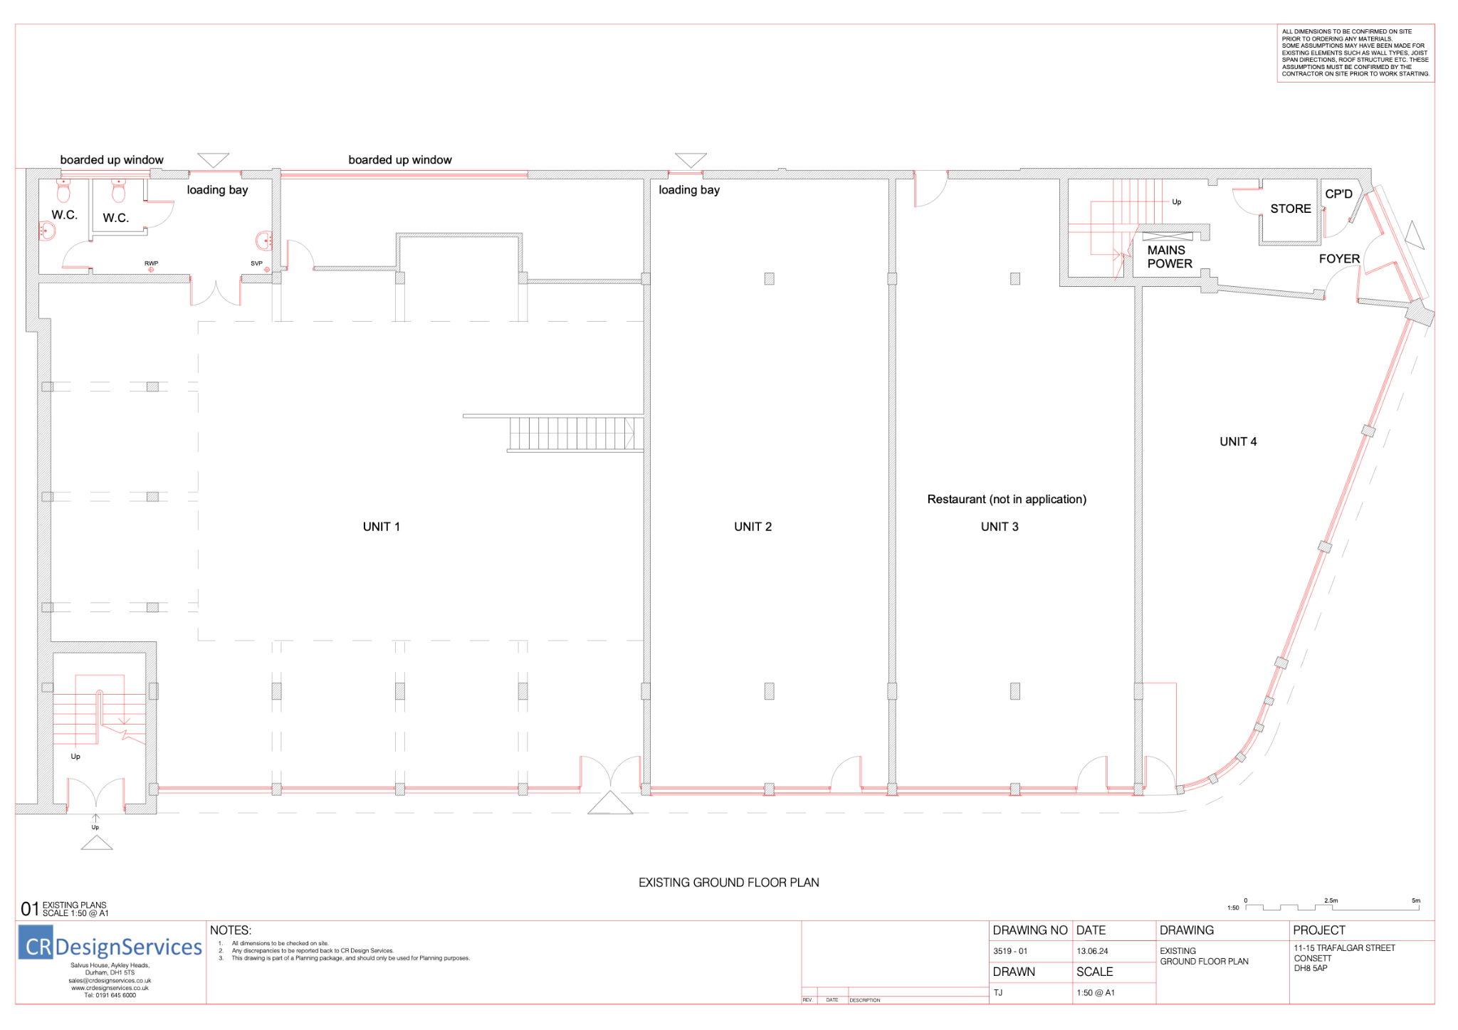
Existing Ground Floor

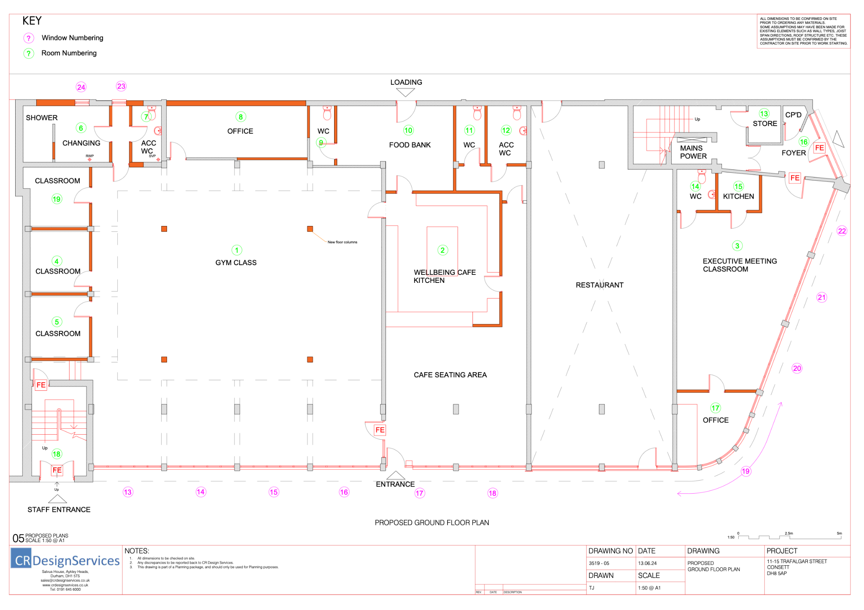
Proposed Ground Floor

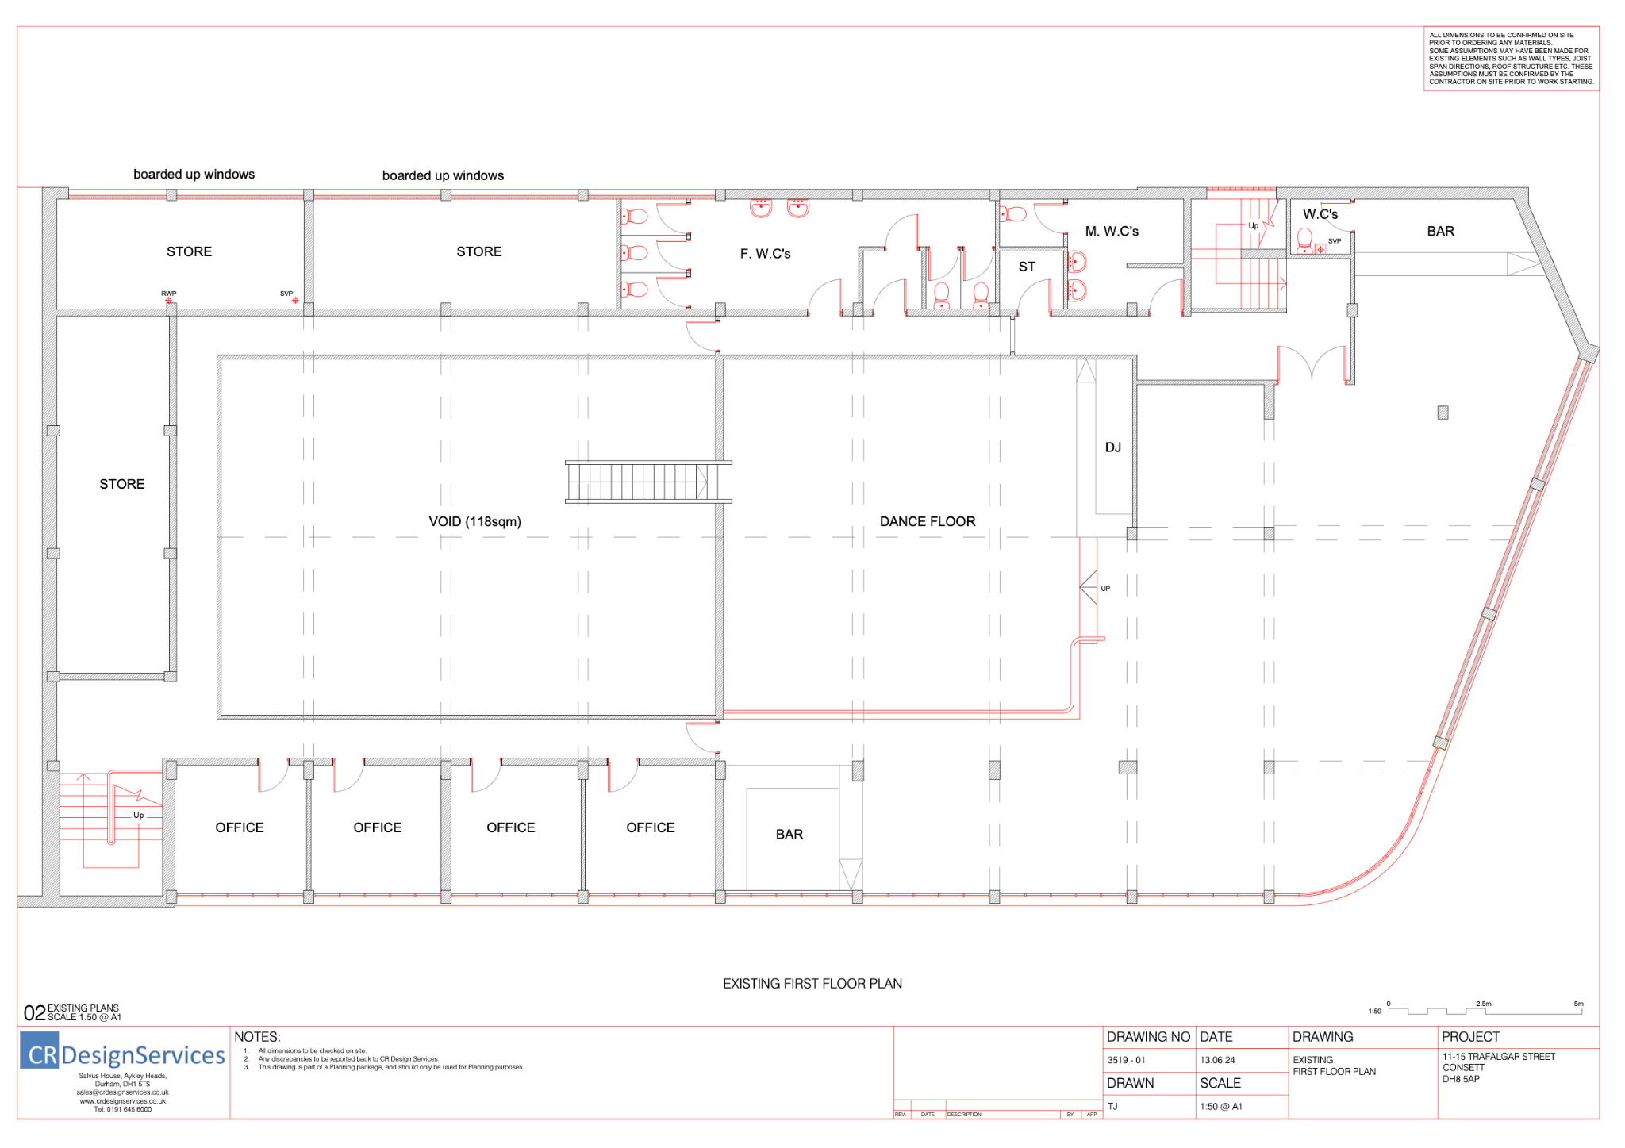
Existing First Floor

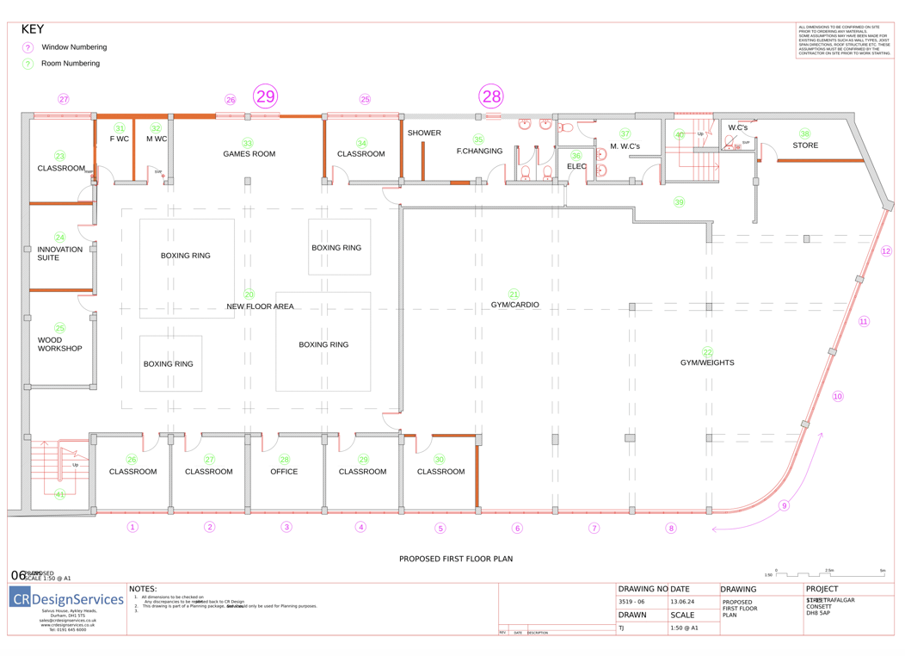
Proposed First Floor

Existing Elevations

Proposed Elevations

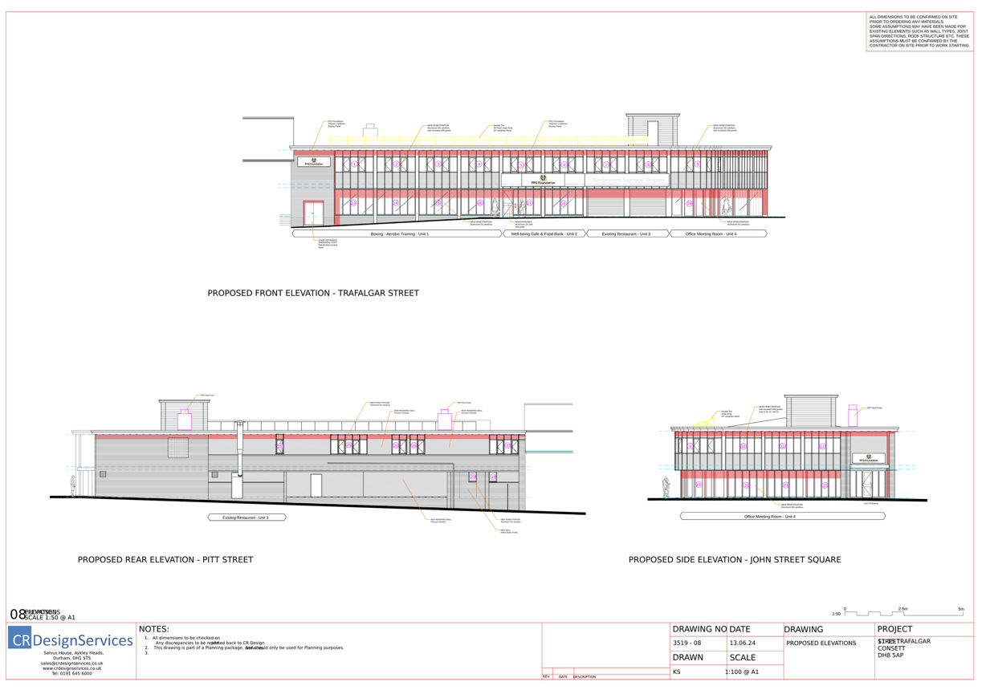
Proposed Elevation

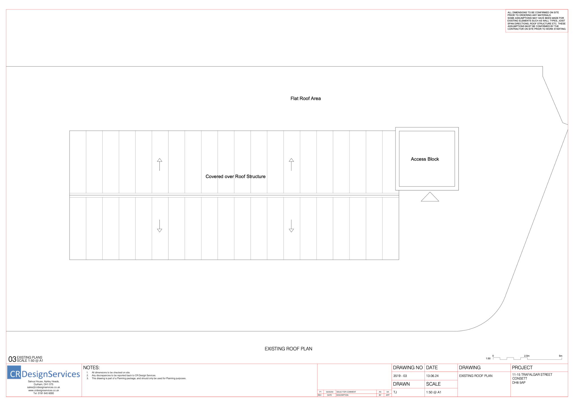
Existing Roof Plan
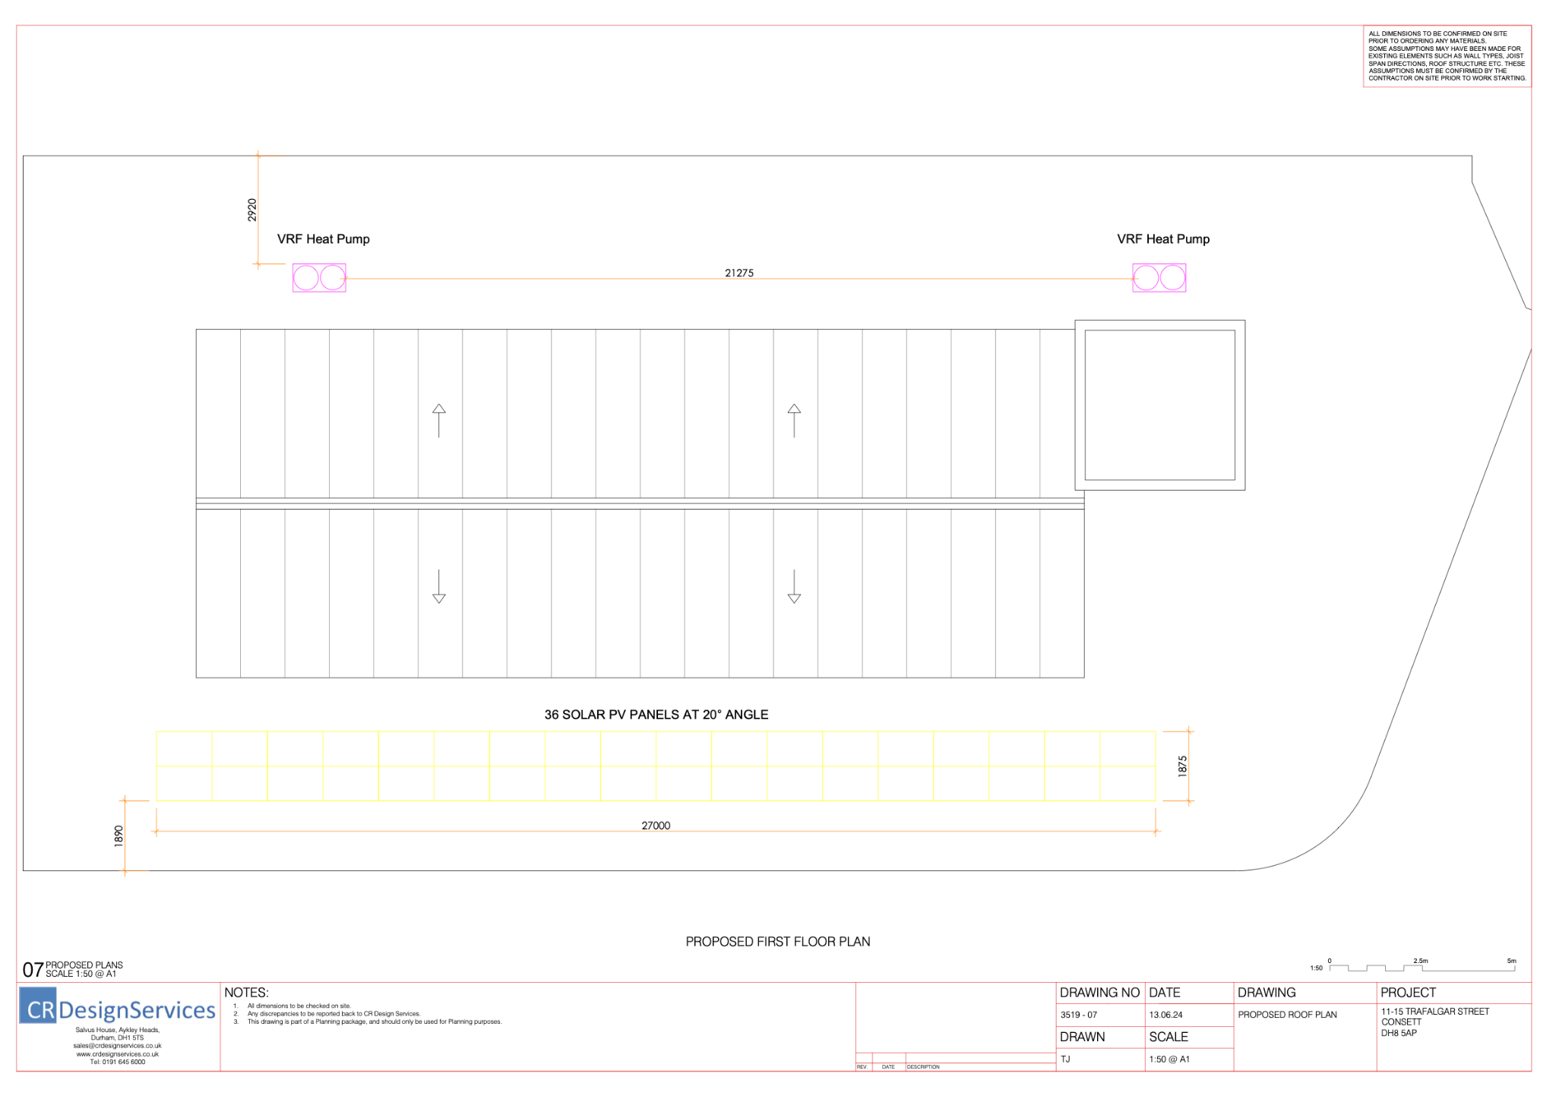
Proposed Roof Plan

Building Elevations

Front & Side Elevation

Exterior Construction and Installation
Windows:
- Install 94 new double-glazed, black-tinted aluminium windows on the front and side elevations.
- Install 65 new double-glazed, black-tinted aluminium curtain walling windows (Windows 1-19, including the windows to the right side of window 9).
- Install 29 new double glazed, black-tinted aluminium windows.
- Install tinting onto current double-glazed windows (windows 20-22 on the right side of window 19) with matching tinted windows.
Entrances:
- Install a new glass door with black tint as the main entrance for the wellbeing café.
- Install a new heavy-duty staff entrance double door with access control measures, also serving as an emergency exit (located to the left of window 13).
Signage:
- Install new signage above entrances 17 and 18 as specified.

Exterior Finishes
Painting:
- Paint the full exterior of the building black to match the design specifications.

Security and Lighting
Security:
- Install 4 CCTV cameras to monitor the front and side elevations of the building.
Lighting:
- Install new exterior building lighting on the front and side elevations, with fixtures placed between pillars to illuminate the exterior pathways.

Rear Elevation

Exterior Construction and Installation
Windows:
- Install 14 new tinted windows on the back elevation (Windows 23-29).
- Install a frosted window for Window 24.
- Apply new privacy tinting to the window left of Window 28, located in the women’s changing room.
Wall Rendering and Insulation:
- Apply new rendered walls with insulation on the back elevation. Refer to the building plans for specific details on the wall spaces that require rendering and insulation.
Exterior Finishes
Painting:
- Paint the full exterior of the building black, ensuring that all rendered surfaces, as well as new and existing structural elements, are uniformly finished.

Roof Plan

Energy Systems Installation
Solar Panels:
- Install appropriate solar panels on the roof to supplement the building’s energy use. Ensure the panels are positioned for optimal sunlight exposure and integrated with the building’s existing electrical system.
Air Source Heat Pump:
- Install an air source heat pump (air-to-air) to support the air conditioning units. This system should be capable of providing both heating and cooling.
Air Cleaning System:
- Install an air cleaning system as part of the HVAC setup. This system should be integrated with the hot and cold air conditioning units to ensure clean, filtered air throughout the building.
Roof Access and Repairs
Loft Hatch Installation:
- Create a new lockable loft hatch with a retractable ladder to provide secure access to the roof for maintenance and inspections.
Roof Repairs:
- Perform minor roof repairs to address and stop small leaks in two identified areas. Ensure that the repairs are durable and weatherproof to prevent future issues.

Throughout Building Development

Mechanical and Electrical Systems
HVAC Systems:
- Install heating and cooling air conditioning throughout the building, with 21 units in total. This system includes a mechanism for air cleaning.
- Remove old radiator systems in section 4 upstairs and patch holes in walls to ensure a clean and professional appearance.
Electrical Systems:
- Complete a full refit of the building's electrical systems, including new power sources, plug sockets, and wiring.
- Install new PIR (Passive Infrared) controls throughout the building to enhance energy savings.
Fire Safety:
- Install a new fire safety system, including alarms, sensors, and control panels as per the latest safety standards.

Security and Access Control
CCTV System:
- Install a new CCTV viewing system that can be monitored from offices 8 and 17.
Access Control Systems:
- Install 30 new access control systems throughout the building, capable of being edited per user membership with timed access to certain areas.
- Install 33 new heavy-duty doors with door frames, integrated with access control systems.

Communication and Audio Systems
Surround Sound System:
- Install a new surround sound system that is controlled via offices 8 and 17.
Audio System:
- Install a new audio system in the main rooms on the ground floor and 1st floor, also controlled via offices 8 and 17.
WiFi Extension:
- Extend WiFi coverage around the entire building to ensure strong and consistent internet connectivity.
Interior Finishes
Colour Scheme:
- Apply the new colour theme throughout the building, incorporating black, gold, white, and grey tones.
Waste Management:
- Manage the waste produced from building deconstruction and construction activities, ensuring proper disposal and recycling where possible.

Ground Floor - Rooms 1-19

AREA 1
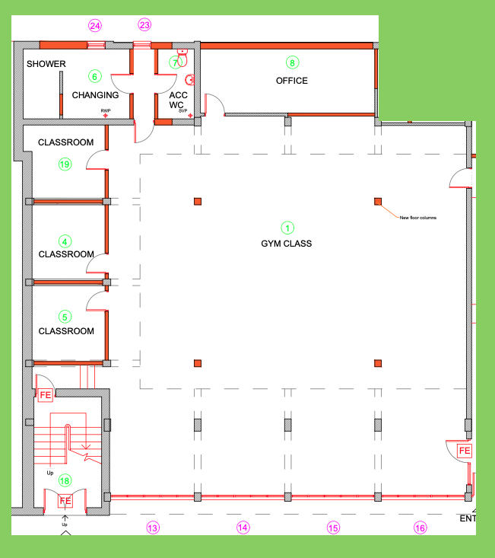

Room 1 = Main Gym Space (Boxing Bag Area)

Structural Modifications
Support Beams and Mezzanine Flooring:
- Install 4 support beams to add mezzanine flooring and room space above. Ensure the flooring is sturdy and built to support weight for walking and additional activities.
Stairs Removal:
- Remove the existing stairs and the door at the top of the stairs. Brick up the door space to create a seamless wall.
Wall Modifications:
- Remove part of the right wall to create new doorways for access to the wellbeing café, fire exit, and main entrance. Install new heavy-duty strong doors with magnetic access control systems.

Mechanical and Electrical Systems
Air Conditioning:
- Install 2 air conditioning units (hot and cold) to regulate the temperature in the gym space.
Lighting:
- Install 15 new spotlights into the ceiling, ensuring they do not interfere with activities like skipping. Fit gold/yellow lights around the room to add a stylish flare.
Surround Sound System:
- Install a surround sound system in the gym to enhance the environment during workouts.
PIR Controls:
- Install PIR (Passive Infrared) controls to manage lighting and energy use efficiently.
CCTV Installation:
- Install 4 CCTV cameras to monitor the gym space.

Interior Finishes
Flooring:
- Lay thick 20mm rubber flooring (1x1m squared) throughout the gym to ensure durability and safety.
Column Finishing:
- Neaten up the surrounding columns with board sections to ensure a clean and professional look, making them strong enough to withstand impacts from boxing bags.
Painting and Aesthetics:
- Paint the bag frames white and the bag chains gold.
- Paint the walls black to align with the overall design aesthetic of an industrial, sleek gym space.
Window Protection:
- Install a form of window protection, such as elasticated netting, on windows 13, 14, 15, and 16 to prevent damage from activities like football.

Additional Considerations
Prowler Track:
- Place a professional prowler track in the center of the gym space as detailed in appendix 1.
Rainwater Pipe Redirection:
- Redirect the rainwater pipe parallel to 18 (stairways) at the second column to the outside to prevent flooding in the downstairs area.

Rooms 4 + 5 + 19 + New Corridor = Meeting Room / Classroom 6 students

Structural Modifications
Partition Walls:
- Remove Existing Walls: Remove the current partition walls in Rooms 4, 5, and 19.
- Add New Walls: Construct new partition walls to create the desired room layout for the meeting room/classroom space.
Corridor Creation:
- New Corridor Construction: Build a new corridor with stairs and install a heavy-duty door with an access control system. The doorway leading into the larger stairs will be converted into a structural supporting wall, requiring structural calculations and support.

Mechanical and Electrical Systems
HVAC Systems:
- Install Air Conditioning: Install heating and cooling air conditioning units in each of the three rooms (Rooms 4, 5, and 19).
Electrical Systems:
- Classroom Power System: Install a classroom power cable system with wall plastic coverage to neatly organise and protect power cables.
- PIR Controls: Install PIR (Passive Infrared) controls in each room to manage lighting and energy use efficiently.
- Smoke Alarms: Install smoke alarms in each room to ensure fire safety (three alarms in total).

Interior Finishes
Flooring:
- Carpeting: Install new carpeting in each classroom to create a clean and professional appearance.
Doors:
- Install Heavy-Duty Doors: Install three new heavy-duty doors, each equipped with an access control system for security and controlled access.

Safety and Compliance
Structural Support:
- Supporting Wall Calculations: Ensure that the new structural supporting wall (created from the doorway) is properly calculated and reinforced to comply with building safety standards.

Room 6 = Male Changing Room / Wet Room

Structural Modifications
Wall Modifications:
- Remove Existing Wall: Remove the wall for the old bathroom to create a more open space for the changing room.
- New Wall Construction: Build a new wall with a heavy-duty door and doorframe, including an access control system for secure entry.
Rear Elevation Work:
- Brick-Up Loading Bay: Brick up the existing loading bay (Window 23) as part of the rear elevation modifications.
- Window Installation: Install small black-tinted windows in the loading bay and changing area (Windows 23 and 24). These windows should have limited opening ability for privacy and security.

Mechanical and Electrical Systems
Ventilation and Extraction:
- Install Ventilation System: Install a ventilation and extraction system to ensure proper air circulation and moisture control in the wet room and changing area.
PIR Controls:
- Lighting Controls: Install PIR (Passive Infrared) controls to manage lighting and energy use efficiently in the changing room and hallway areas.

Interior Finishes
Wet Room and Tiling:
- Waterproofing: Ensure the wet room is fully waterproofed, including the installation of appropriate tiling throughout the shower area and wet room.
Flooring:
- Changing Room Flooring: Install easy-to-mop flooring in the changing room area for easy maintenance and cleanliness.
- Hallway Flooring: Consider using 20mm thick rubber flooring (1x1 square blocks) in the hallway between Rooms 6 and 7. Alternatively, explore other flooring options that may be better suited for this area.
Benches and Storage:
- Install Benches: Install one long bench with underneath bag storage at the bottom of the room, and a smaller bench with underneath storage at the top right of the room.
- Overhead Storage: Install open 2-tier overhead storage for bags above the benches.
- Install Pegs: Provide pegs for users to hang up their bags and clothes.

Accessibility Features
Accessible Shower Cubicle:
- Install Shower Cubicles: Install three shower cubicles on the top left wall, with one larger cubicle designed for disabled access on the very left.
Wheelchair Accessibility:
- Ensure Accessibility: Ensure that the changing room and wet room are fully accessible to wheelchair users, including the layout of benches, storage, and the accessible shower cubicle.

Room 7 = Accessible Toilets

Structural Modifications
Wall and Door Installation:
- New Wall Construction: Build a new wall with a heavy-duty frame and door to ensure durability and secure access to the accessible toilets.

Mechanical and Electrical Systems
PIR Controls:
- Lighting Controls: Install PIR (Passive Infrared) controls to manage lighting and energy use efficiently in the accessible toilets.
Hand Dryer Installation:
- Jet Hand Dryer: Install a jet hand dryer for efficient and hygienic hand drying.

Interior Finishes
Waterproofing and Wall Coverings:
- Waterproofing: Apply waterproofing to areas prone to moisture to protect the infrastructure.
- Washable Wall Coverings: Install washable wall coverings around the room to ensure easy maintenance and hygiene.
Flooring:
- Easy-Mop Flooring: Install flooring that is easy to mop, ensuring that the space remains clean and safe for all users.
Fixtures and Accessories:
- New Sink: Install a new sink with accessibility features.
- New Toilet: Install a new, accessible toilet suitable for wheelchair users.
- Toilet Roll Holder: Mount a toilet roll holder on the wall for convenience.
- Mirror: Install a mirror at an appropriate height for wheelchair users.
- Sanitary Bin: Provide a sanitary bin for proper waste disposal.

Accessibility Features
Accessibility Compliance:
- Accessible Design: Ensure that all features, including the sink, toilet, and mirror, are installed at heights and in locations that are accessible for wheelchair users.
- Space Layout: Ensure sufficient space within the toilet area to accommodate wheelchair movement and transfer.
Room 8 = Office

Structural Modifications
Wall Modification:
- Back Wall Work: Brick up the back wall as part of the rear elevation work. Assess whether the existing wall needs to be taken down to brick it up, especially considering the windows behind it.
Door Installation:
- Heavy-Duty Door: Install a new heavy-duty door with a door frame, integrated with an access control system to ensure secure entry to the office.

Mechanical and Electrical Systems
Air Conditioning:
- Heating and Cooling System: Install a heating and cooling air conditioning system to maintain a comfortable working environment.
Electrical Systems:
- Wire Management: Clean up and organise all wires within the office to ensure a neat and professional appearance.
- PIR Controls: Install PIR (Passive Infrared) controls to manage lighting and energy use efficiently in the office.
- Smoke Alarm: Install a smoke alarm to ensure fire safety in the office.
CCTV System:
- CCTV Installation: Install a new CCTV system with 32+ cameras. Ensure the office has the capability to monitor CCTV feeds from other office spaces.
- Shelf Installation: Install a shelf specifically designed to hold the CCTV monitor and mouse pad for easy access and operation.

Interior Finishes
Flooring:
- New Carpet: Install new carpeting in the office to create a clean and professional atmosphere.
Wall Treatment:
- Soundproofing: Replace the bottom portion of the walls and consider adding soundproofing to reduce noise and enhance privacy within the office.
Painting and Cleaning:
- Paint Touch-Up: Clean up and refresh the paint on the walls to maintain a professional appearance.

Room 18 – Foyer / Fire Exit

Structural Modifications
Door Installation:
- Access Control Doors: Install new heavy-duty, strong access control double doors for secure entry and exit in the foyer and fire exit areas.

Mechanical and Electrical Systems
PIR Controls:
- Lighting Controls: Install PIR (Passive Infrared) controls to manage lighting and energy use efficiently in the foyer and fire exit areas.
Smoke Alarm:
- Fire Safety: Install a smoke alarm to ensure fire safety in the foyer and fire exit areas.

Interior Finishes
Wall Coverings:
- Wipeable Wall Covering: Install wipeable wall coverings up to waist/hip height to prevent scuffing and maintain a professional appearance.
Flooring:
- Foot Wipe Mat: Install a new mat designed for wiping feet, ensuring it fits the designated area in the foyer for optimal functionality.
Painting:
- Touch-Up Paint: Apply fresh paint to ensure the foyer and fire exit areas maintain a clean and professional look.

AREA 2
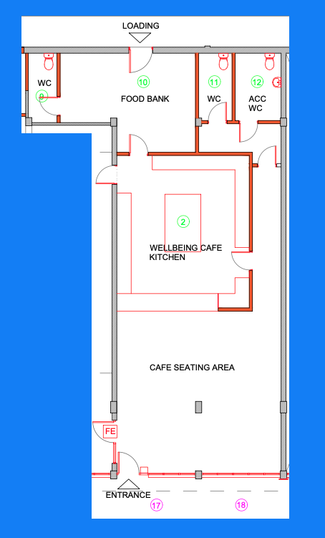

2 = Wellbeing Café - Kitchen & Seating Area

Structural Modifications
Wall Construction:
- Kitchen Area: Build a wall around the kitchen area to create a defined space separate from the seating area.
Door Installation:
- Access Control Doors: Install two new heavy-duty strong doors with magnetic access control systems—one from the kitchen to the seating area and another from the kitchen to the food bank area.

Mechanical and Electrical Systems
Electrical Systems:
- Lighting: Install industrial-looking electrical trays with suspended warm lighting throughout the café, particularly in the seating area. Fit electrical plugs and lights within the kitchen and along the walls of the café area, using thin, discrete silver fittings.
- PIR Controls: Install PIR (Passive Infrared) controls to manage lighting and energy use efficiently.
- Smoke Alarms: Install two smoke alarms—one in the kitchen area and one in the seating area—for fire safety.
- CCTV Installation: Install four CCTV cameras to monitor the café area, ensuring coverage of all critical points.
- Air Conditioning: Install one air conditioning unit (hot and cold) to maintain a comfortable temperature in the café.
Commercial Kitchen Equipment:
- Equipment Installation:
  - Install a commercial 3-tier stainless steel freezer and fridge, each with a worktop on top.
  - Install an extra-large 6-person stainless steel prep area/worktop with underneath storage. Consider the possibility of making it lockable for security.
  - Install a 2-tier sink with a drying rack and a commercial jet wash cleaner.
  - Install a double commercial electric cooker/oven.
  - Install a second-hand commercial coffee machine, a glass display cabinet, a commercial panini/toastie maker, a commercial mixer, and a commercial hot plate.
  - Install a hot air ventilation system to manage heat and airflow within the kitchen.
  - Apply stainless steel boards on the walls for easy cleaning and durability.
  - Install hard-wearing, washable flooring in the kitchen area for safety and hygiene.

Interior Finishes
Flooring:
- Wooden Flooring: Install dark burnt-type wooden flooring in the café seating area to match the aesthetic theme. Open to other suggestions if necessary.
Furnishings:
- Café Furniture:
  - Install 24 café seats in total, including 2 x 2-seater café tables with matching style café chairs.
  - Install a 3.5m long darkened wooden high table with 4 high chairs along the left side of the room.
  - Install 4-seater café tables.
  - Add one sofa and two decorative plants to create a cosy, inviting atmosphere.
- Entertainment Setup:
  - Install a pool table and a darts board, including wall protection for the darts board area to create a professional setup.
- TV Installation: Fit two existing TVs on the wall for entertainment.
Window and Door Finishes:
- Window Protection: Install a suspended window protection net to prevent damage from activities such as pool playing.
- Tinted Glass Installation: Ensure the installation of black tinted glass windows and a black tinted front door with access control (timed) as specified in the Front Elevations section.

Aesthetic and Design Considerations
Café Aesthetics:
- Theme: Maintain an industrial café theme with cosy, warm, and sheek design elements. Incorporate burnt woody type seating, industrial beams with hanging warm lighting, and golden veins running through darkened wooden furniture.

10 = Store Room – Pantry for Food Bank

Structural Modifications
Wall Removal and Construction:
- Wall Removal: Remove existing walls to extend the food bank area, creating a larger and more functional space.
- Wall Construction: Add new walls to define the new space for the food bank area as outlined in the plans.

Mechanical and Electrical Systems
PIR Controls:
- Lighting Controls: Install PIR (Passive Infrared) controls to manage lighting and energy use efficiently in the pantry and storage areas.
Smoke Alarm:
- Fire Safety: Install a smoke alarm to ensure fire safety in the pantry and storage area.

Interior Finishes
Flooring:
- Washable Flooring: Install easy-to-wash flooring to maintain cleanliness and hygiene in the pantry.
Shelving:
- Storage Shelves: Install lots of fitted storage shelves designed for effective storage of food items and boxes, maximising the use of space and ensuring easy access to stored items.
Surface Treatment:
- Cleanable Surfaces: Apply cleanable surfaces to walls and other areas to ensure the space remains sanitary and easy to maintain.

Rooms 9 + 11 = W.C.’s

Mechanical and Electrical Systems
PIR Controls:
- Lighting Controls: Install PIR (Passive Infrared) controls to manage lighting and energy use efficiently in the W.C.
Smoke Alarm:
- Fire Safety: Install a smoke alarm to ensure fire safety in the W.C.
Hand Dryer:
- Jet Hand Dryer: Install a jet hand dryer for efficient and hygienic hand drying.

Interior Finishes
Flooring:
- Washable Flooring: Install easy-to-wash flooring in the W.C. area to ensure cleanliness and ease of maintenance.
- Tile Flooring: Consider installing tile flooring for durability and ease of cleaning.
Wall Treatment:
- Splash-Proof Walling: Install splash-proof wall coverings around the toilet, sink, and hand dryer areas to protect against moisture and ensure a clean, professional appearance.
Fixtures and Accessories:
- New Sink: Install a new sink to match the clean and professional aesthetic.
- New Mirror: Install a mirror at an appropriate height and location within the W.C.
- Sanitary Bin: Provide a sanitary bin for proper waste disposal.

Aesthetic and Cleanliness Considerations
General Cleanliness:
- Clean and Professional Look: Ensure that the W.C. maintains a clean and professional appearance through regular maintenance and attention to detail in the finishes.

Room 12 = Disabled Toilet

Mechanical and Electrical Systems
PIR Controls:
- Lighting Controls: Install PIR (Passive Infrared) controls to manage lighting and energy use efficiently in the disabled toilet.
Smoke Alarm:
- Fire Safety: Install a smoke alarm to ensure fire safety in the disabled toilet.
Hand Dryer:
- Jet Hand Dryer: Install a jet hand dryer for efficient and hygienic hand drying.

Accessibility Features
Accessible Design:
- New Toilet: Install a new toilet that is fully accessible for wheelchair users, ensuring it meets all relevant accessibility standards.
- New Sink: Install a new sink at a height and position that is accessible for users with disabilities.
- Space Layout: Ensure that the layout of the toilet provides sufficient space for wheelchair manoeuvrability.

Interior Finishes
Flooring:
- Easy-Mop Flooring: Install flooring that is easy to mop, ensuring that the space remains clean and safe for all users.
Wall Treatment:
- Splash-Proof Walling: Install splash-proof wall coverings around the toilet, sink, and hand dryer areas to protect against moisture and ensure a clean, professional appearance.
Fixtures and Accessories:
- Mirror: Install a mirror at an appropriate height for wheelchair users.
- Sanitary Bin: Provide a sanitary bin for proper waste disposal.

Aesthetic Considerations
Clean and Professional Look:
- General Cleanliness: Ensure that the disabled toilet maintains a clean and professional appearance through the use of high-quality materials and regular maintenance.

AREA 3
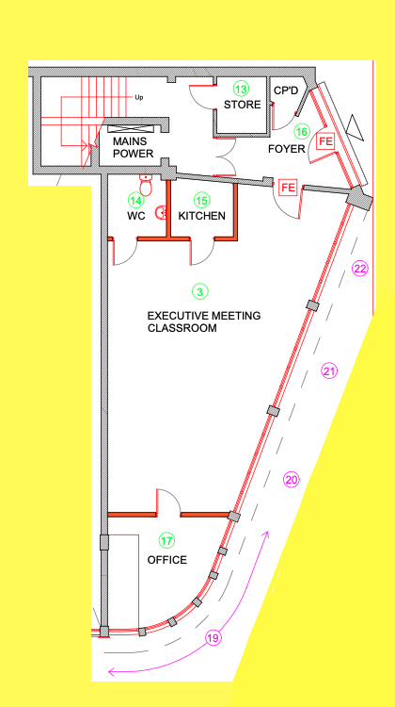

Room 3 = Executive Meeting Room / Post 16 Classroom

Structural Modifications
Wall and Door Installation:
- New Wall Section: Build a wall section with an access control door between Room 3 (Executive Meeting Room) and Room 17.
- Access Control Door: Install a new access control door to ensure secure entry to Room 3. If the existing door is suitable, it can be retained and integrated with the access control system.

Mechanical and Electrical Systems
HVAC System:
- Heating and Cooling: Install a heating and cooling air conditioning system to maintain a comfortable environment in the executive meeting room.
Electrical Systems:
- Lighting Installation: Install long lighting fixtures to ensure the room is well-lit, aligning with the professional, corporate atmosphere.
- PIR Controls: Install PIR (Passive Infrared) controls to manage lighting and energy use efficiently.
- CCTV Installation: Install one CCTV camera to monitor the room, ensuring security and safety.
- Smoke Alarm: Install a smoke alarm to ensure fire safety in the meeting room.

Interior Finishes
Ceiling Work:
- Ceiling Space: Remove and tidy up the ceiling space to create a clean and professional look.
Flooring:
- Broadloom Carpet: Install broadloom carpet to enhance the room's aesthetic, contributing to the pristine and executive feel.
Wall Treatment:
- Painting: Apply fresh paint to the walls to maintain a clean and professional appearance.
Windows:
- Tinted Windows: Install black tinted glass windows with aluminium frames to provide a sleek and modern look while ensuring privacy.

Furnishings
Meeting Table and Chairs:
- Executive Furnishings: Install a large executive meeting table with accompanying chairs to complete the corporate atmosphere of the room.

Room 13 = Storeroom

Structural Modifications
Wall Modifications:
- Knock Through Back Wall: Knock through the back wall to extend the storeroom into the adjoining cupboard area. (not shown on plans)
- Partition Wall Construction: Build a new partition wall to join the storeroom with the adjoining cupboard, creating a unified storage space.
Door and Skirting Work:
- New Skirting Board: Install new skirting boards around the room for a clean finish.
- Door Framing: Install new framing around the door to enhance durability and appearance.
- Heavy Duty Door: Install a new heavy-duty door with access control to ensure secure entry to the storeroom.

Mechanical and Electrical Systems
Hot Water System:
- Hot Water Tank Installation: Install a 300-litre hot water tank to supply the entire building with hot water, ensuring it meets the building’s demand.
Electrical Systems:
- Lighting Installation: Install long lighting fixtures to ensure the storeroom is well-lit, making it easier to access and organise supplies.
- PIR Controls: Install PIR (Passive Infrared) controls to manage lighting and energy use efficiently in the storeroom.
- Smoke Alarm: Install a smoke alarm to ensure fire safety in the storeroom.

Interior Fittings
Shelving:
- Storage Shelves: Install shelving units designed for storing cleaning equipment, such as hoovers, mops, and other supplies.

Rooms 14 = W.C.

Mechanical and Electrical Systems
PIR Controls:
- Lighting Controls: Install PIR (Passive Infrared) controls to manage lighting and energy use efficiently in the W.C.
Smoke Alarm:
- Fire Safety: Install a smoke alarm to ensure fire safety in the W.C.
Hand Dryer:
- Jet Hand Dryer: Install a jet hand dryer for efficient and hygienic hand drying.

Interior Finishes
Flooring:
- Washable Flooring: Install easy-to-wash flooring in the W.C. area to ensure cleanliness and ease of maintenance.
- Tile Flooring: Consider installing tile flooring for durability and ease of cleaning.
Wall Treatment:
- Splash-Proof Walling: Install splash-proof wall coverings around the toilet, sink, and hand dryer areas to protect against moisture and ensure a clean, professional appearance.
Fixtures and Accessories:
- New Sink: Install a new sink to match the clean and professional aesthetic.
- New Mirror: Install a mirror at an appropriate height and location within the W.C.
- Sanitary Bin: Provide a sanitary bin for proper waste disposal.

Aesthetic and Cleanliness Considerations
General Cleanliness:
- Clean and Professional Look: Ensure that the W.C. maintains a clean and professional appearance through regular maintenance and attention to detail in the finishes.

15 = Kitchen

Structural Modifications
Worktop Installation:
- Replace Worktops: Remove the old worktops and install the new worktops that are already available, ensuring they are fitted to create a clean and professional kitchen space.
Cabinet Installation:
- Install Matching Cupboards: Fit matching cupboards in the kitchen area to create a cohesive and organised look.

Mechanical and Electrical Systems
Electrical Systems:
- Lighting Installation: Install long lighting fixtures to ensure the kitchen is well-lit, providing a bright and functional workspace.
- PIR Controls: Install PIR (Passive Infrared) controls to manage lighting and energy use efficiently in the kitchen.

Interior Finishes
Flooring:
- New Flooring: Install new flooring that is durable, easy to clean, and aligns with the overall aesthetic of the kitchen.
Painting and Decoration:
- Paint and Decorate: Apply fresh paint and decorate the kitchen to maintain a clean, professional appearance.
Appliance Fitting:
- Fridge/Freezer Installation: Fit the existing fridge/freezer into the kitchen with a focus on creating a clean and organised layout.

Room 16 = Foyer Area

Structural Modifications
Door and Window Installation:
- Access Control Door: Install a new heavy-duty, strong access control double door to ensure secure entry and exit from the foyer area.
- Fire Exit Door and Windows: Install a black tinted glass fire exit door and windows with aluminium frames to provide a sleek, modern appearance while ensuring safety and functionality.

Mechanical and Electrical Systems
Electrical Systems:
- Lighting Installation: Install long lighting fixtures to ensure the foyer area is well-lit, providing a bright and welcoming environment.
- PIR Controls: Install PIR (Passive Infrared) controls to manage lighting and energy use efficiently in the foyer.
- Smoke Alarm: Install a smoke alarm to ensure fire safety in the foyer area.

Interior Finishes
Painting and Decoration:
- Painting: Apply fresh paint to the foyer area to maintain a clean and professional appearance.
- Finishing Touches: Complete any finishing touches needed to ensure the area looks polished and welcoming.

Room 17 = Post 16 Office

Structural Modifications
Wall and Door Modifications:
- Door to Window Conversion: Replace the existing door with a window.
- Wall Construction: Brick up part of the wall and install two small black-tinted windows.
- New Wall and Door Installation: Construct a new wall with a heavy-duty door and door frame, integrated with an access control system to ensure secure entry.

Mechanical and Electrical Systems
Electrical Installation:
- Plugs and Lighting: Install 4 double electrical plugs and a hanging light to provide ample power and lighting in the office.
- PIR Controls: Install PIR (Passive Infrared) controls to manage lighting and energy use efficiently.
- Smoke Alarm: Install a smoke alarm to ensure fire safety in the office.
HVAC System:
- Heating and Cooling: Install a heating and cooling air conditioning system to maintain a comfortable environment in the office.
CCTV System:
- CCTV Monitoring: Install a shelf for a CCTV monitor and mouse pad. Ensure the office has the capability to monitor CCTV feeds.

Interior Finishes
Flooring:
- New Carpet: Install new carpeting to enhance the room's aesthetic, contributing to the clean and professional feel.
Window Treatments:
- Long Blinds: Install long blinds for the windows to control light and provide privacy.
Painting and Decoration:
- Painting: Apply fresh paint to maintain a clean and professional appearance in the office.

4. Office Furnishings
4.1 Storage:
- Lockable Storage: Install lockable storage units to secure important documents and office supplies.

First Floor – Rooms 20-41


AREA 4
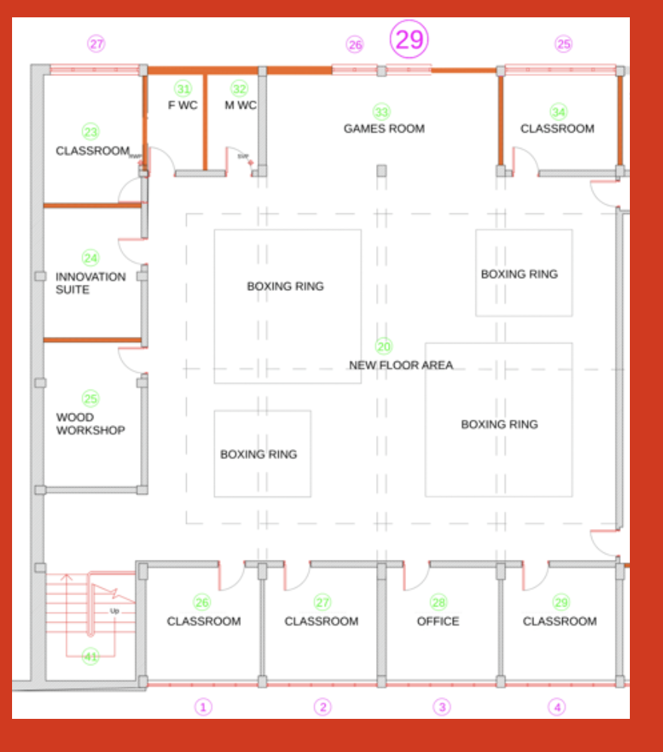

Room 20 – Open Plan Boxing Rings (New Mezzanine Floor Area)

Structural Modifications
Roofing Work:
- Roof Insulation and Boarding: Fit the roof with insulation and cover it with boarding to improve energy efficiency and create a clean, finished appearance.
Door Installation:
- Access Control Doors: Install two new heavy-duty single doors with access control systems on the right wall of the room to ensure secure entry and exit.

Mechanical and Electrical Systems
HVAC System:
- Air Conditioning Units: Install two large air conditioning units (hot and cold) to maintain a comfortable temperature in the boxing area.
Electrical Systems:
- Lighting Installation: Install long, bright lighting fixtures to ensure the area is well-lit.
- PIR Controls: Install PIR (Passive Infrared) controls to manage lighting and energy use efficiently.
- CCTV Installation: Install eight CCTV cameras to monitor the boxing rings and the games room area, ensuring security and safety.
- Smoke Alarms: Install smoke alarms to ensure fire safety in the open-plan area.

Interior Finishes
Flooring:
- Rubber Flooring: Install black rubber roll mat flooring to provide a durable, safe surface for the boxing rings.
Wall Protection:
- Wall Lining: Install lining on the walls up to waist height to prevent damage from boxing activities and equipment.
- Decorative Lighting: Add yellow/golden decorative lighting in line with the Foundation for Good (FFG) branding to enhance the aesthetics of the room.
Painting and Decoration:
- Paint and Decorate: Paint and decorate the area with a focus on creating a clean, professional, and sleek black-themed environment.

Furnishings and Equipment
Lockers and Vending Machine:
- Large Lockers: Install large lockers for secure storage of personal belongings.
- Drinks Vending Machine: Install a drinks vending machine to provide refreshments for users of the boxing rings.

Room 33 – Games Room

1. Structural Modifications
1.1 Wall and Cupboard Removal:
- Wall Removal: Remove the existing walls as specified to open up the space for the games room.
- Cupboard Removal: Remove any existing cupboards to create a more open and usable area.
1.2 Window Modifications:
- Window Removal and Wall Modification: Remove the existing window, take off the wooden board, and brick up the area as part of the rear elevation work.
- Small Windows Installation: Install small black-tinted windows with cages that can be accessed with a key, ensuring durability and safety, particularly in an environment where pool balls are in use.

2. Mechanical and Electrical Systems
2.1 Electrical Work:
- Plug Sockets: Install sufficient plug sockets to support the needs of the games room, ensuring they are conveniently located.
- Lighting Installation: Install new lighting fixtures, including potential neon lights to enhance the high-tech aesthetic.
- PIR Controls: Install PIR (Passive Infrared) controls to manage lighting and energy use efficiently.
- Smoke Alarm: Install a smoke alarm to ensure fire safety in the games room.

3. Interior Finishes
3.1 Asbestos Removal:
- High-Grade Asbestos Boiler Removal: Safely remove the high-grade asbestos boiler, ensuring compliance with health and safety regulations.
3.2 Painting and Decoration:
- Paint and Decorate: Paint and decorate the room to create a clean, high-tech environment that aligns with the intended use of the space.

4. Furnishings and Equipment
4.1 Games Room Equipment:
- Pool Table and Football Table: Install the existing pool table and football table, ensuring they are well-positioned within the room to maximise usability and space.
Room 23 – Classroom 6 students

Structural Modifications
Wall Removal and Construction:
- Wall Removal: Remove the existing wall as specified to reconfigure the classroom space.
- New Partition Wall: Construct a new partition wall to create the desired room layout.
Wall Integrity and Repairs:
- Wall Inspection: Assess the integrity of the left side wall to ensure it meets safety and structural standards.
- Wall Repair: Replaster and repair the left wall as needed to ensure it is smooth and ready for painting and decoration.
Door Installation:
- Access Control Door: Install a new heavy-duty door with an access control system to ensure secure entry to the classroom.

Mechanical and Electrical Systems
HVAC System:
- Air Conditioning: Install an air conditioning unit (hot and cold) to maintain a comfortable temperature in the classroom.
Electrical Work:
- Classroom Power System: Install a classroom power cable system with wall plastic coverage to keep cables organised and protected.
- PIR Controls: Install PIR (Passive Infrared) controls to manage lighting and energy use efficiently.
- Smoke Alarm: Install a smoke alarm to ensure fire safety in the classroom.

Interior Finishes
Painting and Decorating:
- Paint and Decorate: Paint and decorate the classroom to create a clean and professional learning environment.
Windows:
- Black Tinted Windows: Ensure the installation of black tinted windows as specified in the Rear Elevation section.

Furnishings
Desks:
- Double Desks: Install three double desks to accommodate six students in the classroom.

Room 24 – Innovation Suite / 6 Students

Structural Modifications
Wall Removal and Construction:
- Wall Removal: Remove the existing surrounding walls to open up the space for the Innovation Suite.
- New Wall Construction: Build a new wall to define the space, including the installation of a heavy-duty door with an access control system.
Ceiling and Skylight:
- Ceiling Repair: Repair the ceiling as needed, ensuring it is smooth and ready for painting.
- New Skylight: Install a new skylight to bring natural light into the room.

Mechanical and Electrical Systems
HVAC System:
- Air Conditioning: Install an air conditioning unit (hot and cold) to maintain a comfortable temperature in the Innovation Suite.
Electrical Work:
- Power Installation: Fit the room with the necessary electrical outlets and power systems to support all technology and equipment.
- Lighting Installation: Install appropriate lighting to ensure the room is well-lit for various activities.
- PIR Controls: Install PIR (Passive Infrared) controls to manage lighting and energy use efficiently.
- CCTV Camera: Install a CCTV camera to monitor the Innovation Suite.
- Smoke Alarm: Install a smoke alarm to ensure fire safety in the room.

Interior Finishes
Wall Treatment:
- Lining: Install wall lining up to waist height to prevent damage and maintain the room's aesthetic.
- Painting and Decorating: Paint and decorate the room to create a clean and professional environment conducive to innovation and creativity.

Furnishings and Equipment
Desks and Seating:
- Classroom Desks: Install three new double classroom desks to accommodate six students.
- Work Desk and Seats: Provide a new work desk and seating arrangements that support collaborative and individual work.
Technology and Resources:
- 3D Printer: Install a commercial-grade 3D printer (second-hand) for student use.
- VR and AR Equipment: Equip the room with Virtual Reality (VR) and Augmented Reality (AR) devices to enhance learning experiences.
- Idea Wall: Install an "Idea Wall," a wipeable board for brainstorming and planning.
- Touch Screen Devices: Provide iPads or other touch screen devices for student use.
- Resource Library: Set up shelving with books and resources on innovation, creativity, design, and technology.
- Computer: Install a computer to support the suite’s various digital needs.

Room 25 – Wood Workshop / 6 Students

Structural Modifications
Wall Work:
- Wall Removal and Replacement: Remove the old walling and replace it with new walling that is durable and suitable for a workshop environment.
- New Wall Construction: Ensure new walls are installed with proper lining up to waist height to protect against damage from workshop activities.
Ceiling and Skylight:
- Ceiling Repair: Repair the ceiling as needed, ensuring it is smooth and ready for painting.
- New Skylight: Install a new skylight to provide natural light in the workshop.

Mechanical and Electrical Systems
HVAC and Ventilation:
- Air Conditioning Unit: Install one air conditioning unit (hot and cold) to maintain a comfortable temperature in the workshop.
- Ventilation System: Install a ventilation system designed to handle dust, ensuring a safe working environment for students.
Electrical Work:
- Power Installation: Fit the room with the necessary electrical outlets and power systems to support all tools and equipment.
- Lighting Installation: Install appropriate lighting to ensure the workshop is well-lit for detailed work.
- PIR Controls: Install PIR (Passive Infrared) controls to manage lighting and energy use efficiently.
- CCTV Camera: Install a CCTV camera to monitor the workshop area.
- Smoke Alarm: Install a special smoke alarm that is not affected by dust, ensuring fire safety in the workshop.

Interior Finishes
Wall Treatment:
- Lining: Install wall lining up to waist height to prevent damage from tools and activities.
- Painting and Decorating: Paint and decorate the room to create a clean and professional workshop environment.

Furnishings and Equipment
Workstations:
- Work Benches and Stations: Install fitted work benches and workstations for six students, ensuring they are sturdy and suitable for woodworking activities.
Tools and Storage:
- Tool Rack: Install a tool rack with tools, including outlines on the wall for easy organisation and access.
- Still Saw and Equipment: Provide a still saw and other necessary workstations relevant to a wood workshop.
Door Installation:
- Access Control Door: Install a new heavy-duty door with an access control system to secure the workshop area.

Rooms 26 + 27 + 29 – Classroom / 6 Students

Structural Modifications
Door Installation:
- Heavy Duty Doors: Install new heavy-duty doors in each classroom with reconstructed strong doorways, integrated with access control systems for secure entry.

Mechanical and Electrical Systems
HVAC System:
- Air Conditioning Units: Install one air conditioning unit (hot and cold) in each classroom to maintain a comfortable temperature for students and teachers.
Electrical Work:
- Power Outlets: Install power outlets with plastic coverings that span the width of the wall and extend to the sides of each room, providing ample sockets for laptop plugins, smart boards, and teacher devices.
- PIR Controls: Install PIR (Passive Infrared) controls in each classroom to manage lighting and energy use efficiently.
- Fire Alarms: Install fire alarms in each classroom to ensure fire safety.

Interior Finishes
Windows:
- Black Tinted Windows: Ensure that the black tinted, aluminium-framed windows are installed as specified in the Front Elevation section to maintain a professional appearance and provide privacy.

Furnishings and Equipment
Classroom Desks:
- Desks: Install three classroom desks in total across the three rooms to accommodate six students in each classroom.
Smart Boards:
- Fixed Smart Boards: Install four smart boards fitted on the walls across the classrooms.
- Moveable Smart Board: Provide one moveable smart board that can be shared among the classrooms as needed.

28 – Alternative Provision Office

Structural Modifications
Door Installation:
- Heavy Duty Door: Install a new heavy-duty door with a reconstructed strong doorway, integrated with an access control system to secure the office.

Mechanical and Electrical Systems
HVAC System:
- Air Conditioning Unit: Install one air conditioning unit (hot and cold) to maintain a comfortable temperature in the office.
Electrical Work:
- PIR Controls: Install PIR (Passive Infrared) controls to manage lighting and energy use efficiently in the office.
- Smoke Alarm: Install a smoke alarm to ensure fire safety in the office.
- CCTV System: Install a CCTV camera in the office and a monitor to view the CCTV feed. Ensure the system allows for monitoring of security footage within this office.

Interior Finishes
Windows:
- Black Tinted Windows: Ensure that the black tinted, aluminium-framed windows are installed as specified to maintain privacy and a professional appearance.

Furnishings and Equipment
Office Furniture:
- Double Desk: Install one double desk to provide workspace for staff.
- Computer Desk: Provide a computer desk to house the office computer.
- Locked Storage: Install locked storage units for securing important documents and office supplies.
Office Equipment:
- Computer: Provide a computer for the office, ensuring it is set up for use with the CCTV monitoring system.

Room 31 – Female W.C.

Structural Modifications
Window and Wall Work:
- Window Removal and Replacement: Remove the old window, take off the wooden board, and render the wall. Install a new tinted privacy window to maintain privacy while allowing natural light.
- Wall Removal and Replastering: Remove any old or damaged walls, strip the remaining walls, and replaster to create a smooth, clean surface.
- New Wall and Door Installation: Construct a new wall and install a heavy-duty door with a reconstructed strong doorway for secure entry.

Mechanical and Electrical Systems
HVAC and Ventilation:
- Extractor Fan: Install an extractor fan to manage moisture and odors, ensuring proper ventilation in the W.C.
Electrical Work:
- PIR Controls: Install PIR (Passive Infrared) controls to manage lighting and energy use efficiently in the W.C.
- Smoke Alarm: Install a smoke alarm to ensure fire safety in the W.C.

Interior Finishes
Plumbing Fixtures:
- New Toilet and Sink: Install a new toilet and sink that align with the clean and professional aesthetic of the W.C.
- Jet Hand Dryer: Install a jet hand dryer for efficient hand drying.
- Toilet Roll Holder: Mount a toilet roll holder on the wall for convenience.
Wall and Floor Treatment:
- Waterproofing and Wall Covering: Apply waterproofing and install washable wall coverings around the room to ensure the space is easy to clean and maintain.
- Painting and Decoration: Paint and decorate the room to create a clean and professional environment.
Additional Fixtures:
- Sanitary Bin: Provide a sanitary bin for proper waste disposal.
- Mirror: Install a new mirror at an appropriate height for users.

Room 32 – Male W.C.

Structural Modifications
Window and Wall Work:
- Window Removal and Replacement: Remove the old window, take off the wooden board, and render the wall. Install a new tinted privacy window to maintain privacy while allowing natural light.
- Wall Removal and Replastering: Remove any old or damaged walls, strip the remaining walls, and replaster to create a smooth, clean surface.
- New Wall and Door Installation: Construct a new wall and install a heavy-duty door with a reconstructed strong doorway for secure entry.

Mechanical and Electrical Systems
HVAC and Ventilation:
- Extractor Fan: Install an extractor fan to manage moisture and odors, ensuring proper ventilation in the W.C.
Electrical Work:
- PIR Controls: Install PIR (Passive Infrared) controls to manage lighting and energy use efficiently in the W.C.
- Smoke Alarm: Install a smoke alarm to ensure fire safety in the W.C.

Interior Finishes
Plumbing Fixtures:
- New Toilet and Sink: Install a new toilet and sink that align with the clean and professional aesthetic of the W.C.
- Jet Hand Dryer: Install a jet hand dryer for efficient hand drying.
- Toilet Roll Holder: Mount a new toilet roll holder on the wall for convenience.
Wall and Floor Treatment:
- Waterproofing and Wall Covering: Apply waterproofing and install washable wall coverings around the room to ensure the space is easy to clean and maintain.
- Painting and Decoration: Paint and decorate the room to create a clean and professional environment.
Additional Fixtures:
- Mirror: Install a new mirror at an appropriate height for users.

Room 34 - Classroom - Music studio / 6 Students

Structural Modifications
Door Installation:
- Access Control Door: Install a new heavy-duty door with an access control system to secure the music studio.
Soundproofing:
- Wall Soundproofing: Install soundproofing materials on the walls to minimise sound leakage and external noise interference.
- Carpet Installation: Install a thick new carpet to aid in soundproofing and reduce floor reflections, enhancing the acoustic environment of the studio.

Mechanical and Electrical Systems
HVAC System:
- Air Conditioning Unit: Install one air conditioning unit (hot and cold) to maintain a comfortable temperature for students and equipment in the music studio.
Electrical Work:
- Lighting Installation: Provide adjustable LED lighting suitable for studio use, ensuring it is non-intrusive and minimises heat production.
- PIR Controls: Install PIR (Passive Infrared) controls to manage lighting and energy use efficiently in the studio.
- Power Outlets: Ensure all electrical connections are safe and compliant with local regulations. Install additional power outlets if required for studio equipment.
- Smoke Alarm: Install a smoke alarm to ensure fire safety in the music studio.

Interior Finishes
Windows:
- Black Tinted Windows: Ensure the installation of black tinted, aluminium-framed windows to maintain a professional appearance and provide privacy.
Painting and Decorating:
- General Décor: Paint and decorate the studio to create a clean, professional environment suitable for music production and teaching.

Furnishings and Equipment
Studio Desk and Furniture:
- Studio Desk: Provide and install a compact studio desk suitable for holding a computer, audio interface, MIDI controller, and other small studio equipment. Include cable management solutions and potential rack space for future expansion.
- Studio Chair: Supply an ergonomic, adjustable studio chair that fits comfortably within the space.
Technology and Audio Equipment:
- Computer and DAW Setup:
  - Computer: Supply and set up a compact desktop computer (e.g., Mac Mini) or a powerful laptop, pre-installed with the chosen DAW software (e.g., Logic Pro, Ableton Live, or FL Studio).
  - DAW Installation: Install and configure the DAW software, ensuring it is fully operational with all necessary drivers and plugins.
- Audio Interface: Supply a compact audio interface (e.g., Focusrite Scarlett 2i2) and connect it to the computer, ensuring neat and organised cable management.
- Studio Monitors: Provide and install two small to medium-sized studio monitors (e.g., Yamaha HS5 or KRK Rokit 5) on stands or isolation pads, and calibrate them for optimal sound quality.
- Headphones: Provide a pair of high-quality, closed-back studio headphones (e.g., Audio-Technica ATH-M50x).
- Microphone and Stand: Supply a versatile condenser microphone (e.g., Rode NT1-A) with a compact boom arm or stand, and include a pop filter for the microphone setup.
- MIDI Controller: Supply a compact MIDI controller (e.g., Akai MPK Mini or Novation Launchkey Mini) that fits on the studio desk.
Acoustic Treatment:
- Bass Traps: Install bass traps in all four corners of the room to manage low-frequency sound reflections.
- Acoustic Panels: Install acoustic panels on the walls, particularly on the side walls and behind the monitors, to minimise sound reflections.
- Floor Treatment: Provide and install a thick rug or carpet to further reduce floor reflections.
Storage Solutions:
- Shelving and Storage Units: Provide shelving or small storage units for keeping accessories such as microphones, cables, and headphones when not in use.

Room 41 – Stairs Fire Exit 1st Floor Ring Entrance

Structural Modifications
Wall Treatment:
- Wipeable Wall Covering: Install wipeable wall coverings up to waist/hip height to prevent scuffing and maintain a professional appearance. This will help keep the walls clean and free of damage from frequent use.

Mechanical and Electrical Systems
Electrical Work:
- PIR Controls: Install PIR (Passive Infrared) controls to manage lighting and energy use efficiently in the stairwell.
Fire Safety:
- Smoke Alarms: Install smoke alarms to ensure fire safety in the stairwell, providing early detection of any fire hazards.

Interior Finishes
Painting and Decoration:
- Paint and Decorate: Paint and decorate the stairwell to create a clean, professional, and inviting appearance that aligns with the overall aesthetic of the building.

- Painted and decorated
- Wipeable wall covering to avoid scuffing up to waist / hip height? professional looking and finish
- Smoke alarms
- PIR Controls

AREA 5
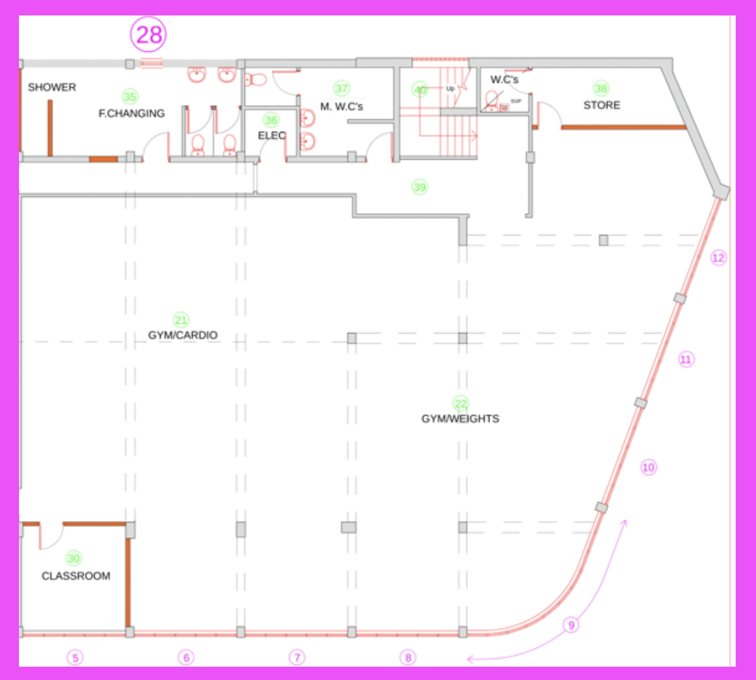

21+ 22 – Gym Space Cardio Area + Gym Space - Weights

Structural Modifications
Floor and Wall Modifications:
- Remove Dance Floor: Remove the old dance floor to prepare the space for gym use.
- Remove DJ Desk: Remove the DJ desking to clear space for gym equipment and activities.
- Wall Replacement with Electronic Shutter: Remove the specified wall and replace it with an electronic shutter that can be integrated into the building's electronic circuit, allowing for flexible space usage.
Column and Beam Work:
- Column Finishing: Neaten up the surrounding columns with board sections, ensuring they are clean, pristine, and strong enough to withstand impacts from gym activities.
- Beam Painting: Paint the beams black with gold trims to enhance the aesthetic appeal of the gym space.

Mechanical and Electrical Systems
HVAC System:
- Air Conditioning Units: Install three air conditioning units (hot and cold) to maintain a comfortable temperature in the gym areas.
Electrical Work:
- Lighting Installation:
  - Install new long LED bright lighting to ensure the gym is well-lit for workouts.
  - Add decorative yellow neon lighting in line with the Foundation for Good (FFG) branding to create a modern, commercial gym aesthetic.
- PIR Controls: Install PIR (Passive Infrared) controls to manage lighting and energy use efficiently in the gym areas.
- Surround Sound System: Install a surround sound system to enhance the gym environment with music and announcements.
Security and Safety:
- CCTV Cameras: Install four CCTV cameras to monitor the gym spaces, ensuring security and safety.
- Smoke Alarms: Install smoke alarms to ensure fire safety in the gym areas.

Interior Finishes
Flooring:
- Rubber Gym Flooring: Install thick black rubber 20mm 1x1m squared gym flooring throughout both the cardio and weights areas to provide a durable, safe surface for workouts.
Wall Treatment:
- Wall Lining: Install lining on the walls up to waist height to prevent damage and maintain a professional appearance.
- Metal Lining Near Weights: Install metal lining on the walls next to the free weights area to prevent damage from weights hitting the walls.
- Wall Painting: Paint the walls black to align with the sleek, modern aesthetic of the gym.
- Decorative Painting: Consider adding decorative painting elements to enhance the visual appeal of the space.

30 – Classroom / 6 students

1. Structural Modifications
1.1 Wall and Door Installation:
- New Wall and Door: Install a new wall and fit it with a heavy-duty door that includes an access control system to ensure secure entry to the classroom.

2. Mechanical and Electrical Systems
2.1 HVAC System:
- Air Conditioning Unit: Install one air conditioning unit (hot and cold) to maintain a comfortable temperature for students and teachers in the classroom.
2.2 Electrical Work:
- Power Outlets: Install power outlets with plastic coverings that extend the whole width of the wall and onto the sides of the room. These outlets should be sufficient to supply students' laptops, smart boards, and teacher devices.
- PIR Controls: Install PIR (Passive Infrared) controls to manage lighting and energy use efficiently in the classroom.
- Smoke Alarm: Install a smoke alarm to ensure fire safety in the classroom.

3. Interior Finishes
3.1 Windows:
- Black Tinted Windows: Ensure the installation of black tinted, aluminium-framed windows as specified in the Front Elevation section to maintain a professional appearance and provide privacy.

4. Furnishings and Equipment
4.1 Desks and Storage:
- Classroom Desks: Install three new double desks to accommodate six students in the classroom.
- Lockable Storage: Provide lockable storage units for securing classroom materials and equipment.
- Shelving: Install shelving to organise and store educational resources and materials.

35 – Female changing rooms + Female toilets

Structural Modifications
Door and Window Installation:
- Access Control Door: Install a new heavy-duty, strong door with an access control system to secure the entrance to the female changing rooms and toilets.
- Window Installation: Install a single small black-tinted window with limited opening ability to ensure privacy while providing ventilation and natural light.

Mechanical and Electrical Systems
HVAC and Ventilation:
- Ventilation System: Install a ventilation and extraction system to manage moisture and odours in both the changing room and wet room areas.
Electrical Work:
- PIR Controls: Install PIR (Passive Infrared) controls to manage lighting and energy use efficiently in the changing rooms and toilets.
- Bathroom Power Socket: Install a power socket in the bathroom for the use of electrical devices, such as the jet air hand dryer.
- Jet Air Hand Dryer: Install a jet air hand dryer for efficient and hygienic hand drying.

Interior Finishes
Wet Room and Tiling:
- Waterproofing and Tiling: Ensure the wet room is fully waterproofed, including the installation of appropriate tiling throughout the shower area and wet room.
Flooring:
- Easy-Mop Flooring: Install flooring that is easy to mop, ensuring that the changing room area remains clean and safe for all users.
Benches and Storage:
- Benches with Storage: Install one long bench with underneath bag storage at the bottom of the room and a smaller bench with underneath storage at the top right of the room.
- Overhead Storage: Install open 2-tier overhead storage for bags above the benches.
- Pegs: Provide pegs for users to hang up their bags and clothes.
Painting and Decoration:
- Refurbishment: Refurbish the area to ensure it is clean and professional, with a focus on maintaining a high standard of appearance.

Plumbing Fixtures
Showers:
- Shower Cubicles: Install three shower cubicles along the top left wall, with one larger cubicle designed for disabled access on the very left.
Sink Installation:
- New Sink: Install a sink in the changing room area to provide handwashing facilities.

Furnishings
Fixtures:
- Mirror: Install a mirror at an appropriate height for users.
- Sanitary Bin: Provide a sanitary bin for proper waste disposal.

Room 36 – Electric Cupboard

Structural Modifications
Door Installation:
- Access Control Door: Install a new heavy-duty door with an access control system to secure the electric cupboard.

Mechanical and Electrical Systems
Electrical Work:
- PIR Controls: Install PIR (Passive Infrared) controls to manage lighting and energy use efficiently within the electric cupboard.

Room 37 – Male Toilets

Structural Modifications
Accessibility Features:
- Accessibility: Ensure that all features, including toilets, sinks, and urinals, are accessible and comply with relevant accessibility standards.

Mechanical and Electrical Systems
Electrical Work:
- PIR Controls: Install PIR (Passive Infrared) controls to manage lighting and energy use efficiently in the male toilets.
- Smoke Alarm: Install a smoke alarm to ensure fire safety in the toilets.
- Jet Hand Dryer: Install a jet hand dryer for efficient and hygienic hand drying.

Plumbing Fixtures
Sinks and Urinals:
- New Sinks: Install two new sinks to provide handwashing facilities.
- New Urinals: Install two new urinals to accommodate the needs of users.
- New Toilet: Install a new toilet that aligns with the clean, commercial aesthetic of the space.

Interior Finishes
Flooring:
- Easy-Mop Flooring: Install flooring that is easy to mop, ensuring that the male toilets remain clean and safe for all users.
Wall Treatment:
- Waterproofing and Decoration: Decorate the walls with waterproof and easy-to-clean materials to ensure durability and ease of maintenance.
Painting and Decoration:
- Bathroom Décor: Apply new bathroom décor to create a clean, commercial look that aligns with the overall design aesthetic of the building.

Furnishings
Fixtures:
- Mirror: Install a mirror at an appropriate height for users to complete the bathroom furnishings.
Room 38 – Store Cupboard

1. Mechanical and Electrical Systems
1.1 Electrical Work:
- PIR Controls: Install PIR (Passive Infrared) controls to manage lighting and energy use efficiently within the store cupboard.

Room 39 – Hallway

Structural Modifications
Door Removal:
- Double Door Removal: Remove the double doors to open up the hallway space.

Mechanical and Electrical Systems
Electrical Work:
- CCTV Camera: Install a CCTV camera to monitor the hallway for security purposes.
- PIR Controls: Install PIR (Passive Infrared) controls to manage lighting and energy use efficiently in the hallway.
- Smoke Alarm: Install a smoke alarm to ensure fire safety in the hallway.

Interior Finishes
Painting and Decorating:
- Painting: Apply fresh paint to the hallway walls to maintain a clean and professional appearance.
- Decorating: Complete any necessary decorating to enhance the aesthetic of the hallway.

Room 40 – Stairs gym entrance

1. Mechanical and Electrical Systems
1.1 Electrical Work:
- Neon Lights: Consider installing neon lights to create a vibrant and welcoming entrance to the gym. These lights can be decorative and functional, enhancing the gym's aesthetic.
- PIR Controls: Install PIR (Passive Infrared) controls to manage lighting and energy use efficiently in the stairwell.
- Smoke Alarm: Install a smoke alarm to ensure fire safety in the stairwell.

2. Interior Finishes
2.1 Painting and Decorating:
- Paint and Decorate: Apply fresh paint to the walls to maintain a clean and professional appearance.
- Decorative Painting: Add decorative painting elements to enhance the aesthetic appeal of the gym entrance, creating a visually engaging space.
2.2 Cleanliness and Functionality:
- Clean and Tidy: Ensure the stairwell is kept clean, tidy, and functional to provide a safe and pleasant entryway to the gym.

Appendix

- https://bestgymflooring.co.uk/products/platoon-sled-prowler-track?variant=42812158738589
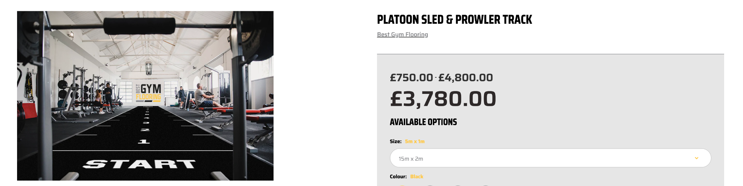

- This style of table with darker wood This kind of style of comfy chairs (double seats alongside right wall of wellbeing cafe)
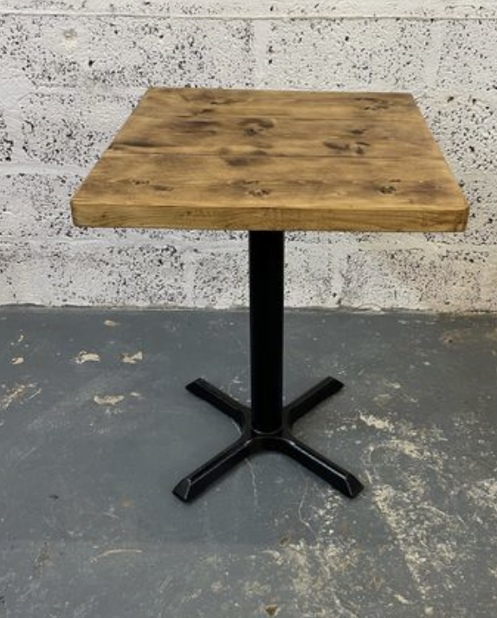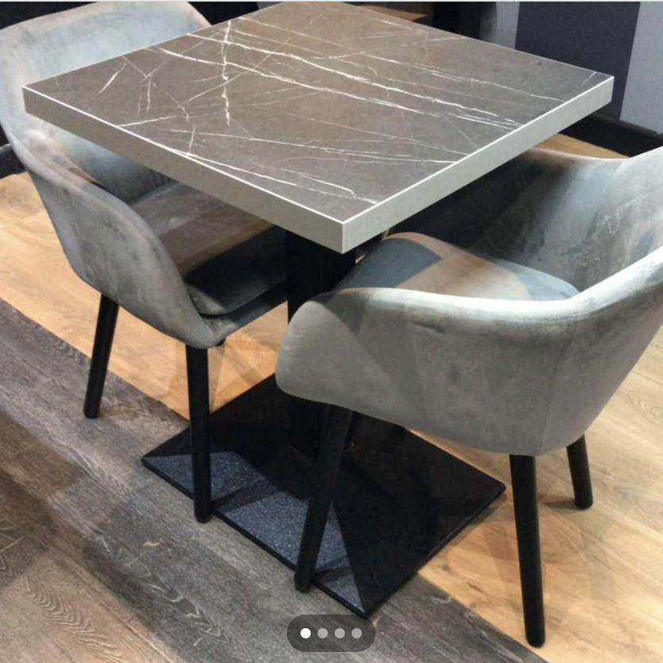

- This style for high rise long table against the wall - Chairs more comfy?
