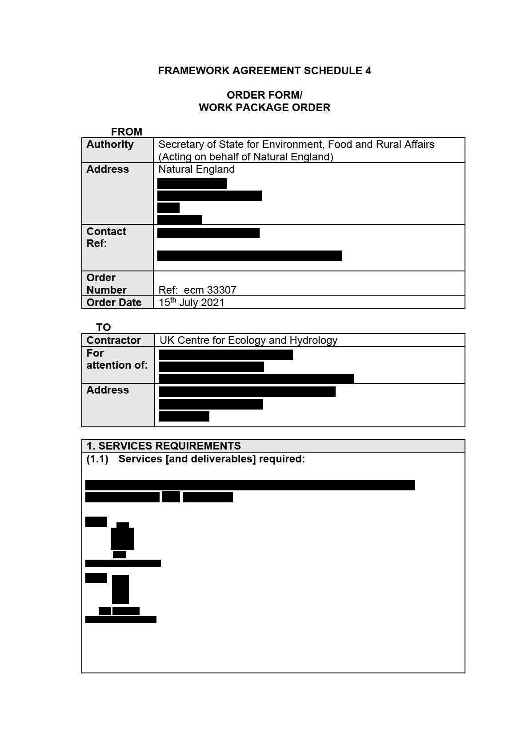

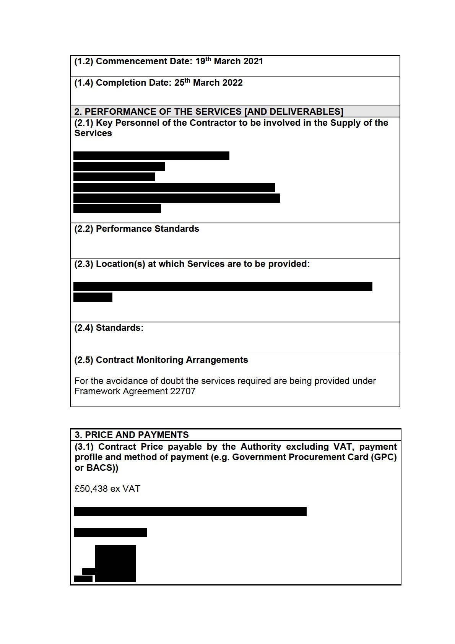

|  |
| --- |
|  |
| **(3.2) Invoicing and Payment**    The supplier shall issue electronic invoices in arrears following completion of key tasks as agreed. |

|  |
| --- |
| **4. Invoicing Requirements** |
| All invoices should be sent to the Natural England Project Officer. |

**BY APPROVING THIS ORDER FORM THE CONTRACTOR AGREES** to enter a legally binding contract with the Authority to provide to the Authority and natural England the Services specified in this Order Form, incorporating the rights and obligations in the Call-Off Contract that are set out in the Framework Agreement entered into by the Contractor and Defra on [insert commencement date].

**Electronic Signature**

Acceptance of the award of this Contract will be made by electronic signature carried out in accordance with the 1999 EU Directive 99/93 (Community framework for electronic signatures) and the UK Electronic Communications Act 2000. Acceptance of the offer comprised in this Contract must be made within 7 days and the Agreement is formed on the date on which the Contractor communicates acceptance on the Customer’s electronic contract management system (“Bravo”). No other form of acknowledgement will be accepted.