This document has been produced for advertising on HM Gov. Website 'Contract Finder' as required by Local Government Act (1972) & Public Contracts Regulations (2015)

**Invitation to tender - Mitre Field - Design & Installation of multi- wheeled pump track**

**Invitation made by Repton Parish Council**

**Published date** 17/09/2024

Open opportunity - This means that the contract is currently active, and suppliers are being sought to fulfil the contract.

**Closing Date** 29/10/2024 23:59

**Contract Summary**

**Industry**

Design and Construction

**Location**

DE65 6FJ

**Value of Contract**

£0 to £100,000

**Procurement Reference**

MitreFieldPumpTrack01

**Published Date**

17/09/2024

**Closing Date**

29/10/2024

**Closing Time**

23:59

**Contract Start Date**

28/02/2025

**Contract End Date**

30/04/2025

**Contract Type**

Works

**Procurement type**

Open procedure

**Contract is suitable for SMEs?**

Yes

**Contract suitable for VCSEs?**

Yes

**Description**

Repton Parish Council (as trustees of Repton Recreation Ground Charity no. 509372 - Mitre Field), following a full consultation process, wish to add a purpose designed multi-wheel pump track to an existing playing field area within the village. Suitable contractors are asked to submit tenders to undertake the design and supply of the pump track. It is intended that the track is suitable for a variety of non-motorised small wheeled devices and is to be provided for the benefit of the inhabitants of Repton and in particular, but not exclusively, those of the said inhabitants who are children under the age of 14 years with the object of improving the conditions of life for the said inhabitants.

1 **Site Location**

Mitre Field, Mitre Drive, Repton, Derbyshire DE65 6FJ

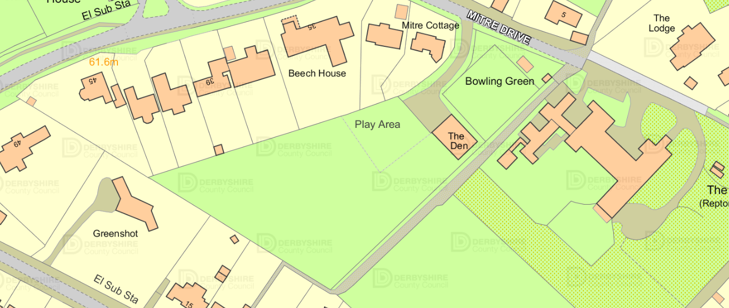

Mitre Field

Mitre Field

Mitre Drive

Repton

Derbyshire

DE65 6FJ

The Den

22m

Pump Track 55m

18m 11m

6m

Diagram of site with Pump Track 'footprint' positioned and dimensioned.

(Diagram not to scale, m = metre)

2 **Scope of Supply**

2.1 Track Design

2.2 Associated technical documentation

2.3 Complete site installation

3 **Form of Response**

Tenders are to provide the following documentation

3.1 Proposed track layout drawing/illustration and profile diagram.

3.2 Technical description, to include but not be limited by the following:-

Project Management & Controls applied

Principal materials and construction method

Access & Laydown requirements and reinstatement on completion

Rainwater and drainage management

Landscaping proposals

Signage and notices proposed during construction and permanent

Construction site security & management

Construction progress reporting method

Compliance with RoSPA safety guidelines statement

Track design life & Warranty provision

Risk assessment methodology & Safety Management

Track care and maintenance requirements

Handover/Acceptance process and documentation

3.3 Reference relevant experience

3.4 Project timescale, indicating periods from contract award to design completion, access to site,

installation completion, formal hand-over.

3.5 Project cost. Tenders are to provide individual costs for the following stages:-

3.5.1 Detailed design matching the footprint defined in section 1 above.

3.5.2 Technical description as defined in section 3.2 above.

3.5.3 Complete site construction from preparation to completion and handover.

3.5.4 Final fixed total price.

Any stage payments required should be quantified against the milestone periods given in 3.4 above.

Any pre contract award costs such as the provision of further technical information in support of a formal planning application should be shown separately.

4 **Tender Return Details**

4.1 Tenders should be returned in a sealed envelope with the bid reference ***MitreFieldPumpTrackTender*** on the top left hand corner, by the time and date given below.

Return date & Time - 11.59pm on 29th October 2024

Return Address-

Parish Clerk

Repton Parish Council

Repton Village Hall

Askew Grove

Repton

Derbyshire

DE65 6GR

4.2 All tenders must include a covering letter signed and dated by an appropriate person authorising the submission and confirming that the business submitting has sufficient resources and expertise to deliver the entire offer.

4.3 All tenders received will be opened together by the Parish Clerk and witnessed by a Parish Councillor. A structured evaluation process will follow leading to the identification of a preferred bidder. This process will be recorded for future scrutiny if required.

4.4 The preferred bidder will be invited to support an application for planning permission from the local authority. On successful completion of the planning process, the contract will be awarded to the preferred bidder, subject to their being adequate funding in support of the project.

4.5 The results of the tender evaluation process will be published on the website after contract award.

5 **Question /Answers**

5.1 Any queries should be sent by email to the Parish Clerk quoting the following reference ***MitreFieldPumpTrackTender***

5.2 Arrangements for visits to the site can be made via the Parish Clerk quoting the reference ***MitreFieldPumpTrackTender***

Parish Clerk email address - clerk@repton-pc.gov.uk

6 **Tender Validity**

To allow sufficient time to identify a preferred bidder and complete the planning process, we request that all bids remain valid for 6 months from submission.

**How to apply**

Follow the instruction given in sections 3 & 4 above.

**About the buyer**

**Contact Name**

Parish Clerk

**Address**

Repton Parish Council

Repton Village Hall

Askew Grove

Repton

Derbyshire

DE65 6GR

**Telephone**

07341 907137

**Email**

clerk@repton-pc.gov.uk

**Further Information**

Details of the tender process and evaluation methods can be found on the following website:-

www.repton-pc.gov.uk