Church Walk Restoration

Project Breakdown
Number on Drawing | Details | Comments
1 | Steel bollard to be installed at the A50 end to stop unauthorised traffic along Church Walk. Must be removable for occasional and controlled access by landlords and business owners. The design should be suitable for a Conservation Area and match as closely as possible the bollards outside the Red Lion | Design to be provided and approved with separate costing including installation.
2 | Arch across the A50 end of Church Walk – Manufactured from steel with words ‘Church Walk’ within frame. The steel frame to be attached to walls on either side of Church Walk. Painted black. Must be designed so that cars/small vans can have access and allow for pedestrian buggies and disabled use. Final design to be agreed with the PC.  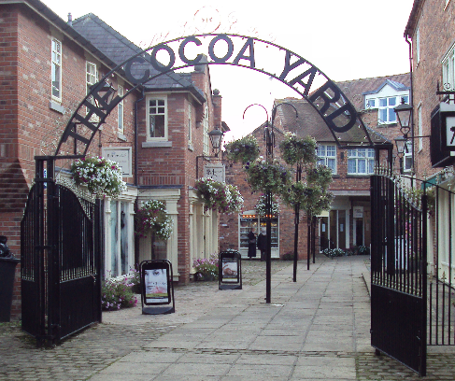 | Additional item with separate costing including installation. Options on design to be provided with RFQ response.
3 | 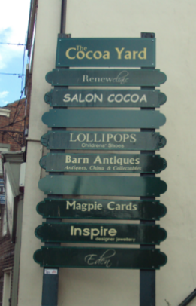  One name board to be erected at the side of the entrance to Church Walk (A50 end) to identify businesses in Church Walk and Church House. Ability to change names of businesses is required. Position of the installation to be agreed and must not impair the installation of the Arch in 2 above. | Additional item with separate costing including installation.
4 | Pave surface of Church Walk and continuation in front of Cheshire House (see plan) using Marshall’s Tegula block paving. Option to continue paving into side alley bin store by the Co-op.  Example shown below:  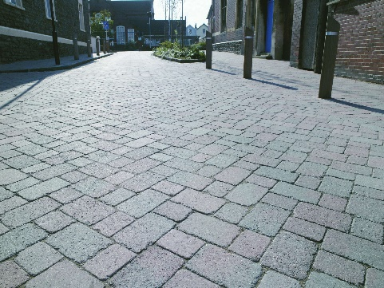 | Quote to be split between Church Walk and in front of Cheshire House and may be completed by separate projects. Supplier expected to provide incentives to complete as one project.
5 | Re-mark the road area between Church Walk and Church House to indicate pedestrian priority and no parking zone. | Additional item with separate costing including installation
6 | Remove existing high-level light above Print Shop and replace with 3 lamps at positions L1 to L3 at a similar height. The light to have a character to blend into the heritage setting of the conservation area. Example below:  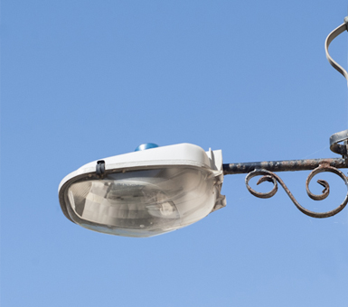 | Supplier to provide examples. Additional item with separate costing including installation
7 | Remove existing concrete planter
8 | Install two bench seats. Exact location to be defined. | Benches to be provided by Parish Council. Supplier to provide costing for installation.
9 | Conceal existing bin store with timber gates. Material and design to be defined but must be able to open safely to allow for the waste bins to be moved to refuse lorries. Example below, alternatives can be proposed. It is suggested that gates are made 1/3rd:2/3rds so that the right-hand side opens with a Yale type lock. This will allow easier personnel access to the bins and the external door at the back of the sandwich shop  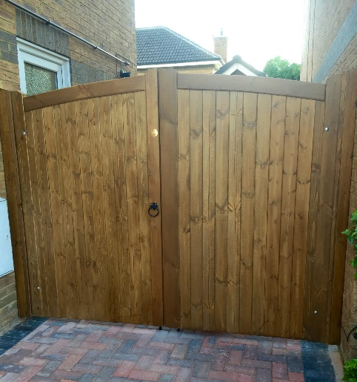 | Additional item with separate costing including installation
10 | Possible placement of benches to be determined at a later date after completion of the project.

11 | May not be required if railing replaced as 12 below. If no replacement, brick planter to be repaired. | Require costing please.
12 | Replace the entire railing with a suitable heritage design such as the example below. Include an additional gap in the railings at the far end of walk (position 12) and form an entrance/drop onto walkway. Example below from Metal Railings | Jacksons Fencing (jacksons-fencing.co.uk)  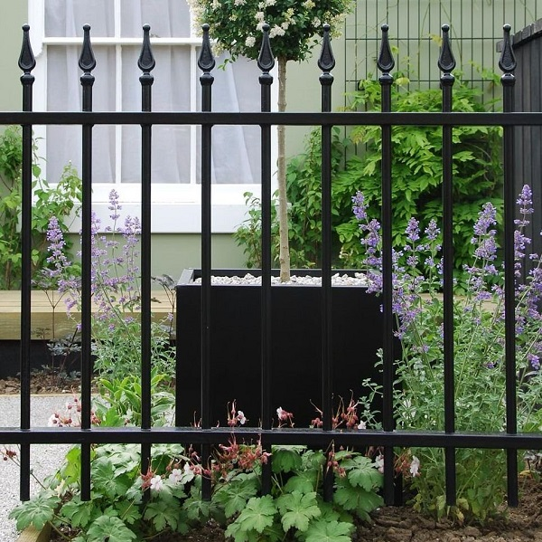 | Require costing and including installation
13 | All area to be paved. Consideration at a later date of possible raised ‘Planter Beds’.

