
Invitation to Tender
NCITT009
NorseCare Standard Furniture Range & Interior Design Service for Residential Care Homes

Dated 08/05/2017

General Conditions
NorseCare Ltd is requesting bids from qualified vendors for the supply of a standardised range of Care Home furniture which will become the standard range offered to its 20 residential care homes.
A desirable element of this ITT is to also receive offerings that include interior design services
As well as a standardised range, it is expected that the winning bidder will make available their full range of care home furniture to NorseCare residential homes.
The winning bid will be offered a 24 month contract (with optional 2 year extension) which will be managed from the NorseCare Head office, Norwich, Norfolk. It is expected that the value of this offering will be a minimum of £100,000 per year.
This ITT is being provided for your consideration. To be considered by NorseCare, your company must meet the qualifications and satisfy the requirements set forth in this ITT.
This ITT will be managed by:
Simon Bullimore MCIPS
Procurement & Contracts Manager
NorseCare Ltd
Lancaster House
16 Central Avenue
St Andrews Business Park
Norwich
NR7 0HR

The Procurement Process

Stage 1 will be an initial ITT based upon specifications and performance requirements.

Bidders will firstly be required to complete Appendix 1 ‘Bidder Information’ and then Appendix 2 ‘Grounds for Exclusion’ Parts 1 and 2. As explained within this section, any answers that give grounds for exclusion may lead to your bid being rejected.

Specifications for the furniture range are detailed in Appendix 3 of this ITT titled ‘Product Specifications’ Bidders are expected to price against this list and this will be used to make up a price score. All furniture proposed needs to be classed as Dementia Friendly furniture.

Appendix 4 is the Quality & Performance section and includes question for bidders to answer, this will be used to make up a quality score.

Appendix 5 is the proposed Service Level Agreement that the winning bidder will enter into. All bidders need to review this and confirm adherence to it by signing the declaration.

Full review of products proposed, the prices and answers given against the quality and performance criteria will be reviewed and best vendors selected for Stage 2 of the ITT project.

Stage 2 will consist of selected vendors presenting their proposal and furniture range to a selected group of the NorseCare management team at a pre agreed venue and date. This is where the design of the proposed furniture will be assessed and your company presentation heard.

Procurement scoring

Stage 1 Price = 40%
Quality and Performance = 50%

Stage 2 Presentations = 10%

Initial ‘Proposed’ Timetable
ITT Released: 08/05/2017
Deadline for submission of questions: 19/05/2017
Deadline for receipt of bids: 02/06/2017 – (noon)
Selection of stage 2 vendors 14/06/2017
Stage 2 Presentations: During w/c 19/06/2017
Pre contract award negotiations, supplier visit/s & contract creation: w/c 03/07/2017
Contract Award: by w/e 11/08/2017
Contract Commences: 21/08/2017

Although prices and total cost of ownership will be an important factor when awarding the contract, NorseCare is not obliged by any ruling or regulation to award the bid on the basis of cost alone.

Accordingly, NorseCare reserves the right to evaluate all proposals, negotiate changes in any design or product specification with the company determined to have submitted the proposal that is in the best interest of NorseCare.

It is to be understood that this ITT constitutes specifications only for the purpose of receiving proposals for goods and services and does not constitute an agreement for those services.

Modification of Proposals

Proposals shall remain valid for a minimum of one month after submission, modifications will not be accepted after the deadline for submission.

Method of Submission

The tender shall be returned in a sealed envelope titled NCITT009 ‘DO NOT OPEN’ to the following address:
Simon Bullimore
Procurement & Contracts Manager
NorseCare Ltd
Lancaster House
16 Central Avenue
St Andrews Business Park
Norwich
NR7 0HR

Alternatively e-mail to simon.bullimore@norsecare.co.uk before noon on June 2nd, 2017.

Final proposals for Stage 1 must be received at the address noted above by no later than midday on Friday June 2nd, 2017.

Tender submissions that are delivered after the time and date stipulated may well be liable to disqualification.

Prices

All prices need to be submitted in sterling (£) not inclusive of VAT and clearly listed against the relevant product reference number being priced. Prices to be submitted on a separate sheet.

The prices submitted make up 40% of total score with the best prices submitted against the standard range scoring a full 40 marks and all other higher bids scored according to the percentage difference against the best price.
Eg;
Best price for 1 of each item = £4,000 receives 40 marks
Second best price = £4,300 (7.5% higher) receives 37 marks (40 marks minus the 7.5% which is a loss of 3 marks)
Third best price = £4,850 (21% higher) receives 31.6 marks (40 marks minus the 21% which is a loss of 8.4 marks
Additional Costs

Any additional costs that the proposing vendor envisages should be detailed separately. These costs may include but are not limited to:
- Delivery charges
- Set up charges
- Extra charges beyond those requested.

Tender Queries

All queries in relation to this tender should be directed in the first instance to Mr Simon Bullimore, using e-mail address simon.bullimore@norsecare.co.uk

Queries are likely to be published along with the answer to all participating bidders.

Evaluation Criteria

There will be 6 x key questions detailed in Appendix 4 of which marks will be available for each answer. These marks will be added up to give a best total score from 50 marks. More than one bidder can score full marks on this stage, each question will be scored separately. Each question is given a weighting and a final weighted score will be calculated to give a final score out of 50.
The marks are given using Descriptors, a copy of the descriptors is shown at the end of the Appendix.

Stage 2 Presentations
The 4 x highest scoring bids will be invited to present their proposed products to a NorseCare selection team. This team will consist of Procurement staff, Design staff and NorseCare’s Dementia Lead.

The final 10 x marks will be given against the presented products and presentation given. There is likely to be a title/topic for the presentation which will be forwarded to successful bidders at the appropriate time.

NorseCare will meet the costs and arrangements of the venue for the presentation but are not liable for any costs any bidder may incur by carrying out any presentation. The presentations will be carried out w/c June 19th 2017, please make sure you are available during that week if asked to take part in Stage 2.

Requirements and Statements.
All responses to the requirements and statements listed below need to be submitted separately from the main Quality answers and pricing.
Contract Scope

The supplier will be expected to deliver direct to any one the Norse Care homes detailed in Appendix 6 of this agreement. If delivery costs are not clearly shown as ‘Additional Costs’ as per instruction then delivery will be deemed as being free of charge when calculating Total Cost of Ownership figures.
The supplier will be expected to hold stock of the NorseCare standardised range of products in order to offer a 3 day delivery service on items selected. In the case of multiple colours being offered for the same product a delivery time must be stated if the Care Home wished to deviate from initial colour.
Continuous Improvement
NorseCare recognises continuous improvement is an ongoing effort to improve products, services or processes. These efforts can seek “incremental” improvement over time or “breakthrough” improvement all at once. Please state in your proposal your companies approach to continuous improvement and examples as to how this will be applied in the case of this offering.
Payment Terms
Payment terms will be 30 days from receipt of invoice.
Confidentiality Undertaking
The vendor understands and agrees that they may be requested at any time during the proposal to sign a Confidentiality Undertaking which is included as Appendix 3 in the Service Level Agreement
Stock Holding Proposal
Competitors are to detail their offering of a stock holding service of the NorseCare product range in full. How this stock will be stored and managed and any time period to which stock must be consumed. Any costs of stock holding are also to be detailed.

Case Studies
Competitors are required to offer case study evidence in respect to similar projects undertaken and/or contracts held. These case studies need to be as relevant as possible but are not expected to be limited to the Care Sector.
Sustainability and Corporate Social Responsibility (CSR)
NorseCare Ltd challenges the competitors to offer up alternative options and ideas in order to enhance the efficiency, environmental and social aspects of this offering.
For example, the use of recycled materials, procurement of local materials and labour, equal opportunities, relations strategies, workplace health & safety and community impact.
Please also state any policies and practices currently in place within your company that promote apprenticeship schemes and work placement opportunities.
Company Profile
The competitor is to detail in their proposal full company details and history, including financial status and current turnover. This should also include all relevant experience within the care sector and contain references for possible investigation prior to contract award. NorseCare also wishes to understand the process of manufacture of the products being offered and where the competitor sits within this process.
Accreditations
Please state all quality and environmental and industry accreditations achieved by your company along with copies of valid certification.
Images
The successful tenderer will need to make available jpeg image files of all furniture proposed, for use by NorseCare within internal documentation and systems.
Delivery & Installation/s
The competitor must detail that their full offering includes delivery to the Care Home, unwrapping and installation of product and disposal of packaging. On the basis of the competitors CSR profile they will detail their methods of disposing of packaging. This is included in the attached SLA in Appendix 5
E-Invoicing
The competitor is required to demonstrate their compatibility with E-Invoicing and detail their current accounting software package to ensure compatibility.
Public Liability and Indemnities
The competitor is to include a copy of their Public Liability Insurance Certificate and indemnity offering to NorseCare.
PLEASE NOTE THAT FAILURE TO PROVIDE ANY OF THE REQUESTED INFORMATION MAY RESULT IN YOUR TENDER SUBMISSION BEING DISQUALIFIED.

Appendix 1: Bidder Information

Please answer the following questions in full. Note that every organisation that is being relied on to meet the selection must complete and submit the Part 1 and Part 2 self-declaration.
Section 1 | Potential supplier information
Question number | Question | Response
1.1(a) | Full name of the potential supplier submitting the information
1.1(b) – (i) | Registered office address (if applicable)
1.1(b) – (ii) | Registered website address (if applicable)
1.1(c) | Trading status  - public limited company  - limited company  - limited liability partnership  - other partnership  - sole trader  - third sector  - other (please specify your trading status)
1.1(d) | Date of registration in country of origin
1.1(e) | Company registration number (if applicable)
1.1(f) | Charity registration number (if applicable)
1.1(g) | Head office DUNS number (if applicable)
1.1(h) | Registered VAT number
1.1(i) - (i) | If applicable, is your organisation registered with the appropriate professional or trade register(s) in the member state where it is established? | Yes ☐  No ☐  N/A ☐
1.1(i) - (ii) | If you responded yes to 1.1(i) - (i), please provide the relevant details, including the registration number(s).
1.1(j) - (i) | Is it a legal requirement in the country where you are established for you to possess a particular authorisation, or be a member of a particular organisation in order to provide the services specified in this procurement? | Yes ☐  No ☐
1.1(j) - (ii) | If you responded yes to 1.1(j) - (i), please provide additional details of what is required and confirmation that you have complied with this.
1.1(k) | Trading name(s) that will be used if successful in this procurement
1.1(l) | Relevant classifications (state whether you fall within one of these, and if so which one)  - Voluntary Community Social Enterprise (VCSE)  - Sheltered Workshop  - Public service mutual

1.1(m) | Are you a Small, Medium or Micro Enterprise (SME)? | Yes ☐  No ☐
1.1(n) | Details of Persons of Significant Control (PSC), where appropriate:  - Name;  - Date of birth;  - Nationality;  - Country, state or part of the UK where the PSC usually lives;  - Service address;  - The date he or she became a PSC in relation to the company (for existing companies the 6 April 2016 should be used);  - Which conditions for being a PSC are met;  - Over 25% up to (and including) 50%,  - More than 50% and less than 75%,  - 75% or more.  (Please enter N/A if not applicable)
1.1(o) | Details of immediate parent company:  - Full name of the immediate parent company  - Registered office address (if applicable)  - Registration number (if applicable)  - Head office DUNS number (if applicable)  - Head office VAT number (if applicable)  (Please enter N/A if not applicable)
1.1(p) | Details of ultimate parent company:  - Full name of the ultimate parent company  - Registered office address (if applicable)  - Registration number (if applicable)  - Head office DUNS number (if applicable)  - Head office VAT number (if applicable)  (Please enter N/A if not applicable)

Please note: A criminal record check for relevant convictions may be undertaken for the preferred suppliers and the persons of significance in control of them.

Section 1 | Bidding model
Question number | Question | Response
1.2(a) - (i) | Are you bidding as the lead contact for a group of economic operators? | Yes ☐  No ☐  If yes, please provide details listed in questions 1.2(a) (ii), (a) (iii) and to 1.2(b) (i), (b) (ii), 1.3, Section 2 and 3.  If no, and you are a supporting bidder please provide the name of your group at 1.2(a) (ii) for reference purposes, and complete 1.3, Section 2 and 3.
1.2(a) - (ii) | Name of group of economic operators (if applicable)
1.2(a) - (iii) | Proposed legal structure if the group of economic operators intends to form a named single legal entity prior to signing a contract, if awarded. If you do not propose to form a single legal entity, please explain the legal structure.
1.2(b) - (i) | Are you or, if applicable, the group of economic operators proposing to use sub-contractors? | Yes ☐  No ☐
1.2(b) - (ii) | If you responded yes to 1.2(b)-(i) please provide additional details for each sub-contractor in the following table: we may ask them to complete this form as well.
  Name
  Registered address
  Trading status
  Company registration number
  Head Office DUNS number (if applicable)
  Registered VAT number
  Type of organisation
  SME (Yes/No)
  The role each sub-contractor will take in providing the works and /or supplies e.g. key deliverables
  The approximate % of contractual obligations assigned to each sub-contractor

Contact details and declaration – For Appendix 1
I declare that to the best of my knowledge the answers submitted and information contained in this document are correct and accurate.
I declare that, upon request and without delay I will provide the certificates or documentary evidence referred to in this document.
I understand that the information will be used in the selection process to assess my organisation’s suitability to be invited to participate further in this procurement.
I understand that the authority may reject this submission in its entirety if there is a failure to answer all the relevant questions fully, or if false/misleading information or content is provided in any section.
I am aware of the consequences of serious misrepresentation.

Section 1 | Contact details and declaration
Question number | Question | Response
1.3(a) | Contact name
1.3(b) | Name of organisation
1.3(c) | Role in organisation
1.3(d) | Phone number
1.3(e) | E-mail address
1.3(f) | Postal address
1.3(g) | Signature (electronic is acceptable)
1.3(h) | Date

NOT USED

Appendix 2: Grounds for Exclusion
Please answer the following questions in full. Note that every organisation that is being relied on to meet the selection must complete and submit the Part 1 and Part 2 self-declaration.
Section 2 | Grounds for mandatory exclusion
Question number | Question | Response
2.1(a) | Regulations 57(1) and (2)  The detailed grounds for mandatory exclusion of an organisation are set out on website https://www.gov.uk, which should be referred to before completing these questions.  Please indicate if, within the past five years you, your organisation or any other person who has powers of representation, decision or control in the organisation have been convicted anywhere in the world of any of the offences within the summary below and listed on website https://www.gov.uk
 | Participation in a criminal organisation. | Yes ☐  No ☐  If Yes please provide details at 2.1(b)
 | Corruption. | Yes ☐  No ☐  If Yes please provide details at 2.1(b)
 | Fraud. | Yes ☐  No ☐  If Yes please provide details at 2.1(b)
 | Terrorist offences or offences linked to terrorist activities | Yes ☐  No ☐  If Yes please provide details at 2.1(b)
 | Money laundering or terrorist financing | Yes ☐  No ☐  If Yes please provide details at 2.1(b)
 | Child labour and other forms of trafficking in human beings | Yes ☐  No ☐  If Yes please provide details at 2.1(b)
2.1(b) | If you have answered yes to question 2.1(a), please provide further details.  Date of conviction, specify which of the grounds listed the conviction was for, and the reasons for conviction,  Identity of who has been convicted  If the relevant documentation is available electronically please provide the web address, issuing authority, precise reference of the documents.
2.2 | If you have answered Yes to any of the points above have measures been taken to demonstrate the reliability of the organisation despite the existence of a relevant ground for exclusion ? (Self Cleaning) | Yes ☐  No ☐
2.3(a) | Regulation 57(3)  Has it been established, for your organisation by a judicial or administrative decision having final and binding effect in accordance with the legal provisions of any part of the United Kingdom or the legal provisions of the country in which the organisation is established (if outside the UK), that the organisation is in breach of obligations related to the payment of tax or social security contributions? | Yes ☐  No ☐
2.3(b) | If you have answered yes to question 2.3(a), please provide further details. Please also confirm you have paid, or have entered into a binding arrangement with a view to paying, the outstanding sum including where applicable any accrued interest and/or fines.
2.4 | NorseCare will complete a credit rating check using the EXPERIAN credit check software. A score of 30 or less will result in exclusion from this bid.

Please Note: The authority reserves the right to use its discretion to exclude a potential supplier where it can demonstrate by any appropriate means that the potential supplier is in breach of its obligations relating to the non-payment of taxes or social security contributions.

Section 3 | Grounds for discretionary exclusion
 | Question | Response
3.1 | Regulation 57 (8)  The detailed grounds for discretionary exclusion of an organisation are set out on https://www.gov.uk, which should be referred to before completing these questions.  Please indicate if, within the past three years, anywhere in the world any of the following situations have applied to you, your organisation or any other person who has powers of representation, decision or control in the organisation.
3.1(a) | Breach of environmental obligations? | Yes ☐  No ☐  If yes please provide details at 3.2
3.1 (b) | Breach of social obligations? | Yes ☐  No ☐  If yes please provide details at 3.2
3.1 (c) | Breach of labour law obligations? | Yes ☐  No ☐  If yes please provide details at 3.2
3.1(d) | Bankrupt or is the subject of insolvency or winding-up proceedings, where the organisation’s assets are being administered by a liquidator or by the court, where it is in an arrangement with creditors, where its business activities are suspended or it is in any analogous situation arising from a similar procedure under the laws and regulations of any State? | Yes ☐  No ☐  If yes please provide details at 3.2
3.1(e) | Guilty of grave professional misconduct? | Yes ☐  No ☐  If yes please provide details at 3.2
3.1(f) | Entered into agreements with other economic operators aimed at distorting competition? | Yes ☐  No ☐  If yes please provide details at 3.2
3.1(g) | Aware of any conflict of interest within the meaning of regulation 24 due to the participation in the procurement procedure? | Yes ☐  No ☐  If yes please provide details at 3.2
3.1(h) | Been involved in the preparation of the procurement procedure? | Yes ☐  No ☐  If yes please provide details at 3.2
3.1(i) | Shown significant or persistent deficiencies in the performance of a substantive requirement under a prior public contract, a prior contract with a contracting entity, or a prior concession contract, which led to early termination of that prior contract, damages or other comparable sanctions? | Yes ☐  No ☐  If yes please provide details at 3.2
3.1(j)  3.1(j) - (i)  3.1(j) - (ii)  3.1(j) –(iii)  3.1(j)-(iv) | Please answer the following statements  The organisation is guilty of serious misrepresentation in supplying the information required for the verification of the absence of grounds for exclusion or the fulfilment of the selection criteria.  The organisation has withheld such information.  The organisation is not able to submit supporting documents required under regulation 59 of the Public Contracts Regulations 2015.  The organisation has influenced the decision-making process of the contracting authority to obtain confidential information that may confer upon the organisation undue advantages in the procurement procedure, or to negligently provided misleading information that may have a material influence on decisions concerning exclusion, selection or award. | Yes ☐  No ☐  If Yes please provide details at 3.2  Yes ☐  No ☐  If Yes please provide details at 3.2  Yes ☐  No ☐  If Yes please provide details at 3.2  Yes ☐  No ☐  If Yes please provide details at 3.2

3.2 | If you have answered Yes to any of the above, explain what measures have been taken to demonstrate the reliability of the organisation despite the existence of a relevant ground for exclusion? (Self Cleaning)

Contact details and declaration – For Appendix 2
I declare that to the best of my knowledge the answers submitted and information contained in this document are correct and accurate.
I declare that, upon request and without delay I will provide the certificates or documentary evidence referred to in this document.
I understand that the information will be used in the selection process to assess my organisation’s suitability to be invited to participate further in this procurement.
I understand that the authority may reject this submission in its entirety if there is a failure to answer all the relevant questions fully, or if false/misleading information or content is provided in any section.
I am aware of the consequences of serious misrepresentation.

Section 1 | Contact details and declaration
Question number | Question | Response
1.3(a) | Contact name
1.3(b) | Name of organisation
1.3(c) | Role in organisation
1.3(d) | Phone number
1.3(e) | E-mail address
1.3(f) | Postal address
1.3(g) | Signature (electronic is acceptable)
1.3(h) | Date

Appendix 3: Product Specifications

Offerings should ensure high quality, user friendly, durable and well detailed furniture. The choice proposed should enhance NorseCare’s vision of creating non institutional homely interior environments which in turn contribute to residents’ well-being, independence and enjoyment of the building and its facilities. Ergonomic design for older people, encompassing good practise dementia design features is an important and key factor.

Product Reference 01
Profiling Bed
Nors Standard Range
Item Criteria

Materials:
Metal powder coated frame with vinyl wrapped/laminated
finish.

Size:
Approximately 2200mm Long X 1040mm Wide
Highest Mattress setting 675mm – Lowest setting 275mm

Warranty:
Minimum 5 Years

Colours:
Must be available in finishes to coordinate with bedroom
wardrobe, cabinet and 4 drawer unit.

Test Standards:
IEC 60601-2-52:2009 Particular requirements for the basic
safety and essential performance of medical beds.

NorseCare Specific Requirements:
Bed must provide Dementia friendly design aspects:
- Must be designed with ‘non medical’ aesthetics to assist in creating a homely feel.
- Rounded corners to reduce injury.
- Colour contrast where possible to identify edges.
- Mechanical framework must be well concealed

NB: Alternative height settings would be considered by NorseCare
but those stated are currently those utilised and agreed with
NorseCare Ltd lifting and handling advisor.

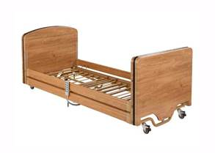

Image is for guidance only

Product Reference 02
Bedside Cabinet
Nors Standard Range
Item Criteria

Materials:
Vinyl wrapped/laminated finish. Generally constructed from
18mm MDF.

Size:
Approximately 660mm High X 445mm Wide X 460mm Deep

Warranty:
Minimum 5 Years

Colours:
Must be available in matching wood finishes to other bedroom
furniture specified. Minimum of 5 finishes to chose from.

Test Standards:
BS EN 4875-8:1998 Non Domestic Cabinets
BS EN 16121:2013 Level 1 – General contract use for cabinet
furniture.
FSC Chain of Custody Certification

NorseCare Specific Requirements:
Must provide Dementia friendly design aspects as follows:
- Must be designed with ‘non medical’ aesthetics to assist in creating a homely feel.
- Rounded corners to reduce injury.
- Choice of handle to be easy to grip.
- Must be supplied with Perspex panel to cupboard front.
Must be supplied with Cam lock to drawer unit and spare key.

Image is for guidance only

Product Reference 03
Bedroom Wardrobe
Nord Range
Item Criteria

Materials:
Vinyl wrapped/laminated finish. Generally constructed from
18mm MDF.

Size:
Approximately 1800mm High X 760mm Wide X 580mm Deep

Warranty:
Minimum 5 Years

Colours:
Must be available in matching wood finishes to other bedroom
furniture specified. Minimum of 5 finishes to chose from.

Test Standards:
BS EN 4875-8:1998 Non Domestic Cabinets
BS EN 16121:2013 Level 1 – General contract use for cabinet furniture.
FSC Chain of Custody Certification

NorseCare Specific Requirements:
Must provide Dementia friendly design aspects as follows:
- Must be designed with ‘non medical’ aesthetics to assist in creating a homely feel.
- Choice of handle to be easy to grip and contrasting matt finish.
- Must be supplied with Perspex panel to 1No. Door front.
Internal rail required (anti ligature not required)
Internal high level shelf required.
Image is for guidance only

Product Reference 04
Bedroom 4 Drawer Unit
da Range
Item Criteria

Materials:
Vinyl wrapped/laminated finish. Generally constructed from
18mm MDF.

Size:
Approximately 610mm High X 760mm Wide X 460mmm Deep

Warranty:
Minimum 5 Years

Colours:
Must be available in matching wood finishes to other bedroom
furniture specified. Minimum of 5 finishes to chose from.

Test Standards:
BS EN 4875-8:1998 Non Domestic Cabinets
BS EN 16121:2013 Level 1 – General contract use for cabinet
furniture.
FSC Chain of Custody Certification

NorseCare Specific Requirements:
Must provide Dementia friendly design aspects as follows:
- Must be designed with ‘non medical’ aesthetics to assist in creating a homely feel.
- Choice of handle to be easy to grip and contrasting matt finish.
- Must be supplied with Perspex panels to drawer fronts.

Image is for guidance only

Product Reference 5
Dressing Table
No
Item Criteria

Materials:
Vinyl wrapped/laminated finish. Generally constructed from
18mm MDF.

Size:
Approximately 762mm High X 1230mm Wide X 460mm Deep

Warranty:
Minimum 5 Years

Colours:
Must be available in matching wood finishes to other bedroom
furniture specified. Minimum of 5 finishes to chose from.

Test Standards:
BS EN 4875-8:1998 Non Domestic Cabinets
BS EN 16121:2013 Level 1 – General contract use for cabinet
furniture.
FSC Chain of Custody Certification

NorseCare Specific Requirements:
Must provide Dementia friendly design aspects as follows:
- Must be designed with ‘non medical’ aesthetics to assist in creating a homely feel.
- Choice of handle to be easy to grip and contrasting matt finish.
- Must be supplied with Perspex panel to drawer fronts
- Knee hole section must permit chairs with arms and/or skids to fit beneath

Image is for guidance only
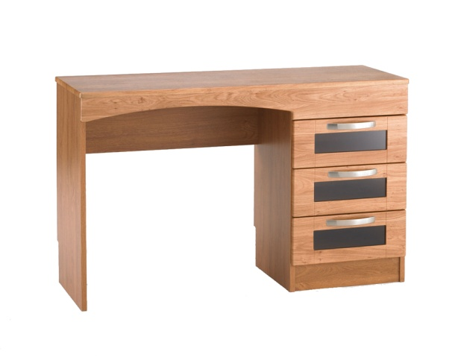

Product Reference 06
Bedroom High Back Upholstered
Chair
Standard Range
Item Criteria

Materials:
Fully Upholstered Beachwood frame with suitable CHMR/CME
Foam.

Size:
Approximately 1060mm High X 780mm Wide X 720mm Deep

Warranty:
Minimum 5 Years

Colours:
Leg colour available in stain to match bedroom/living room
furniture finish.

Test Standards:
BS EN 16139: 2013 Level 1 – General contract use for chairs
BS EN 15373:2007 – Strength and Durability
BS EN 7176:2007 Source 5
FSC Chain of Custody Certification

NorseCare Specific Requirements: Panaz colour ranges desirable.
- Seat back to be upholstered in Panaz Highland fabric.
- Seat pad to be upholstered in Panaz Aston fabric
- A choice of two seat heights to be available
Image is for guidance only

Product Reference 07
Mattress Type 01

INVACARE SOFTFORM PREMIER OR EQUAL APPROVED
Nard Range
Item Criteria

Materials:

Size:
Must be suitable for use with Profiling Bed choice see Product
Reference 01 for approximate size. TBC once final selection
has been made by NorseCare.

Warranty:
10 Year Foam
5 Year Cover

Colours:
N/A

Test Standards:
BS EN 597-1 Cig, BS EN 597-2 Match.
Foam Interior: BS 5852: 1990 Crib Source 5
Cover BS7175: 1989 Crib Source 5.

NorseCare Specific Requirements:
Must be rated up to 39Stone/247.6kg.

Product Reference 08
Mattress Type 02

INVACARE ESSENTIAL PLUS OR EQUAL APPROVED
Nod Range
Item Criteria

Materials:

Size:
Must be suitable for use with Profiling Bed choice see Product
Reference 01 for approximate size. TBC once final selection
has been made by NorseCare.

Warranty:
4 Year Foam
2 Year Cover

Colours:
N/A

Test Standards:
BS EN 597-1 Cig, BS EN 597-2 Match.
Foam Interior: BS 5852: 1990 Crib Source 5
Cover BS7175: 1989 Crib Source 5.
BS 7177: 1996 Crib Source 5

NorseCare Specific Requirements:
Must be rated up to 22Stone/140kg.

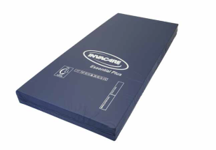

Product Reference 09
High Coffee Table

Images for guidance only
No Standard Range
Item Criteria

Materials:
Solid wood construction minimum 18mm Top with laminated
surfaces and rounded edge detail stained and lacquered to
match.

Size:
Must be available in the following options
Square approximately 460mmW x 460mmD x 635mmH
Rectangular approximately 1000mmW x 460mmD x 635mmH
Circular approximately 600mm Dia

Warranty:
Minimum 5 Years

Colours:
Leg colour and tops available in stain to match bedroom/living
room furniture finish.

Test Standards:
FSC Chain of Custody Certification
BS EN 15372: 2008 Level 2 – General Contract use for tables

NorseCare Specific Requirements:
- Must have rounded edges.
- Must be of solid construction and not easily tipped.
- Must match style of other bedroom/living furniture.

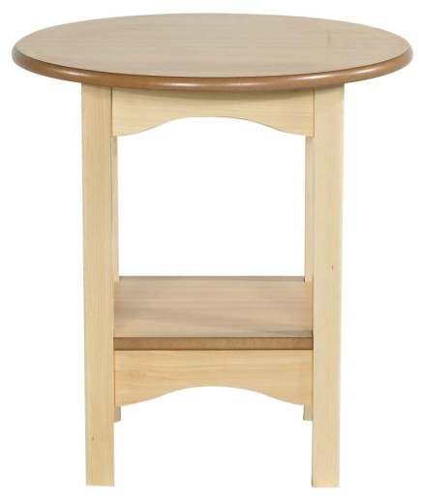

Product Reference 10
Low Coffee Table
Nod Range
Item Criteria

Materials:
Solid wood construction minimum 18mm Top with laminated
surfaces and rounded edge detail stained and lacquered to
match.

Size:
Must be available in the following options
Square approximately 460mmW x 460mmD x 635mmH
Rectangular approximately 1000mmW x 460mmD x 635mmH
Circular approximately 600mm Dia

Warranty:
Minimum 5 Years

Colours:
Choice of natural wood finishes

Test Standards:
FSC Chain of Custody Certification
BS EN 15372: 2008 Level 2 – General Contract use for tables

NorseCare Specific Requirements:
- Must have rounded edges.
- Must be of solid construction and not easily tipped.
- Must have heat and impact resistant top
- Option to have shelf if required

Image is for guidance only

Product Reference 11
Upholstered Armchair Type 1
No
Item Criteria:

Materials:
Fully Upholstered Beachwood frame with suitable CHMR/CME
Foam.

Size:
Approximately 915mm High X 940mm Wide X 890mm Deep

Warranty:
Minimum 5 Years

Colours:
Leg colour available in stain to match bedroom/living room
furniture finish.

Test Standards:
BS EN 16139: 2013 Level 1 – General contract use for chairs
BS EN 15373:2007 – Strength and Durability
BS EN 7176:2007 Source 5
FSC Chain of Custody Certification

NorseCare Specific Requirements: Panaz colour ranges desirable.
- To be upholstered in Panaz Highland Fabric or equivalent cost.
- Design to match two seat sofa product reference 13

Image is for guidance only

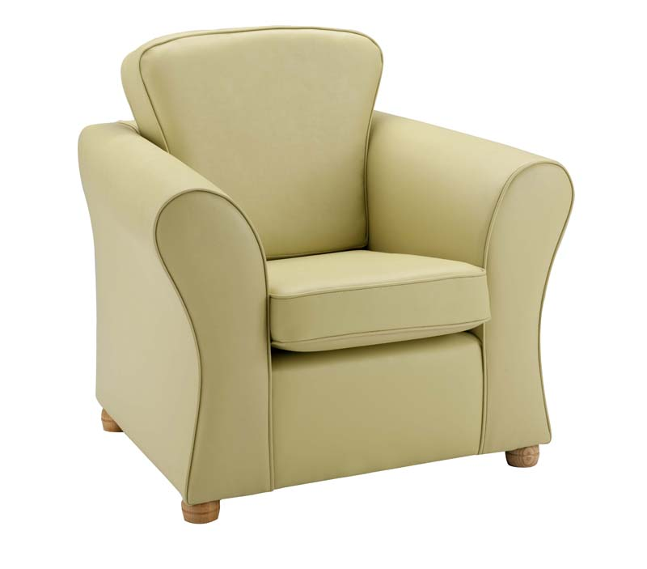

Product Reference 12
Upholstered Armchair Type 2

Item Criteria

Materials:
Fully Upholstered Beachwood frame with suitable CHMR/CME
Foam.

Size:
Approximately 1040mmH x 800mmW X 800mmD
Seat height 500mm

Warranty:
Minimum 5 Years

Colours:
Leg colour available in stain to match bedroom/living room
furniture finish.

Test Standards:
BS EN 16139: 2013 Level 1 – General contract use for chairs
BS EN 15373:2007 – Strength and Durability
BS EN 7176:2007 Source 5
FSC Chain of Custody Certification

NorseCare Specific Requirements: Panaz colour ranges desirable.
- To be upholstered in Panaz Highland Fabric or equivalent cost.
- Design to match two seat sofa product reference 14
- Frame/leg height must permit use of mobile hoist

Image is for guidance only

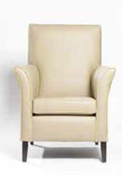

Product Reference 13
Two Seat Sofa Type 1
Nard Range
Item Criteria

Materials:
Fully Upholstered Beachwood frame with suitable CHMR/CME
Foam.

Size:
Approximately 915mm High X 1420mm Wide X 890mm Deep

Warranty:
Minimum 5 Years

Colours:
Leg colour available in stain to match bedroom/living room
furniture finish.

Test Standards:
BS EN 16139: 2013 Level 1 – General contract use for chairs
BS EN 15373:2007 – Strength and Durability
BS EN 7176:2007 Source 5
FSC Chain of Custody Certification

NorseCare Specific Requirements: Panaz colour ranges desirable.
- To be upholstered in Panaz Highland Fabric or equivalent cost.
- Design to match upholstered armchair product reference 11

Image is for guidance only
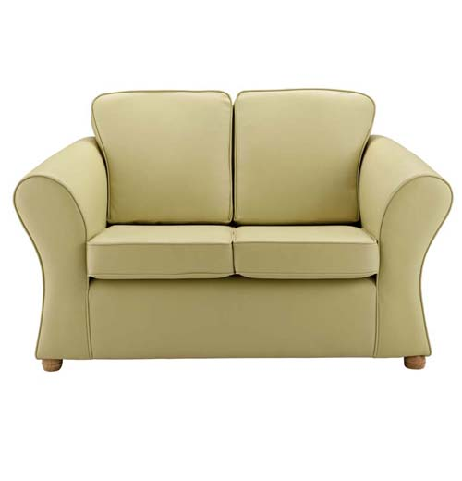

Product Reference 14
Two Seat Sofa Type 2
Nore Standard Range
Item Criteria

Materials:
Fully Upholstered Beachwood frame with suitable CHMR/CME
Foam.

Size:
Approximately 1040mmH X 1300mmW X 800mmD
Seat height 500mm

Warranty:
Minimum 5 Years

Colours:
Leg colour available in stain to match bedroom/living room
furniture finish.

Test Standards:
BS EN 16139: 2013 Level 1 – General contract use for chairs
BS EN 15373:2007 – Strength and Durability
BS EN 7176:2007 Source 5
FSC Chain of Custody Certification

NorseCare Specific Requirements: Panaz colour ranges desirable.
- To be upholstered in Panaz Highland Fabric or equivalent cost.
- Design to match upholstered armchair product reference 12
- Frame/leg height must permit use of mobile hoist

Image is for guidance only

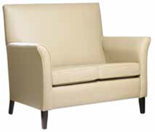

Product Reference 15
Bookcase

Item Criteria

Materials:
Solid wood construction
18mm carcass and back panel

Size:
Approximately 900mm Wide X 350mm Deep X
1300/1800mm High as specified

Warranty:
Minimum 5 Years

Colours:
Choice of natural wood finishes

Test Standards:
FSC Chain of Custody Certification
Durability tested to BS6250

NorseCare Specific Requirements:
- Must have rounded edges.
- Must be of solid construction and not easily tipped.

Image is for guidance only
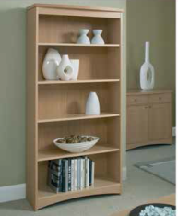

Product Reference 16
Music Cabinet
Nor Standard Range
Item Criteria

Materials:
Solid wood construction
18mm carcass

Size:
Approximately 600mm Wide X 500mm Deep X 760mm High

Warranty:
Minimum 5 Years

Colours:
Choice of natural wood finishes

Test Standards:
FSC Chain of Custody Certification
Durability tested to BS6250

NorseCare Specific Requirements:
- Must have rounded edges.
- Robust 160 degree opening hinges

Image is for guidance only

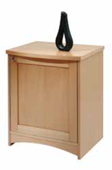

Product Reference 17
TV Unit

Item Criteria

Materials:
Solid wood construction
18mm carcass

Size:
Approximately 895mm Wide X 500mm Deep X 610mm High

Warranty:
Minimum 5 Years

Colours:
Choice of natural wood finishes

Test Standards:
FSC Chain of Custody Certification
Durability tested to BS6250

NorseCare Specific Requirements:
- Must have rounded edges.
- Double thickness Drawer Fronts with 18mm back and sides
- Heavy Duty Metal Drawer Runners

Image is for guidance only

Product Reference 18
Display Cube Unit

Item Criteria

Materials:
Solid wood or 25mm mfc construction
Vinyl wrapped/laminated finish to all edges and faces

Size:
Approximately 900mm Wide X 400mm Deep X 1500mm High
Option for single or double width

Warranty:
Minimum 5 Years

Colours:
Choice of natural wood finishes

Test Standards:
FSC Chain of Custody Certification
Durability tested to BS6250

NorseCare Specific Requirements:
- Must have rounded edges.

Image is for guidance only

Product Reference 19
Welsh Dresser
an
Item Criteria

Materials:
Solid wood or 25mm mfc construction
Vinyl wrapped/laminated finish to all edges and faces

Size:
Approximately 900mm Wide X 500mm Deep X 1800mm High

Warranty:
Minimum 5 Years

Colours:
Choice of natural wood finishes

Test Standards:
FSC Chain of Custody Certification
Durability tested to BS6250

NorseCare Specific Requirements:
- Must have rounded edges.
- D shaped handles
- To be available either with or without top shelf section
- Top section where requested must be securely fixed to bottom section

Image is for guidance only

Product Reference 20
Foot Stool
Nord Range
Item Criteria

Materials:
Upholstered Beachwood frame with suitable CHMR/CME
Foam.

Size:
Approximately 430mm High

Warranty:
Minimum 5 Years

Colours:
Leg colour available in stain to match bedroom/living room
furniture finish.

Test Standards:
BS EN 16139: 2013 Level 1 – General contract use for chairs
BS EN 15373:2007 – Strength and Durability
BS EN 7176:2007 Source 5
FSC Chain of Custody Certification

NorseCare Specific Requirements: Panaz colour ranges desirable.
- To be upholstered in Panaz Highland Fabric or similar cost equivalent.

Image is for guidance only

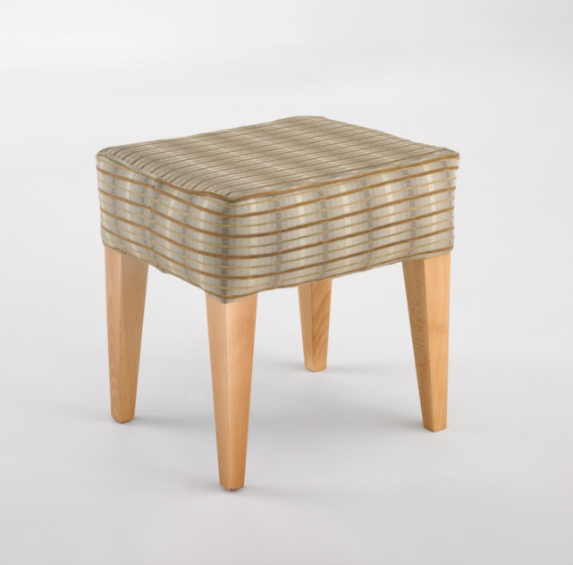

Product Reference 21
Dining Table
Nors Standard Range
Item Criteria

Materials:
Solid wood construction minimum 18mm Top with laminated
surfaces and rounded edge detail stained and lacquered to
match.

Size:
To be available in
Rectangular approximately 1520mmW x 910mmD x 760mmH
Square approximately 910mmW x 910mmD x 760mmH
Circular approximately 1070mmDia x 760mmH

Warranty:
Minimum 5 Years

Colours:
Leg, frame and top colour available in stain to match dining
chair finish product reference 13

Test Standards:
FSC Chain of Custody Certification
BS EN 15372: 2008 Level 2 – General Contract use for tables
NorseCare Specific Requirements:
- Must have rounded edges.
- Must be of solid construction
- Clearance beneath frame must permit dining chairs product reference 13 to fit underneath when fitted with arms and skids and wheelchairs.
- Top to be heat and impact resistant

Images are for guidance only

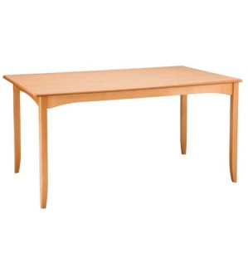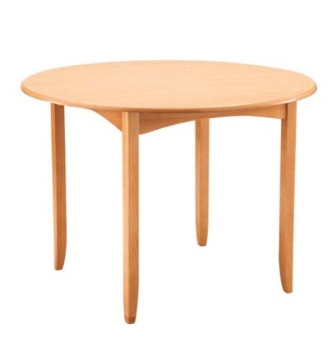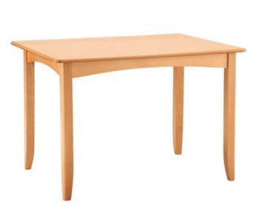

Product Reference 22
Dining Chair
da Range
Item Criteria

Materials:
Solid wood frame construction.
Upholstered back panel and seat pad with suitable
CHMR/CME Foam.

Size:
Approximately 1060mm High X 780mm Wide X 720mm Deep

Warranty:
Minimum 5 Years

Colours:
Frame colour available in stain to match dining table product
reference 14

Test Standards:
BS EN 16139: 2013 Level 1 – General contract use for chairs
BS EN 15373:2007 – Strength and Durability
BS EN 7176:2007 Source 5
FSC Chain of Custody Certification

NorseCare Specific Requirements: Panaz colour ranges desirable.
- To be upholstered in Panaz Highland Fabric or Panaz Aston or equivalent cost
- To be available with options for arms and/or skids
Image is for guidance only

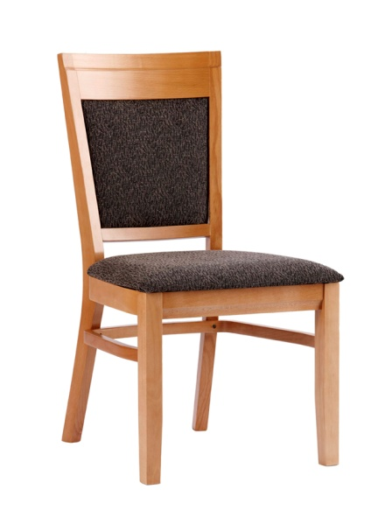

Appendix 4: Quality and Performance Criteria
- Bidders are to reproduce this form retaining the questions and numbering, and return it as part of their tender submission. Bidders are to answer all questions.
- Bidders’ responses shall be clearly legible and in at least 11 point type, on a line spacing of at least 1.3 times the type size.
- The answer to each question shall be self-contained. Responses such as ‘see answer to question x’ are not acceptable.
- Applicants should not assume that the evaluators have any prior knowledge of the tendering organisation, its capabilities or the solutions it offers.
- No documents are to be annexed unless specifically requested below.
- Where answers are limited to a maximum number of words, do not go over that limit. Any part of an answer beyond the point of the maximum will be disregarded.
- Please answer on separate pages and ensure these are fully referenced to the relevant question.
- Failure to adhere to these instructions will result in the tender being discarded without further consideration.
- The scoring marks provided is to assist evaluators in establishing areas of the proposals that concern them, and those areas that they think are good.

PLEASE REMEMBER TO EXPLAIN HOW YOU INTEND TO MEET THE REQUIREMENTS NOT JUST THAT YOU WILL.

4.1 Manufacturing & Quality Monitoring – 10% Weighted
Please describe your manufacturing set up, it’s location and what is done during the manufacturing process and during goods outwards inspection to ensure quality products with zero defects are delivered. Please also confirm you quality accreditations:

(Maximum 750 words)
Type your response here

4.2 Customer Service and Field Sales Support Set up – 10% Weighted
Please detail your field sales support and in house customer support set up and what additional benefits you believe you can bring to NorseCare from a customer service point of view.

(Maximum 1000 words) Type your response here

4.3 Care Sector Experience – 10% Weighted
Please detail your experience within the care sector, relevant case studies and your strategy towards manufacturing dementia friendly furniture and interior design services.

(Maximum 750 words)

4.4 Rejects & Returns Policy and Procedure – 8% Weighted
Please detail your response to faulty product claims and your returns policy and process in relation to any defective products delivered.

(Maximum 750 words) Type your response here

4.5 Interior Design Skillset – 6% Weighted

Please detail your interior design skillset and capabilities and willingness to undertake interior design services free of charge on the back of holding this contract with NorseCare and supplying all furniture exclusively against the design project.

(Maximum 750 words)

Type your response here

4.6 Contract Roll Out – 6% Weighted

Please describe how you would assist NorseCare during new contract roll out if you were the successful bidder, this may include;
- Creating bespoke brochures
- Providing images to upload to NorseCare’s in house catalogue and ordering system
- Visiting homes requiring furniture and/or design services.
- Creating bespoke welcome packs for each home.
(Maximum 750 words)
Type your response here

Descriptors for the allocation of quality scores

Descriptor | Mark awarded
Applicant fails to provide a response or Applicant provides a response of such a poor standard as to provide no confidence that the Applicant meets the requirements.  If any question receives a score of ‘0’, the entire submission will be rejected. | 0
Applicant provides a response of such a poor standard as to provide little confidence that the Applicant meets the requirements. The response shows many or all of the issues listed at mark 2. | 1
A response with some clear strengths but giving some concern, because some of the following apply:  - The question is only answered in part; and/or  - The approach described appears to only partially meet the requirement; and/or  - The approach described appears not to deliver expected levels of (as appropriate) functionality, performance, environmental performance, outcome, ease of use or other relevant characteristics; and/or  - The approach does not reflect accepted good practice; and/or  - The response is insufficiently specific; and/or  - The supporting documents (where requested) are of insufficient quality, depth or relevance. | 2
An acceptable response, with some degree of weakness but where the weakness does not cause fundamental concerns and is outweighed by the strengths. | 3
A good response where the strengths clearly outweigh any minor weakness(es), and the majority of aspects below apply:  - All aspects of the question are fully answered;  - The approach described fully meets the requirement;  - The approach reflects accepted good practice;  - The response is tailored to the requirement and, where relevant, to specific circumstances;  - The approach offers good levels of (as appropriate) functionality, performance, environmental performance, outcomes, ease of use and other relevant characteristics; and  - The supporting documents (where requested) are of good quality, relevant and of sufficient depth. | 4
An excellent response with all relevant bullet points from a mark of 4 applying. | 5

Appendix 5: Service Level Agreement (SLA)

SERVICE LEVEL AGREEMENT
Standardised Furniture Range & Interior Design Services Supply
SLA016 Rev: 1

(INSERT LOGO)

Introduction and Scope of Supply
This agreement is between (INSERT NAME) whose offices are based at (INSERT INFO) for the supply of Care Home Furniture products to NorseCare Ltd who offices are based at Lancaster House, 16 Central Avenue, St Andrews Business Park, Norwich, NR7 0HR
This SLA also includes the provision of stock holding of higher usage items for NorseCare.
The SLA operates on the basis that NorseCare buys a controlled range of Care Home Furniture products from (INSERT NAME) and that (INSERT NAME) stock hold the products at agreed levels in order to better service the NorseCare requirement for reduced lead times for core items.
Manufacture

All core products shown in Appendix 1 will be manufactured by (INSERT NAME) in the UK.

Delivery and Installation

(INSERT NAME) will be expected to be able to deliver to all of the 23 x NorseCare Residential Care Homes as detailed in Appendix 4 of this SLA.

Lead times on all core products will be 3-5 working days.

Larger deliveries will be carried out by one of (INSERT NAME)’s own fleet of vehicles, using (INSERT NAME) trained staff.
All furniture must be fully wrapped and protected during transport.

(INSERT NAME) will be expected to deliver to the point of use, unpack all delivered items and remove all packaging from the NorseCare site.

Product Warranties

All core products shown in Appendix 1 will have a minimum 2 year guarantee.

Confidentiality

(INSERT NAME) employees shall regard care home business as confidential and shall not disclose to any persons other than that authorised by the NorseCare Procurement & Contracts Manager any information in connection with the provision of the services within this SLA.

(INSERT NAME) staff shall not solicit gifts or gratuities from the residents, visitors or staff of NorseCare.

Continuous Improvement

NorseCare recognises continuous improvement is an ongoing effort to improve products, services or processes. These efforts can seek “incremental” improvement over time or “breakthrough” improvement all at once. NorseCare expects as a condition of this SLA that (INSERT NAME) will explore methods of continuous improvement in direct relation to this agreement and the products and services it provides NorseCare.

Duration

This SLA and it terms and contents will be in place for two years (24 months) from the date of signatories.

Review Meetings

(INSERT NAME) and NorseCare will meet a minimum of once every 6 (six) months to review performance against this SLA. It is the responsibility of both parties to ensure availability of the relevant staff to attend such reviews.

E-Invoicing

NorseCare operates a system that requires invoices to be sent electronically, (INSERT NAME) will ensure all invoices will quote the relevant purchase order number and be sent to the following e-mail address:
ncl@compleat-einvoicing.com

Variations

Any variations to this SLA must be agreed by both parties and will be added to the agreement by means of an additional Appendix until such time as SLA review and new revision creation. No variation to this SLA can be added without written agreement from both NorseCare and (INSERT NAME).

Terms & Conditions
All orders placed will be under the NorseCare Standard Terms and Conditions.
Prices
Prices for all core products supplied by (INSERT NAME) are detailed in Appendix 1 of this SLA. All prices within this Appendix are fixed for the full 2 year duration of this SLA. Any new or non core products required by NorseCare Residential Homes will be bought exclusively through (INSERT NAME) on the basis that required products can be supplied at competitive market rates.
Retrospective Rebate
An incentive to the SLA will be a retrospective rebate payable to NorseCare upon 12 month completion of the SLA and every 12 months thereafter. Rebate review will be every 12 months.

The rebate will be: 1% of total spend up to £125,000
2% of total spend up to £150
3% of total spend up to £500,000
4% of total spend over and above £500,001

The rebate will not be split in respect certain amounts falling into certain categories, once a spend level is hit the entire amount will qualify for the relevant percentage rebate.
Eg: A spend of £175,000 will attract a full 3% rebate of £5,250
It WILL NOT be calculated as 1% of 125,000, 2% of £25,000 and 3% of £25,000 which = £2,500
The rebate will be payable in the form of a cheque payment or BACS transfer NOT in the form of Credit against future spend.
Stock Holding & Storage
(INSERT NAME) will supply a free of charge storage facility for NorseCare core products. All products that go into storage with (INSERT NAME) will be deemed the property and responsibility of (INSERT NAME) until payment has been made by NorseCare upon successful delivery and installation.
(INSERT NAME) will hold stock of the core products that NorseCare use on the basis of reducing lead times for critical items. The list of products to be held in storage and the amount per item to be stored is detailed in Appendix 2 of this SLA. Some products will be held in a flat pack form, and built upon customer call off. All products will be held in stock by (INSERT NAME) on the basis of agreed amounts and do not represent a commercial under write on behalf of NorseCare.
Sustainability and Corporate Social Responsibility
(INSERT NAME) operations in relation to NorseCare product manufacture are to be geared around minimising negative impact on the environment. (INSERT NAME) will make every effort to comply with and exceed the requirements of current environmental legislation and relevant industry codes of best practice, make efficient use of resources during design and manufacture to minimise raw material waste, procure materials from sustainable and law abiding sources and prevent unnecessary energy consumption by investigating all energy saving methods.
Product Images
(INSERT NAME) will provide all images in a format (Jpeg 100 x 100 pixel) that NorseCare can use to help promote the agreed range within its care homes and for addition to its COMPLEAT P2P System which is used within all the locations.
Termination
This contract can be terminated by either party by serving 90 days written notice to the other party. For greater certainty, neither party shall be entitled to any additional amounts or compensations in the event that the agreement is terminated.
Either party shall have the right to terminate this agreement immediately and without liability for compensation or damages on the happening of any of the following:

- If either party commits a serious breach or breaches of any provision of this agreement or the confidentiality undertaking included in Appendix 3.
- If one of the parties to this agreement becomes insolvent, bankrupt, has a receiving order made against it, makes any arrangement with creditors generally or takes or suffers any similar action as a result of debt.
- If any part of this agreement is found to be false or incorrectly misrepresented during any time of the agreement.

Disputes

The parties will work together to resolve any disputes arising from the servicing of this contract in an amicable way. The parties may agree procedures and protocols for dispute resolution from time to time. Both parties reserve the right to contact any legal authority in order to seek advice regarding contractual disputes and this agreement does not seek to clarify the manner in which they would be resolved.

Volume of Work
No guarantees of volumes of work to be carried out under this SLA are given. All information given is provided for guidance only.

Equalities
(INSERT NAME) agrees that there shall be no discrimination by it against any person with respect to opportunity for employment or conditions of employment, because of age, culture, disability, gender, marital status, race, religion or sexual orientation. (INSERT NAME) shall in all matters arising in the performance of this SLA comply with the provisions of the Sex Discrimination act 1975 and the Disability Discrimination Act 1995 and any regulations made there under. (INSERT NAME) shall in all matters arising in the performance of this SLA comply with the provisions of the Employment Equality (Age) Regulations 2006. (INSERT NAME) must comply with the provisions of the Race Relations Act 1976 and the Race Relations (Amendment) Act 2002 and shall ensure that they perform their responsibilities under this contract with due regard to the need to eliminate unlawful racial discrimination, and to promote equality of opportunity and good relationships between different racial groups.

Corruption
NorseCare shall be entitled to cancel this SLA, and recover any resulting loss from (INSERT NAME), if (INSERT NAME), or any of (INSERT NAME)’s employees or agents with or without (INSERT NAME)’s knowledge, has (i) Offered, given, or agreed to give any person any gift or consideration of any kind (a) as an inducement or reward for doing or not doing anything in relation to the obtaining or carrying out of this SLA or any other contract with NorseCare (b) for showing or not showing favour or disfavour to any person in relation to this SLA, or any other contract with the Consortium; and/or (ii) committed an offence under the Prevention of Corruption Acts 1889 to 1916, or given any fee or reward the receipt of which is an offence under Section 117 of the Local Government Act 1972.

Protection of Children Act 1999
Neither (INSERT NAME) nor any sub-contractors are to have direct contact with children during any delivery or attendance at any NorseCare establishment. (INSERT NAME) shall ensure that those engaged in undertaking the duties under this SLA including employees, servants, agents and others are of suitable standing and good character.
(INSERT NAME) shall take all reasonable measures when recruiting and monitoring staff to ensure compliance with the above requirements.

Observance of Statutory Requirements
(INSERT NAME) shall comply with all statutory and other provisions (including health and safety legislation) to be observed and performed in connection with this SLA and shall indemnify NorseCare against any breach thereof and in particular (INSERT NAME) shall indemnify in full NorseCare Ltd, its servants and agents against any and all actions, claims, demands, proceedings, damages, costs, charges, expenses and fines whatsoever arising out of (INSERT NAME)’s failure to comply with its obligations.
(INSERT NAME) will guarantee that the services comply in all respects with all the relevant requirements of any statute, Statutory Rule or order or other instrument having the force of law or Code of Practice, which may be in force during the SLA period.
Notwithstanding the above provisions, (INSERT NAME) shall ensure that all drivers and other personnel engaged in delivering the services are competent and suitably trained to carry out their duties.

Transfer of Contract
(INSERT NAME) shall be prohibited from transferring or assigning directly or indirectly to any person or persons whatsoever the whole or any portion of the SLA without the written permission of NorseCare Ltd. This includes any sub-letting which may be customary in the industry concerned.

Governing Law

This SLA will be governed under English Law. The SLA will be executed in duplicate and each copy signed by both parties. Each party confirms that a duly authorised officer of their company will be responsible for implementing and monitoring the commitments made.

Notices

During the SLA period notices and communications will be expected using electronic e-mail.

Entire Agreement

This document constitutes the entire agreement and is considered as agreed upon based on the completion of the signatories section.

Undertakings

(INSERT NAME) confirms it has the authority and right under law to enter into and to carry out its obligations and responsibilities under this agreement and to provide the services agreed.

Health & Safety

(INSERT NAME) shall maintain a Health and Safety Policy statement and codes of practice, Risk Assessments and any other safe systems of work documents.

Insurance

(INSERT NAME) confirms it has the appropriate Public Liability coverage of no less than £5,000,000

(INSERT NAME) confirms it has the appropriate Employers Liability coverage of no less than £10,000,000

(INSERT NAME) confirms it has the appropriate Products Liability coverage of no less than £5,000,000

Modern Day Slavery Act 2015

By signing this SLA (INSERT NAME) acknowledges to be aware of the Modern Day Slavery Act 2015 and confirms all possible actions have been taken within its business and supply chain to adhere to the requirements of the act.

Appendix 1

Prices

Product Reference | Description | Price
Product Reference 1 | Profile Bed
Product Reference 2 | Bedside Cabinet
Product Reference 3 | Bedroom Wardrobe
Product Reference 4 | Bedroom 4 Drawer Unit
Product Reference 5 | Dressing Table
Product Reference 6 | Bedroom high Back Upholstered Chair
Product Reference 7 | Mattress Type 1
Product Reference 8 | Mattress Type 2
Product Reference 9 | High Coffee Table
 | Square
 | Rectangular
 | Circular
Product Reference 10 | Low Coffee Table
 | Square
 | Rectangular
 | Circular
Product Reference 11 | Upholstered Armchair Type 1
Product Reference 12 | Upholstered Armchair Type 2
Product Reference 13 | Two Seat Sofa Type 1
Product Reference 14 | Two Seat Sofa Type 2
Product Reference 15 | Bookcase
Product Reference 16 | Music Cabinet
Product Reference 17 | TV Unit
Product Reference 18 | Display Cube Unit
Product Reference 19 | Welsh Dresser
Product Reference 20 | Foot Stool
Product Reference 21 | Dining Table
 | Square
 | Rectangular
 | Circular
Product Reference 22 | Dining Chair
 | With Arms

Appendix 2

Stock Holding

Product Reference | Description | (INSERT NAME) Stock Amount
Product Reference 1 | Profile Bed
Product Reference 2 | Bedside Cabinet
Product Reference 3 | Bedroom Wardrobe
Product Reference 4 | Bedroom 4 Drawer Unit
Product Reference 5 | Dressing Table
Product Reference 6 | Bedroom High Back Upholstered Chair Core Colour
Product Reference 7 | Mattress Type 1
Product Reference 8 | Mattress Type 2
Product Reference 9 | High Coffee Table
 | Square
 | Rectangular
 | Circular
Product Reference 10 | Low Coffee Table
 | Square
 | Rectangular
 | Circular
Product Reference 11 | Upholstered Armchair Type 1 Core Colour
Product Reference 12 | Upholstered Armchair Type 2 Core Colour
Product Reference 13 | Two Seat Sofa Type 1 Core Colour
Product Reference 14 | Two Seat Sofa Type 2 Core Colour
Product Reference 15 | Bookcase
Product Reference 16 | Music Cabinet
Product Reference 17 | TV Unit
Product Reference 18 | Display Cube Unit
Product Reference 19 | Welsh Dresser
Product Reference 20 | Foot Stool Core Colour
Product Reference 21 | Dining Table
 | Square
 | Rectangular
 | Circular
Product Reference 22 | Dining Chair Core Colour
 | With Arms

Appendix 3

Confidentiality Undertaking
From

(INSERT NAME)

(“We”, “Our”, “Us”)

This Undertaking dated ___________ 2017 will apply to confidential proprietary and technical information of the sort referred to in Part 1 of the Schedule to this Undertaking ("Confidential Information") disclosed or to be disclosed to us by or on behalf of NorseCare Limited ("NCL").

In respect of all Confidential Information released by NCL (including Confidential Information so released prior to the date of this Undertaking) we undertake with NCL as follows (each paragraph to be deemed to be given by us as a separate undertaking):-

1. We will recognise the confidential nature of the Confidential Information.

2. We will respect the confidential nature of the Confidential Information by maintaining the secrecy of the Confidential Information.

3. That the Confidential Information (or any part of it) will not without the prior written consent of NCL, be used by us or on our behalf for any purpose except that set out in Part 2 of the Schedule to this Undertaking.

4. We will not disclose the Confidential Information to others without the prior written consent of NCL and where such disclosure is so authorised we shall first obtain a written undertaking from the person to whom disclosure is to be made substantially in the form of this Undertaking.

5. That the Confidential Information will not be used by us or by any person on our behalf in any way that would be detrimental or harmful to any company within the Norse Group.

6. That NCL retains all intellectual property rights in the Confidential Information at all times and for all purposes including the copyright (or any other intellectual property rights) in materials produced by us relating to the Confidential Information.

7. Forthwith at NCL’ request, we shall ensure the destruction of copies which we may hold of any documents, source codes, data storage media, notes, files or, without limitation, any other documents which we may possess and which contain Confidential Information and to ensure that any such documents which have been disclosed to any third parties have also been so destroyed.
We further agree to fully and promptly indemnify NCL from and against any and all losses incurred by it as a result of any breach of the above undertakings. We acknowledge that any breach by us or anyone on our behalf of the above undertakings may give rise to significant damage to NCL or to the Norse Group, that damages may not be an adequate remedy in consequence thereof, and that NCL (or, as the case may be, the relevant member of the Norse Group) shall be entitled to such equitable remedies as may be appropriate in the event of such breach.
The following information shall not be regarded as Confidential Information to which this Undertaking applies:-

(a) Information which was in or comes into the public domain before or after the date of this Undertaking, otherwise than as a result of a disclosure by us or on our behalf that has not been authorised by NCL;
- Information which we can establish by documentary evidence was already in our possession at the time of disclosure by or on behalf of NCL otherwise than as a result of a breach of a confidentiality undertaking owed to NCL;

(c) Information which is required to be disclosed pursuant to a legal or regulatory obligation, provided that we shall give NCL as much notice as possible prior to making such disclosure and shall co-operate fully with NCL and use our reasonable endeavours to limit or prevent such disclosures so far as is possible.
For the purposes of this Undertaking the term "Norse Group" shall mean Norse Group Limited and any of its subsidiaries from time to time (as the term subsidiary is defined in Section 1159 of the Companies Act 2006).
English Law shall apply to this Undertaking and the English Courts shall have exclusive jurisdiction in relation to its terms.
Signed by a duly authorised representative for and on behalf of [INSERT NAME]

Signature: ___________________________________________
Date: ___________________________________________

Appendix 4

NorseCare Residential Care Homes List

Ellacombe | Beauchamp House | Bishop Herbert House | Westfields
Ella Road, | Proctor Road, | 34 Globe Place, | Westfields Road
NORWICH | Chedgrave | Vauxhall St. | SWAFFHAM
NR1 4BP | NORWICH | NORWICH | Norfolk
 | NR14 6HN | NR2 2SG | PE37 7HE
Burman House | Cranmer House | Harker House | Woodlands
Mill Road, | Norwich Road | Flowerpot Lane | Grimston Road
Terrington St John | FAKENHAM | Long Stratton, | South Wootton
KINGS LYNN | NR21 8HR | NORWICH | KING’S LYNN
PE14 7SF |  | NR15 2TS | PE30 3HU
 | High Haven | Linden Court | Lydia Eva Court
 | Howdale Road | Church Walk, | Peterhouse Ave
 | DOWNHAM MARKET | Watton | Gorleston
 | PE38 9AB | THETFORD | GT YARMOUTH
 |  | IP25 6ET | NR31 7PZ
 | Mountfield | Munhaven | Rebecca Court
 | Millcroft, | Munhaven Close | 9 Staithe Road,
 | NORWICH | Mundesley | Heacham
 | NR3 3LS | NORFOLK | KING’S LYNN
 |  | NR11 8AR | PE31 7EF
Rose Meadow | Bowthorpe Care Village | Springdale | Priorsmead
64 Yarmouth Road | Ladysmock Way | Cucumber Lane, | Canterbury Way
NORTH WALSHAM | Bowthorpe | Brundall | THETFORD
NR28 9AU | Norwich | NORWICH | NORFOLK
 | NR5 9BF | NR13 5QY | IP24 1EB
St Edmunds | St Nicholas House | Sydney House
Surrogate Street | Littlefields | Brumstead Road
ATTLEBOROUGH | DEREHAM | Stalham
NORFOLK | NORFOLK | NORWICH
NR17 2AW | NR19 1BG | NR12 9BJ

Signatures

On behalf of NORSECARE Ltd On Behalf of (INSERT NAME)

Signed............................................................... Signed..............................................................

Name: Simon Bullimore Name:

Position: Procurement & Contracts Manager Position:

Date......................................................... Date...............................................................

Contact details and declaration – For Appendix 5
I declare that to we as a business would be happy to enter into the Service Level Agreement detailed in Appendix 5 of this ITT.
I am aware of the consequences of serious misrepresentation.

Section 1 | Contact details and declaration
Question number | Question | Response
1.3(a) | Contact name
1.3(b) | Name of organisation
1.3(c) | Role in organisation
1.3(d) | Phone number
1.3(e) | E-mail address
1.3(f) | Postal address
1.3(g) | Signature (electronic is acceptable)
1.3(h) | Date

Appendix 6: Site Locations
P
e
Ellacombe | Beauchamp House | Bishop Herbert House | Westfields
Ella Road, | Proctor Road, | 34 Globe Place, | Westfields Road
NORWICH | Chedgrave | Vauxhall St. | SWAFFHAM
NR1 4BP | NORWICH | NORWICH | Norfolk
 | NR14 6HN | NR2 2SG | PE37 7HE
Burman House | Cranmer House | Harker House | Woodlands
Mill Road, | Norwich Road | Flowerpot Lane | Grimston Road
Terrington St John | FAKENHAM | Long Stratton, | South Wootton
KINGS LYNN | NR21 8HR | NORWICH | KING’S LYNN
PE14 7SF |  | NR15 2TS | PE30 3HU
St Nicholas House | High Haven | Linden Court | Lydia Eva Court
Littlefields | Howdale Road | Church Walk, | Peterhouse Ave
Dereham | DOWNHAM MARKET | Watton | Gorleston
Norfolk | PE38 9AB | THETFORD | GT YARMOUTH
NR19 1BG |  | IP25 6ET | NR31 7PZ
Sydney House | Mountfield | Munhaven | Rebecca Court
Brumstead Road | Millcroft, | Munhaven Close | 9 Staithe Road,
Stalham | NORWICH | Mundesley | Heacham
Norfolk | NR3 3LS | NORFOLK | KING’S LYNN
NR13 9BJ |  | NR11 8AR | PE31 7EF
Rose Meadow | Bowthorpe Care Village | Springdale | Priorsmead
64 Yarmouth Road | Ladysmock Way | Cucumber Lane, | Canterbury Way
NORTH WALSHAM | Bowthorpe | Brundall | THETFORD
NR28 9AU | Norwich | NORWICH | NORFOLK
 | NR5 9BF | NR13 5QY | IP24 1EB
St Edmunds
Surrogate Street
ATTLEBOROUGH
NORFOLK
NR17 2AW
nd al
and Performance Criteria ix 4: Quality and Performance Criteria

Checklist

Make sure you have completed the following with your submission:
- Completed Appendix 1 and signed the declaration
- Completed Appendix 2 and signed the declaration
- Priced against all the items in Appendix 3 (submitting as a separate document and pricing against each Product Reference number)
- Answered all questions completely in Appendix 4
- Signed the declaration and confirmed your acceptance of the SLA in Appendix 5
- Submitted Case Study Evidence (Requirements and statements)
- Submitted Business References (Requirements and statements)
- Submitted copies of Quality Accreditations
- Included copies of your Public Liability Insurance Certificate and indemnity offering to NorseCare.
- Confirmation of Stock Holding Proposal.

