National Army Museum

Brief for the design, print and fulfilment of printed materials relating to membership schemes

June 2019

Contents Page

1. Introduction 3
2. Scope of works 4
3. Budget 6
4. Copyright 6
5. Schedule 7
6. Tender process 7
7. Appendices 12

For information:
Appendix A: Background to the National Army Museum Appendix B: Our Audiences Appendix C: A Brand Guidelines
For action:
Appendix D: Form of Tender
Appendix E: Certificate of Bona-Fide Tender
Appendix F: Supplier Statement
Appendix G: Pricing Schedule

1. Introduction

The National Army Museum (NAM) reopened in March 2017 following a major redevelopment project. The project saw the wholesale transformation of the Museum building, galleries, archive, learning, retail, cafe and visitor services which was underpinned by a new brand and ethos.

To compliment the Museum offer, and support NAM’s objectives the Museum is looking to appoint a suitably qualified and experienced company to provide a suite of printed membership materials and manage the on-going fulfilment of these materials.

There are 2 elements to the membership scheme:

The new membership scheme which is due to launch in August 2019. This scheme will also incorporate an external friends organisation (SOFNAM) into the NAM membership scheme. The incorporation of these members into the NAM membership scheme is essential to the on-going financial success of the membership scheme and as such the membership scheme, benefits along with its look and feel will evolve over the 2 years of this contract.

In addition to the membership scheme the Museum will be refreshing it’s offer to it’s existing patrons whilst also wishing to attract new patrons. This is a small and important group and as such much of the correspondence with the Patrons will be directly via the team at NAM. Both schemes are key to the Museums offer and the materials must be a reflection of the Museum’s brand and values. As such the company appointed must be able to translate the brand whilst ensuring the product is both attractive and viable.

If you want to help us deliver this product, and are interested in tendering for this, this document provides the following information:

- Scope of works
- Schedule
- Tender Process

We would welcome your application to work with us.

2. Scope of works

NAM is ideally seeking to appoint a single company to design, edit, print and post materials relating to its new membership scheme. It must translate the brand and values to reflect the Museum; it’s rich collection and new galleries.

The appointed company will be expected to deliver a creative and innovative solution on time and must meet the Museum’s aims as set out in the brief and in any subsequent briefings.

The initial design services will be a single contract with print and fulfilment services running for a 2 -year period from July 2019 with the option to extend for up to an additional two further years at the end of June 2021.

2.1 Design and editing services

2.1.1 Design

Membership Cards

- To develop the design treatment for the following membership materials:

Membership Card -1 design
Patron Card and Carrier – 1 design

- These will be produced utilising the guidelines, design brief and subsequent client feedback on the creative treatment submission.

Members Magazine – 2 per year

- Prepare and provide sample pages for consideration and approval
- Prepare and provide full page layouts to for consideration and approval
- Produce final artwork for approval by NAM including a mock-up of the final design if required

2.1.2 Copyedit service

- To provide copy editing services for Members Magazine content using NAM’s house style and tone of voice guidelines.
- Provide revised copies for NAM to review and comment.

2.2 Print and Fulfilment Services

2.2.1 Print Services

- To print as a one-off batch the following membership material:

Membership card – 950 cards
Patron card – 50 cards
Patron card carrier – 50 carriers
Newsletter – 1,000 copies, bi-annual

These will be printed as per the agreed design and to the specification laid out in the design brief

- Suitably packed and stored to be issued as per fulfilment service

2.2.2 Membership Fulfilment Services

- To fulfil the print and postage of following membership mailings

Personalised membership card for attachment to either welcome letter or renewed membership letter
Welcome letters (2 types), personalised with card attached
Renewal letters (2 types), personalised
Renewed member letter (1 type)
Membership expired letter (1 type)

- The memberships will be sent by the appointed supplier direct to the customer.

- The methods for the transfer of data in order to fulfil the service should be included as part of the tender response

2.2.3 Patron Fulfilment Services

- To fulfil print and postage of following patron mailing

Personalised patron card for attachment to patron card mailer

These will be printed as per the agreed design and to the specification laid out in the design brief (to be issued on Friday 21st June 2019) and mailed according to the mailout schedule at appendix H

- The patron card and mailer will be sent to NAM for insertion into Welcome Pack produced and sent by NAM.

- The methods for the transfer of data in order to fulfil the service should be included as part of the tender response

2.2.4 Magazine Fulfilment Services

- To fulfil the bi-annual postage of the Magazine direct to Members and NAM

These will be mailed as per the agreed design and to the specification laid out in the design brief (to be issued Friday 21st June 2019) and mailed according to the mailout schedule at appendix H

- The methods for the transfer of data in order to fulfil the service should be included as part of the tender response

2.4 Project management

- Prepare a detailed programme for delivery of the project
- Liaise with NAM to ensure content deadlines are met
- Prepare a final budget for the project based on the agreed design solution(s)

2.5 NAM’s requirements in fulfilling these services

NAM is looking for a company with the ability to deliver this programme of works as a complete package. We are therefore looking for a company, which can take a holistic approach and facilitate all elements of this brief.

Ideally, we are seeking one supplier to deliver this project, in order that the final product is consistent. However, we would welcome quotations which include the use of subcontractors. All references must be provided as part of the tender submission and the main contractor must manage these sub-contractors.

As a start you will have:

- Previous experience and success in creating and delivering engaging magazines

- Ability to translate a brand through visual communication

- Previous experience of producing membership collateral and magazines for a Museum or Visitor attraction

- Ability to maintain high-volume, high quality print whilst meeting tight deadlines

NAM will provide:

- Design briefing documentation including magazine structure approach

- All text and image assets

- Brand and house style materials

3. Budget

In order to ensure the clear comparison of submissions a detailed price breakdown for submissions, at appendix G is provided.

All costs for individual elements detailed in the response must be fully disclosed along with all calculations.

Quoted fees must include all of the following:

- Professional fees

- Development, research and design costs

- Print, delivery and storage costs

- Travel and expenses

- Accommodation

- Disbursements

- An estimate of any contingency

- All third-party fees

- Report, printing and presentation costs

- All other expenses and costs required in the delivery of the project.

The fees should indicate if they include or exclude VAT.

4. Copyright

It must be noted by the designer that all rights (including ownership and copyright) in any reports, documents, specifications, instructions, plans, drawings, patents, models or designs whether in writing or on other media:

- Provided or made available to the designer by NAM shall remain vested in NAM.
- Prepared by or for the designer (or any subcontractors employed or contracted by the designer) for use, or intended use, in relation to this project will be assigned to and shall vest in NAM absolutely.

The contractors should therefore allow for such vesting rights to be included within the fee bid.

5. Schedule

NAM would like to discuss the delivery schedule in detail with the appointed company as part of the kick off meeting.

However, the delivery mailout schedule at appendix H gives the key milestones for delivery and we would ask that the tender response included an indication of requirements and deadlines in order to meet this schedule.

Please note that all assests required for the production of membership and patron cards as well as the members magazine will be handed over by NAM to the appointed supplier at the kick off meeting.

6. Project team

Project sponsor team
Helen Chalmers – Membership and Patrons Manager
Linda Stranks – Head of Marketing and Communications

Project manager
Dawn Watkins – Assistant Director (Enterprise))

7. Tender process

7.1 Tender requirements

Proposals should comprise the following.

7.1.1 Response to brief

Response to the brief should demonstrate:
- An illustrative response to the brief with any thoughts about further development, limited to 2no. responses
- A clear methodology statement for the development and delivery of the works detailed in section 2
- An outline work plan identifying key milestones and sign off points informed by this brief
- Confirmation of team members, including sub-contractors if relevant.
- Cost plan detailing the tasks and staff responsibilities, daily and hourly rates and expenses.

7.1.2 Tenderers project team, qualifications and experience

Provide details of three relevant projects that demonstrate qualifications and experience. For each project, include a description of the project, you, your company’s and/or sub-contractors’ role, client, budget and project dates.

7.1.3 Fee

The Fee is to be a fixed sum for the provision of all Works as outlined in the Scope of Works.

The Fee is to include all expenses. This will include travel costs, accommodation, disbursements, reports and all other expenses and costs required in the provision of the Works. The fee should exclude VAT at the prevailing rate.

7.1.4 Instalment payments

Provide a suggested fee drawdown schedule in your response. NAM reserves the right to amend any suggested drawdown schedule.

7.1.5 Insurance

Please provide copies of up-to-date insurance - NAM requires Public
Liability with a minimum of £10 million, Employers Liability with a minimum £10 million and Professional Indemnity Insurance to the value of £2 million.

7.1.6 References

Provide reference details of three recent contracts that are relevant to this project. Include the name and contact details of the clients’ representatives who could be approached for references. References will be taken up before confirmation of appointment.

7.1.7 Financial

Please provide a copy of the company’s published accounts for the last three years.

7.2 Tender submission

Tenders should comprise 2x hard copies and 1 x electronic on DVD/memory stick of all tender content as outlined below:

- Membership Scheme Proposal
- The completed Form of Tender (Appendix D)
- The completed Certificate of Bona-Fide Tender (Appendix E)
- The completed Supplier Statement (Appendix F)
- The completed detailed price breakdown (Appendix G)
- Any other information that is required to clarify the tender.

  - Tender return

- Tenders must be submitted no later than 1200hrs on 28th June 2019 in a plain envelope labelled only with the address below and clearly marked “Tender – Membership Scheme ”. No other marks or wording (including pre-paid franked stamps), which might indicate the identity of the sender, shall appear on the envelope containing the tender.

The tender shall be submitted to:

D Gerrard
National Army Museum
Royal Hospital Road
Chelsea
London SW3 4HT

Tenders can also be returned via email at the above date and time to: tenders@nam.ac.uk. The subject of the email should state “Tender –Membership Scheme”.

7.4 Tendering costs

NAM will not be responsible for or pay for any costs or expenses that are incurred by any tendering consultant in preparing and submitting their tender.

7.5 Contract award criteria

The tender board may consist of the following NAM representatives:

- Assistant Director (Enterprise)
- Head of Marketing and Communications
- Membership and Patrons Manager

Tenders will be assessed on the following criteria:

- Response to brief 30%
- Qualifications and Experience 20%
- Project Team and Resourcing 20%
- Fee 30%

Each proposal will be given a score. A proposal considered to be unsuitable shall be rejected at this stage if it does not respond to important aspects of the brief. NAM shall notify unsuccessful tenderers of the rejection of their proposal after completing the selection process.

Tenders will be awarded on the absolute discretion of the Board of NAM, in accordance with internal policies and statutory regulations. NAM is not required to accept the lowest priced tender.

The decision will be final and binding, no correspondence will be entered into.

7.6 Tender programme

The key dates in relation to this tender exercise are detailed below.
Activity | Date
Brief issued | 18 June 2019
Tender submission deadline | 12:00hrs 03 July 2019
Notification shortlisted candidates | 05 July 2019
Interviews | 08 July 2019
Appointment of chosen company | 09July 2019
Initial project start up meeting – agreement of timings going forward | 10 July 2019 tbc

The above programme is indicative of NAM’s timescales

The forward programme will be developed in discussion with the appointed company.

7.7 Enquiries

Any enquiries arising must be submitted in writing via email to:

Dawn Watkins, Assistant Director (Enterprise), National Army Museum
Email: dwatkins@nam.ac.uk

Enquiries will be answered within three working days.

Appendix A: Background to The National Army Museum

The National Army Museum is a leading authority on the British Army and its impact on society past and present. The Museum’s vision is bold. To use its rich historical and developing contemporary collections to foster people’s awareness, understanding and knowledge of the British Army, its soldiers and legacy. And through this exploration, encourage debate about an institution that is little understood but is intrinsically part of our democratic society and enables us to live with the freedoms we enjoy everyday.
Appendix B: Our Audiences

The Museum’s audience segments

The Museum has used these segments to guide the development of the exhibitions and services within the Museum

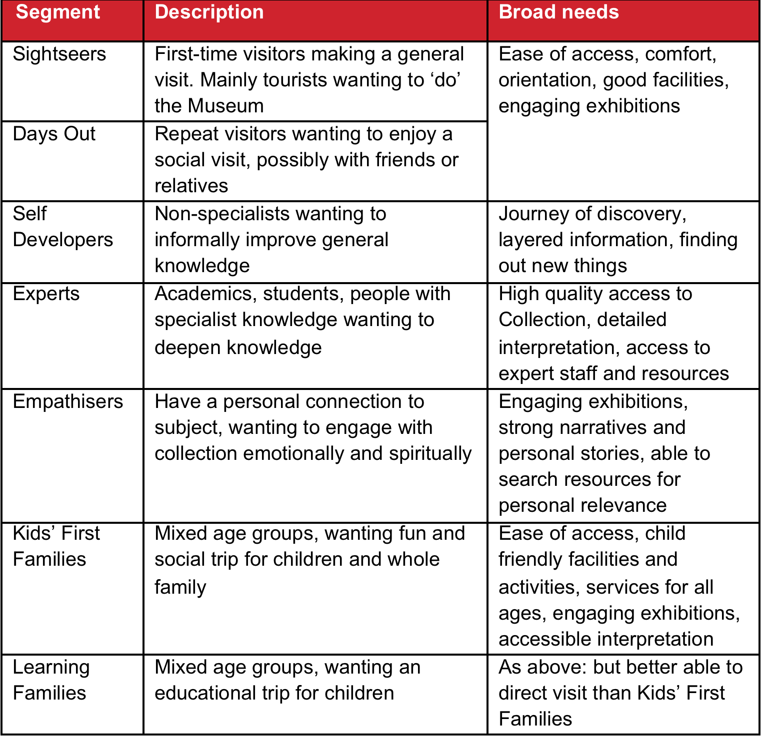
Figure 1: National Army Museum - Visitor segmentation

Our potential Members and Patrons largely fall into the following segmentation types:

Self-Developers
Experts
Empathisers

Appendix C: A brand

The Museum has developed a brand and approach to visual communications.

The new brand model was developed in 2014-15, and has guided the development of the Museum – from the galleries themselves to the interior design of the Museum and its facilities

Whilst detailed information will be provided to the successful consultant, NAM’s new brand model is provided here to convey the nature of our new brand

Appendix D: Form of Tender

Tender for: National Army Museum – Membership Scheme

To: The Council and Director of the National Army Museum

Sirs,

I/We the undersigned, having examined the enclosed tender documents and Appendices, do hereby offer to execute and complete in accordance with the said documents the works described therein:

For the sum as listed in the attached document:

Tenderer Reference:

I/We hereby affirm our agreement to enter into a contract with the Council of the National Army Museum for the due performance of the Works in the form described by the above said documents.

I/We have completed the Certificate of Bona-Fide Tender included in this document.

I/We understand that the Trustees are not bound to accept the lowest or any tender which may be received nor or responsible for any cost incurred in the preparation of any tender.

I/We declare that this offer is to remain open for acceptance for a period of 60 days from the date fixed for the receipt of tenders.

Signed: ____________________________________________________

In the capacity of

Duly authorised to sign the tender on behalf of:

Date:

APPENDIX E: CERTIFICATE OF BONA-FIDE TENDER

Tender for: National Army Museum – Membership Scheme

I/We certify that this is a bona-fide tender and that I/we have not fixed or adjusted the amount thereof by or under in accordance with any agreement or arrangement with any other person.

I/We also certify that I/We have not done, and I/We undertake that I/we will not do at any time any of the following acts:

- Communicate to a person other than the person calling for these tenders the amount or approximate amount of the proposed tender except where the disclosure, in confidence, of such amount(s) was necessary to obtain insurance premium quotations required for the preparation of the tender.

- Enter into any agreement or arrangement with any other person that he shall refrain from tendering or as to the amount of any tender to be submitted;

- Offer or pay or give or agree to pay or give any sum of money or valuable consideration directly or indirectly to any person for doing or having done or causing or have caused to be done in relation to any other tender or proposed tender for the said work any act or thing of the sort described above.

In this certificate the word “person” includes any person and any body, association, corporate or un-incorporated; and “any agreement” includes such transaction, formal or informal, and whether legally binding or not.

Signed: ____________________________________________________

In the capacity of

Duly authorised to sign the tender on behalf of:

Date:

APPENDIX F: SUPPLIER STATEMENT

We certify that the information supplied is accurate to the best of our knowledge and that we accept the conditions and undertakings requested in the assessment. We understand that false information could result in our exclusion from the Tender process or the Approved Suppliers List at any time, even after initial inclusion. We also understand that it is a criminal offence to give or offer any gift or consideration whatsoever as an inducement or reward to any servant of a public body and that any such action will empower such body to cancel any contract currently in force and will result in exclusion from the Tender and / or the Approved Suppliers List.

Signed by: _____________________________________________________

Name: (in BLOCK LETTERS) ______________________________________

Title: _________________________________________________________

Date: _________________________________________________________

for and on behalf of: _____________________________________________

This form should be signed by a Director, Partner or other authorised signatory of the organization and returned as part of the Tender Response

Appendix G – Price breakdown

Design and Edit | Fee | Breakdown of Costs (where applicable)
Design Services – Membership and Patron Cards
Design Services – Magazine (per edition)
Provision of Proof Documents
Provision of Mock Up
Copy Edit Services – Magazine (per edition)
Provision of Proof Documents (per edition)
Provision of Mock Up (per edition)

Print | Total Fee | Breakdown of Costs (where applicable)
Single Run Print – 950 x Membership Cards
Single Run Print – 50 x Patron Cards
Print and Package Newsletter 4p cover and 12p interior (Per edition)
Print and Package Newsletter 16p self-cover

Delivery | Fee | Total Cost
Delivery Fee - Patron Cards to NAM (as and when required)
Delivery Fee – c. 50 x Membership Magazine to NAM (per edition)

Membership Fulfilment  (all posted 2nd class) | Fee (per mailing) | Breakdown of Costs (where applicable)
Bulk Welcome Member Mailing
Fortnightly New Member Mailing
Monthly New Member Mailing
Magazine Mailing
Bulk Renewal Mailing
Fortnightly Renewal Letter
Monthly Renewal Letter
Monthly Membership Expired Mailing
Fortnightly Renewed Member Mailing
Monthly Renewed Member Mailing

Set Up Costs | Fee | Breakdown of costs

Appendix H – Mail Out Schedule and Contents

Schedule

 | 2019 |  |  |  |  |  |  |  | 2020 |  |  |  |  |  |  |  | 2021
 | Jul | Aug | Sep | Oct | Nov | Dec | Jan | Feb | Mar | Apr | May | Jun | Jul | Aug | Sep | Oct | Nov | Dec | Jan | Feb | Mar | Apr | May | Jun
Bulk Welcome Member Mailing (WELMEM A)
Fortnightly/Monthly Member Mailing (WELMEM B)
Magazine Mailing Members (MAG MEM)
Magazine Mailing Patrons (MAG PAT)
Bulk Renewal Letter (RENEW A)
Fortnightly/Monthly Renewal Letter (RENEW A and B)
Monthly Membership Expired Mailing (EXP)
Fortnightly/Monthly Renewed Member (RENEWED)

Contents

NEWMEM A

Contents | Personalised welcome letter A with membership card attached
 | Magazine
 | What's on guide
Specification | C4 window envelope
 | 100 gsm
 | Return address printed
 | Single colour
NEWMEM B

Contents | Personalised welcome letter B with membership card attached
 | Magazine
Specification | C4 window envelope
 | 100 gsm
 | Return address printed
 | Single colour
MAG MEM

Contents | Magazine
Specification | Polywrap
 | 30microm biodegradable
 | Postal and Return Address printed
MAG PAT

Contents | Magazine
Specification | Suitable Packed for Postage
 | Mailed direct to NAM for distribution
RENEW A

Contents | Personalised renewal letter A (folded)
Specification | DL window envelope
 | 80 gsm
 | Return Address printed
 | Single colour
RENEW B

Contents | Personalised renewal Letter B (folded)
Specification | DL window envelope
 | 80 gsm
 | Return Address printed
 | Single Colour
EXP

Contents | Personalised expired membership letter (folded)
Specification | DL Envelope
 | 80 gsm
 | Return Address printed
 | Single colour
RENEWED

Contents | Personalised renewed member letter with card attached (folded)
Specification | C5 Window Envelope
 | 80gsm
 | Return address printed
 | Single colour

