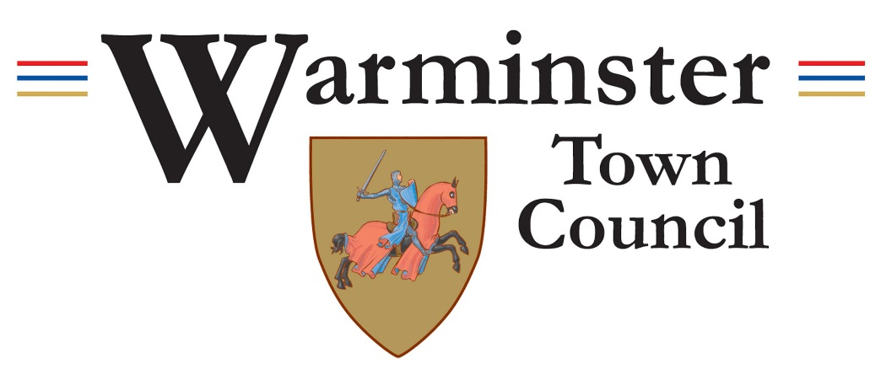

Warminster Town Council

Under 5’s Multiplay replacement, Lake Pleasure Grounds

Contract requirements and schedule of client specification

Contract Reference: PEM 112023

Contents
Page Number
Section 1 - Information and Instructions 3 - 4
Section 2 - Project Timescale and location 4 - 5
Appendix A 6
Section 1 – Information and Instructions
1.1 Introduction
Warminster Town Council maintains nine play areas within the town. The largest of these is in the Lake Pleasure Grounds.
The existing under 5’s Multiplay in the Lake Pleasure Grounds is coming to the end of its life and Warminster Town Council is looking to replace this with a similar metal trail. It is intended to enter into a contract with a suitably qualified and experienced Contractor to undertake the delivery of this.
1.2 Warminster Town Council's Requirements
The fee submissions will comprise a financial element and a written submission. Tender submissions will need to comply with the requirements set out below (Appendix A) as well as contain the documentation and information requested.
1.3 Assessment of Submission
It is the intention of the Town Council to assess the bid through the use of a quality matrix with a weighting of 40% price and 60% quality.
The Town Council does not bind itself to accept the lowest or any tender, nor will it pay any expenses which may be incurred by any Tenderer in the preparation of this tender.
All recipients of these documents, whether or not they submit a tender, shall treat them as private and confidential. Tenders which do not conform to the foregoing instructions will not be considered. All rates and prices must be, and will deem to have been, tendered exclusive of VAT.
1.4 Warminster Town Council Project Team
The Contractor’s team will work alongside the Estate Manager under the overall supervision of the Town Clerk and any other persons nominated by Warminster Town Council.
1.5 Queries
This tender is administered by the officer below, who is based at Warminster Town Council. Any queries regarding the tender process, the proposed contract, or the specification should be addressed to: -
Mr Stuart Legg, Estate Manager
Telephone: 01985 214847
E-mail: stuart.legg@warminster-tc.gov.uk
1.6 Conditions of Contract
The Town Council intend to enter into a formal contract with the successful tenderer.
1.7 Conditions of Tender
The completed Form of Tender and written submission, as specified in the Schedule of Documents below, are to be returned to the Town Clerk at the offices of Warminster Town Council by 12 noon, Monday 18th December 2023. Email address townclerk@warminster-tc.gov.uk
The tenderer must not contact councillors or staff, other than the specified point of contact for the Town Council as identified above, for any reason at all.
The tenderer must not contact councillors or staff to encourage or support their tender outside the prescribed process.
The tenderer is to provide an electronic copy of the submission to the email address above. The electronic copy may be via email but must also be submitted on a USB. This must be sent to Warminster Town Council, Warminster Civic Centre, Sambourne Road, Warminster, Wiltshire, BA12 8LB. The Town Council offices are open between 9am – 4.30pm. Any tenders delivered outside of these times will not be accepted.
Please note, the comprehensiveness and quality of the answers will be used to assess the tender returns.
1.7.1 Schedule of Documents
The documents listed below will be required as part of the submission for assessment.

- A. Programme
Please submit a programme, outlining the key project dates, milestones, and stages.

- B. Financial cost Statement
Please submit a Financial Cost Statement detailing how the contract will be delivered within the submitted budget. This will include an elemental breakdown of all costs.

- C. Work to be carried out
See appendix A.

- D. Experience
Please submit details of previous similar projects that you have undertaken. Please provide contact details for the clients and all relevant information such as value of works, contract duration, and client liaison

E. Insurances
- Please submit copies of your relevant insurances.

F. Health and Safety
Please submit examples of RAMs for installation of play equipment and associated work.

- G. Additional Information
Please submit any additional information that would be beneficial to the assessment of the tender.

Section 2 - Timescale
2.1 Outline of Timescale
In order for all work to be completed within this financial year we have outlined a proposed timescale below: -

- A. Week Commencing 31st October 2023 – Tender documents to be available to contractors.

- B. 18th December 2023 – The completed Form of Tender and written submission, as specified in the schedule of Documents, are to be returned to the offices of Warminster Town Council by 12 noon.

- C. 22nd January 2024 Parks and Estate Committee meeting – Formal approval of contractor by committee, based on assessment of Tender submission.

- F. Week commencing 29th January 2024 – Contract awarded to approved contractor.

- G. Works to begin – Spring 2024

2.2 Location

The play area is located in Warminster.
The Lake Pleasure Grounds BA12 9NP ///ever.imperious.decompose

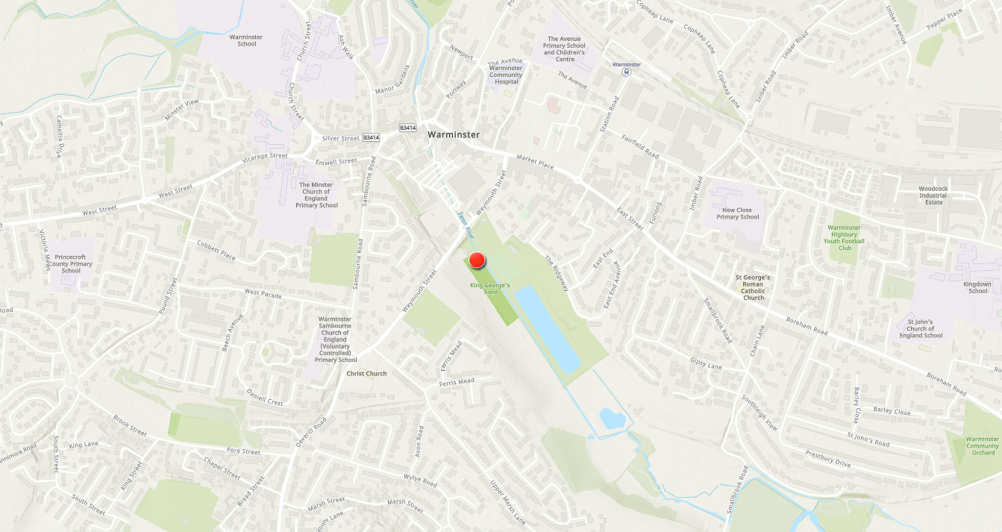
Appendix A

- Lake Pleasure Grounds Under 5’s Multiplay replacement.
- Remove and replace the existing Multiplay with a new version.
- Existing Multiplay to be removed and disposed of.
- Tenderers to design, supply, and install an appropriate Multiplay to fill the existing space making good the
Safety Surface where required. (The council do not require a new play surface).
- All equipment to conform to current play area standards.

