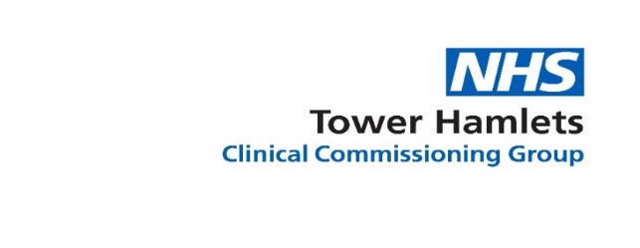

Pre-procurement Engagement Event: An Integrated Homeless Service
NHS Tower Hamlets and City and Hackney Clinical Commissioning Groups (CCG) will be hosting a pre-procurement engagement event in relation to 2 different services for homeless people.
- The Tower Hamlets CCG Integrated Homeless Service planned for 2019, and
- The City and Hackney CCG Greenhouse Specialist Homeless APMS Practice planned for 2019.
This first step of this pre-procurement engagement will be a structured and facilitated workshop with potential bidders and other stakeholders.
The aim of the pre-procurement engagement for the two services will be to test out and refine thinking around the service model requirements. Both CCGs are keen to capture ideas from stakeholders on specific areas of the service model, including feasibility and possible delivery options. This information will be used to inform and develop the service model and service specification.
Both services will include, as a minimum, an APMS Primary Care Service. They will also need to be patient centred, deliver a consistently high quality service and deliver good value for money.
The model for both services will also need to deliver a holistic and seamless service that is accessible, timely, responsive, personalised, and tailored towards the complex needs of homeless people. It will also need to deliver improved health and social care outcomes for the target population.
The target homeless population cohorts the services will focus on:
- Patients who are registered with the Specialist GP APMS Homeless Practice
- Homeless people who are admitted to local hospitals
- Rough sleepers
- People living in hostels or supported accommodation.

Critical Success Factors of the Service
- An integrated, personalised service model is designed around the needs of the patient, and that can respond to their holistic needs.

- Care is integrated at the point of delivery and will deliver seamless, efficient and effective care, eliminating barriers and gate-keeping and improve access to appropriate care.

- Seamless pathways of care and support so that homeless people experience easy, equitable and excellent access to health and social care services.

- A shared commitment to joint action across health, social care and the third sector on improving healthcare, social care, mental health and housing.

- Improved opportunities so that users and stakeholders have a say in how homeless services are delivered in the borough.

- Care is proactive, flexible and responsive to patients needs in order to maximise engagement and change.

- Care is Prevention and Recovery focussed - Preventing rough sleeping and homelessness and supporting individuals to move towards and maintain independence.

- Dignity and Respect - Services must ensure that patient dignity, privacy and confidentiality is protected and preserved and that staff behave professionally and with discretion towards patients at all times.

Registration details
Date: The pre-procurement engagement event will take place on Wednesday 23rd May 2018.
Time: 10am – 3pm.
Venue: Professional Development Centre. 229 Bethnal Green Road, London E2 6AB.
If you are interested in working with the CCGs to develop a service model that will address the needs of this vulnerable population and deliver the critical success factors register to attend now.
Anyone who wants to attend must complete the Attendee registration Form and answer the pre-registration questions. The registration form and answer to the questions need to be submitted no later than Monday 14th May 2018.
Forms must be sent via email to: David.Mansfield3@nhs.net
Attendance will be confirmed no later than 16th May 2018.
A maximum of two attendees per organisation will be permitted to attend due to space limitations.
A total of 30 spaces will be made available. i.e. 15 organisations maximum.
Please note, following receipt of questionnaire responses, Commissioners will review submissions and allocate places in order to ensure the optimum breadth of experience and knowledge necessary to make the engagement event meaningful, within the limitations of Commissioner availability and venue confines. Consequently, Providers are requested to note that submission of a registration form and questionnaire is not a guarantee of attendance. However, outputs from engagement will subsequently be made available to all prospective bidders via this portal, as an upload to this advertisement, thereby ensuring equal treatment, transparency and fairness in practice. Any subsequent Bidder event will also be advertised in alignment with formal procurement timelines (date and venue tbc).
Please note this is a pre-procurement engagement event. Any subsequent procurement will be advertised separately.

