**Call-Off Schedule 1 (Transparency Reports) – N/A**

**Call-Off Schedule 2 (Staff Transfer) – N/A**

**Call-Off Schedule 3 (Continuous Improvement) – N/A**

**Call-Off Schedule 4 (Call Off Tender)**

**Statement Relating to Good Standing (PCR 2015)**

**Contract Title: Provision of Additional LoadRunner Licences (DInfoCom/0231)**

**Contract Number: 705371451**

1. We confirm, to the best of our knowledge and belief, that Akhter Computers Limited including its directors or any other person who has powers of representation, decision or control or is a member of the administrative, management or supervisory body of Akhter Computers Limited has not been convicted of any of the following offences within the past 5 years:

a. conspiracy within the meaning of section 1 or 1A of the Criminal Law Act 1977 or article 9 or 9A of the Criminal Attempts and Conspiracy (Northern Ireland) Order 1983 where that conspiracy relates to participation in a criminal organisation as defined in Article 2 of Council Framework Decision 2008/841/JHA;

b. corruption within the meaning of section 1(2) of the Public Bodies Corrupt Practices Act 1889 or section 1 of the Prevention of Corruption Act 1906;

c. common law offence of bribery;

d. bribery within the meaning of section 1,2 or 6 of the Bribery Act 2010; or section 113 of the Representation of the People Act 1983;

e. any of the following offences, where the offence relates to fraud affecting the European Communities financial interests as defined by Article 1 of the Convention on the protection of the financial interests of the European Communities:

1. the common law offence of cheating the Revenue;

1. the common law offence of conspiracy to defraud;

1. fraud or theft within the meaning of the Theft Act 1968, the Theft Act (Northern Ireland) 1969, the Theft Act 1978 or the Theft (Northern Ireland) Order 1978;

1. fraudulent trading within the meaning of section 458 of the Companies Act 1985, Article 451 of the Companies (Northern Ireland) Order 1986 or section 933 of the Companies Act 2006;

1. fraudulent evasion within the meaning of section 170 of the Customs and Excise Management Act 1979 or section 72 of the Value Added Tax Act 1994;

1. an offence in connection with taxation in the European Union within the meaning of section 71 of the Criminal Justice Act 1993;

1. destroying, defacing or concealing of documents or procuring the extension of a valuable security within the meaning of section 20 of the Theft Act 1968 or section 19 of the Theft Act (Northern Ireland) 1969;

1. fraud within the meaning of section 2,3 or 4 of the Fraud Act 2006; or

1. the possession of articles for use in frauds within the meaning of section 6 of the Fraud Act 2006, or making, adapting, supplying or offering to supply articles for use in frauds within the meaning of section 7 of that Act;

f. any offence listed:

1. in section 41 of the Counter Terrorism Act 2008; or

1. in Schedule 2 to that Act where the court has determined that there is a terrorist connection;

g. any offence under sections 44 to 46 of the Serious Crime Act 2007 which relates to an offence covered by (f) above;

h. money laundering within the meaning of section 340(11) and 415 of the Proceeds of Crime Act 2002;

i. an offence in connection with the proceeds of criminal conduct within the meaning of section 93A, 93B, or 93C of the Criminal Justice Act 1988 or article 45, 46 or 47 of the Proceeds of Crime (Northern Ireland) Order 1996;

j. an offence under section 4 of the Asylum and Immigration (Treatment of Claimants etc) Act 2004;

k. an offence under section 59A of the Sexual Offences Act 2003;

l. an offence under section 71 of the Coroners and Justice Act 2009;

m. an offence in connection with the proceeds of drug trafficking within the meaning of section 49, 50 or 51 of the Drug Trafficking Act 1994; or

n. an offence under section 2 or 4 of the Modern Slavery Act 2015;

o. any other offence within the meaning of Article 57(1) of Public Contracts Directive –

1. as defined by the law of any jurisdiction outside England and

Wales and Northern Ireland: or

(2) created in the law of England and Wales or Northern Ireland after the day on which these Regulations were made;

p. any breach of its obligations relating to the payment of taxes or social security contributions where the breach has been established by a judicial or administrative decision having final and binding effect in accordance with the legal provisions of the country in which it is established or with those of any jurisdictions of the United Kingdom.

2. Akhter Computers Limited further confirms to the best of our knowledge and belief that within the last 3 years it:

a. has fulfilled its obligations relating to the payment of taxes and social security contributions of the country in which it is established or with those of any jurisdictions of the United Kingdom;

b. is not bankrupt or is not the subject of insolvency or winding-up proceedings, where its assets are being administered by a liquidator or by the court, where it is in an agreement with creditors, where its business activities are suspended or it is in any analogous situation arising from a similar procedure under the laws and regulations of any State;

c. has not committed an act of grave professional misconduct, which renders its integrity questionable;

d. has not entered into agreements with other suppliers aimed at distorting competition;

e. Is not subject to a conflict of interest within the meaning of regulation 24;

f. has not been involved in the preparation of this procurement procedure which would result in distortion of competition which could not be remedied by other, less intrusive, measures other than exclusion from this procedure;

g. has not had a contract terminated, damages or other comparable sanctions taken as a result of significant or persistent deficiencies in the performance of a substantive requirement under a prior public contract, a prior contract, or a prior concession contract as defined by the Concession Contracts Regulations 2016;

h. is not guilty of serious misrepresentation in providing any information required by this statement.

i. has not unduly influenced the decision-making process of the Authority or obtained confidential information that may confer upon it undue advantages in the procurement procedure;

j. in relation to procedures for the award of a public services contract, is licensed in the relevant State in which he is established or is a member of an organisation in that relevant State where the law of that relevant State prohibits the provision of the services to be provided under the contract by a person who is not so licensed or who is not such a member;

k. has fulfilled its obligations in the fields of environmental, social and labour law established by EU law, national law, collective agreements or by the international environmental, social and labour law provisions listed in the Public Contracts Directive as amended from time to time (as listed in PPN 8/16 Annex C).

I confirm that to the best of my knowledge my declaration is correct.  I understand that the contracting authority will use the information in the selection process to assess my organisation’s suitability to be invited to participate further in this procurement, and I am signing on behalf of my organisation.  I understand that the Authority may reject my submission if there is a failure to provide a declaration or if I provide false or misleading information

|  |
| --- |
|  |
| **Organisation’s name** |
| **Signed   REDACTED**  **(By Director of the Organisation or equivalent)** |
| **Name: REDACTED** |
| **Position: REDACTED** |
| **Date: 18th Oct, 2022** |

REDACTED

**Call-Off Schedule 5 (Pricing Details)**

**Core Years + Option year**

REDACTED

**Call-Off Schedule 6 (ICT Services)**

1. Definitions
   1. In this Schedule, the following words shall have the following meanings and they shall supplement Joint Schedule 1 (Definitions):

|  |  |
| --- | --- |
| **"Buyer Property"** | the property, other than real property and IPR, including the Buyer System, any equipment issued or made available to the Supplier by the Buyer in connection with this Contract; |
| **"Buyer Software"** | any software which is owned by or licensed to the Buyer and which is or will be used by the Supplier for the purposes of providing the Deliverables; |
| **"Buyer System"** | the Buyer's computing environment (consisting of hardware, software and/or telecommunications networks or equipment) used by the Buyer or the Supplier in connection with this Contract which is owned by or licensed to the Buyer by a third party and which interfaces with the Supplier System or which is necessary for the Buyer to receive the Deliverables; |
| **"Defect"** | any of the following:   1. any error, damage or defect in the manufacturing of a Deliverable; or 2. any error or failure of code within the Software which causes a Deliverable to malfunction or to produce unintelligible or incorrect results; or |
|  | 1. any failure of any Deliverable to provide the performance, features and functionality specified in the requirements of the Buyer or the Documentation (including any adverse effect on response times) regardless of whether or not it prevents the relevant Deliverable from passing any Test required under this Call Off Contract; or 2. any failure of any Deliverable to operate in conjunction with or interface with any other Deliverable in order to provide the performance, features and functionality specified in the requirements of the Buyer or the Documentation (including any adverse effect on response times) regardless of whether or not it prevents the relevant Deliverable from passing any Test required under this Contract; |
| **"Emergency Maintenance"** | ad hoc and unplanned maintenance provided by the Supplier where either Party reasonably suspects that the ICT Environment or the Services, or any part of the ICT Environment or the Services, has or may have developed a fault; |
| **"ICT Environment"** | the Buyer System and the Supplier System; |
| **"Licensed Software"** | all and any Software licensed by or through the Supplier, its Sub-Contractors or any third party to the Buyer for the purposes of or pursuant to this Call Off Contract, including any COTS Software; |
| **"Maintenance Schedule"** | has the meaning given to it in paragraph 8 of this Schedule; |
| **"Malicious Software"** | any software program or code intended to destroy, interfere with, corrupt, or cause undesired effects on program files, data or other information, executable code or application software macros, whether or not its operation is immediate or delayed, and whether the malicious software is introduced wilfully, negligently or without knowledge of its existence; |
| **"New Release"** | an item produced primarily to extend, alter or improve the Software and/or any Deliverable by providing additional functionality or performance enhancement (whether or not defects in the Software and/or Deliverable are also corrected) while still retaining the original designated purpose of that item; |
| **"Open Source Software"** | computer software that has its source code made available subject to an open-source licence under which the owner of the copyright and other IPR in such software provides the rights to use, study, change and distribute the software to any and all persons and for any and all purposes free of charge; |
| **"Operating Environment"** | means the Buyer System and any premises (including the Buyer Premises, the Supplier’s premises or third-party premises) from, to or at which:   * 1. the Deliverables are (or are to be) provided; or   2. the Supplier manages, organises or otherwise directs the provision or the use of the Deliverables; or   3. where any part of the Supplier System is situated; |
| **"Permitted Maintenance"** | has the meaning given to it in paragraph 8.2 of this Schedule; |
| **"Quality Plans"** | has the meaning given to it in paragraph 6.1 of this Schedule; |
| **"Sites"** | has the meaning given to it in Joint Schedule 1(Definitions), and for the purposes of this Call Off Schedule shall also include any premises from, to or at which physical interface with the Buyer System takes place; |
| **"Software"** | Specially Written Software, COTS Software and non-COTS Supplier and third party Software; |
| **"Software Supporting Materials"** | has the meaning given to it in paragraph 9.1 of this Schedule; |
| **"Source Code"** | computer programs and/or data in eye-readable form and in such form that it can be compiled or interpreted into equivalent binary code together with all related design comments, flow charts, technical information and documentation necessary for the use, reproduction, maintenance, modification and enhancement of such software; |
| **"Specially Written Software"** | any software (including database software, linking instructions, test scripts, compilation instructions and test instructions) created by the Supplier (or by a Sub-Contractor or other third party on behalf of the Supplier) specifically for the purposes of this Contract, including any modifications or enhancements to COTS Software. For the avoidance of doubt Specially Written Software does not constitute New IPR; |
| **"Supplier System"** | the information and communications technology system used by the Supplier in supplying the Deliverables, including the COTS Software, the Supplier Equipment, configuration and management utilities, calibration and testing tools and related cabling (but excluding the Buyer System); |

1. When this Schedule should be used
   1. This Schedule is designed to provide additional provisions necessary to facilitate the provision of ICT services which are part of the Deliverables.
2. **Buyer due diligence requirements** 
   1. This paragraph 3 applies where the Buyer has conducted a Further Competition. The Supplier shall satisfy itself of all relevant details, including but not limited to, details relating to the following;
      1. suitability of the existing and (to the extent that it is defined or reasonably foreseeable at the Start Date) future Operating Environment;
      2. operating processes and procedures and the working methods of the Buyer;
      3. ownership, functionality, capacity, condition and suitability for use in the provision of the Deliverables of the Buyer Assets; and
      4. existing contracts (including any licences, support, maintenance and other contracts relating to the Operating Environment) referred to in the Due Diligence Information which may be novated to, assigned to or managed by the Supplier under this Contract and/or which the Supplier will require the benefit of for the provision of the Deliverables.
   2. The Supplier confirms that it has advised the Buyer in writing of:
      1. each aspect, if any, of the Operating Environment that is not suitable for the provision of the Deliverables;
      2. the actions needed to remedy each such unsuitable aspect; and
      3. a timetable for and the costs of those actions.
3. **Software warranty**
   1. The Supplier represents and warrants that:
      1. it has and shall continue to have all necessary rights in and to the Licensed Software made available by the Supplier (and/or any Sub-Contractor) to the Buyer which are necessary for the performance of the Supplier’s obligations under this Contract including the receipt of the Deliverables by the Buyer;
      2. all components of the Specially Written Software shall:
         1. be free from material design and programming errors;
         2. perform in all material respects in accordance with the relevant specifications and Documentation; and
         3. not infringe any IPR.
4. Provision of ICT Services
   1. The Supplier shall:
      1. ensure that the release of any new COTS Software in which the Supplier owns the IPR, or upgrade to any Software in which the Supplier owns the IPR complies with any interface requirements of the Buyer specified in this Contract and (except in relation to new Software or upgrades which are released to address Malicious Software) shall notify the Buyer three (3) Months before the release of any new COTS Software or Upgrade;
      2. ensure that all Software including upgrades, updates and New Releases used by or on behalf of the Supplier are currently supported versions of that Software and perform in all material respects in accordance with the relevant specification;
      3. ensure that the Supplier System will be free of all encumbrances;
      4. ensure that the Deliverables are fully compatible with any Buyer Software, Buyer System, or otherwise used by the Supplier in connection with this Contract;
      5. minimise any disruption to the Services and the ICT Environment and/or the Buyer's operations when providing the Deliverables;
5. **Standards and Quality Requirements**
   1. The Supplier shall, where specified by the Buyer as part of their Further Competition, and in accordance with agreed timescales, develop quality plans that ensure that all aspects of the Deliverables are the subject of quality management systems and are consistent with BS EN ISO 9001 or any equivalent standard which is generally recognised as having replaced it ("**Quality Plans**")**.**
   2. The Supplier shall seek Approval from the Buyer (not be unreasonably withheld or delayed) of the Quality Plans before implementing them. Approval shall not act as an endorsement of the Quality Plans and shall not relieve the Supplier of its responsibility for ensuring that the Deliverables are provided to the standard required by this Contract.
   3. Following the approval of the Quality Plans, the Supplier shall provide all Deliverables in accordance with the Quality Plans.
   4. The Supplier shall ensure that the Supplier Personnel shall at all times during the Call Off Contract Period:
      1. be appropriately experienced, qualified and trained to supply the Deliverables in accordance with this Contract;
      2. apply all due skill, care, diligence in faithfully performing those duties and exercising such powers as necessary in connection with the provision of the Deliverables; and
      3. obey all lawful instructions and reasonable directions of the Buyer (including, if so required by the Buyer, the ICT Policy) and provide the Deliverables to the reasonable satisfaction of the Buyer.
6. **ICT Audit**
   1. The Supplier shall allow any auditor access to the Supplier premises to:
      1. inspect the ICT Environment and the wider service delivery environment (or any part of them);
      2. review any records created during the design and development of the Supplier System and pre-operational environment such as information relating to Testing;
      3. review the Supplier’s quality management systems including all relevant Quality Plans.
7. **Maintenance of the ICT Environment**
   1. If specified by the Buyer undertaking a Further Competition, the Supplier shall create and maintain a rolling schedule of planned maintenance to the ICT Environment ("**Maintenance Schedule**") and make it available to the Buyer for Approval in accordance with the timetable and instructions specified by the Buyer.
   2. Once the Maintenance Schedule has been Approved, the Supplier shall only undertake such planned maintenance (which shall be known as "**Permitted Maintenance**") in accordance with the Maintenance Schedule.
   3. The Supplier shall give as much notice as is reasonably practicable to the Buyer prior to carrying out any Emergency Maintenance.
   4. The Supplier shall carry out any necessary maintenance (whether Permitted Maintenance or Emergency Maintenance) where it reasonably suspects that the ICT Environment and/or the Services or any part thereof has or may have developed a fault. Any such maintenance shall be carried out in such a manner and at such times so as to avoid (or where this is not possible so as to minimise) disruption to the ICT Environment and the provision of the Deliverables.
8. **Intellectual Property Rights in ICT**
   1. Assignments granted by the Supplier: Specially Written Software
      1. The Supplier assigns (by present assignment of future rights to take effect immediately on it coming into existence) to the Buyer with full guarantee (or shall procure assignment to the Buyer), title to and all rights and interest in the Specially Written Software together with and including:
         1. the Documentation, Source Code and the Object Code of the Specially Written Software; and
         2. all build instructions, test instructions, test scripts, test data, operating instructions and other documents and tools necessary for maintaining and supporting the Specially Written Software and the New IPR (together the "**Software Supporting Materials**").
      2. The Supplier shall:
         1. inform the Buyer of all Specially Written Software or New IPRs that are a modification, customisation, configuration or enhancement to any COTS Software;
         2. deliver to the Buyer the Specially Written Software and any computer program elements of the New IPRs in both Source Code and Object Code forms together with relevant Documentation and all related Software Supporting Materials within seven days of completion or, if a relevant Milestone has been identified in an Implementation Plan, Achievement of that Milestone and shall provide updates of them promptly following each new release of the Specially Written Software, in each case on media that is reasonably acceptable to the Buyer and the Buyer shall become the owner of such media upon receipt; and
         3. without prejudice to paragraph 9.1.2(b) provide full details to the Buyer of any of the Supplier’s Existing IPRs or Third Party IPRs which are embedded or which are an integral part of the Specially Written Software or New IPR and the Supplier hereby grants to the Buyer and shall procure that any relevant third party licensor shall grant to the Buyer a perpetual, irrevocable, non-exclusive, assignable, royalty-free licence to use, sub-license and/or commercially exploit such Supplier’s Existing IPRs and Third Party IPRs to the extent that it is necessary to enable the Buyer to obtain the full benefits of ownership of the Specially Written Software and New IPRs.
      3. The Supplier shall promptly execute all such assignments as are required to ensure that any rights in the Specially Written Software and New IPRs are properly transferred to the Buyer.
   2. Licences for non-COTS IPR from the Supplier and third parties to the Buyer
      1. Unless the Buyer gives its Approval the Supplier must not use any:
9. of its own Existing IPR that is not COTS Software;
10. third party software that is not COTS Software
    * 1. Where the Buyer Approves the use of the Supplier’s Existing IPR that is not COTS Software the Supplier shall grant to the Buyer a perpetual, royalty-free and non-exclusive licence to use adapt, and sub-license the same for any purpose relating to the Deliverables (or substantially equivalent deliverables) or for any purpose relating to the exercise of the Buyer’s (or, if the Buyer is a Central Government Body, any other Central Government Body’s) business or function including the right to load, execute, store, transmit, display and copy (for the purposes of archiving, backing-up, loading, execution, storage, transmission or display) for the Call Off Contract Period and after expiry of the Contract to the extent necessary to ensure continuity of service and an effective transition of Services to a Replacement Supplier.
      2. Where the Buyer Approves the use of third-party Software that is not COTS Software the Supplier shall procure that the owners or the authorised licensors of any such Software grant a direct licence to the Buyer on terms at least equivalent to those set out in Paragraph 9.2.2. If the Supplier cannot obtain such a licence for the Buyer it shall:
         1. notify the Buyer in writing giving details of what licence terms can be obtained and whether there are alternative software providers which the Supplier could seek to use; and
         2. only use such third party IPR as referred to at paragraph 9.2.3(a) if the Buyer Approves the terms of the licence from the relevant third party.
      3. Where the Supplier is unable to provide a license to the Supplier’s Existing IPR in accordance with Paragraph 9.2.2 above, it must meet the requirement by making use of COTS Software or Specially Written Software.
      4. The Supplier may terminate a licence granted under paragraph 9.2.2 by giving at least thirty (30) days’ notice in writing if there is an Authority Cause which constitutes a material Default which, if capable of remedy, is not remedied within twenty (20) Working Days after the Supplier gives the Buyer written notice specifying the breach and requiring its remedy.
    1. Licenses for COTS Software by the Supplier and third parties to the Buyer
       1. The Supplier shall either grant, or procure that the owners or the authorised licensors of any COTS Software grant, a direct licence to the Buyer on terms no less favourable than those standard commercial terms on which such software is usually made commercially available.
       2. Where the Supplier owns the COTS Software it shall make available the COTS software to a Replacement Supplier at a price and on terms no less favourable than those standard commercial terms on which such software is usually made commercially available.
       3. Where a third party is the owner of COTS Software licensed in accordance with this Paragraph 9.3 the Supplier shall support the Replacement Supplier to make arrangements with the owner or authorised licencee to renew the license at a price and on terms no less favourable than those standard commercial terms on which such software is usually made commercially available.
       4. The Supplier shall notify the Buyer within seven (7) days of becoming aware of any COTS Software which in the next thirty-six (36) months:
          1. will no longer be maintained or supported by the developer; or
          2. will no longer be made commercially available
    2. Buyer’s right to assign/novate licences
       1. The Buyer may assign, novate or otherwise transfer its rights and obligations under the licences granted pursuant to paragraph 9.2 (to:
          1. a Central Government Body; or
          2. to any body (including any private sector body) which performs or carries on any of the functions and/or activities that previously had been performed and/or carried on by the Buyer.
       2. If the Buyer ceases to be a Central Government Body, the successor body to the Buyer shall still be entitled to the benefit of the licences granted in paragraph 9.2.
    3. Licence granted by the Buyer
       1. The Buyer grants to the Supplier a royalty-free, non-exclusive, non-transferable licence during the Contract Period to use the Buyer Software and the Specially Written Software solely to the extent necessary for providing the Deliverables in accordance with this Contract, including the right to grant sub-licences to Sub-Contractors provided that any relevant Sub-Contractor has entered into a confidentiality undertaking with the Supplier on the same terms as set out in Clause 15 (Confidentiality).
    4. Open Source Publication
       1. Unless the Buyer otherwise agrees in advance in writing (and subject to paragraph 9.6.3) all Specially Written Software and computer program elements of New IPR shall be created in a format, or able to be converted (in which case the Supplier shall also provide the converted format to the Buyer) into a format, which is:
          1. suitable for publication by the Buyer as Open Source; and
          2. based on Open Standards (where applicable),

and the Buyer may, at its sole discretion, publish the same as Open Source.

* + 1. The Supplier hereby warrants that the Specially Written Software and the New IPR:
       1. are suitable for release as Open Source and that the Supplier has used reasonable endeavours when developing the same to ensure that publication by the Buyer will not enable a third party to use them in any way which could reasonably be foreseen to compromise the operation, running or security of the Specially Written Software, New IPRs or the Buyer System;
       2. have been developed using reasonable endeavours to ensure that their publication by the Buyer shall not cause any harm or damage to any party using them;
       3. do not contain any material which would bring the Buyer into disrepute;
       4. can be published as Open Source without breaching the rights of any third party;
       5. will be supplied in a format suitable for publication as Open Source ("**the Open Source Publication Material**") no later than the date notified by the Buyer to the Supplier; and
       6. do not contain any Malicious Software.
    2. Where the Buyer has Approved a request by the Supplier for any part of the Specially Written Software or New IPRs to be excluded from the requirement to be in an Open Source format due to the intention to embed or integrate Supplier Existing IPRs and/or Third Party IPRs (and where the Parties agree that such IPRs are not intended to be published as Open Source), the Supplier shall:
       1. as soon as reasonably practicable, provide written details of the nature of the IPRs and items or Deliverables based on IPRs which are to be excluded from Open Source publication; and
       2. include in the written details and information about the impact that inclusion of such IPRs or Deliverables based on such IPRs, will have on any other Specially Written Software and/or New IPRs and the Buyer’s ability to publish such other items or Deliverables as Open Source.
  1. Malicious Software
     1. The Supplier shall, throughout the Contract Period, use the latest versions of anti-virus definitions and software available from an industry accepted anti-virus software vendor to check for, contain the spread of, and minimise the impact of Malicious Software.
     2. If Malicious Software is found, the Parties shall co-operate to reduce the effect of the Malicious Software and, particularly if Malicious Software causes loss of operational efficiency or loss or corruption of Government Data, assist each other to mitigate any losses and to restore the provision of the Deliverables to its desired operating efficiency.
     3. Any cost arising out of the actions of the Parties taken in compliance with the provisions of paragraph 9.7.2 shall be borne by the Parties as follows:
        1. by the Supplier, where the Malicious Software originates from the Supplier Software, the third party Software supplied by the Supplier or the Government Data (whilst the Government Data was under the control of the Supplier) unless the Supplier can demonstrate that such Malicious Software was present and not quarantined or otherwise identified by the Buyer when provided to the Supplier; and
        2. by the Buyer, if the Malicious Software originates from the Buyer Software or the Buyer Data (whilst the Buyer Data was under the control of the Buyer).

1. **Supplier-Furnished Terms**
   1. Software Licence Terms
      1. Terms for licensing of non-COTS third party software in accordance with Paragraph 9.2.3 are detailed in Annex A of this Call-Off Schedule 6.
      2. Terms for licensing of COTS software in accordance with Paragraph 9.3 are detailed in Annex B of this Call-Off Schedule 6.
   2. Software Support & Maintenance Terms
      1. Additional terms for provision of Software Support & Maintenance Services are detailed in Annex C of this Call-Off Schedule 6.
   3. Software as a Service Terms
      1. Additional terms for provision of a Software as a Service solution are detailed in Annex D of this Call-Off Schedule 6.
   4. Device as a Service Terms
      1. Additional terms for provision of a Device as a Service solution are detailed in Annex E to this Call-Off Schedule 6;
      2. Where Annex E is used the following Clauses of the Core Terms shall not apply to the provision of the Device as a Service solution:

Clause 8.7

Clause 10.2

* + - 1. Clause 10.3.2]

**11. Customer Premises**

11.1 Licence to occupy Customer Premises

11.1.1 Any Customer Premises shall be made available to the Supplier on a non-exclusive licence basis free of charge and shall be used by the Supplier solely for the purpose of performing its obligations under this Call- Off Contract. The Supplier shall have the use of such Customer Premises as licensee and shall vacate the same immediately upon completion, termination, expiry or abandonment of this Call-Off Contract [ and in accordance with Call-Off Schedule 10 (Exit Management)].

11.1.2 The Supplier shall limit access to the Buyer Premises to such Supplier Staff as is necessary to enable it to perform its obligations under this Call-Off Contract and the Supplier shall co-operate (and ensure that the Supplier Staff co-operate) with such other persons working concurrently on such Buyer Premises as the Buyer may reasonably request.

11.1.3 Save in relation to such actions identified by the Supplier in accordance with paragraph 3.2 of this Call-Off Schedule 6 and set out in the Order Form (or elsewhere in this Call Off Contract), should the Supplier require modifications to the Buyer Premises, such modifications shall be subject to Approval and shall be carried out by the Buyer at the Supplier's expense. The Buyer shall undertake any modification work which it approves pursuant to this paragraph 11.1.3 without undue delay. Ownership of such modifications shall rest with the Buyer.

11.1.4 The Supplier shall observe and comply with such rules and regulations as may be in force at any time for the use of such Buyer Premises and conduct of personnel at the Buyer Premises as determined by the Buyer, and the Supplier shall pay for the full cost of making good any damage caused by the Supplier Staff other than fair wear and tear. For the avoidance of doubt, damage includes without limitation damage to the fabric of the buildings, plant, fixed equipment or fittings therein.

11.1.5 The Parties agree that there is no intention on the part of the Buyer to create a tenancy of any nature whatsoever in favour of the Supplier or the Supplier Staff and that no such tenancy has or shall come into being and, notwithstanding any rights granted pursuant to this Call-Off Contract, the Buyer retains the right at any time to use any Buyer Premises in any manner it sees fit.

11.2 Security of Buyer Premises

11.2.1 The Buyer shall be responsible for maintaining the security of the Buyer Premises. The Supplier shall comply with the reasonable security requirements of the Buyer while on the Buyer Premises.

11.2.2 The Buyer shall afford the Supplier upon Approval (the decision to Approve or not will not be unreasonably withheld or delayed) an opportunity to inspect its physical security arrangements.

**12. Buyer Property**

12.1 Where the Buyer issues Buyer Property free of charge to the Supplier such Buyer Property shall be and remain the property of the Buyer and the Supplier irrevocably licences the Buyer and its agents to enter upon any premises of the Supplier during normal business hours on reasonable notice to recover any such Buyer Property.

12.2 The Supplier shall not in any circumstances have a lien or any other interest on the Buyer Property and at all times the Supplier shall possess the Buyer Property as fiduciary agent and bailee of the Buyer.

12.3 The Supplier shall take all reasonable steps to ensure that the title of the Buyer to the Buyer Property and the exclusion of any such lien or other interest are brought to the notice of all Sub-Contractors and other appropriate persons and shall, at the Buyer's request, store the Buyer Property separately and securely and ensure that it is clearly identifiable as belonging to the Buyer.

12.4 The Buyer Property shall be deemed to be in good condition when received by or on behalf of the Supplier unless the Supplier notifies the Buyer otherwise within five (5) Working Days of receipt.

12.5 The Supplier shall maintain the Buyer Property in good order and condition (excluding fair wear and tear) and shall use the Buyer Property solely in connection with this Call-Off Contract and for no other purpose without Approval.

12.6 The Supplier shall ensure the security of all the Buyer Property whilst in its possession, either on the Sites or elsewhere during the supply of the Services, in accordance with Call- Off Schedule 9 (Security) and the Buyer’s reasonable security requirements from time to time.

12.7 The Supplier shall be liable for all loss of, or damage to the Buyer Property, (excluding fair wear and tear), unless such loss or damage was solely caused by a Buyer Cause. The Supplier shall inform the Buyer immediately of becoming aware of any defects appearing in or losses or damage occurring to the Buyer Property.

**13. Supplier Equipment**

13.1 Unless otherwise stated in this Call Off Contract, the Supplier shall provide all the Supplier Equipment necessary for the provision of the Services.

13.2 The Supplier shall not deliver any Supplier Equipment nor begin any work on the Buyer Premises without obtaining Approval.

13.3 The Supplier shall be solely responsible for the cost of carriage of the Supplier Equipment to the Sites and/or any Buyer Premises, including its off-loading, removal of all packaging and all other associated costs. Likewise on the Call-Off Expiry Date the Supplier shall be responsible for the removal of all relevant Supplier Equipment from the Sites and/or any Buyer Premises, including the cost of packing, carriage and making good the Sites and/or the Buyer Premises following removal.

13.4 All the Supplier's property, including Supplier Equipment, shall remain at the sole risk and responsibility of the Supplier, except that the Buyer shall be liable for loss of or damage to any of the Supplier's property located on Buyer Premises which is due to the negligent act or omission of the Buyer.

13.5 Subject to any express provision of the BCDR Plan (if applicable) to the contrary, the loss or destruction for any reason of any Supplier Equipment shall not relieve the Supplier of its obligation to supply the Services in accordance with this Call Off Contract, including the Service Levels.

13.6 The Supplier shall maintain all Supplier Equipment within the Sites and/or the Buyer Premises in a safe, serviceable and clean condition.

13.7 The Supplier shall, at the Buyer’s written request, at its own expense and as soon as reasonably practicable:

13.7.1 remove from the Buyer Premises any Supplier Equipment or any component part of Supplier Equipment which in the reasonable opinion of the Buyer is either hazardous, noxious or not in accordance with this Call-Off Contract; and

13.7.2 replace such Supplier Equipment or component part of Supplier Equipment with a suitable substitute item of Supplier Equipment.

**Annex A: Non-COTS Third Party Software Licensing Terms – N/A**

**Annex B: COTS Licensing Terms**

[Supplier to enter]

**Annex C: Software Support & Maintenance Terms**

[Supplier to enter]

**Annex D: Software as a Service Terms – N/A**

**Annex E*:* Device as a Service Terms – N/A**

**Call-Off Schedule 7 (Key Supplier Staff) - N/A**

**Call-Off Schedule 8 (Business Continuity and Disaster Recovery) – N/A**

Call-Off Schedule 9 (Security)

Part A: Short Form Security Requirements

1. Definitions

### In this Schedule, the following words shall have the following meanings and they shall supplement Joint Schedule 1 (Definitions):

|  |  |
| --- | --- |
| "Breach of Security" | 1. the occurrence of:    1. any unauthorised access to or use of the Deliverables, the Sites and/or any Information and Communication Technology ("ICT"), information or data (including the Confidential Information and the Government Data) used by the Buyer and/or the Supplier in connection with this Contract; and/or    2. the loss and/or unauthorised disclosure of any information or data (including the Confidential Information and the Government Data), including any copies of such information or data, used by the Buyer and/or the Supplier in connection with this Contract, 2. in either case as more particularly set out in the Security Policy where the Buyer has required compliance therewith in accordance with paragraph 2.2; |
| "Security Management Plan" | 1. the Supplier's security management plan prepared pursuant to this Schedule, a draft of which has been provided by the Supplier to the Buyer and as updated from time to time. |

# Complying with security requirements and updates to them

# The Buyer and the Supplier recognise that, where specified in Framework Schedule 4 (Framework Management), CCS shall have the right to enforce the Buyer's rights under this Schedule.

# The Supplier shall comply with the requirements in this Schedule in respect of the Security Management Plan. Where specified by a Buyer that has undertaken a Further Competition it shall also comply with the Security Policy and shall ensure that the Security Management Plan produced by the Supplier fully complies with the Security Policy.

# Where the Security Policy applies the Buyer shall notify the Supplier of any changes or proposed changes to the Security Policy.

# If the Supplier believes that a change or proposed change to the Security Policy will have a material and unavoidable cost implication to the provision of the Deliverables it may propose a Variation to the Buyer. In doing so, the Supplier must support its request by providing evidence of the cause of any increased costs and the steps that it has taken to mitigate those costs. Any change to the Charges shall be subject to the Variation Procedure.

## Until and/or unless a change to the Charges is agreed by the Buyer pursuant to the Variation Procedure the Supplier shall continue to provide the Deliverables in accordance with its existing obligations.

# Security Standards

## The Supplier acknowledges that the Buyer places great emphasis on the reliability of the performance of the Deliverables, confidentiality, integrity and availability of information and consequently on security.

## The Supplier shall be responsible for the effective performance of its security obligations and shall at all times provide a level of security which:

### is in accordance with the Law and this Contract;

### as a minimum demonstrates Good Industry Practice;

### meets any specific security threats of immediate relevance to the Deliverables and/or the Government Data; and

### where specified by the Buyer in accordance with paragraph 2.2 complies with the Security Policy and the ICT Policy.

## The references to standards, guidance and policies contained or set out in Paragraph 3.2 shall be deemed to be references to such items as developed and updated and to any successor to or replacement for such standards, guidance and policies, as notified to the Supplier from time to time.

## In the event of any inconsistency in the provisions of the above standards, guidance and policies, the Supplier should notify the Buyer's Representative of such inconsistency immediately upon becoming aware of the same, and the Buyer's Representative shall, as soon as practicable, advise the Supplier which provision the Supplier shall be required to comply with.

# Security Management Plan

## Introduction

### The Supplier shall develop and maintain a Security Management Plan in accordance with this Schedule. The Supplier shall thereafter comply with its obligations set out in the Security Management Plan.

## Content of the Security Management Plan

### The Security Management Plan shall:

#### comply with the principles of security set out in Paragraph 3 and any other provisions of this Contract relevant to security;

#### identify the necessary delegated organisational roles for those responsible for ensuring it is complied with by the Supplier;

#### detail the process for managing any security risks from Subcontractors and third parties authorised by the Buyer with access to the Deliverables, processes associated with the provision of the Deliverables, the Buyer Premises, the Sites and any ICT, Information and data (including the Buyer’s Confidential Information and the Government Data) and any system that could directly or indirectly have an impact on that Information, data and/or the Deliverables;

#### be developed to protect all aspects of the Deliverables and all processes associated with the provision of the Deliverables, including the Buyer Premises, the Sites, and any ICT, Information and data (including the Buyer’s Confidential Information and the Government Data) to the extent used by the Buyer or the Supplier in connection with this Contract or in connection with any system that could directly or indirectly have an impact on that Information, data and/or the Deliverables;

#### set out the security measures to be implemented and maintained by the Supplier in relation to all aspects of the Deliverables and all processes associated with the provision of the Goods and/or Services and shall at all times comply with and specify security measures and procedures which are sufficient to ensure that the Deliverables comply with the provisions of this Contract;

#### set out the plans for transitioning all security arrangements and responsibilities for the Supplier to meet the full obligations of the security requirements set out in this Contract and, where necessary in accordance with paragraph 2.2 the Security Policy; and

#### be written in plain English in language which is readily comprehensible to the staff of the Supplier and the Buyer engaged in the provision of the Deliverables and shall only reference documents which are in the possession of the Parties or whose location is otherwise specified in this Schedule.

## Development of the Security Management Plan

### Within twenty (20)Working Days after the Start Date and in accordance with Paragraph 4.4, the Supplier shall prepare and deliver to the Buyer for Approval a fully complete and up to date Security Management Plan which will be based on the draft Security Management Plan.

* + 1. If the Security Management Plan submitted to the Buyer in accordance with Paragraph 4.3.1, or any subsequent revision to it in accordance with Paragraph 4.4, is Approved it will be adopted immediately and will replace the previous version of the Security Management Plan and thereafter operated and maintained in accordance with this Schedule. If the Security Management Plan is not Approved, the Supplier shall amend it within ten (10) Working Days of a notice of non-approval from the Buyer and re-submit to the Buyer for Approval. The Parties will use all reasonable endeavours to ensure that the approval process takes as little time as possible and in any event no longer than fifteen (15) Working Days from the date of its first submission to the Buyer. If the Buyer does not approve the Security Management Plan following its resubmission, the matter will be resolved in accordance with the Dispute Resolution Procedure.
    2. The Buyer shall not unreasonably withhold or delay its decision to Approve or not the Security Management Plan pursuant to Paragraph 4.3.2. However a refusal by the Buyer to Approve the Security Management Plan on the grounds that it does not comply with the requirements set out in Paragraph 4.2 shall be deemed to be reasonable.

### Approval by the Buyer of the Security Management Plan pursuant to Paragraph 4.3.2 or of any change to the Security Management Plan in accordance with Paragraph 4.4 shall not relieve the Supplier of its obligations under this Schedule.

## Amendment of the Security Management Plan

### The Security Management Plan shall be fully reviewed and updated by the Supplier at least annually to reflect:

#### emerging changes in Good Industry Practice;

#### any change or proposed change to the Deliverables and/or associated processes;

#### where necessary in accordance with paragraph 2.2, any change to the Security Policy;

#### any new perceived or changed security threats; and

#### any reasonable change in requirements requested by the Buyer.

### The Supplier shall provide the Buyer with the results of such reviews as soon as reasonably practicable after their completion and amendment of the Security Management Plan at no additional cost to the Buyer. The results of the review shall include, without limitation:

#### suggested improvements to the effectiveness of the Security Management Plan;

#### updates to the risk assessments; and

#### suggested improvements in measuring the effectiveness of controls.

### Subject to Paragraph 4.4.4, any change or amendment which the Supplier proposes to make to the Security Management Plan (as a result of a review carried out in accordance with Paragraph 4.4.1, a request by the Buyer or otherwise) shall be subject to the Variation Procedure.

### The Buyer may, acting reasonably, Approve and require changes or amendments to the Security Management Plan to be implemented on timescales faster than set out in the Variation Procedure but, without prejudice to their effectiveness, all such changes and amendments shall thereafter be subject to the Variation Procedure for the purposes of formalising and documenting the relevant change or amendment.

# Security breach

# Either Party shall notify the other in accordance with the agreed security incident management process (as detailed in the Security Management Plan) upon becoming aware of any Breach of Security or any potential or attempted Breach of Security.

## Without prejudice to the security incident management process, upon becoming aware of any of the circumstances referred to in Paragraph 5.1, the Supplier shall:

### immediately take all reasonable steps (which shall include any action or changes reasonably required by the Buyer) necessary to:

#### minimise the extent of actual or potential harm caused by any Breach of Security;

#### remedy such Breach of Security to the extent possible and protect the integrity of the Buyer and the provision of the Goods and/or Services to the extent within its control against any such Breach of Security or attempted Breach of Security;

#### prevent an equivalent breach in the future exploiting the same cause failure; and

#### as soon as reasonably practicable provide to the Buyer, where the Buyer so requests, full details (using the reporting mechanism defined by the Security Management Plan) of the Breach of Security or attempted Breach of Security, including a cause analysis where required by the Buyer.

## In the event that any action is taken in response to a Breach of Security or potential or attempted Breach of Security that demonstrates non-compliance of the Security Management Plan with the Security Policy (where relevant in accordance with paragraph 2.2) or the requirements of this Schedule, then any required change to the Security Management Plan shall be at no cost to the Buyer.

Part B: Long Form Security Requirements – N/A

**Part C: Commodity Service Security Requirements – N/A**

Call-Off Schedule 10 (Exit Management)

Part A: Long Form Exit Management Requirements – N/A

**Part B: Short Form Exit Management Requirements**

* 1. Within 20 (twenty) working days of the Start Date the Supplier must provide the Buyer with an exit plan which ensures continuity of service and which the Supplier will follow.
  2. The Supplier must ensure that the exit plan clearly sets out the Supplier’s methodology for achieving an orderly transition of the Services from the Supplier to the Buyer or its Replacement Supplier at the expiry or if the contract ends before the scheduled expiry.
  3. The exit plan should set out full details of timescales, activities and roles and responsibilities of the Parties for:
     1. the transfer to the Buyer of any technical information, instructions, manuals and code reasonably required by the Buyer to enable a smooth migration from the Supplier;
     2. the strategy for export and migration of Buyer data from the Supplier system to the Buyer or a Replacement Supplier, including conversion to open standards or other standards required by the Buyer;
     3. the transfer of project- specific IPR items and other Buyer customisations, configurations and databases to the Buyer or a replacement supplier;
     4. the testing and assurance strategy for exported Buyer data;
     5. if relevant, TUPE-related activity to comply with the TUPE regulations;
     6. any other activities and information which are reasonably required to ensure continuity of Service during the exit period and an orderly transition.
  4. When requested, the Supplier will help the Buyer to migrate the Services to a Replacement Supplier in line with the exit plan. This will be at the Supplier’s own expense if the Call-Off Contract ended before the Expiry Date due to Supplier cause. Otherwise any additional costs incurred by the Supplier in providing such assistance shall be subject to the Variation Procedure.

Call-Off Schedule 11 (Installation Works) - N/A

**Call-Off Schedule 12 (Clustering) – N/A**

Call-Off Schedule 13 (Implementation Plan and Testing) – N/A

Call-Off Schedule 14 (Service Levels) – N/A

**Call-Off Schedule 15 (Call-Off Contract Management) – N/A**

**Call-Off Schedule 16 (Benchmarking) – N/A**

**Call-Off Schedule 17 (MOD Terms)**

1. Definitions
   1. This Schedule 17 shall be incorporated into all Call-Off Contracts placed by the Ministry of Defence
   2. In this Schedule, the following words shall have the following meanings and they shall supplement Joint Schedule 1 (Definitions):

|  |  |
| --- | --- |
| **"MOD Terms and Conditions"** | the terms and conditions listed in this Schedule; |
| **"MOD Site"** | shall include any of Her Majesty's Ships or Vessels and Service Stations; |
| **"Officer in charge"** | shall include Officers Commanding Service Stations, Ships' Masters or Senior Officers, and Officers superintending Government Establishments; |

* 1. **Supplying to the Ministry of Defence**- the Supplier shall comply with all specified MOD additional terms where required. MOD source of CCS catalogue content is Basware Government eMarketplace. Orders, invoice and payment will be transacted through the Contracting Purchasing and Finance payment system.

1. Access to MOD sites
   1. The Buyer shall issue passes for those representatives of the Supplier who are approved for admission to the MOD Site and a representative shall not be admitted unless in possession of such a pass. Passes shall remain the property of the Buyer and shall be surrendered on demand or on completion of the supply of the Deliverables.
   2. The Supplier's representatives when employed within the boundaries of a MOD Site, shall comply with such rules, regulations and requirements (including those relating to security arrangements) as may be in force for the time being for the conduct of staff at that MOD Site. When on board ship, compliance shall be with the Ship's Regulations as interpreted by the Officer in charge. Details of such rules, regulations and requirements shall be provided, on request, by the Officer in charge.
   3. The Supplier shall be responsible for the living accommodation and maintenance of its representatives while they are employed at a MOD Site. Sleeping accommodation and messing facilities, if required, may be provided by the Buyer wherever possible, at the discretion of the Officer in charge, at a cost fixed in accordance with current Ministry of Defence regulations. At MOD Sites overseas, accommodation and messing facilities, if required, shall be provided wherever possible. The status to be accorded to the Supplier's staff for messing purposes shall be at the discretion of the Officer in charge who shall, wherever possible give his decision before the commencement of this Contract where so asked by the Supplier. When sleeping accommodation and messing facilities are not available, a certificate to this effect may be required by the Buyer and shall be obtained by the Supplier from the Officer in charge. Such certificate shall be presented to the Buyer with other evidence relating to the costs of this Contract.
   4. Where the Supplier's representatives are required by this Contract to join or visit a Site overseas, transport between the United Kingdom and the place of duty (but excluding transport within the United Kingdom) shall be provided for them free of charge by the Ministry of Defence whenever possible, normally by Royal Air Force or by MOD chartered aircraft. The Supplier shall make such arrangements through the Technical Branch named for this purpose in the Buyer Contract Details. When such transport is not available within a reasonable time, or in circumstances where the Supplier wishes its representatives to accompany material for installation which it is to arrange to be delivered, the Supplier shall make its own transport arrangements. The Buyer shall reimburse the Supplier's reasonable costs for such transport of its representatives on presentation of evidence supporting the use of alternative transport and of the costs involved. Transport of the Supplier's representatives locally overseas which is necessary for the purpose of this Contract shall be provided wherever possible by the Ministry of Defence, or by the Officer in charge and, where so provided, shall be free of charge.
   5. Out-patient medical treatment given to the Supplier's representatives by a Service Medical Officer or other Government Medical Officer at a Site overseas shall be free of charge. Treatment in a Service hospital or medical centre, dental treatment, the provision of dentures or spectacles, conveyance to and from a hospital, medical centre or surgery not within the Site and transportation of the Supplier's representatives back to the United Kingdom, or elsewhere, for medical reasons, shall be charged to the Supplier at rates fixed in accordance with current Ministry of Defence regulations.
   6. Accidents to the Supplier's representatives which ordinarily require to be reported in accordance with Health and Safety at Work etc. Act 1974, shall be reported to the Officer in charge so that the Inspector of Factories may be informed.
   7. No assistance from public funds, and no messing facilities, accommodation or transport overseas shall be provided for dependants or members of the families of the Supplier's representatives. Medical or necessary dental treatment may, however, be provided for dependants or members of families on repayment at current Ministry of Defence rates.
   8. The Supplier shall, wherever possible, arrange for funds to be provided to its representatives overseas through normal banking channels (e.g. by travellers' cheques). If banking or other suitable facilities are not available, the Buyer shall, upon request by the Supplier and subject to any limitation required by the Supplier, make arrangements for payments, converted at the prevailing rate of exchange (where applicable), to be made at the Site to which the Supplier's representatives are attached. All such advances made by the Buyer shall be recovered from the Supplier

# DEFCONS and DEFFORMS

## The DEFCONS and DEFORMS listed in Annex 1 to this Schedule are incorporated into this Contract. Where a DEFCON or DEFORM is updated or replaced the reference below shall be taken as referring to the updated or replacement DEFCON/DEFORM.

## In the event of a conflict between any DEFCONs and DEFFORMS listed in the Order Form and the other terms in a Call Off Contract, the DEFCONs and DEFFORMS shall prevail.

**Annex 1 - DEFCONS & DEFFORMS**

The full text of Defence Conditions (DEFCONs) and Defence Forms (DEFFORMS) are available electronically via <https://www.gov.uk/acquisition-operating-framework>.

The following MOD DEFCONs and DEFFORMs form part of this contract:

**DEFCONs**

|  |  |  |
| --- | --- | --- |
| **DEFCON No** | **Version** | **Description** |
| ***Applicable to all Lots:*** | | |
| DEFCON 513 | 04/22 | Value Added Tax |
| DEFCON 514 | 08/15 | Material Breach |
| DEFCON 518 | 02/17 | Transfer |
| DEFCON 520 | 08/21 | Corrupt Gifts And Payments Of Commission |
| DEFCON 522 | 11/21 | Payment And Recovery of Sums Due |
| DEFCON 525 | 10/98 | Acceptance |
| DEFCON 526 | 08/02 | Notices |
| DEFCON 527 | 09/97 | Waiver |
| DEFCON 529 | 09/97 | Law (English) |
| DEFCON 530 | 12/14 | Dispute Resolution (English Law) |
| DEFCON 531 | 09/21 | Disclosure Of Information |
| DEFCON 532B | 09/21 | Protection of Personal Data (Where Personal Data is being processed on behalf of the Authority) |
| DEFCON 537 | 12/21 | Rights of Third Parties |
| DEFCON 538 | 06/02 | Severability |
| DEFCON 550 | 02/14 | Child Labour and Employment Law |
| DEFCON 566 | 10/20 | Change of Control of Contractor |
| DEFCON 602B | 12/06 | Quality Assurance (without Quality Plan) |

**DEFFORMs (Ministry of Defence Forms)**

|  |  |  |
| --- | --- | --- |
| **DEFFORM No** | **Version** | **Description** |
| DEFFORM 111 | 07/21 | Addresses and Other Information |
| DEFFORM 532 | 10/19 | Personal Data Particulars |

**Call-Off Schedule 18 (Background Checks)**

1. When you should use this Schedule
   1. This Schedule should be used where Supplier Staff must be vetted before working on Contract.
2. Definitions
   1. “Relevant Conviction” means any conviction listed in Annex 1 to this Schedule.
3. Relevant Convictions
   1. The Supplier must ensure that no person who discloses that they have a Relevant Conviction, or a person who is found to have any Relevant Convictions (whether as a result of a police check or through the procedure of the Disclosure and Barring Service (DBS) or otherwise), is employed or engaged in any part of the provision of the Deliverables without Approval.
   2. Notwithstanding Paragraph 2.1 for each member of Supplier Staff who, in providing the Deliverables, has, will have or is likely to have access to children, vulnerable persons or other members of the public to whom the Buyer owes a special duty of care, the Supplier must (and shall procure that the relevant Sub-Contractor must):
      1. carry out a check with the records held by the Department for Education (DfE);
      2. conduct thorough questioning regarding any Relevant Convictions; and
      3. ensure a police check is completed and such other checks as may be carried out through the Disclosure and Barring Service (DBS),

and the Supplier shall not (and shall ensure that any Sub-Contractor shall not) engage or continue to employ in the provision of the Deliverables any person who has a Relevant Conviction or an inappropriate record.

**Annex 1: Relevant Convictions**

Any conviction passed in a Court of Law.

**Call-Off Schedule 19 (Scottish Law)** **– N/A**

**Call-Off Schedule 20 (Call-Off Specification)**

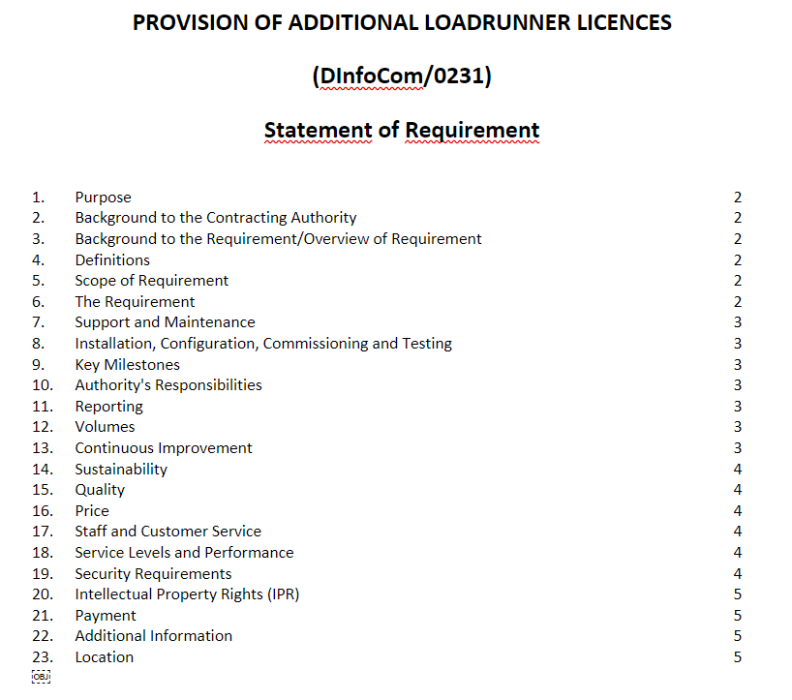

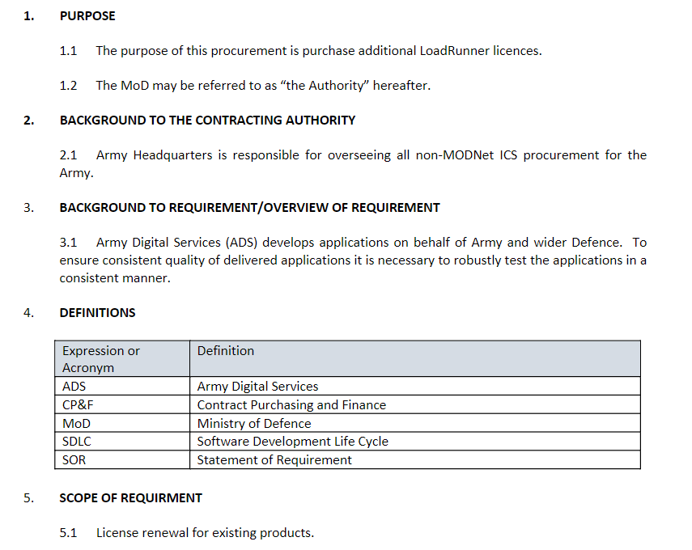

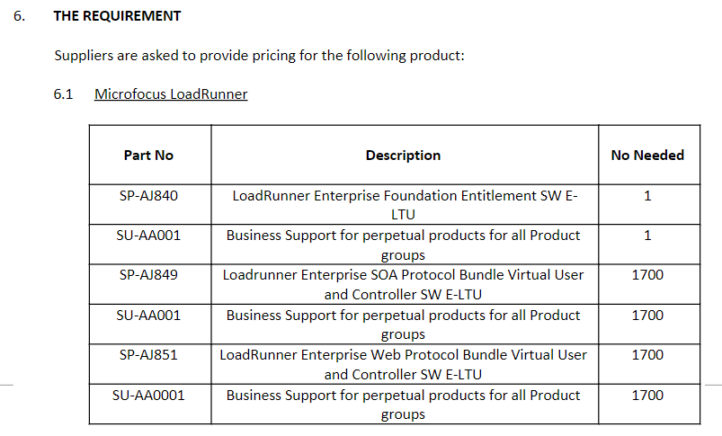

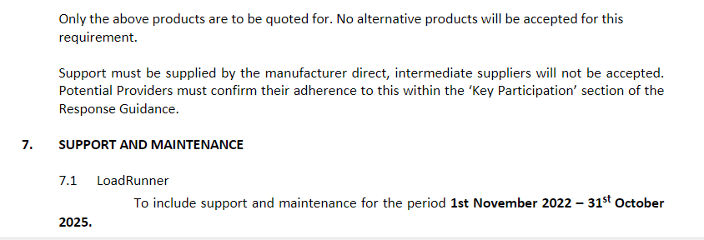

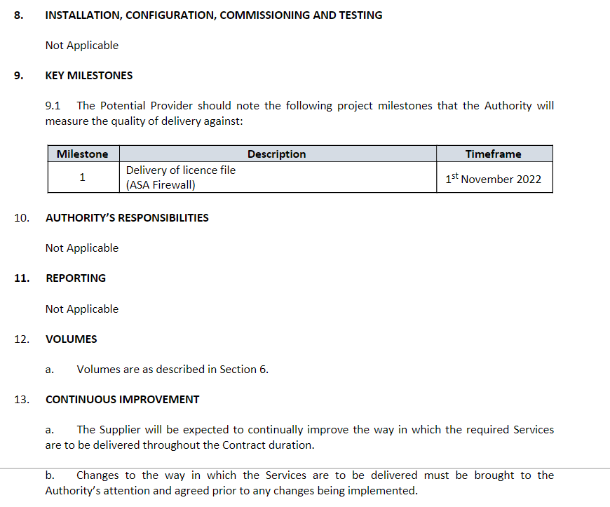

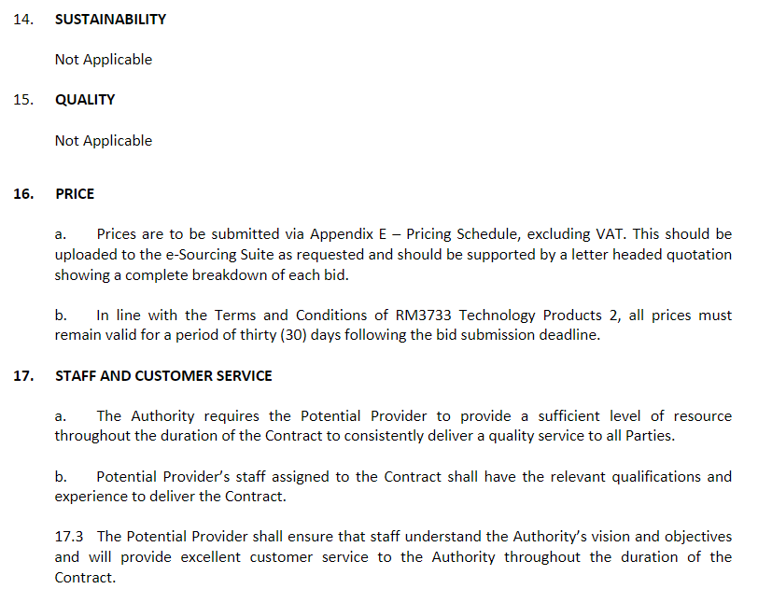

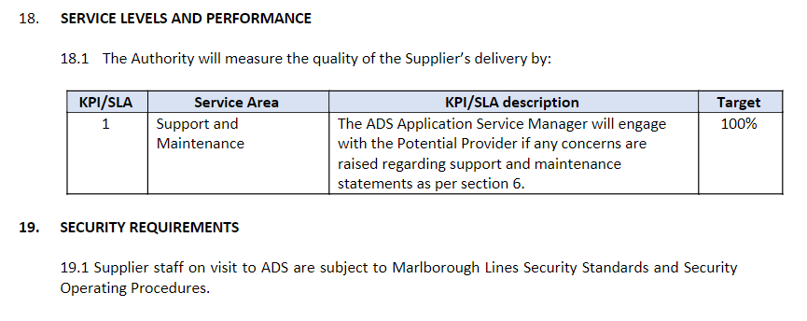 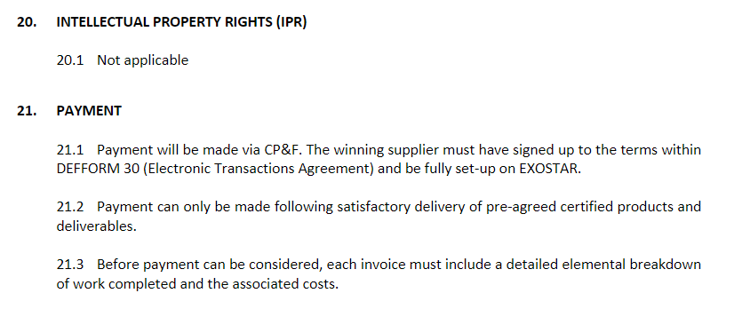

**23. Location**

REDACTED

**Call-Off Schedule 21 (Northern Ireland Law) – N/A**

# Call-Off Schedule 22 (Lease Terms) – N/A

**Call-Off Schedule 23 (Optional Provisions) – N/A**