Conversion of MAN 15T HX77
Support Vehicles to EPLS Mk3 Variant
OSVP/0032

Emergent Work Procedure
Out of Scope Repairs

Annex L

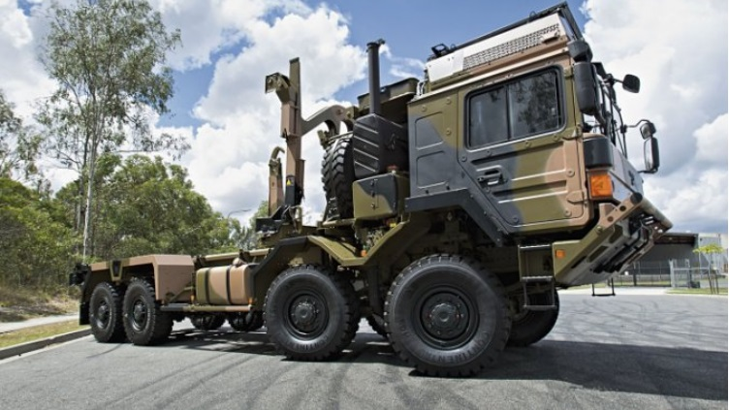
V2

Version History

Issue: V2
Author:
Date: 28-November-2017.
Authorised by:

Signature:
Date: 28-November-2017
Checked for The Authority by:
Signature:
Date:
 | Version | Amendment |  |  | Date
 | V1 | First Submission Document |  |  | 29/09/17
 | V2 | Amendment for extension of time |  |  | 28/11/2017

Contents

1. Introduction 4
2. Objective 5
3. Emergent Work - Categorisation and Authorisation 6
4. Reporting and Authorisation Process 7
5. Assumptions 8
6. Process Flow Diagram 9
7. Attachment A - Contractors Emergent Work Authorisation Form 10
8. Attachment B - Example of Annex M to the Contract 11

Tables
Table 1: Table of Abbreviations 3

Table 1: Table of Abbreviations

Abbreviation | Interpretation for this Document
CEWCF | Contractor’s Emergent Work Claim Form
ILHS | Integrated Load Handling System
EPLS | Enhanced Palletised Loading System
EW | Emergent Work
MTBAG | MAN Truck & Bus Aktiengesellschaft
MTBUK | MAN Truck and Bus UK Limited
SI | Service Information
EnSIR | Entry Standard Inspection Report
JAMES | Joint Asset Management and Engineering Solutions
GFA | Government Furnished Assets
VOR | Vehicle off the Road
NTWY | Non Task Worthy (NTWY)

Introduction

This document sets out the Emergent Work Procedure for Out of Scope Repairs undertaken under the Contract OSVP/0032.
The OSVP/0032 Contract is between the Secretary of State for Defence of the United Kingdom (the Authority) and MAN Truck and Bus Limited (MTBUK) and is for the conversion of *REDACTED* In-Service HX77 Cargo Vehicles from the Support Vehicle Fleet to the EPLS Mark 3 Build Standard.
The donor HX77 Cargo Chassis, released to the Contractor (MTBUK) as GFA, shall be subject to a Vehicle Presentation Handover Standard (Annex I) to ensure that only fully roadworthy vehicles enter into the Conversion Programme. However, following release of a vehicle by the Authority’s agent; unscheduled or Out of Scope work may emerge during the Conversion Process that requires remedial action.
Such work, designated as ‘Emergent Work’, may be identified at any stage during the Conversion Process whilst vehicles are assigned and classified as GFA “Issued Property” to the Contractor, the Chassis Convertor or any of their agents.

Objective

The objective of the Emergent Work Procedure is to ensure that any work identified is documented, communicated to the interested parties and, once authorised, actioned in an expedient manner, with a minimum of disruption to the Conversion Process.
During the execution of the contract, the Contractor or the Chassis Convertor may identify additional work further to that described elsewhere in the Contract that would otherwise prevent the Contractor from meeting its obligations under the Contract. Such Emergent Work by definition will be Out of Scope and identified during the Conversion Process whilst the donor vehicles are classed as GFA “Issued Property”.
Emergent work will include but not be limited to:
    - Defects accepted following Vehicle Presentation Handover Standard, subsequently adjudged to require attention so as not to disrupt the Conversion Programme;
    - Vehicle Non-Task Worthy (NTWY) - Vehicle Breakdown during transit between sites or on Road Test;
    - Rectification Work identified during Dismantling;
    - Rectification Work identified during Rebuild;
    - Outstanding or incomplete Service Information Actions.

Emergent Work - Categorisation and Authorisation
In accordance with the principles of Contract Condition 3.3, Emergent Work shall be categorised as either Emergent Work- Minor or Emergent Work – over £1,000 (Ex VAT).
  - Emergent Work – Minor
Emergent Work – Minor will have a value, inclusive of parts and labour, of up to a maximum of £1,000 (Ex VAT) per vehicle, and have no impact on the schedule by requesting an extension of time. Such work may commence immediately without prior authorisation from the Authority, subject to the cumulative value [£] of the Emergent Work for an individual vehicle not exceeding £1,000 (Ex VAT).
The Contractor shall keep a running total [£] value for all Emergent Work for each individual vehicle.
When Emergent Work – Minor is identified for an individual vehicle, the Contractor shall check that the cumulative [£] value of all preceding Emergent Work for that vehicle, including the new Minor Work, does not exceed the cumulative £1,000 (Ex VAT) limitation.
The Contractor shall document all Emergent Work on an individual vehicle basis on the Contractor’s Emergent Work Authorisation Form [CEWAF] shown at Attachment A; allocate a sequential Unique Reference and document individual job costs. The CEWAF shall be used in support of the Monthly Claims Procedure for payment of such work.
Should the running total on an individual vehicle exceed £1,000 (Ex VAT), or an extension of time requested, the Contractor, before commencing the work, should seek authorisation from the Authority’s Project Manager by submitting a CEWAF. The CEWAF shall be annotated “Minor Work Cumulatively Exceeding the £1,000 Limitation” or “Extension of Time Requested” and follow the Emergent Work – Exceeding £1,000 (Ex VAT) Value procedure, as detailed below.
  - Emergent Work – Exceeding £1,000 (Ex VAT) Value
Emergent Work – Over £1,000 will be used for work that has an estimated value exceeding £1,000 (Ex VAT) for an individual vehicle and/or an extension of time is requested and will require authorisation from the Authority before that work can proceed.
The Contractor shall notify the Authority’s Project Manager in writing by email, using the Contractor’s Emergent Work Authorisation Form [CEWAF], shown at Attachment A in this document.
The form will provide a description of the work needed to be undertaken, supported by evidence; a detailed cost breakdown and a firm price quote. Furthermore, the Contractor shall detail any impact to the Contract should the Emergent Work not be authorised or approved in a timely manner.
In the event the Contractor considers itself entitled to an Extension of Time to the Delivery Schedule to reflect the additional time required to remedy defects and deficiencies, the Contractor shall follow due process to request an Extension of Time in accordance with Condition 9.7 of the OSVP/0032 Contract. The CEWAF shall be completed accordingly.
Upon receipt of written authorisation from the Authority’s Project Manager, the Contractor shall proceed with the Emergent Work under the agreed terms and conditions and within the agreed time frame.
The Contractor shall keep a running total [£] value for Emergent Work for each individual vehicle.

Reporting and Authorisation Process

The Contractor shall keep a running total of all Emergent Work; both on an individual vehicle basis and cumulatively for all vehicles. The cumulative value [£] of all Emergent Work shall not exceed the Limit of Liability defined in the OSVP/0032 Contract, SOR Item 5 of the Schedule of Requirements.
On a monthly basis (from the date of receipt of the first donor vehicle), the Contractor shall provide the Authority’s Commercial Officer with a duly completed Emergent Work Claim Form, as detailed at Annex M to the Contract [see example at Attachment B], detailing all authorised Emergent Work for Authority payment in accordance with Condition 10.1.7.
The OSVP/0032 Emergent Work Claim Form – Annex M, shall be supported by a Price Breakdown, in accordance with the principles of DEFFCON 800.
A unique serial number in a sequential series [commencing 001] shall identify each line entry on the Summary Emergent Work Form as per Annex M. These numbers, prefixed with the contract number OSVP/0032, shall be quoted in all associated correspondence and documentation related to the Emergent Work, including claims for payment.
The Authority’s Commercial Officer shall periodically record a summary of the Emergent Work authorised on Emergent Work Task Claim Forms, at Annex M to the Contract [see Attachment B].

Assumptions

For the Emergent Work process to work efficiently and effectively, all involved parties must collaborate and communicate so that the end goal is achieved. To achieve this working harmonisation, a set of assumptions have been made which are outlined below. The failure of one or more of these assumptions may lead to delays and inefficiencies in the system adopted to deal with Emergent Work, thereby potentially affecting the overall Conversion Programme.

- Emergent Work can only be identified when vehicles are designated GFA and classed as “Issued Property;”
- The Donor Vehicle shall be presented in accordance with Annex I, Vehicle Presentation Handover Standard;
- The Authority’s Project Manager shall deal with Emergent Work in an efficient and timely manner so as not to incur delays to the Delivery Schedule;

- Emergent Work shall be under the control and management of the Chassis Convertor.

Process Flow Diagram

Attachment A - Contractors Emergent Work Authorisation Form

Contractors Emergent Work Authorisation Form [CEWAF]
for EPLS Mk3 Conversion Contract OSVP/0032
This form recommends Emergent Work scheduled to be carried out on behalf of the Authority.
Where the total cost of the work exceeds £1,000, work shall not proceed without prior authorisation from the Authority.

Date |  |  | Vehicle Registration Number |  |  |  | Converter Ref
Description of Work

Attachments – Yes / No
Job Card Ref | Job Date | Brief Description |  |  | Material Cost [£] |  |  | Sub-Contractor Cost [£] | Labour Cost [£] | Total  Job Cost [£]
Submitted by the Contractor/Convertor for Authorisation within 24hrs [EM > £1000(Ex VAT)]
Name& Position |  |  |  | Date |  | Signed |  |  | Contact Tel Nº
Conversion Schedule Impact / Delay

Extension of Time Requested YES/NO Estimated Duration ……………Days
For Authority Use [EM > £1000(Ex VAT)] Project Manager - Authorised by on behalf of OSVP
Name& Position |  |  |  | Date |  | Signed |  |  | Contact Tel Nº
Project Manager OSVP Reference |  |  |  | Authorised  YES NO |  | CP&F Purchase Order/Reference

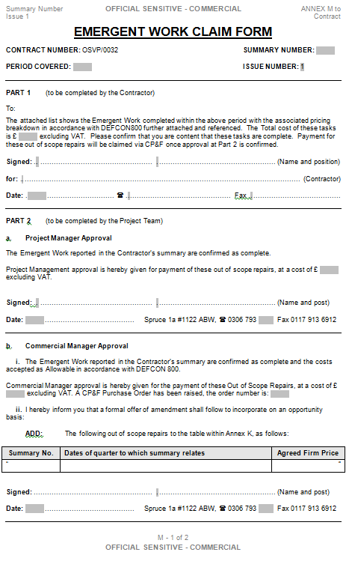
Attachment B - Example of Annex M to the Contract

