HDC 202203 - Fleet Pond mitigation work specification detail
Overview
As part of Hart District Council’s project to widen the northern footway and provide a slipway from Boathouse corner, mitigation work has been agreed with Natural England for approximately 400m² of marginal vegetation that will be impacted.
The mitigation work is for the creation of an open water flash in North East Marsh, and the creation of a reedbed and riparian edge in Brookly reedbed/Kenilworth Wood.
Scope of work
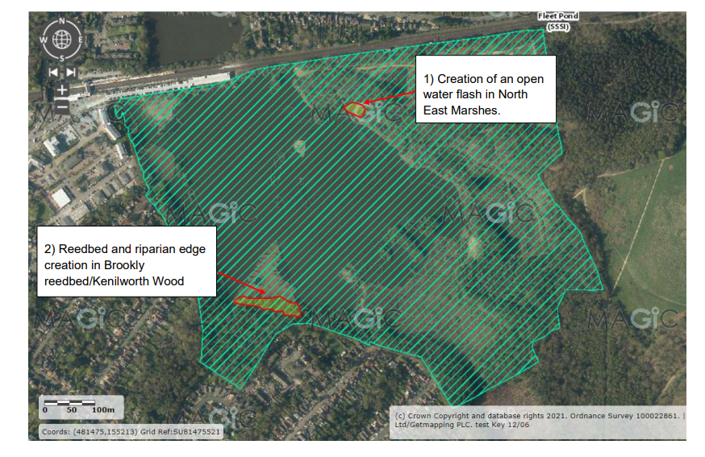Map 1. Mitigation area locations (outlined in red)
Part 1: Creation of an open water flash in North East Marsh
To create an area of open water by scraping down to the original pond bottom to create a sheltered area of shallow, open water.
Part 2: Reedbed and riparian edge creation in Brookly reedbed/ Kenilworth Wood
The current willow and alder scrub in this area will be cleared back to an existing ditch line located to the south of the existing reedbed.

Site background and access
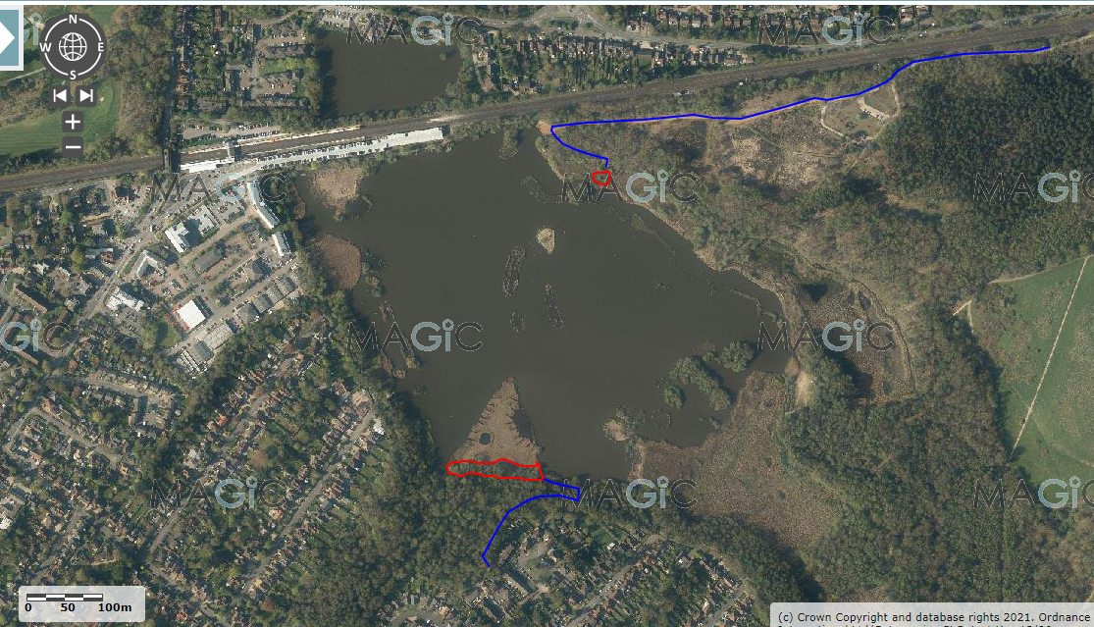
Map 2. Red areas indicate the mitigation areas. Blue lines indicate the vehicle access routes.
Fleet Pond is a SSSI nature reserve in Hampshire, with a high volume of daily visitors accessing the site.
Access to the North East marsh is through the car park (Cove Road, off the A3031) via lockable bollards, a 2.1m height barrier is in place and can be opened to allow entry. This access point is suitable for most vehicles and machinery, but there are some restrictions within the site.
Access to Brookly reedbed is through the Countryside Workshop (Old Pump House Close, GU51 3DN) along narrow footpaths which will only be suitable for small tractors, ATVs or similar.
To gain access to the site, contractors will need to agree with Site Ranger 48 hours in advance.
Timings of work
These works must be complete before 31st March 2022, as Natural England assent only works to take place outside the bird nesting season.
Contractor MUST provide at least two weeks’ notice prior to commencing works, to enable Hart District Council to carry out appropriate visitor engagement and notify stakeholders.
Health and safety
- Contractors must supply Hart District Council with the H&S Working Practices and associated risk assessments before any site works can commence. Contractors must adhere to the council’s Countryside Contractor Code of Conduct (Appendix 2) and Contractors Code of Safety (Appendix 3).
- The requirements of health and safety and other current legislation and codes of practice must be observed in all work undertaken.
- No works shall commence until a method statement is provided and approved by the Client. The method statement must plan, manage and coordinate work, taking account of all Health & Safety legislations and Codes of Practice.
- Contractors must ensure that any staff operating machinery have the relevant, in-date qualification. Including, but not limited to, CS30/31, PA1, PA6aw, Safe Use of a Manually Fed Wood Chipper and Excavator/digger training.
- All PPE worn onsite is to be in good condition and free from rips, tears, holes and excessive discolouration or staining.
- The Contractor will provide triangular Men at Work signs to be positioned by access points to the work site. The signs will be clean and legible for the duration of the works.
Operational details
Part 1: Creation of an open water flash in North East Marsh
Area of scrub for removal: scrape area and buffer zone over approximately 5 metres from edge of scrape, see attached photos as provided in appendix 1 and refer to Map 1. Scrape area to be approximately 780m ² (0.08Ha)
Description of scrub: mainly mature willow and alder scrub and trees less than 25 years of age
Special considerations:
- Cut, remove, and treat all trees and scrub within area shown on Map 1.
- Scrub root system to be removed, the use of a digger or forestry flail may be appropriate depending on access
- Where access allows, a woodchipper can be used to dispose of excess materials and chip into an identified spoil heap location adjacent to working area, to be covered by scrape spoil
- All herbicide treatment to be carried out in accordance with manufacturer’s recommendations. Application record to be supplied to Hart District Council on completion of work.
Scrape detail:
- Scrape should be an irregular shape to maximise the length of its edge, with sides to be graded so there is a gentle slope from the shallow margins (3cm – 5cm deep) to a maximum depth of no more than 20cm further into the scrape. Final depths will need to be agreed during the course of the works on site with Hart District Council staff and the contractor. These depths will depend on the surface uncovered
- Clear off all surface vegetation, to include removal of wooden stumps and root plates, reedmace rhizomes.
- Prior to works commencing, the contractors to arrange a joint walked survey of the area with Hart District Council Biodiversity Officer, to enable retention of ecologically important species (i.e., mark out and agree with the contractor sections to avoid scraping). These areas should then be avoided and not disturbed during the works.
- Scraped spoil material to be banked up into woodland edge as per photos seen in Appendix 1.
Additional comments:
- Contractor should use a vehicle transport method that avoids damaging the existing good quality marsh habitat, which should be discussed and agreed with Site Ranger. Examples could include ground plates, temporary tracks or similar.
- Contractors must stick to the agreed route over the rest of the wetland habitat. The Contractor shall form, maintain, and subsequently remove any materials, barriers and fencing required for the purpose of accessing the site in a safe manner and is responsible for keeping the access routes safe for other users where permitted/ unavoidable. All such features should be removed on completion of the works or as instructed by the Project Manager.
- Any vehicle used on the public footpaths will be restricted to 5mph with a flashing beacon and hazard lights. A banksman is required to ensure safe movement across site for both pedestrians and contractors.

Part 2: Reedbed and riparian edge creation on Brookly reedbed/Kenilworth Wood
Area of scrub for removal: 0.23 Ha (2285m ²) in total, all scrub to the north of the ditch, between the ditch and pond edge, plus one meter south of the ditch to include overhanging branches (Map 1 - Section 2 indicates work area).
Description of scrub: mainly mature willow and alder scrub and trees less than 25 years of age
Special considerations:
- Scrub works to be undertaken using hand tools/machinery (i.e., chainsaws).
- A fire site can be identified and used for burning materials, but this must be away from the tree canopy and the cleared area and agreed with Site Ranger. Corrugated sheets must be used for any burning (to be supplied by contractor).
- Reeds, within the scrub area, to be retained, where possible.
Other:
- Cut, remove and treat all trees and scrub within area shown on Map 4. This largely consists of young and mature willow/alder trees with diameters no greater than 25cm.
- All stumps to be cut to ground level and stump treated with visually detectable dye and appropriate herbicide (e.g. glyphosate). Larger scrub (over 15cm diameter) to be treated with herbicide plugs.
- All herbicide treatment to be carried out in accordance with manufacturer’s recommendations. Application record to be supplied to Hart District Council on completion of work.
Disposal: Main chord wood to be processed in to 2 metre lengths and stacked into log piles at designated area. Brash material can be dragged into the woodland to be chipped onto chord wood, where chipper access is possible. Contractor to assess and agree with Site Ranger, prior to quotation.
Contractor is responsible for all permit applications and permissions from Environment Agency, relating to pesticide application in and around water. See DEFRA guidance on this: https://www.gov.uk/government/publications/application-to-use-herbicides-in-or-near-water
Remediation work
- Remove any temporary signage, barriers and fencing from site.
- Make good all damage to adjoining surfaces caused by the works, by access to the works by plant and machinery, by storage of materials and other causes within the contractor’s control.
- Compacted soil should be decompacted and regraded. Contaminated soil (for example accidental spillage of fuel) must be excavated and removed from site to an approved landfill site and replaced with uncontaminated subsoil and topsoil to match existing soil profile.
- Make good any damage to retained trees and other woody plants by pruning back damage to healthy growth in accordance with good arboricultural practice.
- Leave site clean and tidy. Remove all excess materials from site to the contractor’s store or to an approved tip, unless otherwise agreed in writing.

Appendix 1 - Photos
Part 1: Creation of an open water flash in North East Marsh
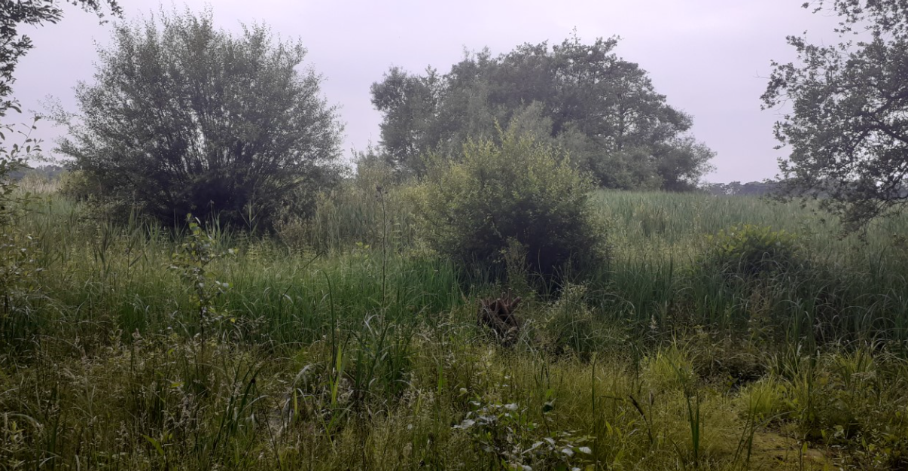Image 1. Typical habitat within the scrape area
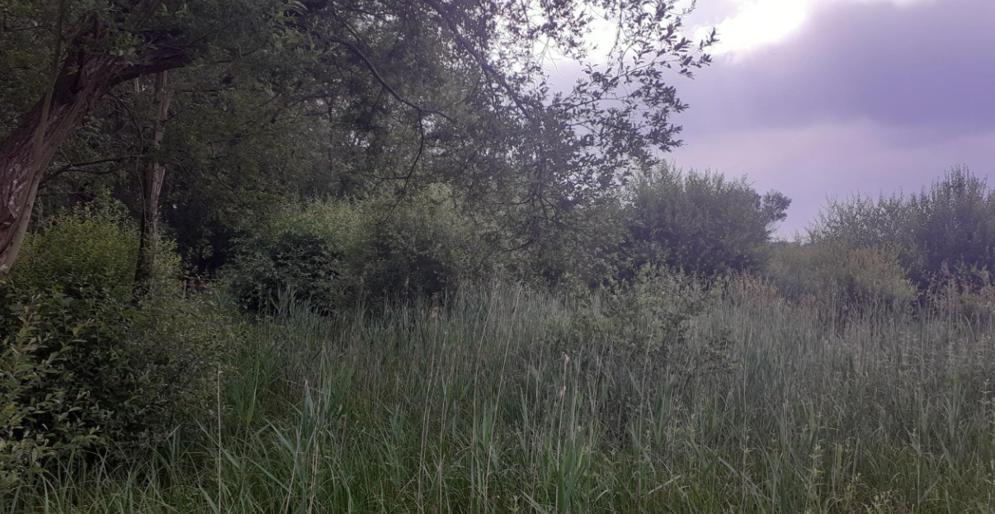Image 2. Typical habitat within scrape and willow/scrub to be removed (blue)
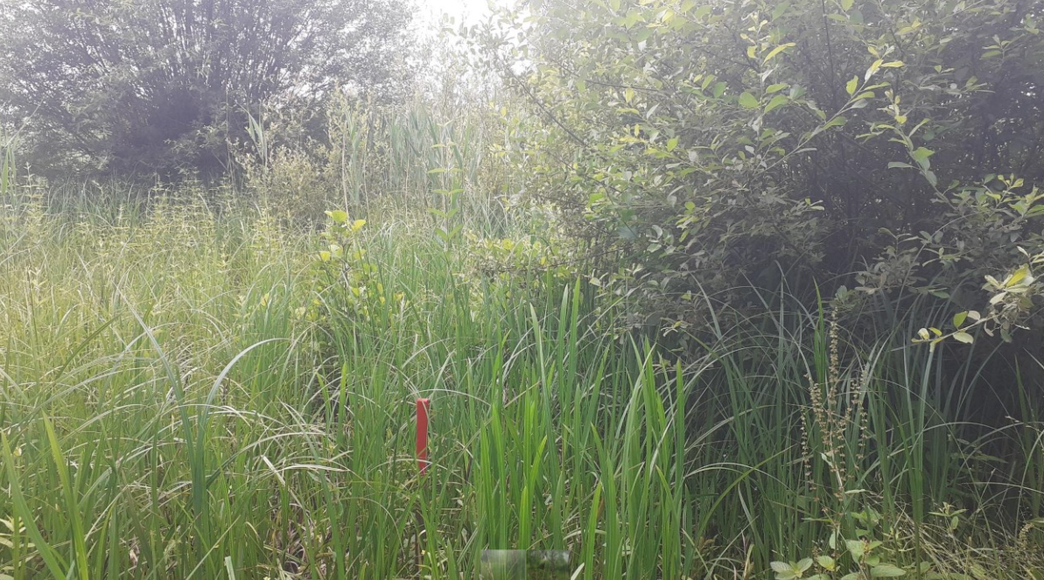Image 3. Red stakes on the ground will identify perimeter of scrape. Remove scrub (blue)
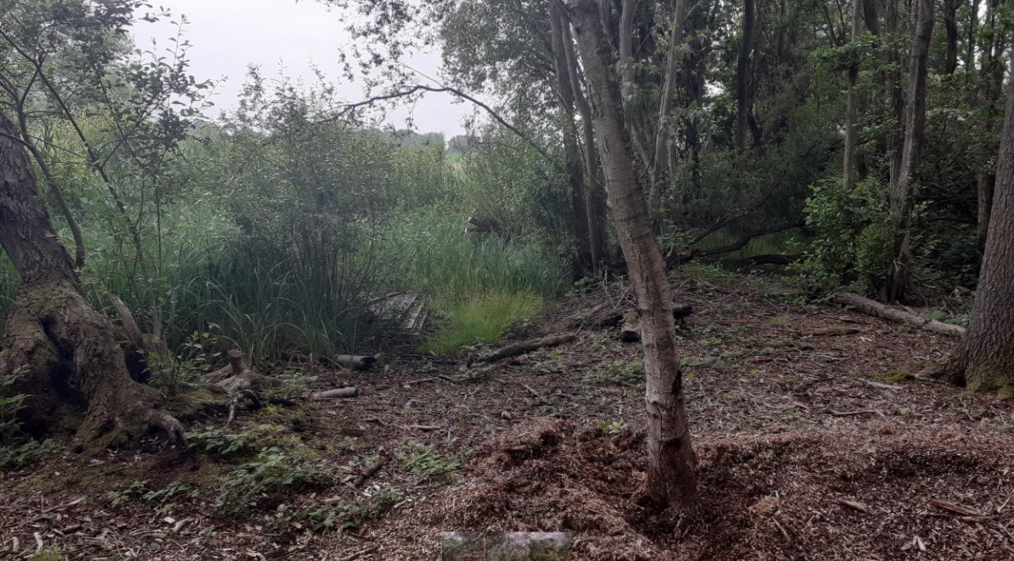Image 4. Future access to be retained here. Remove trees in foreground (blue)
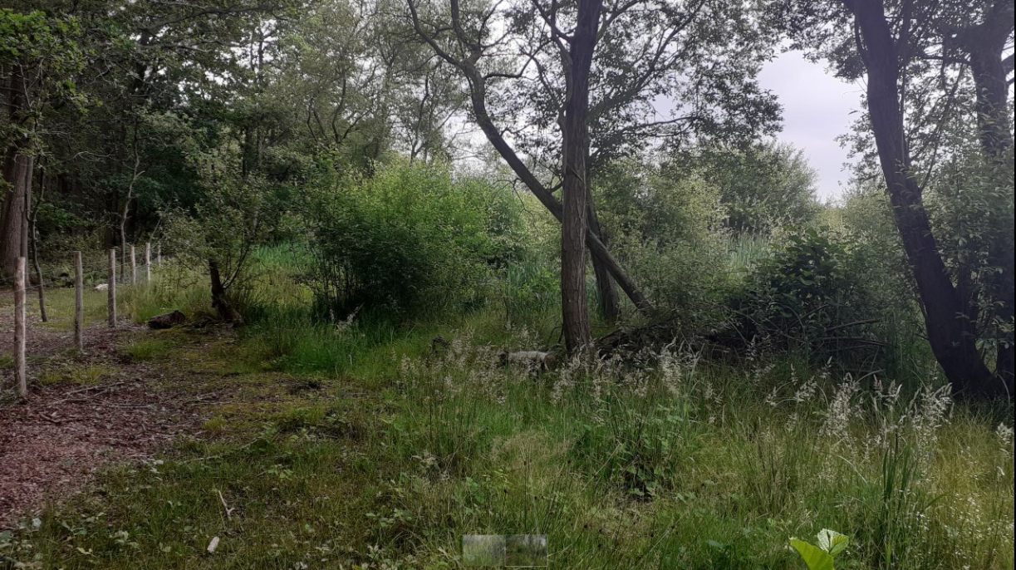Image 5: Approximate location of spoil (yellow). Potentially remove trees in photo (blue) but to be confirmed during works.
Part 2: Reedbed and riparian creation in Brookly reedbed/Kenilworth Wood
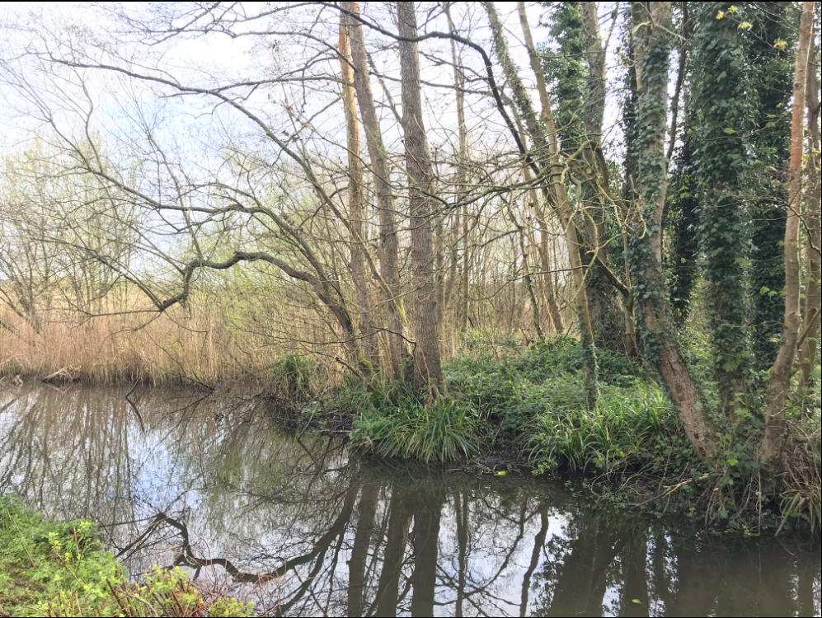
Image 1: View of the reedbed from the bank of Brookly stream. Blue lines indicate the ditch line.

Appendix 2 – Countryside Contractor Code of Conduct
Whilst carrying out contracted work for Hart District Council Leisure & Environmental Promotion Department all contractors, their employees and any sub-contractors are expected to abide by the following: -
- Be polite, respectful and considerate to others be they Hart DC staff or members of the Public
- Not to discriminate unlawfully against any person for any reason
- Bad language, unnecessarily raised voices and language or behaviour that could be offensive on the grounds of age, physical appearance, gender, sexuality, disability, ethnicity or religion are all forbidden. Examples include –
- Verbal abuse, or insulting behaviour
- Sexist jokes, racist jokes, jokes about an individual’s sexual orientation or jokes about disability
- Unwanted physical contact ranging from touching to serious assault
- Display or circulation of sexually suggestive or racially abusive material
- Bullying, coercive or menacing behaviour
- Ridicule or exclusion of an individual for cultural or religious differences
- Obscene slogans on T-shirts, other items of clothing, stuck to tool boxes, etc.
- No alcohol or drugs (unless prescription medication) are to be consumed whilst in the work place or brought into the workplace.
- All should be in a fit state to work and not under the influence of drink or drugs
- Must observe any relevant national codes of practice and standards for his or her particular area of work
- Be appropriately trained and certificated for what they are doing and / equipment they are operating
- Comply with agreed arrangements relating to where, when and how works are to be completed
- Observe operational regulations, safety rules, regulations and codes of practice, safe working procedures
- Provide copies of all relevant paperwork regarding health & safety for what they are doing, i.e., Risk assessments, hot works certification, etc.
- Be responsible for their personal safety, mindful for that of others working with them, that of staff members of Hart DC and of members of the public
Appendix 3 – Contractors Code of Safety
It is expected that all contractors, sub-contractors and consultants, awarded contracts by Hart District Council shall perform all work with due regard to the Health and Safety at Work etc Act 1974, the Management of Health and Safety Regulations 1992/99, the Construction (Design and Management) Regulations 2015 and all other relevant Regulations, Approved Codes of Practice and HSE guidance. It is also expected that all contractors and their employees will be conversant with any specific safety rules of the premises and the particular area in which they are to work prior to any work commencing.
The contractor shall be responsible for nominating a representative/officer (Site Manager) whose name will be documented in any written contract prior to works proceeding. The contract document shall also name the officer responsible, who will act as the site contact for all matters concerning the works.
The main contractor shall be responsible for notifying all sub-contractors of any factors affecting their health, safety and welfare and the safety of others who could be affected by the work activites being carried out. The main contractor shall ensure that any sub-contractors receive a copy[s] of the site rules and that they are understood. The main contractor shall fully inform the Site Manager of the fact that sub-contractors will be used to perform the works.
Starting work
Appropriate arrangements for health, safety and welfare and safety shall be made and a safe system of work arranged with the Site Manager before the contractor’s operations begin.
Daily, prior to commencing work, the contractor must report to the Site Manager or other previously designated manager in his/her absence.
When contractors’ operations are expected to create special hazards on any particular day(s) e.g. hot works, electrical work, work in confined spaces, demolition work, use of dangerous substances or articles, working at height or any other activity then the attention of the Site Manager must be drawn to these hazards and adequate precautions must be taken. A “permit to work” scheme may be deemed necessary for the given examples' dependent upon the findings of any assessment (i.e. serious risk, COSHH, confined spaces or fire).
When Contractors’ employees may be at risk when working in certain areas on the premises, the Contractor will be notified accordingly and will also be provided with all relevant information relating to the identified risk. There will be a joint responsibility on the Site Manager and the Contractor to assess and inform their employees and to advise Hart DC of such hazards. Instruction and training will also need to be considered if the hazard is significant.
Services
Contractors must not connect or interfere with any electrical, gas, water, compressed air or other service on the premises without the expressed written permission of the Site Manager. The connection of portable electrical tools, such as drills, by means of a standard plug top is exempt from this rule provided that the appliances are of the 110volt centre tapped to earth type. The provision of any step-down transformer shall be designated as the responsibility of the Contractor.
Tools & Equipment
All plant, tools, tackle and equipment used by contractors on the premises must be suitable for the work and environment, in which it is being undertaken, must comply with all relevant legal standards and must be maintained in accordance with appropriate safety standards. The personnel using such equipment must be adequately trained and competent in the use of such equipment. Hart DC encourage the use of battery operated wherever possible.
Contractors are expressly forbidden to use any plant, tools, tackle or equipment which belongs to the premises at which the work is being performed.
Electrical Plant & Equipment
The contractor or his employees shall not enter any area of the premises without the expressed permission of the Site Manager or other previously designated manager in his/her absence.
It is recommended that battery powered tools and equipment are used whenever practicable. They have shown to emit lower noise levels and far lesser hand, arm vibration.
Portable electrical tools and equipment must be sufficiently earthed or double insulated. In appropriate cases, i.e. working in a wet environment e.g. swimming pools, such equipment must be of a voltage not exceeding 50volts for lighting and 100volts for portable tools. The electrical supply shall be by means of a double-wound transformer with the secondary circuit being centre tapped to earth.
As further means of protection from excess electrical current all equipment shall be sufficiently fused and the contractor shall use circuit breakers, miniature circuit breakers and residual current devices where possible. All such devices incorporate earth monitoring devices capable of switching off the electrical supply in the event of the earth connection being broken.
Guards, Fences, Barriers, Screens and Enclosures
Guards or fences must not be removed from any machinery or plant except to carry out work on that equipment and then only with the written permission of the Site Manager. Guards or machinery must not be removed while machinery plant is in motion or energized. Guards or Fences must also always be replaced and secured as soon as work is complete and before the machinery/plant is reinstated or energized.
All contractors’ machinery brought onto the premises must comply with the Provision and Use of Work Equipment Regulations 1998 (PUWER) relating to that type of equipment, and must where appropriate, be adequately guarded or fenced. Where a contractor is performing work on the premises which involves the breaking of stone, grinding of metals, sand blasting etc. then the contractor shall be responsible for the installation and maintenance of suitable screening or enclosures to protect persons other than their employees who may be endangered by the activity. Test and examination certificates shall be made available as requested.
Working above ground
When work by a contractor involves the erection and use of any scaffold support, mobile tower scaffolds, mobile elevated work platforms, cradles and/or ladders then the contractor shall be responsible for the safety of such structures. The contractor’s responsibility extends to incorporate features such as scaffold “fans”, ties, walkways, covers, guard rails, toe boards, warning lights etc. as may be deemed necessary for reasons of safety. Daily inspections and precautions must be taken to ensure safety on such structures by the removal of ladders or other means of access when work ceases. Test and examination certificates shall be made available as requested.
Working below ground
Ground on premises may not be broken without the expressed permission of the Site Manager and Hart DC. Nearby underground services must be positively located by the contractor and their presence pointed out to those persons performing the excavations, prior to the work commencing. Excavators and JCB’s should not be used in the vicinity of buried services. A “permit to excavate” may be issued to ensure these precautions are carried out. The excavation must be made safe by means of barriers, stop blocks and suitable warning notices until the ground is restored to its previous state.
All trenches and excavations, particularly those adjacent to roads or existing buildings must be adequately “shored”, and falls of material prevented by “battering back”, caissons, or other effective means in accordance with any guidance and good practice. The safety of other persons on site is to be a continuous priority and excavations boarded over where practicable and/or otherwise suitably protected and signed when work is not actually proceeding.
Confined Space Entry
Contractors' employees may not enter any chamber, tank, pit, vat, silo, trench, pipe, sewer, flue, well or other similar confined space where there may be dangerous fumes or lack of oxygen, without the expressed permission of the Site Manager and Hart DC. If permission is given then work in such spaces shall be carried out taking all necessary precautions and using the methods outlined in The Confined Spaces Regulations 1997.
Permits to work
In cases of specifically hazardous work or where contractors' operations need to be strictly coordinated with those of the premises to ensure safety, the work shall be governed by means of a formal permit system. The relevance of such a system to the work envisaged must have been discussed and documented wherever possible during the planning stage. The necessity for such a system to be adopted must be noted before work commences and the Site Manager and Hart DC informed.
Control of pollution/waste
Contractors may not deposit any waste, chemical or other substance whatsoever into any drains, skips, bins or any other area on the premises. All waste must be disposed of as agreed in the contract, by an approved and authorised waste disposal contractor(s). Further advice can be obtained from the Environment Agency.
Cartridge operated fixing tools
Cartridge fixing tools may not be used on the premises without prior permission from the Site Manager. If permission has been granted, such tools may only be used in compliance with the standards set out in the PUWER Regulations.
Fire
Smoking, the use of flame lights or the application of heat e.g. welding or burning, is prohibited in most of the premises. When this type of work is essential contractors and their employees must seek prior written approval from the Site Manager and Hart DC.
Contractors are responsible for the provision of a formal Fire Risk Assessment and suitable and sufficient fire fighting equipment appropriate to the work involved and possibly a ‘Fire Watch Person to remain on site until the heat source or embers are made safe. Contractors and their employees must conduct the following checks upon their arrival at the work site:
- The nearest means of escape in case of fire.
- The location, type and method of operation of the nearest fire fighting appliance.
- The location and method of operation of the nearest fire alarm.
Contractors must obey all alarm signals whilst on the premises. Contractors using one or more of the premises’ fire fighting appliances must notify the Site Manager and Hart DC immediately.
Personal Protection
The contractor shall be responsible for providing his own employees with personal protective equipment as may be required for the work in hand. Such equipment may include eye and ear protection, respirators, head protection and breathing apparatus etc.
Reporting a near miss, accident or incident involving a contractors’ employee or other person affected by the contractors’ work
Any accidents of this nature must be reported to the Site Manager immediately. Copies of Reports should also be submitted to the Councils’ Corporate Health and Safety Adviser in Environmental Health Services department. All accident reports should be presented on an official Council accident/incident report form (ARF1) and completed on the same day as the accident/incident or within 3 days if a weekend.
Reporting an unsafe condition or hazard.
Unsafe conditions or unexpected hazards must be reported to the Site Manager immediately.

CONTRACTORS PROCEDURAL BRIEF
Permits to Work – Contractors must notify sub-contractors of any safety systems in place.
Safety Standards
- All contractors working on site must sign in at reception/office daily.
- Observe all local site rules. e.g. No smoking etc.
- Always notify the Site Manager of any hot works, welding etc.
- The creation of dust and fumes shall be controlled and kept to an absolute minimum.
- Contractor’s electrical tools and other equipment must be suitable for the work and environment in which the work is being performed. Tools and equipment must also be adequately maintained and conform with current regulations.
- Contractors are not permitted to make use of any premises services without the prior approval of the Site Manager.
- Contractors must not operate any dead eye, hoist, lift or any other equipment without the approval of the Site Manager.
- Contractors must maintain safe means of access and egress from every area where the contractors’ employees will be working.
- Contractors are required to use premises roads and gangways to and from the site of operation and are unauthorised to be in any other part of the site.
- All excavations at all times must be securely protected and sign posted with warning lights. Some sites may require trenches to be filled/covered if left overnight.
- Contractors shall report all accidents/incidents to the Site Manager immediately.
- Good housekeeping is to be undertaken at all times by the contractor. All gangways, corridors and roads are to be kept clear of obstruction at all times.
- The premises shall provide a safe place of work. The contractor and sub-contractors have a duty to implement and maintain a safe system of work.
- On completion of work the contractor shall ensure that all materials and waste is removed from site and appropriately disposed of.
- All contractors’ personnel must be competent, adequately trained and equipped to perform the specific task required.

Countryside Site Works
Due to the very varied sites covered by the Service and varied weather conditions “contractors” must inform the Rangers when and where they are working at all times on council land.
Contractors must be courteous to the general public at all times and communicate any positive or negative feedback from the public back to the Countryside Service.
Any weekend working must be authorised before proceeding.

