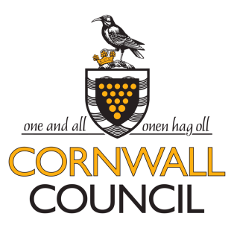
Developing our Children and Young People Independent Specialist Placements for Special Educational Needs
Provider and Commissioner Workshop
6th February 2019

- There was discussion of the pattern of resource bases in Cornwall. It was confirmed that Cornwall has a higher proportion of pupils in its 20 resource bases than in the rest of the country, and that a wide range of need is catered for.
- It was confirmed that at any one time there are about 20 education specialist provider placements outside Cornwall.
- Providers described the complexity of need they meet. This was acknowledged by the local authority. The importance of longer term planning for pupils, in terms of returning to mainstream provision and Preparing for Adulthood, was agreed.

- The needs that currently are not met in Cornwall are for small numbers of:
- Children under seven years of age with complex social, emotional and mental health difficulties usually related to trauma
- Children and young people with learning difficulties and associated challenging behaviour generally associated with a diagnosis of autism.

- Providers requested better data on the changing demographics of Cornwall. LA support for purposeful information can be really useful.
- There was a discussion of the cost/benefits of a Dynamic Purchasing System (DPS). Key points made were:
- Healthy processes are ones that listen to the needs of providers.
- The DPS needs to remain child-centred rather than cost based.

- The provider engagement sessions held have been very useful and it was acknowledged that face to face meetings are really important and support open, quality communication. A provider forum would be a really good option as long as it’s structured and clear. It would be a good place to share, and allow a great networking opportunity. The local authority agreed to explore this further with providers.

Some contracts sessions are run with generic help, smaller providers sometimes may need more support with tenders.

- Providers asked if their staff could access local authority training, this would create added value and help to keep costs down. They would like to buy training from Cornwall Council but they don’t know who to ask. Providers should look at Services4Schools on the Cornwall Council website.
- Cornwall’s Statutory SEN Service was complimented as being open to constructive ongoing dialog with the team are always helpful and approachable. Caseworkers know the schools well and are open and honest with parents and teachers. The placements have confidence in case workers. Providers want to maintain the current positive situation we have now with a new system coming in.

