(CCCC21823 Order Form Template and Call-Off Schedules - Further Competition)

If an electronic purchasing system is used instead of signing as a hard-copy, text below must be copied into the electronic order form starting from 'APPLICABLE FRAMEWORK CONTRACT' and up to, but not including, the Signature block

It is essential that if you, as the Buyer, add to or amend any aspect of any Call-Off Schedule, then you must send the updated Schedule with the Order Form to the Supplier]

Order Form

CALL-OFF REFERENCE: THE BUYER:
BUYER ADDRESS

THE SUPPLIER: SUPPLIER ADDRESS:

REGISTRATION NUMBER: DUNS NUMBER:
CALL-OFF START DATE: IMPLEMENTATION DATE:

CALL-OFF EXPIRY DATE:

CALL-OFF Initial Period:
CCCC21823

The Home Office
2 Marsham Street, London SW1P 4DF Clarity Travel Limited
4th Floor, Broadhurst House, 56 Oxford Street, Manchester, M1 6EU
7413801
216951075
26/06/2023

To be agreed by Parties during implementation period but no later than 26/02/2024

2 years from Implementation Date

2 Years

CALL-OFF OPTIONAL EXTENSION PERIOD ONE: 1 year from initial Expiry Date

CALL-OFF OPTIONAL EXTENSION PERIOD TWO: 1 year from Extension Period One Expiry Date

GO LIVE DATE: The Supplier shall provide a further draft Implementation Plan 20 days after the Call-Off Start Date in accordance with Call-Off Schedule 13

APPLICABLE FRAMEWORK CONTRACT

This Order Form is for the provision of the Deliverables and dated 21st March 2023.

This Order Form is issued under the Framework Contract with the reference number RM6217 for the provision of Travel and Venue Solutions (CCCC21B23).

CALL-OFF LOT(S) AND APPLICABLE SCHEDULE 20 (CALL-OFF SPECIFICATION) TERMS:

Column 1 |  | Column 2
LOT NUMBER AND DESCRIPTION | Tick as applicable | SCHEDULE 20 (CALL-OFF SPECIFICATION) APPLICABLE PARAGRAPHS
Lot 1: Booking Solutions UK Points of Sale - Low Touch |  | Paragraph 3 (Mandatory Service Requirements All Lots) Paragraph 4 (Mandatory Service Requirements: Lots 1-3) Paragraph 5 (Lot 1: Booking Solutions UK Points of Sale - Low Touch)

CALL-OFF INCORPORATED TERMS

The following documents are incorporated into the Call-Off Contract. Where Schedule numbers are missing this is intentional as they do not apply to the Call-Off Contract. If the documents conflict, the following order of precedence applies:

- This Order Form including the Call-Off Special Terms and Call-Off Special Schedules.
- Joint Schedule 1 (Definitions and Interpretation) RM6217.
- Framework Special Terms
- The following Schedules in equal order of precedence:

  - Joint Schedules for RM6217:
    - Joint Schedule 2 (Variation Form)
    - Joint Schedule 3 (Insurance Requirements)
    - Joint Schedule 4 (Commercially Sensitive Information)
    - Joint Schedule 5 (Corporate Social Responsibility)
    - Joint Schedule 6 (Key Subcontractors)
    - Joint Schedule 7 (Financial Difficulties)
    - Joint Schedule 8 (Guarantee)
    - Joint Schedule 9 (Minimum Standards of Reliability)
    - Joint Schedule 10 (Rectification Plan)
    - Joint Schedule 11 (Processing Data)
    - Joint Schedule 12 (Supply Chain Visibility)

- Call-Off Schedules for RM6217:
  - Call-Off Schedule 1 (Transparency Reports)
  - Call-Off Schedule 2 (Staff Transfer)
  - Call-Off Schedule 3 (Continuous Improvement)
  - Call-Off Schedule 4 (Call-Off Tender)
  - Call-Off Schedule 5 (Pricing Details)
  - Call-Off Schedule 7 (Key Supplier Staff)
  - Call-Off Schedule 8 (Business Continuity and Disaster Recovery)
  - Call-Off Schedule 9A (Security) PART B
  - Call-Off Schedule 10 (Exit Management)
  - Call-Off Schedule 13 (Implementation Plan and Testing)
  - Call-Off Schedule 14 (Service Levels)
  - Call-Off Schedule 15 (Call-Off Contract Management)
  - Call-Off Schedule 16 (Benchmarking)
  - Call-Off Schedule 18 (Background Checks)
  - Call-Off Schedule 20 (Call-Off Specification)

- The Core Terms (version 3.0.11)
- Joint Schedule 5 (Corporate Social Responsibility) RM6217
- Call-Off Schedule 4 (Call-Off Tender) provided any parts of the Call-Off Tender that offer a better commercial position for the Buyer (as decided by the Buyer) take precedence over the documents above.

No other Supplier terms are part of the Call-Off Contract. That includes any terms written on the back of, added to this Order Form, or presented at the time of delivery/performance.

CALL-OFF SPECIAL TERMS - None

The clauses in the Core Terms shall be amended in accordance with the following Call-Off Special Terms which shall be incorporated into the Call-Off Contract:
Clause 2.4 shall be deleted and replaced with the following wording:
"If the Buyer decides to buy Deliverables under the Framework Contract it must use Framework Schedule 7 (Call-Off Award Procedure) and must state its requirements using either Framework Schedule 6A (Order Form Template and Call-Off Schedules - Direct Award) or Framework Schedule 68 (Order Form Template and Call-Off Schedules - Further Competition). If allowed by the Regulations, the Buyer can:
- make changes to the Order Form Template;
- create new Call-Off Schedules;
- exclude optional template Call-Off Schedules; and/or
- use Special Terms in the Order Form to add or change terms."
Clause 3.1.2 does not apply to the Call-Off Contract;
Clause 3.2 does not apply to the Call-Off Contract;

Clause 4.3(a) shall be deleted and replaced with the following wording:
"exclude VAT (and any other similar or equivalent taxes, duties, fees and levies imposed from time to time by any government or other authority), which is payable in addition to the Charges and the Management Charge in the manner and at the rate prescribed by applicable law, in the jurisdiction in which the relevant supply takes place, from time to time, subject to the provision of a valid VAT invoice (or its local equivalent) as prescribed by local law or practice"
Clause 7.5 shall be amended by the inclusion of the following wording at the end of Clause
7.5: "including arising out of or in connection with the termination of their employment and/or the exercise of the Buyer's right under Clause 7.2";
Clause 10.6.3(b) shall be amended so that the words "in the Contract Year in which termination occurs" will be added before the words "if the Contract' in the second sub-clause of Clause 10.6.3(b);
Clause 10.6.5 shall be amended so that the cross-reference "3.2.1O" is deleted;
Clause 14.4 shall be amended by the inclusion of the words "(including, but not limited to, the Supplier System)" after the words "Supplier system;
Clause 14.8(c), shall be deleted and replaced with the following wording: "must securely (i) destroy all Storage Media that has held Government Data at the end of life of that media, or
(ii) erase all Government Data from all Storage Media prior to any sale, gift or other transfer of that media, in each case using Good Industry Practice";
A new Clause 15.8 shall be added at the end of Clause 15 as follows:
"15.8 Nothing in this Clause 15 shall prevent a Recipient Party from using any techniques, ideas or Know-How which the Recipient Party has gained during the performance of the Contract in the course of its normal business to the extent that this use does not result in a disclosure of the Disclosing Party's Confidential Information or an infringement of its Intellectual Property Rights.".

CALL-OFF DELIVERABLES

See details in Call-Off Schedule 20 (Call-Off Specification) as amended and/or supplemented by this Order Form (in accordance with the Call-Off Special Terms).

Overseas Points of Sale Option A: Lot 1 MAXIMUM LIABILITY
- The limitation of liability for the Call-Off Contract is stated in Clause 11.2 of the Core Terms.

- The Estimated Year 1 Charges used to calculate liability in the first Contract Year is: £20,000,000.00.

CALL-OFF CHARGES

Please see details in Call-Off Schedule 5 (Pricing Details)

All changes to the Charges must use procedures that are equivalent to those in Paragraphs 4, 5 and 6 in Framework Schedule 3 (Framework Prices)

The Charges will not be impacted by any change to the Framework Prices. The Charges can only be changed by agreement in writing between the Buyer and the Supplier because of:
  - [Indexation]
  - [Specific Change in Law]
  - [Benchmarking using Call-Off Schedule 16 (Benchmarking)]

CALL-OFF CONTRACT ANTICIPATED POTENTIAL VALUE

The total anticipated potential value of this Call-Off Contract is in the following potential range - £40,000,000.00 - £80,000,000.00

Notwithstanding anything to the contrary contained in the Call-Off Contract, the total anticipated potential value set out above does not create a commitment of any kind from the Buyer (or bind the Buyer in any way) in relation to any minimum committed spend, volume or otherwise and such anticipated potential value will not be taken into account when calculating any reasonable committed and unavoidable Losses under Clause 10.6.3(b) of the Core Terms.

REIMBURSABLE EXPENSES

None

PAYMENT METHOD
Redacted Under FOIA, Section 40, Personal Information

The Supplier must facilitate payment by the Buyer of the Charges under a Call-Off Contract under any method agreed with the Buyer in the Order Form.

The Supplier must facilitate a change of payment method during the term of any Call-Off Contract.

The Supplier shall not charge the Buyer for a change in payment method during the term of the Call-off Contract.

BUYER'S INVOICE ADDRESS:

Redacted Under FOIA, Section 40, Personal Information

BUYER AUTHORISED REPRESENTATIVE

Redacted Under FOIA, Section 40, Personal Information

BUYER'S ENVIRONMENTAL POLICY

Dated 9th April 2013 and 1st May 2013 available online at:
Assessing environmental impact: guidance - GOV.UK (www.gov.uk)
Government conversion factors for company reporting of greenhouse gas emissions
- GOV.UK (www.gov.uk)

BUYER'S SECURITY POLICY

Please refer at Call-Off Schedule 9A

SUPPLIER AUTHORISED REPRESENTATIVE
Redacted Under FOIA, Section 40, Personal Information

SUPPLIER'S CONTRACT MANAGER

Redacted Under FOIA, Section 40, Personal Information

PROGRESS REPORT FREQUENCY

On the first Working Day of each calendar month

PROGRESS MEETING FREQUENCY

Monthly on the first Working Day of each month.

QUALITY PLANS

Timescale for development of Quality Plans: within 1 Month of Call-off contract Start Date

KEY STAFF

Applies in accordance with Call-Off Schedule 7 (Key Supplier Staff)

Redacted Under FOIA, Section 40, Personal Information

KEY SUBCONTRACTOR(S)

Applies in accordance with Joint Schedule 6 (Key Subcontractors)
Redacted Text Under FOIA, Section 43, Commercial Interests

COMMERCIALLY SENSITIVE INFORMATION

Redacted Text Under FOIA, Section 43, Commercial Interests

SERVICE CREDITS

Service Credits will accrue in accordance with Call-Off Schedule 14 (Service Levels). The Service Credit Cap is: 6% of Annual Charges
The Service Period is: One Month

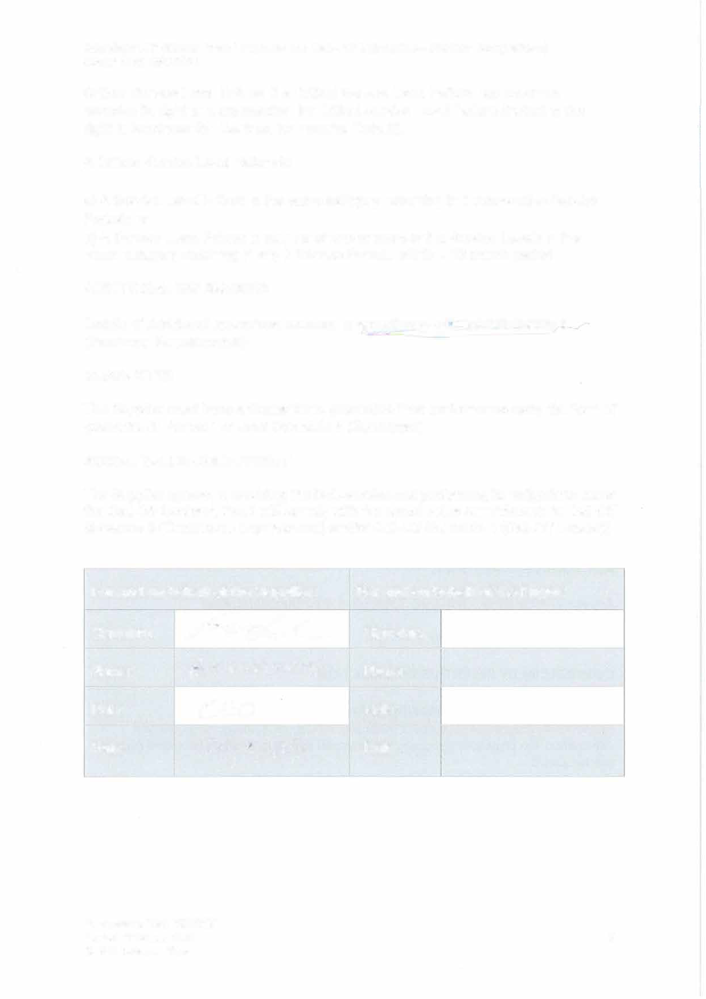
Attachment 5 (Order Form Template and Call-Off Schedules - Further Competition)
Crown Copyright 2022

Critical Service Level Failure: If a Critical Service Level Failure has occurred, exercise its right to compensation for Critical Service Level Failure (including the right to terminate this Contract for material Default).
A Critical Service Level Failure is:

- A Service Level Failure in the same category occurring in 5 consecutive Service Periods or
- A Service Level Failure in respect of one or more of the Service Levels in the same category occurring in any 7 Service Periods within a 12 month period

ADDITIONAL INSURANCES

Details of Additional Insurances required in accordance with Joint Schedule 3 (Insurance Requirements)

GUARANTEE
The Supplier must have a Guarantor to guarantee their performance using the form of guarantee in Annex 1 of Joint Schedule 8 (Guarantee)

SOCIAL VALUE COMMITMENT
The Supplier agrees, in providing the Deliverables and performing its obligations under the Call-Off Contract, that it will comply with the social value commitments in Call-Off Schedule 3 (Continuous Improvement) and/or Call-Off Schedule 4 (Call-Off Tender)]

For and on behalf of the Supplier: |  | For and on behalf of the Buyer:  Signature: Redacted Text Under FOIA, Section 40, Personal Information
Signature: | Redacted Text Under FOIA, Section 40, Personal Information
Name: | Redacted Text Under FOIA, Section 40, Personal Information | Name: Redacted Text Under FOIA, Section 40, Personal Information
Role: | Redacted Text Under FOIA, Section 40, Personal Information | Role:Redacted Text Under FOIA, Section 40, Personal Information
Date: | Redacted Text Under FOIA, Section 40, Personal Information | Date: Redacted Text Under FOIA, Section 40, Personal Information

Framework Ref: RM6217
Project Version: v2.0 8
Model Version: v3.8

