Invitation to tender for
Leicester and Leicestershire Housing Delivery Study


Part A - Contract requirement
NWL106
Contents
Section 1 – Instructions to tenderers 2
Section 2 – Specification 10
Section 3 – Conditions of contract 12

Section 1 – Instructions to tenderers
General requirements
North West Leicestershire District Council are seeking tenders for a consultancy to provide high level housing market advice (in the form of a study) relating to the likely constraints and opportunities to the delivery of housing outlined within the Leicester and Leicestershire Strategic Growth Plan (SGP).

The study is being commissioned by North West Leicestershire District Council on behalf of the following commissioning group:
- Blaby District Council
- Charnwood Borough Council
- Harborough District Council
- Hinckley & Bosworth Borough Council
- The City of Leicester
- Leicestershire County Council
- Melton Borough Council
- North West Leicestershire District Council
- Oadby & Wigston Borough Council

The study will be overseen by a Working Group of representatives from the partner organisations.
The Study will focus on likely market effects on delivery. It does not seek to assess in detail issues such as site by site viability, infrastructure capacity or, planning context; rather the Study will provide evidence on those matters that affect the ability for the housing industry to deliver homes and at what pace.

The Study should provide advice about constraints and opportunities in bringing forward development in line with the spatial strategy identified in the Strategic Growth Plan.

A separate commission will identify the critical infrastructure necessary to deliver the Strategic Growth Plan and will also highlight critical timings for the delivery of such infrastructure. Infrastructure delivery evidence will be made available to the consultants for this Leicester and Leicestershire Housing Delivery Study.

The Study will be expected to test likely market impacts upon delivery including Market Absorption Capacity and interactions both within the Leicestershire Housing Market Area and with adjoining areas, where relevant.

North West Leicestershire District Council (‘The Customer’)’s requirements are defined in the specification.
Contract duration
The contract is for a one-off purchase, Details of any indicative dates will be within the specification.
Process timetable
The procurement project is intended to follow the below timetable:
Step | Date(s) and time(s)
Invitation to tender (ITT) issued | 01/04/2019
Deadline for final clarification questions from suppliers | 15/04/2019
Deadline for the submission of ITT responses | 26/04/2019 at 12PM
Evaluation period | 27/04/2019 – 08/05/2019
Decision and award deadline | 10/05/2019
Contract commencement | To be agreed with successful supplier

The Customer reserves the right to amend this timetable at any time.
The procurement process adopted by the Customer is based on the ‘Open’ tendering procedure as detailed in the European Communities Combined Directive (2004/18/EC) and the Public Contracts Regulations 2015. In brief, the process will be as follows:
- All organisations expressing an interest in the tender have been sent an invitation to tender document.
- An initial examination will be made to establish the completeness of submitted tenders. The Customer reserves the right to disqualify any tender submission which is incomplete.
- Complete tender returns will initially be evaluated to ensure that all the stated essential qualifying criteria will be met.
- All tender returns which meet the essential qualifying criteria will be evaluated in full against the award criteria – this is explained in further detail on the following pages.

All clarification questions to be submitted to procurement@nwleicestershire.gov.uk

Submitting a tender
Tenders must be submitted using the corresponding tender response document (Part B – tender response). This must be completed in full, and signed:
- where the Supplier is an individual, by that individual, or
- where the Supplier is a partnership, by two duly authorised partners, or
- where the Supplier is a limited company, by a director duly authorised for such purposes, or
- where the Supplier is a consortium, by an authorised individual or the lead organisation.
The deadline for submission of tenders is stated within the timetable and on the eProcurement system. Submissions cannot be accessed or opened by the Customer until after the deadline has expired. No documents can be uploaded to the eProcurement system after the deadline has expired. Tenders received in a method other than via the eProcurement system will not be accepted.
It is therefore strongly recommended that your submission is uploaded well before the deadline to avoid traffic and ensure that failure of systems does not result in your tender failing to be submitted by the deadline.

Any queries regarding the tender should be sent via the eProcurement system by the deadline shown in the timetable.

Any additional documents used to support the response must:
- be clearly referred to in the relevant response field
- have a title that clearly identifies the document (so they can be clearly identified when stored electronically)
- have a heading that clearly identifies the document (so they can be clearly identified when printed).
Please submit your tender submissions to procurement@nwleicestershire.gov.uk with the subject header “NWL106 Housing Delivery Study”.
Evaluation
There will be two principal stages to the evaluation of tenders, called ‘qualifying’ and ‘award’. The ‘qualifying’ stage is intended to assess organisations’ general suitability and capability as Tenderers. Those offers that meet the minimum standards and so ‘pass’ the qualifying criteria will then proceed to the second, ‘award’ stage of the evaluation. This stage is designed to assess the merits of each bid, based upon Tenderers’ service delivery proposals.

Tenderers that do not pass the ‘qualifying’ stage in the process will not proceed to the ‘award’ stage and will not be further considered.
Qualifying stage
Assessment against qualifying criteria is essentially a pass/fail exercise, designed to ensure that those Tenderers who proceed to the award stage of the evaluation are considered suitable.

The qualifying criteria against which all tenders will initially be assessed relate to the items addressed in the supplier questionnaire in the tender response document. The qualifying criteria are essentially the minimum standards which Tenderers should meet.
Award stage

The award criteria for the contract will be split between quality and price:
Price

The award criteria for price is 40%.

Suppliers will be required to complete a pricing form / table (either within the tender return document or as a separate attachment). Where appropriate this will contain either actual or estimated usage information which will be used to determine a total project price.

The supplier submitting the lowest price will be awarded the maximum score out of the above percentage. Suppliers submitting higher prices will score proportionately lower using the formula:

(Lowest price / price) x percentage available

Suppliers should satisfy themselves of the accuracy of all fees, rates and prices quoted, since Suppliers will be required to hold these or withdraw their Tender in the event of errors being identified after the submission of Tenders. If a Supplier fails to provide fully for the requirements of the specification in the tender it must either absorb the costs of meeting the full requirements of the specification within its tendered price or withdraw its tender.

Quality

The award criteria for quality is 60%.

Suppliers will be required to respond to a number of questions within the tender return document. The responses to these will be marked using the below methodology:

0 | Completely unsatisfactory/unacceptable response - No response to the question or serious deficiencies in meeting the required standards.
1 | Poor response - The response is partially compliant with some shortfalls in meeting the required standards.
2 | Acceptable response - The response is compliant and meets the basic contract standards. Any concerns are only of a minor nature.
3 | Good response - The response is fully compliant and clearly indicates a full understanding of the contract and ability to consistently deliver all required contract standards.
4 | Excellent response - The response is fully compliant and indicates the ability to exceed the required standards of the contract.

Each question will also have a weighting. This will normally be x1, x2 or x3; however higher weightings may also be used. This will be applied to the mark for each question to establish a total weighted mark for each question. The score for each question will then be added to together to form a total number of weighted marks.

The supplier submitting response with the highest weighted marks will be awarded the maximum score out of the above percentage. Suppliers submitting responses scoring lower weighted marks will score proportionately lower using the formula:

(marks / highest weighted marks ) x percentage available

If a tender scores ‘0’ against any one or more method statements this will give grounds for excluding the tender from any further consideration.
 | Tender specific questions | Max Score per Component | Weighting | Points Available
2.1 | Previous Experience | 4 | 3 | 12
2.2 | Method Statement | 4 | 5 | 20
2,3 | Resource Provision | 4 | 5 | 20
2.4 | Management of contract | 4 | 2 | 8
2.5 | Working with the Councils | 4 | 2 | 8
2.6 | Risk avoidance | 4 | 3 | 12
 | Total |  |  | 80

Please note: The Council reserves the right not to award the contract to the lowest or any bidder, reserving also the right to accept the same in whole or in part.
Preferred supplier

Suppliers’ scores will be added together to give a final score out of 100%. The supplier which achieves the highest total score will be the preferred supplier.
Acceptance of tender

Upon conclusion of the evaluation of tenders, any acceptance of tender(s) will be advised accordingly in writing. Such acceptance, offered pursuant to this Invitation to Tender, will be on the basis of the most economically advantageous tender(s), based on the evaluation criteria listed above.
Tenderers whose tenders it is proposed should not be accepted will be advised of this in writing and will be entitled to receive feedback on the relative merits and characteristics of their tender submission compared with that of the accepted tender(s).
In accordance with the Public Contracts Regulations 2015, the award of the Tender will be subject to a mandatory standstill period of at least 10 days between the notification of award decision and contract conclusion. If representations are received during the standstill period, the Customer may have to suspend the making of the contract and extend the standstill period until any issues have been resolved.
The Customer does not bind itself to accept the lowest or any tender, and unless a tenderer expressly states that a partial award will not be acceptable, then the right is reserved to accept a tender in part.
Upon conclusion of all the above stages, a formal contract will be entered into between the Customer and the Tenderer(s). A copy of the conditions of contract can be found within this document and any Tenderer submitting a bid will be deemed to be agreeing to the terms and conditions contained within. Should a qualification of offer be made to change the terms and conditions by any Tenderer, then grounds will exist to exclude such bids from further consideration.
Upon acceptance of the tender, the Contract shall be immediately constituted and become binding on both parties. The Customer will inform the Supplier of the acceptance of the offer by means of a formal letter accompanied by two copies of the contract document. The Supplier will be expected to sign and return the contract documents to the Customer who will duly sign and return one copy to the Supplier.
Conditions of tender
Tenders must be submitted in accordance with the following conditions. Any Suppliers that do not comply with these instructions or conditions may have their tender rejected.
- Information, costs and expenses
The Supplier is responsible for obtaining all information necessary for the preparation of its submission and all costs expenses and liabilities incurred by the Supplier in connection with the preparation and submission of the tender will be borne by the Supplier.
- Research and investigation
The Supplier will be deemed for all purposes connected with the tender and the Contract to have carried out all researches, investigations and enquiries which can reasonably be carried out and to have satisfied itself as to the nature, extent, and character of the requirements of the Contract (in the context of and as it is described in the Specification), the extent of the materials and equipment which may be required and any other matter which may affect its Tender.
The Supplier shall have no claim whatsoever against the Customer in respect of such matters and in particular (but without limitation) neither the Customer shall make any payments to the Supplier save as expressly provided for in the Contract and (save to the extent set out in the Contract) no compensation or remuneration shall otherwise be payable by any Council to the Supplier in respect of the scope of the Contract being different from that envisaged by the Supplier or otherwise. Information given in respect of current orders is given as a guide and the Customer makes no warranty and accepts no liability as to the actual value or volume of orders to be placed with the Supplier.

- Confidentiality
All documentation and information issued by the Customer relating to the Tender shall be treated by the Supplier as private and confidential for use only in connection with the Tender and any resulting contract and shall not be disclosed in whole or in part to any third party without the prior written consent of the Customer.
The documents which constitute the Contract and all copies are and will remain the property of the Customer (whether or not the Customer shall have charged a fee for the supply of such documents) and must not be copied or reproduced in whole or in part and must be returned to the Customer upon demand.
- Supplier’s warranties
In submitting a Tender the Supplier warrants and represents that:
  - it has complied in all respects with the Conditions of Tender;
  - all information, representations and other matters of fact communicated (whether in writing or otherwise) to the Customer by the Supplier or its employees in connection with or arising out of the Tender are true, complete and accurate in all respects;
  - it had made its own investigations and research, and has satisfied itself in respect of all matters relating to the Tender, the Specification and the Conditions of Contract and that it has not submitted the Tender and will not have entered into the Contract in reliance upon any information, representations or assumptions (whether made orally, in writing or otherwise) which may have been made by the Customer;
  - it has full power and authority to enter into the Contract and will if requested produce evidence of such to the Customer;
  - it is of sound financial standing and the Supplier and its partners, officers and employees are not aware of any circumstances (other than such circumstances as may be disclosed in the accounts or other financial statements of the Supplier which may adversely affect such financial standing in the future;
- Variant bids
Variant bids may only be accepted if indicated within the original contract notice.
In the event that the Supplier has difficulty in complying with any specific provision or wishes to propose any amendment to the specification, it should provide all information and evidence in writing concerning such difficulty or amendment as the Customer may require. The Customer may, at its discretion, consider the difficulty or amendment, and may issue general guidance or waive or amend the relevant provision, but in any case without prejudice to all or any other provisions of the Tender, the Conditions or the Specification or any rights or powers of the Customer hereunder.
No such waiver or amendment shall be binding unless made in writing and signed by the Head of Legal and Democratic Services.

- Freedom of information

Information in relation to this tender or resulting award may be disclosed on demand in accordance with duties imposed on the Customer by the requirements of the Freedom of Information Act 2000.
Suppliers should state if any of the information supplied by them is confidential or commercially sensitive or should not be disclosed in response to a request for information under the Act. Suppliers must provide detailed justifications why they consider the information to be confidential or commercially sensitive and an indication of how long they expect that confidential or commercially sensitive status to subsist.
Suppliers acknowledge that neither an assertion nor the provision of justifications constitutes a guarantee that the information will not be disclosed by the Customer, pursuant to a valid request made under the Act.

- Rejection of tender
Any Tender submitted by a Supplier in respect of which the Supplier:
- fixes and adjusts prices and rates shown in its tender by or in accordance with any agreement or arrangements with any other person or by reference to any other tender or communicates to any person other than the Procurement Officer leading on this tender the amount or approximate amount of the prices and rates shown in its tender except where such disclosure is made in confidence, in order to obtain information for the preparation of the tender documents or for the purposes of financing or insurance; or
- enters into any agreement with any other person that such other person shall refrain from submitting a tender or shall limit or restrict the prices to be shown by any other tenderers in its tender; or
- offers or agrees to pay or does pay or give any sum of money, inducement or valuable consideration directly or indirectly to any person for doing or having or causing or having caused to be done in relation to any other Supplier or any other person’s proposed Tender any act or omission; or
- in connection with the award of the Contract commits an offence under the Prevention of Corruption Acts 1889-1916 or gives any fee or reward the receipt of which is an offence under Sub-Section (2) of Section 117 of the Local Government Act 1972; has directly or indirectly canvassed any member or official of the Customer concerning the acceptance of any Tender or who has directly or indirectly obtained or attempted to obtain information from any such member of official concerning any other Supplier or tender submitted by any other Supplier;
shall be rejected by the Customer provided always that such non-acceptance or rejection shall be without prejudice to any other civil remedies available to the Customer or any criminal liability which such conduct by a Supplier may attract.
- Non-consideration of tender
The Customer may in its absolute discretion refrain from considering any Tender if:
- it is not in accordance with the Form and Conditions of Tender;
- the Supplier makes or attempts to make any variation or alteration to the terms of the Tender, the Conditions or the Specification except where a variation or alteration is invited or permitted in accordance with the terms of all or any of the Tender, the Conditions and the Specification; or
- the Supplier does not provide all the information required by the Customer.
- Words and expressions
Words defined in the Terms and Conditions of Contract shall have the same meaning throughout the Tender document.

- Validity of tender

All suppliers shall keep their respective bids valid and open for acceptance by the Customer for ninety (90) days from the deadline for the submission of tenders.

Section 2 – Specification

Background

  - The Strategic Growth Plan is the overarching plan and sets out the aspirations for delivering growth (housing, economic, infrastructure) in Leicester and Leicestershire until 2050.

  - The Plan is non-statutory and will be used as a basis for preparing or reviewing individual Local Plans, transport plans and economic plans. The spatial strategy in the SGP includes 60% of growth on strategic sites reflecting garden city principles, and includes significant concentrations of growth along the A46 Priority Growth Corridor and at the Leicestershire International Gateway. A map showing the SGP spatial strategy is set out below:

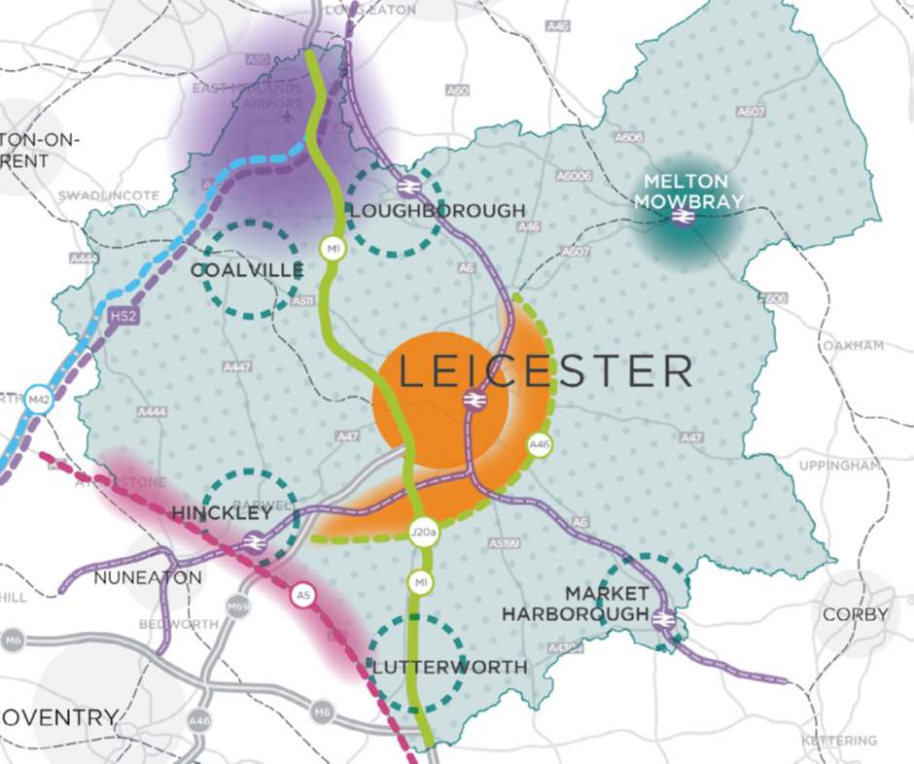

More information about the Leicester and Leicestershire Strategic Growth Plan can be found here:

www.llstrategicgrowthplan.org.uk/the-plan/stage-three/

  - The preparation of the Plan has been overseen by a Members’ Advisory Group (MAG), which includes elected representatives from each of the local authorities, together with the Leicester and Leicestershire Enterprise Partnership (LLEP) whose representative attends as an observer. The MAG is supported by a Strategic Planning Group, which is made up of senior officers from the local authorities.

  - The SGP analysed the amount of development that has already been built, has planning permission or is allocated in adopted or emerging local plans that have been published. This demonstrates that across the Housing Market Area much of our housing and employment land is already provided for in the period 2011-31.

  - Beyond 2031, the SGP sets out the notional housing need and supply up to 2050.

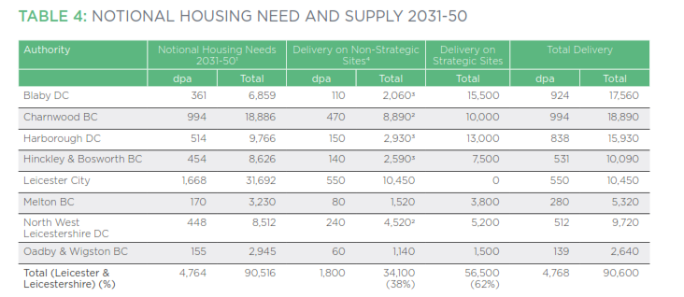

  - The SGP identifies a number of strategic growth areas to accommodate development, the capacity of which is shown in the table below:

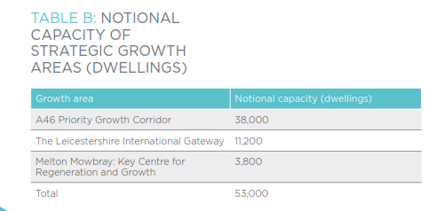

Study Objectives

  - The objectives of the Study are:

- To provide clear conclusions about constraints and opportunities relating to the delivery of housing across the Housing Market Area to 2031 and 2036, with further commentary for the period up to 2050; and
- To provide clear high level recommendations to respond to the constraints and opportunities in housing delivery identified within the Study.

Outputs

  - It is open to consultants to propose their own methodology to meet the Study requirements. However, as a guide, it is anticipated that the Study will include the following outputs:

- Clear and transparent method statement;
- Concise analysis of context, including “Independent Review of Build Out Rates” (Letwin Review), relevant government guidance and policy, and national and regional trends in housing delivery;
- Consultation with stakeholders including house builders and local agents operating within each constituent authority in Leicester and Leicestershire;
- Analysis of housing market factors affecting delivery, including (but not limited to) lead-in times for strategic sites, market absorption capacity within each planning authority area and for the longer term within the cross-boundary Priority Growth Areas, market inter relationships from within the Leicester and Leicestershire Housing Market Area and from surrounding housing market areas;
- Commentary on delivery considerations for strategic development area / strategic sites;
- Clear conclusions at authority and Housing Market Area level about constraints and opportunities to housing delivery in relation to the spatial strategy proposed through the Leicester and Leicestershire Strategic Growth Plan;
- Commentary on delivery models to support the delivery of housing growth across the HMA; and
- Recommendations about minimising constraints to delivery and improving opportunities for delivery in relation to the spatial strategy proposed through the Strategic Growth Plan.

Evidence to be provided to Consultants

  - The consultants carrying out this commission will be supplied with the following information:

  - Strategic Infrastructure Review covering Leicester and Leicestershire (due May 2019).

  - The table below lists the information that each local authority in the Housing Market Area will provide:

Local Authority | Evidence
Leicester City | Leicester Core Strategy (2014)  Local Plan Emerging Options Consultation Documents (2017)  SHELAA (2018) (when published)
Charnwood Borough | Charnwood Core Strategy  Draft Local Plan 2018  SHLAA 2018  Market Delivery Study 2018  Annual Monitoring Report 2018
Hinckley and Bosworth Borough | •Core Strategy 2009  •Site Allocations & Development Management Policies DPD 2016  •Hinckley Town Centre Area Action Plan (AAP) DPD 2011  •Earl Shilton & Barwell AAP DPD 2014  (all available at https://www.hinckley-bosworth.gov.uk/info/1004/planning_policy_and_the_local_plan/101/local_plan_2006_to_2026)  Local Plan Review Scope, Issues and options 2018  Local Plan Review New Directions For Growth 2019  (https://www.hinckley-bosworth.gov.uk/info/1004/planning_policy/1315/local_plan_review)  SHELAA - https://www.hinckley-bosworth.gov.uk/info/856/local_development_framework/429/strategic_housing_land_availability_assessment_shlaa  Residential Land Availability Assessment 2017/18 - https://www.hinckley-bosworth.gov.uk/downloads/download/1349/residential_and_employment_land_availability_monitoring_statement
Northwest Leicestershire District | North West Leicestershire Local Plan 2011-2031  SHLAA 2018  Annual Monitoring Report 2018  Housing Trajectory October 2018
Blaby District | Blaby District Local Plan Core Strategy 2013  Blaby District Local Plan Delivery DPD 2019  Latest SHLAA  Residential Land Availability schedule (RLA) 2017-2018 (or later once published) and any relevant background housing monitoring info.  Latest Annual Monitoring Report
Harborough District
Melton Borough | Melton Local Plan, 2011-2036, available on:  https://www.meltonplan.co.uk/adoptedplan  Housing land supply, Question 6.3 Melton Local Plan:  https://docs.wixstatic.com/ugd/2778e0_c8d78b9cea974c3895929db39ff83f5e.pdf  Melton Local Plan Examination, Nov 2017, Sections 3 & 4 and Appendices 1-3 which include a housing market capacity estate agent survey.  https://docs.wixstatic.com/ugd/2778e0_572b5799bc064067be2e4cfaae053f80.pdf  The following evidence is also all available on  www.meltonplan.co.uk/evidencebase :  MBC/HS1B: Melton Long term Trajectory for Allocated Sites, Dec 2017.  MBC/HS1a: 5 Year Land Supply and Trajectory Update, Dec 2017  MBC/HS4a: Melton SHLAA, August 2017  MBC/HS4e: Melton SHLAA 2017 database  Annual Monitoring report 2017, www.meltonplan.co.uk/amr2017, and (subject to completion) AMR 2018 at https://www.meltonplan.co.uk/copy-of-amr
Oadby and Wigston Borough Council | Oadby and Wigston Core Strategy 2010  The Borough of Oadby and Wigston Local Plan (currently awaiting a Final Inspectors Report)  Most up to date published Strategic Housing Land Availability Assessment (SHLAA)  Most up to date published Residential Land Availability report (RLA)  Most up to date published Housing Implementation Strategy (HIS)  Most up to date published Annual Monitoring Review (AMR)

Timescales

Issue Brief | Commissioning authorities | w/c 01.04.2019
Deadline for tenders | Consultants/NWL | 26.04.2019
Review Tender Submission | NWLCommissioning authorities
Award Contract | NWLCommissioning authorities | 10.05.2019
Inception Meeting | NWLCommissioning authorities/ consultants | 21.05.2019
Collection of evidence and information for consultants | NWLCommissioning authorities | 03.06.2019
Evidence re infrastructure lead in time provided to Delivery Study Consultants | NWLCommissioning authorities | May 2019
Presentation of findings | Consultant | Late August 2019
Draft Final Report | Consultants | 28.8.2019
Review Draft Final Report | CBC/all | 09.09.19
Comments issued to consultant | CBC | 12.09.2019
Final Report | Consultants | w/c 23.09.2019

Method of Working

  - The procuring team is keen for the project(s) to be undertaken quickly so as not to delay progress with any forthcoming Local Plans. The procuring team will therefore expect the assessment to be managed effectively and efficiently with close consultation with the procuring team. Any assistance or information required from the client group should be specified in the submission.

Approach

  - Appropriate and experienced consultants are invited to propose a methodology tailored to respond to the specific requirements in this specification and take account of local circumstances and challenges.

Project Management

  - The successful consultant will be expected to provide details of specific stages with identified outputs and milestones for each stage as part of the Method Statement and Project Plan, and provide assurances about the ability to meet deadlines. The procuring team will expect a fortnightly email or telephone update on the progress with the project.

Section 3 – Conditions of contract

Please find attached the terms and conditions that the supplier will be required to accept. This does not require to be returned with your tender response.

