**RFI Suit Material**

**Introduction**

The UK Ministry of Defence issues Counter-Chemical Biological Radiological and Nuclear (CBRN) Personal Protective Equipment to UK forces personnel to provide them with protection against CBRN threats.

A significant component of the protective equipment supplied to UK forces is the Mk 4a CBRN suit, which has been in-service since 2005. Throughout the Mk 4a’s life there has been continuous assurance testing conducted, and as a result the Authority has a high degree of confidence in the safety and efficacy of the product.

The Mk 4a suit includes the use of a Perfluorohexanoic acid (PFHxA) or ‘C6’ coating on its outer layer. There is currently significant scrutiny on the use of Per and Polyfluoroalkyl Substances (PFAS) due to environmental concerns. As such, the authority is interested in securing a quantity of material that meets the specifications laid out in Annexes A and B, so as to be confident in its ability to manufacture sufficient numbers of Mk 4a suits if and when required.

**Questions**

1. Can your company manufacture / supply quantities of materials in the approximate region of 889,000 Linear Metres (LM) of carbon inner fabric and 979,250 LM of C6 coated outer fabric, as per the material specifications outlined in Annex A and B?
2. What standards have these materials been tested and assessed against? If asked, would you be able to provide evidence of testing and successfully meeting the requirements of those standards?
3. Could your company subsequently store these quantities of materials in a suitable temperature and humidity-controlled environment? If so, for how long could you commit to doing so?
4. What is the shelf life for this material, if stored in the appropriate environmental controlled conditions?
5. What is the lead time to provide this quantity of the materials?
6. Is your company the material manufacturer? Please provide a breakdown of your supply chain, including the chemical supplier and the material manufacturer?
7. To assist our planning, please provide timeframes that your company can guarantee the supply of this type of material for. Provide assumptions and dependencies that you are aware of, that may affect the guaranteed supply.
8. Please could you provide indicative ROM costs for the full quantity of materials at question 1 above, as well as the cost of storage for the same quantity of material.

The MoD is only seeking information from industry at this stage on availability. The RFI is without commitment and is subject to contract.

**Annex A - C6 Coated Outer Fabric Criteria is shown in Table 1 below:**

Table 1 - Outer Coated Fabric Specification

|  |  |  |  |
| --- | --- | --- | --- |
| **Property** | | **Requirement** | **Method of Test** |
| Fabric thickness (mm) | | 0.30 $±$ 0.05 | BS EN ISO 5084 Pressure to be 100g/cm2 & the area of the pressure foot is to be 10cm2 |
| Mass (gm-2) | | 17510% | BS EN ISO 12127 |
| Maximum Air Permeability (mm.s-1) | | 120 | BS EN ISO 9237 |
| Minimum Breaking Load (N) | Warp | 750 | BS EN ISO 13934-1 |
| Weft | 300 |
| Minimum Wing Tear Test peak (N) | Warp | 25 | BS EN ISO 13937-3 |
| Weft | 25 |
| Flammability (3/12l/60) | | Index 3 after 12 wash/dry cycles at 60°C | BS EN ISO 14116 |
| Water Repellency (Spray Rating) | | 4 | BS EN 4920 (2012) |
| Oil Repellency (Oil Rating) | | 6 | See Figure 1 Below BS ENISO14419 (2010) |
| Minimum Abrasion Resistance (rubs) | | 15000 | BS EN ISO 12947-2 |

Figure 1 - Oil Repellency Test

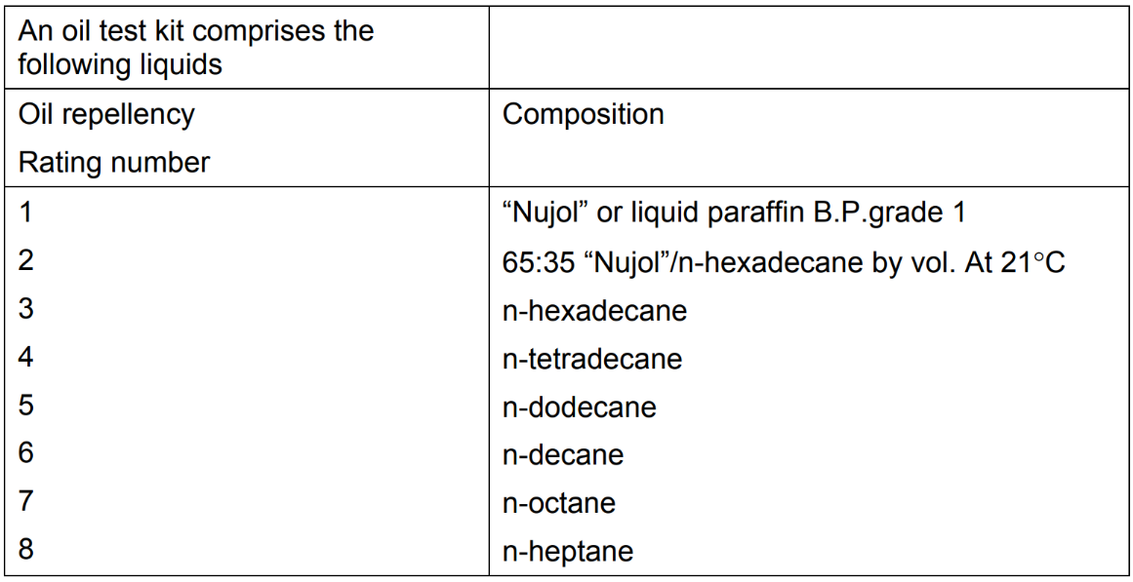

**Annex B - Inner Carbon Fabric Performance Criteria is shown in Table 2 below:**

Table 2 - Inner Carbon Fabric Specification

|  |  |  |  |
| --- | --- | --- | --- |
| **Property** | | **Requirement** | **Method of Test** |
| Mass / (g.m-2) | | 29030 | BS EN 12127 |
| Thickness (mm) | | 1.10 $±$ 0.22 | BS EN ISO 5084  100 (g.cm-2) on pressure foot 10 cm2 |
| Minimum Air permeability (mm.s-1) | | 200 | BS EN ISO 9237  Pressure 100 pa Test area 20cm² |
| Minimum Breaking load (N) | Machine direction (warp way) | 200 | BS EN ISO 13934-1 |
| Across machine (weft way) | 80 |
| Percentage Elongation at break, minimum (%) | Machine direction | 30 | BS EN ISO 13934-1:1999 |
| Across machine | 100 |
| Wing tear test, minimum (N) | Machine direction | 20 | BS EN ISO 13937-3 |
| Across machine | 25 |
| Delamination of backing,  Minimum (N per 76 mm) | Machine direction | 4.0 | BS EN ISO 2411:2017  See Figure 2 below |
| Across machine | 4.0 |
| Stiffness max bending length  (mm) | Machine direction | 55 | BS 3356  Machine Direction max 55  Cross direction max 45 |
| Across machine | 45 |
| Maximum Carbon loss after one wash/dry cycles (g.m-2) | | 18 | See Figure 3 below |

Figure 2 - Delamination Strength of the Covering

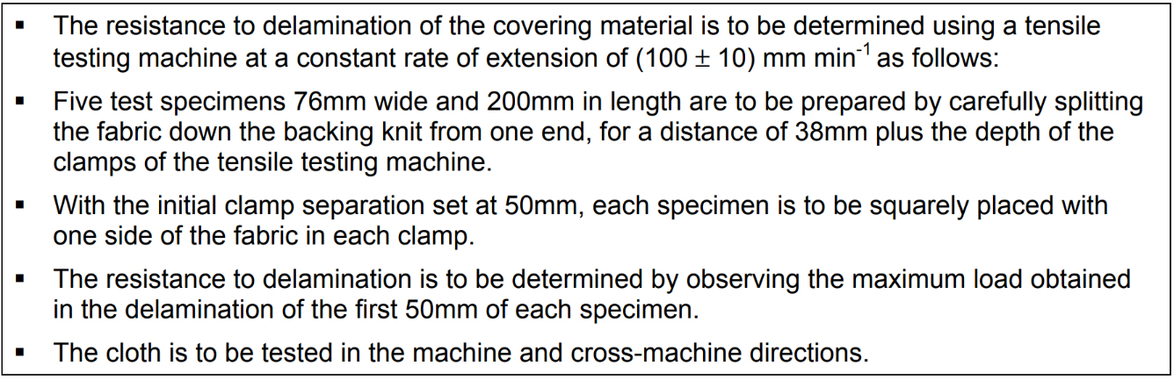

Figure 3 - Wash Test Procedure

