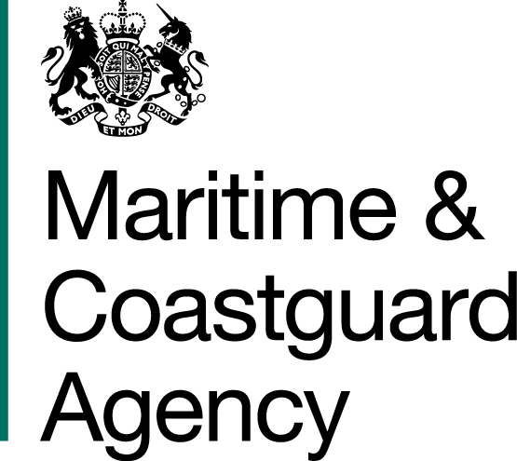 |  |  | Bay 3/21  Spring Place  105 Commercial Road  Southampton  SO15 1EG
 | To whom it may  Concern, |  | Tel:  E-mail: | +44 (0)20 381 72476  contracts@mcga.gov.uk
 |  |  | Your ref:  Our ref: |  | TCA 3/7/1112
First issued 18th July 2019
Last updated 5th August 2019

Dear Sirs

REVIEW OF THE RISK TO THE UK FROM MARINE OIL POLLUTION
QUESTIONS AND ANSWERS -

We have received questions for the above-mentioned tender, and to ensure that all tenderers have access to the same information, we have copied the questions and our answers to you:

Question 1: Would it be possible to view a copy of past Risk Reviews? This would help us to understand what level of detail is required in deliverable.

MCA response: The Authority agrees to provide the executive summaries and contents pages for some of these previous risk reviews which will give an idea of the scope, scale and subject matter covered in these papers. The Authority also agrees to provide a link to the National Audit Office report Dealing with Pollution from Ships, which is already publicly available online:

https://www.nao.org.uk/report/dealing-with-pollution-from-ships/

The rationale for not providing all of the papers in full is that the Authority wishes to avoid a situation where bidders interpret this provision as a desire on the part of the Authority for this risk review to replicate the methodologies used in previous risk reviews, thereby stifling the innovation we are looking for. It should also be noted that these reviews do in themselves vary in terms of approach and focus, depending on the Authority’s stated requirement for those studies and on the analysis tools available at the time.

In terms of level of detail, given the level of resource available and the timescale, the MCA understands that the data analysis carried out to inform this risk review will not be exhaustive. On the other hand, the level of detail and accuracy of the findings should be sufficient to inform the MCA’s resourcing for oil spill response, providing a reasonable basis for this planning. Striking this balance and providing a rationale for the chosen approach is the purview of the bidder and, again, the Authority encourages innovative approaches. To dictate or indicate the appropriate level of detail risks stifling any innovation.

Question 2: Would it be possible if an extension to the deadline for submission of tenders?

MCA response: MCA has extended the deadline for receipt of tenders until midday on the 30th August 2019.

Question 3: Will the MCA provide any tabulated marine traffic and/or tabulated accident statistics data following contract award? If so, what might this include please?

MCA response: AIS data for the UK EEZ is available in a .csv format rendered down into individual days from 2013 up to the end of July 2018. The file sizes are considerable, and an external drive will be the fastest method of transfer. This drive should be provided by the successful bidder.

AIS data from August to December 2018 can be extracted, but at present the timescale for this is not known.

Data on incidents/accidents is available in the weekly summaries of the MCA’s Counter Pollution and Salvage Officers. The successful bidder will have access to these. UK Annual Marine Pollution Surveys published by the Advisory Committee on the Protection of the Sea (ACOPS) are also available up to 2016.

No data held by the MCA will be released prior to contract award.

Question 4: Stage 1 refers to oil cargo. Will this include Hazardous and Noxious Substances?

MCA response: No, the Risk Review will not include hazardous and noxious substances unless the substance in question is also defined as oil under Annex I of the MARPOL Convention. The purpose of the Review is to inform the MCA’s resource planning for its response to marine oil spills and must be confined to this. If this is unclear, bidders should refer to the definition(s) of oil under Annex I of the MARPOL Convention and the examples laid out therein.

Question 5: Annex 3 – Price Evaluation states that “the total project price shall be paid in accordance with Clause 2.4 in the form of contract (Annex 4)”. Clause 2.4 is not in Annex 4 (form of contract). Please clarify.

MCA response: This is a typo – it should refer to Clause 2.1 in the Form of Contract.

Question 6: The ITT refers to Annex 5 on page 8. Annex 5 is not in the provided documentation. Is this an additional document? If so, can a copy please be made available?

MCA response: This is a typo and should refer to the Form of Contract in Annex 4.

Yours faithfully,

Kathy Monk
MCA Procurement Team

