 | Westbury Town Council
The Laverton, Bratton Road, Westbury
Wiltshire BA13 3EN Tel: 01373 822232
E-mail: info@westburytowncouncil.gov.uk
http://www.westburytowncouncil.gov.uk

MUGA Invitation to Tender Document

CONTENTS
Notice to Tenderers
Information and Instructions to Tenderers
Standard Conditions of Contract
Scope of Work
Use of Sites
Form of Tender
Certificate by the Tenderer

APPENDICES
Appendix A Description of Local Authority
Appendix B Health and Safety Policy
Appendix C Site map
Appendix D Documents required prior to commencement of the Contract

Notice to Tenderers

Grassacres play area is one of ten play areas within the town of Westbury and is situated close to the town centre. Westbury Town Council aim to improve and develop public parks and open spaces, Grassacres play area is just one development in that the town council are improving.

To encourage and promote Health and Wellbeing is a priority for the town council. …………

INFORMATION AND INSTRUCTIONS TO TENDERERS

- Grassacres play area.
Westbury Town Council (“Employer”) hereby invites tenders for the carrying out the installation of a Multi-Use Games Area (MUGA) and exercise equipment in accordance with the Contract Documents attached.
Prospective Contractors should note the Council does not bind itself to accept the lowest or any tender that is received. The Council’s decision is final, and no correspondence will be entered into on the reason why a tender has been rejected.
- The Employer
Details of the employer including its areas of responsibilities are included in Appendix A of the Contract Document together with the address of the principal offices of the Employer, and the address of the Town Clerk to whom the Tender is to be delivered.
Prospective Contractors should ensure that they are completely familiar with the nature and extent of the obligations to be accepted by them if their tender is accepted.
- The Basis of the Tender
Tenders are being invited from a list on the basis that the Contract will carry out the installation of a MUGA remove present MUGA, which is a wall, remove the present adult equipment and install new exercise equipment in a reloacted place mapped within the documentation.
- Trade Association
Prospective contractors must state if they are members of a bona fide Trade Association.
- Clarification of Meaning within the Contract
Prospectice contractors are required to keep Tenders valid for acceptance for a period of 90 days from the date of the Tender.
- Commencement Date
The successful Contractor will be required to provide project dates for commencing work and end time
- Tendering Procedure
The tender process will be conducted and in compliance with The Public Procurement Regulations 2015 Public procurement policy - GOV.UK (www.gov.uk) and any updated guidance since.
If the number of submissions is considered too low, and the minimum brief of the responses is not met, the Westbury Town Council has the right to dismiss these tenders and re-issue the documentation, starting the process over. Alternatively, if the brief has or is close to being met, Westbury Town Council may make requests to identify any shortfalls or amend the proposed designs to meet the desired budget and overall objectives, even if only one submission was received.

Contractor / Tenders for the execution of the Service must be made on the Form of Tender included with the Contract Documents and the procedures listed below must be followed:
- The form must be signed by the Contractor / Tenderer and submitted with the following, all of which must be properly completed:
- A certificate that the Tender is bona fide (a copy is included with this document)
- An illustration of the way in which the Contractor / Tenderer proposes to carry out the Contract, including his management, supervision and administrative structure.
- Form of Tender (a copy is included)
- All the documents must be placed in an envelope, sealed and clearly marked Tender for MUGA Grassacres Park.
- Tenders must be delivered in the manner requested to the Town Clerk at the address in Appendix A. No Tender will be considered if it reaches the Named Officer after the time specified.
- Contractor/Tenderers are advised to visit the area to ascertain all relevant conditions and means of access and to thoroughly acquaint themselves with the extent and nature of the proposed Services and will be deemed to have done so before submitting a Tender.
- Contractor/Tenderers should treat details of their Tenders and any subsequent Contract as private and confidential.
The Employer will publish the awarded contract and contractor details on Contractor Finder.

- Quotations
  - Following the receipt of tenders and a preferred contractor being awarded the project, any changes made to the final budget as variations or revisions, will fall within the permissible range of The Public Contracts Regulations 2015 Regulation 72 The Public Contracts Regulations 2015 (legislation.gov.uk).
8.2 All tender pricing should be exclusive of VAT and in GBP (£).
For the duration of the contract all prices will be fixed and firm.
  - The Employer has the right to refuse any or all submissions without tenderers being able to claim any compensation. All costs associated with the tender process and submission are the responsibility of the suppliers that have decided to participate.
  - The Employer may refuse a tender response if there has been any attempt to vary or alter the
details within the document or the tenderer not able to provide all the information required by the Employer to make a full evaluation.
  - Any offence or inappropriate actions by the supplier, including an offence under the Prevention
of Corruption Act may result in disqualification. Anything other than ‘appropriate’ contact made to the individual named within this document for the purposes of clarifying the requirements or raising any questions pertaining to the tender may be considered a breach in the procurement process.
8.6 The successful contractor must be able to provide evidence of:
- Public Liability Insurance of no less than: £10 Million
- Product Liability Insurance of no less than: £5 Million
- Employers Liability Insurance of no less than: £5 Million
- Professional Indemnity Insurance of no less than: £1 Million
8.7 The successful contractor will be expected to arrange and attend, agreed timed meetings on site during construction until work is completed and handed over. The timing of these site visits will be agreed before work commences.
8.8 The contractors plan will include the following:
- A Programme of Works with an expected commencement and completion date
- A Risk Assessment and Method Statement
- Access and Traffic Management Plan
- An Organisational Chart outlining escalation contacts that are available to remedy any issues that arise during construction.
- Out of hours emergency contact details with an agreed time scale for response.

- Contract Conditions.
  - The work is for the design, supply and installation of appropriate groundworks, materials,
surfacing, fencing and associated works that meets the brief and is acceptable by The Employer.

  - If there is evidence that the work does not conform to the required standards and as a result the
materials or workmanship is substandard, unsafe or require replacement or repair, this will be completed at the cost of the Contractor.

The contractor will adhere to the Construction (Design and Management) Regulations 2015 (CDM 2015) Construction - Construction Design and Management Regulations 2015 (hse.gov.uk). The contractor will have the skills, knowledge, and experience, and, if they are an organisation, the organisational capability, necessary to fulfil the role that they are appointed to undertake, in a manner that secures the health and safety of any person affected by the project.
  - The Contractor will adhere to the Sports And Play Construction Association (SAPCA) Code of
Practise for construction of outdoor multi use games areas. In the construction of the MUGA. BS EN 15312 and with exercise equipment BS EN 1176 at Grassacres play area

  - A formal contract will be produced to the successful tender, inline with the attached documents
and the approved design.

CONTRACT FOR
Grassacres MUGA

STANDARD CONDITIONS OF CONTRACT

- DEFINITION
  - In the Contract (as herein under defined) the following words and expressions shall have the meaning hereby assigned to them except where the context otherwise requires.
“EMPLOYER” means Westbury Town Council, The Laverton, Bratton Road, Westbury, Wiltshire, BA13 3EN
“CONTRACTOR” means the person, persons, or company accepted by the Employer and includes the Contractor’s personal representatives, successors and permitted assigns.
“TOWN CLERK” means the Council’s Chief Officer or any other officer to the extent designated by her or the Council in writing to act on behalf of the Employer.
“CONTRACT” means the Conditions of Contract, Specification, Priced Schedules, the Tender, the Written Acceptance thereof and the Contract entered into between the Employer and the Contractor.
“SPECIFICATION” means the specification referred to in the Tender a copy of which is annexed, and any modifications as may from time to time be furnished or approved in writing by the Town Clerk.
“PRICING SCHEDULE” means the Pricing Schedules containing the estimated requirement for one 12-month period, with the rates inserted by the Contractor at the time of Tender.
“TENDER TOTAL” means the total of the Pricing Schedules for which the Contractor has tendered and have been accepted at the date of the Contractor’s Tender for the Services.
“ANNUAL SUM” means the annual sum payable by the Employer to the Contractor calculated in accordance with the Tender.
“ORDER” means an instruction from the Authority to carry out items of work to be performed under this Contract.
“COMMENCEMENT DATE” means the date from which the Contractor commences to provide the Services.
“CONDITIONS” means these conditions and any modification thereof.
“COUNCIL” means Westbury Town Council or any successor authority.
“INDEX” means the “All Items” Index of Retail Prices published by the Office for National Statistics or any Government Department upon which duties in connection with the compilation and maintenance of such Index shall have and/or other appropriate Index as stated in the Appendix.
“SERVICES” mean the Services to be provided by the Contractor under the conditions of this Contract and as set out in the Specification.
“WEEK” means seven consecutive days starting on Monday and ending the following Sunday.
Reference to “EMPLOYEES” of the Contractor shall be deemed to include the Contractor’s agents and sub-contractors unless the context otherwise requires.
“THE ACCOUNT” means the statement submitted to the Council by the Contractor.
“REVIEW DATES” means the first, second and third anniversaries of the Commencement Date as the context requires.

- SUFFICIENCY OF INFORMATION

  - The Contractor shall be deemed to have satisfied himself before submitting his tender as to the accuracy and sufficiency of the rates and prices stated in his tender which shall cover all the Contractor’s obligations under the Contract and shall be deemed to have obtained for himself all the necessary information as to risks, contingencies and any other circumstances which reasonably influence or affect the tender.
  - The Contractor shall visit all locations and satisfy himself as to the accuracy, nature and extent of the services to be provided.

- PERFORMANCE OF SERVICE

  - During the Contract Period the Contractor shall perform the Services (and any modifications) in a manner totally consistent with the terms and conditions of Tender using reasonable care and skill and to the entire satisfaction of the Town Clerk.

- ASSIGNMENT

4.1 The Contractor shall not assign the Contract or any part without the written consent of the
Employer, PROVIDED that any assignment occurring as a result of any internal reconstruction of
a Contractor which is a limited company shall be deemed not to be a breach of this condition.

- SUBCONTRACTING

  - The Contractor shall not sub-let the whole or any part of the contract without the prior written consent of the Employer and such consent, if given, shall not relieve the Contractor from any liability or obligation under the Contract and he shall be responsible for the acts, defaults and neglects of the Contractor, his agents, or employees.

- METHOD OF PAYMENT

  - Provided that the Contractor shall have performed the services in accordance with the Contract the Employer shall pay on mutually agreed payment dates. The full contract sum will not be paid until completion of project.

- AGENCY
  - The Contractor is not and shall in no circumstances hold himself out as being the agent of the Employer.
  - The Contractor is not and shall in no circumstances hold himself out as being authorised to enter into any contract on behalf of the Employer or in any other way to bind the Employer to the performance, variation, release or discharge of any obligation.
  - The Contractor has not and shall in no circumstances hold himself out as having the power to make, vary, discharge or waive any Bye-law or Regulation of any kind.
  - The employees of the Contractor are not, shall not hold themselves out to be and shall not be held out by the Contractor as being, servants or agents of the Employer for any purpose whatsoever.

- VEHICLES, PLANT AND MACHINERY

8.1 The Contractor shall at all times during the Contract Period provide and maintain all such
vehicles, plant, machinery and equipment (together referred to as “Plant”) as are necessary
for the proper performance of the services.
8.2 The Contractor shall at all times be fully responsible for licensing and for the payment of all
licensing fees, taxes and insurances required in connection with or arising out of the possession
or use of all Plant employed in the performance of the Services.
8.3 Plant used in the performance of the services shall comply with the relevant Construction and
Use Regulation and be of a design which is entirely suitable for the purposes of the Contract.
8.4 The Contractor shall at his own expense keep all Plant employed in the performances of the
Service at all times in good and serviceable repair and in such condition as is commensurate with
the proper performance by the Contractor of his obligations under this Contract.
  - All plant and tools used to maintain the park are to be in line with government guidelines for
working towards carbon neutral by 2030 and using sustainable resources/energy.

- OBSERVANCE OF STATUTORY REQUIREMENTS
  - The Contract shall be in all respects governed and construed in accordance with the laws of
England.
  - The Contractor shall comply with any law which prohibits discrimination in relation to
employment on the grounds of colour, race, sex, ethnic or national origin, religion or disability.
  - The Contractor shall ascertain and conform in all respects with the provisions of any general or local Act of Parliament and the Regulations and Bye-Laws of any local or other statutory authority which may be applicable to the Contract.
  - The Employer is indemnified against all penalties and liability of every kind for breach of any such Act, Order, Regulations or Bye-law.

- TERMINATION

10.1 The Council shall be entitled, upon the happening of any of the following events, to terminate
by writing notice the Contract, without prejudice to any other rights the Employer may have
whether against the Contractor directly or pursuant to any guarantee or indemnity:
    - If the Contractor fails to perform or suspends the provision of the whole or any substantial part of the service for more than seven days.
    - Any serious breach by the Contractor of any term or provision of the Contract.
    - If in the Employer’s opinion the Contractor’s performance is in continual default with no obvious improvement.
    - If the Contractor becomes bankrupt, or makes an arrangement with his creditors, or has a proposal in respect of his company for the voluntary arrangements for a composition of debts or any scheme or arrangements approved in accordance with them.
    - If the Contractor has an application made under the Insolvency Act 1986 in respect of his company to the Court for the appointment of an administrative receiver.
    - If the Contractor has a winding-up order made or (except for the purposes of amalgamation or reconstruction) a resolution for voluntary winding up passed.
    - If the Contractor has a provisional liquidator, receiver, or manager of his business or undertaking duly appointed.
    - If the Contractor has an administrative receiver, as defined in the Insolvency Act 1986, appointed.
    - If the Contractor has possession taken by or on behalf of the holder of any debentures secured by a floating charge, or any property comprised in or subject to the floating charge.
    - If the Contractor is in circumstances which entitle the Court or a creditor to appoint, or have appointed a receiver, a manager, or administrative receiver, or which entitles the Court to make a winding-up order.
    - If the Contractor has failed to produce a programme of work not less than FOURTEEN days before the Commencement of the Contract or within FOURTEEN days of any Variation of the Contract.

10.2 If the Contract is terminated under Clause 10 above the Employer shall:
    - Instruct forthwith, or otherwise, the Contractor to cease to perform any of the Services.
    - Be entitled to require the Contractor to pass all relevant data, correspondence etc. to the Town Clerk or other person employed to provide the Service.
    - Be entitled to employ and pay other persons to provide and complete provision of the Service or any part thereof and to use without payment or allowance to the Contractor all such Contractor’s materials, equipment, or other goods for the purpose thereof.
    - Be entitled to deduct from any sum or sums which would but for such termination have been, at the date of such termination, due from the Employer to the Contractor under this Contract or any other contract be entitled to recover from the Contractor as a debt, the amount of any costs loss or damage to the Employer resulting from or arising out of the termination of the Contractor’s employment. Such loss or damage shall include the reasonable cost to the Employer for the time spent by its officers in terminating the Contract.
    - When the total costs, loss and/or damage resulting from or arising out of the termination of the Contract have been ascertained and deducted so far as is practicable from the sum or sums, and set off against any sum which but for termination would have been due to the Contractor, be entitled to recover from the Contractor as a debt any balance shown as due to the Employer or, alternatively, the Employer shall pay the Contractor any balance shown as due to the Contractor. The Town Clerk shall certify the amount by which the said costs, loss and or damage (insofar as not by the date of the certificate already recovered from the Contractor) exceeds or falls short of the amount otherwise due to the Contractor and the amount certified shall be debt payable to the Employer by the Contractor or to the Contractor by the Employer (as the case may be).

10.3 If the Contractor shall have committed any offence under the Prevention of Corruption Acts 1889–1916, Bribery Act 2010 or shall have given any fee or reward to any officer of the Employer, the Employer shall be entitled to terminate the Contract and recover from the Contractor the amount of any loss to the Employer resulting from such termination.
10.4 Without prejudice to the exercise of its powers under 11.1–11.3 inclusive above, the Employer may, without determining the whole of the Contract, determine the Contract in respect of part of the Services only, by notice in writing having immediate effect (whereupon a corresponding reduction in the Contract Price shall be made as if such determination was a Variation) and therefore itself provide or procure a third party to provide such part of the Services.
- VARIATIONS
11.1 The Town Clerk and Named Officer shall be entitled to issue to the Contractor instructions in writing requiring the Contractor to do all or any of the following:
- To omit or cease to provide any part of the Services during such times and for such period or periods as the Town Clerk and Named Officer may determine.
- To provide such services additional to the Services in the Specification as the Town Clerk or Named Officer may reasonably require.
- Permanently to vary the Services or the method of supplying the Service to be provided at any location.

- GRATUITIES

  - The Contractor shall not whether by him or by any persons employed by him to perform the Service, solicit, or accept any gratuity or tip or any other form of money-taking or reward, collection or charge for any of the Services other than charges properly approved by the Employer in accordance with the provisions of the Contract.

- LIABILITY OF EMPLOYER

  - The Employer shall not be liable for any loss damage or injury to the Contractor or its employees, agents or sub-contractors howsoever arising except by loss or damage directly arising from negligent acts or omissions by the Employer, its employees or agents. Damages arising from such negligent acts or omissions shall be limited to direct and unavoidable losses and the Contractor shall take all reasonable steps to mitigate such losses.

- INDEMNITY AND INSURANCE

  - The Contractor shall indemnify and keep indemnified the Employer against the injury to, or death of any person and loss of, or damage to, any property belonging to the Employer and against all actions, claims, demands, proceedings, damages, costs, charges and expenses whatsoever in respect thereof, or in relation thereto EXCEPT and insofar as any of the aforesaid matters may arise out of the act default or negligence of the Employer, its employees or agents not being the Contractor or persons employed by the Contractor.
  - The Contractor shall insure with insurance company indemnity insurance to the value of £15M.
  - The Contractor shall ensure any sub-contractor maintains such insurances as are necessary to cover the liability of the Contractor, or as the case may be of such sub-contractor in respect of personal injury or death of any person and loss of or damage to any property belonging to the Employer and which arises out of or in the course of or caused by the carrying out of the Works, provided that nothing in this clause contained shall impose any liability on the sub-contractor in respect of negligence or default on the part of the Employer, the Contractor, his other Sub-Contractors or their respective servants.
  - The Contractor shall supply to the Employer FOURTEEN days before each Review or upon request the Premium Receipt, Insurance Schedule or any other documents which the Employer may require to ensure compliance with Clause 15.

- PAYMENTS DUE

  - The Employer shall be entitled to deduct from any Contractor’s Account any sum not already deducted by the Contractor certified by the Town Clerk as being deductible by reason of omission by the Contractor or defective performance by the Contractor or any Variation in the Services.
  - The Employer shall add to any Contractor’s Account any sum not already added by the Contractor, certified by the Town Clerk as being due to the Contractor in that period by reason of any additional works performed by the Contractor pursuant to an instruction or any Variation in the Services performed by the Contractor pursuant to an instruction under that Clause issued by the Town Clerk.
  - Within 30 days of the issue of the aforesaid certificate the Employer shall pay to the Contractor the amount certified therein.

- VALUE ADDED TAX

  - The annual sum and detailed rates set out in the Tender shall be exclusive of any Value Added Tax
  - The Employer shall pay to the Contractor any VAT properly chargeable on the supply by the Contractor, of the Services.
  - To receive due payment the Contractor must indicate on his account:
    - Which part or parts of the Services bear a zero rate of VAT;
    - Which part or parts of the Services bear a rate of VAT greater than zero and in each case specifying the exact rate chargeable.

- CONTRACTOR’S EMPLOYEES

  - The Contractor shall employ sufficient persons to ensure that the Service is carried out in line with the contract and such persons are at all times properly and sufficiently qualified and competent to carry out the work.
  - The Contractor shall notify the Town Clerk of the name, address and telephone number of the person who will be in charge of the Contract.
  - The Contractor shall at all times be fully responsible for the payment of all income or other taxes, national insurance contributions or levies of any kind, relating to or arising out of the employment of any person employed by the Contractor and shall fully and promptly indemnify the Council in respect of any liability of the Employer in respect thereof.
  - The Contractor shall ensure that all persons employed in the performance of the Services including Supervisors shall at all times be properly attired and presentable in appropriate clothing. The clothing provided shall be adequate and sufficient to afford protection to the employee in the performance of his duties.

- HEALTH AND SAFETY

  - The Contractor shall at all times comply with the requirements of the Health and Safety at Work Act 1974 and of any other Acts, Regulations or Orders pertaining to the health and safety of employees.
  - The Contractor’s policies, codes or procedures as appropriate for ensuring health and safety for the Contractor’s own employees, those of the employer and all other persons, including members of the public, shall have been submitted by the Contractor with the Tender, if not at a previous stage.
  - The Contractor shall review his health and safety policy and safe working procedure as often as may be necessary and in the light of changing legislation or working practices and shall notify the Employer in writing of any such revisions.
  - Whilst on premises owned by the Employer the Contractor shall require his employees to comply with the lawful requirement of the Employer’s safety advisers. Where the Contractor is working on premises to which the Health and Safety at Work Act applies the Contractor shall require his employees to have due regard to the safety advisers acting for the Employer.
  - Any accident or near miss that occurs which involves any member of the Contractor’s staff while performing duties related to the Contract shall be reported to the Town Clerk.

- PLANT OPERATION

  - The Contractor shall ensure that:
Drivers and operators of the Plant are made aware of their responsibility for the operation and use of the Plant.
- Drivers drive safely at all times in accordance with the statutory regulations and instructions of the Contractor.
- Drivers are trained and thoroughly competent in the safe use of the Plant.
- That the programme agreed with the Town Clerk in accordance with the Schedule of work is complied with.
- Plant operations are carried out in a reasonable and workmanlike manner without causing unnecessary obstruction or annoyance to the public.
- Any damage caused by the incorrect use or choice of Plant and equipment shall be made good at the Contractor’s expense.

- FEES

  - Each party shall bear its own fees in relation to the preparation and submission of the Tender Documents and any formal Contract documents.

- BRITISH AND EUROPEAN STANDARDS

  - Where an appropriate British or European Standard Specification or Code of Practice issued by the British Standards Institution is current, all goods used or supplied by the Contractor and all workmanship shall as a minimum requirement be in accordance with that Standard without prejudice to any higher standard required by the Contract.

- EMERGENCY WORK

  - The Contractor will be required to maintain an acceptable communication and escalation process with the Town Clerk and Named Officer and provide an emergency call out system should immediate work be required to make the Council’s assets safe.

Scope of Works
Westbury Town Council are seeking a qualified and experienced company to design and construct a Multi-Use Games Area (MUGA) in line with SAPCA Code of Practice and BS EN 15312 with exercise equipment BS EN 1176 at Grassacres play area in Westbury, Wiltshire.

The project will consist of the full ground works and installation of a level 15m x 30m MUGA with a tarmac playing surface leading to a 1.4m extended hard standing running whole length of the main side entrance fence line (30 meters), the works will also include an access path running from the parks central gate entrance approx. 1.4meters wide and approx. 20 meters long.
Excess spoil (soil) from the project will be used to create amenity grassed mounds between the MUGA and meshed boundary fence line.
The MUGA’s fence to be a minimum of 3m in height all round (raised at goal ends if required) with three entrances, two of which will make up the recessed goal ends and a chicane entrance into the MUGA accessing the facility from the centre of the fence line of the installation.

The MUGA would have thermographic line markings to identify each activity as well as thermographic play markings/trails running along the access path and extended hardstanding.
Within the design there are three basketball hoops with nets, two of which to facilitate the main pitch and one as an additional hoop placed on the outside for external use.
The plans include several play features included within the design such as cricket/activity targets and smaller goal targets to create two toddler pitches within the MUGA space.
Initial clearing of the site: there is a large, bricked play wall as well as 5 pieces of fitness apparatus within the proposed MUGA’s footprint of which will be removed and cleared.
New gym equipment to be installed at a more accessible part of Grassacres Park. This is to be located in the adjacent green space northeast of the play area.
The desired equipment would suit calisthenics, traditional, social, and inclusive elements and will be within a surfacing to create an identified space for the apparatus.
MUGA surfacing and path surfacing to be minimum 150mm MOT type 1 stone base with geotextile membrane, minimum 40mm Base course and 20mm surface course.
Planning Permission will be required, and a pre-application has been submitted to the Local Authority, Wiltshire Council. The Local Authority have in principle agreed to the project. Suppliers should allow for the cost and supply of block & site plans, elevation drawings and a construction plan, please note this will only be requested from the preferred contractor. These will be used to support planning application to Wiltshire Council.
Companies wishing to tender are invited to contact David Krzyzosiak or Andrew Thomas info@westburytowncouncil.gov.uk to ask any clarifying questions or to arrange a joint site visit.
Please note in the plan view map, in Appendix C the position of the MUGA is for illustration purposes only. The contractor is to design and position the MUGA with the least impact to local residents based on the above criteria.

USE OF SITES

- TRESPASS: The Contractor shall take all reasonable steps to prevent trespass and theft from an unauthorised access to sites included in the Schedules attached.
- DAMAGE: Any instances of damage arising from the clause above shall be deemed to be the responsibility of the Contractor. At the completion of the Contract any works and reparation or replacement not undertaken by the Contractor shall be made good by persons appointed by the Town Clerk and all costs incurred by the Employer will be reclaimed from or deducted from monies owing to the Contractor.
- ADVERSE WEATHER CONDITIONS: In the event of adverse weather conditions preventing completion of works specified in the schedules attached the Contractor may with the prior consent of the Town Clerk or Named Officer modify his method of working. In the event of such modifications being required, the Employer reserves the right to reduce payment to the Contractor in the event of a reduction of work undertaken. The Contractor is deemed to have included for any additional cost of carrying out his work in adverse weather conditions and the Employer will not consider any additional payment for such work.
- BARRIERS/LIGHTING/FOOTWAYS/SIGNS: The Contractor shall be required to provide all necessary barriers, footways and signs etc. at his own expense for the proper protection of staff, members of the public and users of facilities during the progress of works. The Contractor shall indemnify the Employer from any claim which may arise as a result of the contractor activities.
- COMPLAINTS: The Council will normally receive all complaints. However, if the Contractor receives complaints, he will be asked to deal with these in a prompt and courteous manner. The Contractor will keep a written record of all complaints and report these directly to the Clerk.
- DISPOSAL OF RUBBISH: The Contractor shall be required to cart from site all rubbish produced during works. The material as produced shall be taken only to licensed and recognised tips at the expense of the Contractor.

FORM OF TENDER

TENDER FOR WESTBURY TOWN COUNCIL MUGA at Grassacres Play Area Contract

Having examined the Conditions of Contract and the Specification for the performance of the above services we offer to carry out the said Services in conformity therewith.

All the work included in the MUGA construction at Grassacres play area (including provisional sums)

(……....................………………pounds……………pence)

Unless and until a formal agreement is prepared and executed, the Tender/Quotation together with your written acceptance thereof, shall constitute a binding Contract between us.

We understand you are not bound to accept the lowest or any Quotation/Tender you may receive, and you will not pay any expenses incurred by us in connection with the preparation and submission of this Tender.

Signature………………………………………………………………………………………..

Position in Firm or Company…………………………………………………………………..

CERTIFICATE BY THE TENDERER

To: Deborah Urch – Town Clerk
Westbury Town Council
The Laverton
Bratton Road
Westbury
Wiltshire
BA13 3EN

In recognition of the principle that the essence of Tendering is that the client shall receive bona fide competitive Tenders from all those Tendering WE CERTIFY THAT:
- The Tender submitted herewith is a bona fide Tender intended to be competitive.
- We have not fixed or adjusted the amount of the Tender under or in accordance with an agreement or arrangement with any other person.
- We have not and we undertake that we will not do, at any time before the hour specified for the return of the Tender any of the following acts:
- Communicate to a person other than the person calling for these Tenders the amount or the approximate amount of the Tender (except where the disclosure, in confidence, of the approximate amount of the Tender was essential to obtain insurance premium quotations required for the preparation of the Tender).
- Enter into any agreement or arrangement with any other person that he shall refrain from tendering or as to the amount of any tenders to be submitted.
  - Offer or pay or give or agree to give any sum of money or valuable consideration directly or indirectly to any person for doing or having done or causing or having caused to be done in relation to any other tender or proposed tender any act or thing of the sort described above.

In this certificate:
- “Person” includes any person or firm and anybody or association corporate or incorporate; and
- “An agreement or arrangement” includes any transaction of the sort described above, formal or informal and whether legally binding or not.

Dated this day of
Signed (as Tenderer) ......................................................................................................
Duly authorised to sign.
For and on behalf of……………………....................................………………………….................

APPENDICES
APPENDIX A Description of Local Authority

Name of Council Westbury Town Council
Address of correspondence Westbury Town Council
The Laverton
Bratton Road
Westbury
Wiltshire
BA13 3EN
Tel. No. 01373 822232

General Description of Contract Area Grassacres Play Area, Westbury Wiltshire
Population 19,000 approx.

Officer to whom Tenders are to be returned:
Mrs Deborah Urch MBIFM CiLCA
Town Clerk
Westbury Town Council
The Laverton
Bratton Road
Westbury
Wiltshire
BA13 3EN

By 5pm 12th Feb 2024
All packages containing the tender must be clearly marked “Tender for MUGA at Grassacres Play Area” on the outside. This is required for fairness to ensure that all tenders are opened at the same time.

Tenders received after this date and time will not be considered.

APPENDIX B
HEALTH, SAFETY AND ENVIRONMENTAL POLICY STATEMENT

Westbury Town Council regards the promotion of health, safety, welfare and the environment as an essential objective. It therefore recognises and accepts the requirement for providing, so far as is reasonably practicable, a safe and healthy workplace and a safe working environment for employees, sub-contractors, and further accepts its responsibility for the health and safety of other people who may be affected by the Council’s activities.

Elected Members, Management, staff and sub-contractors have the responsibility for implementing this Policy and must ensure that health, safety and environmental considerations are always given priority in planning and day-to-day supervision of work, and that adequate control of health, safety and environmental risks arising from our activities is always provided.

We will:
- Comply with relevant legal and other requirements for health, safety and the environment.
- Consult with our employees on matters affecting their health and safety.
- Provide and maintain safe systems of work and safe facilities, plant and equipment.
- Carry out and review Risk Assessments to identify solutions for reducing or mitigating risk.
- Ensure safe handling and use of substances, committing ourselves to preventing pollution and to continuous improvement in our performance.
- Provide information, instruction and supervision for employees, and ensuring that our policy is properly documented, implemented, maintained and communicated to all our employees.
- Ensure that all our employees are competent to do their tasks, and to give them adequate training; and
- Prevent accidents and cases of work-related ill health.

All Elected Members, employees and sub-contractors are expected to co-operate with the Town Council in carrying out this Policy and must ensure that their own work, so far as is reasonably practicable, is carried out without risk to themselves or others, and the environment in which we operate.

This health, safety and environmental policy will be reviewed regularly and amended as necessary. It will be drawn to the attention of all employees, sub-contractors and copies provided to other interested parties as necessary.

APPENDIX C Grassacres Park, Westbury, Wiltshire, BA13 3QZ

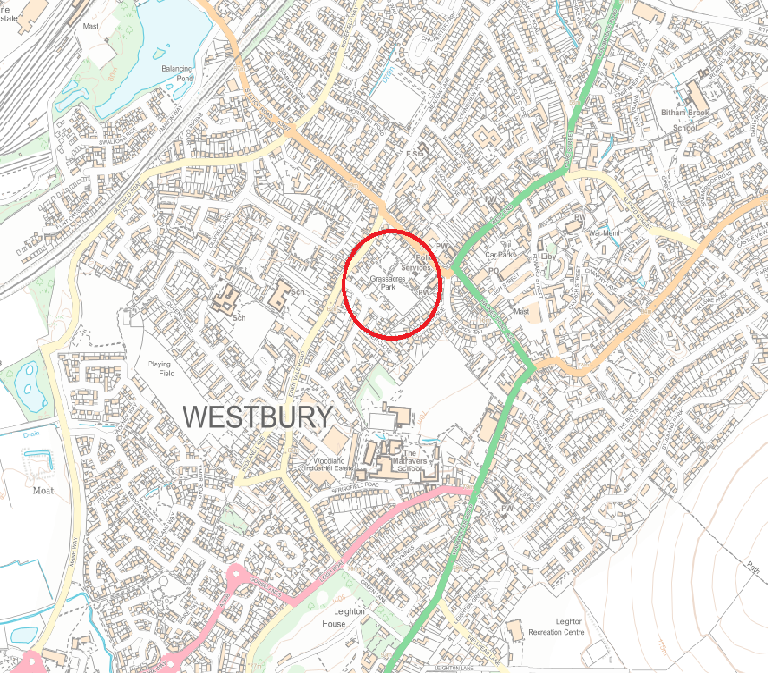

Plan View
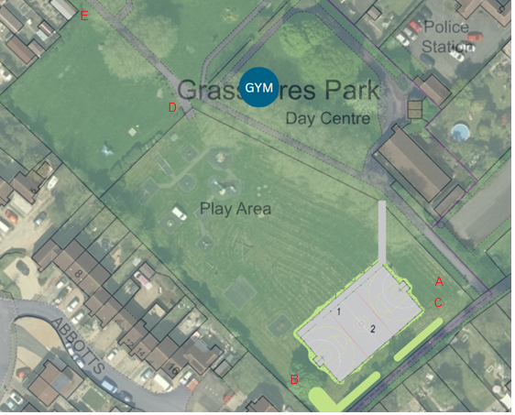

Photo A

Photo B
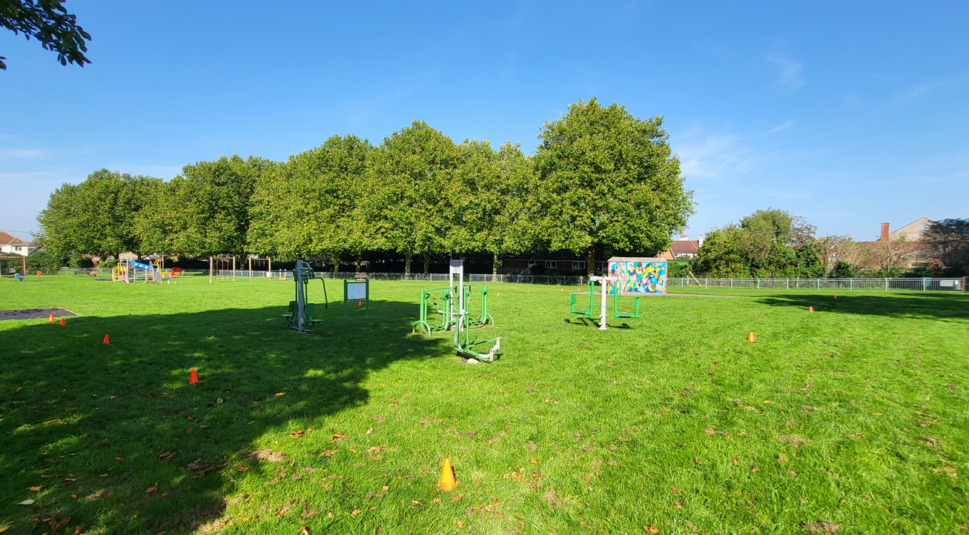

Photo C

Photo D access/maintenance gates to Grassacres play area.


Photo E access gates from Edan Vale Road
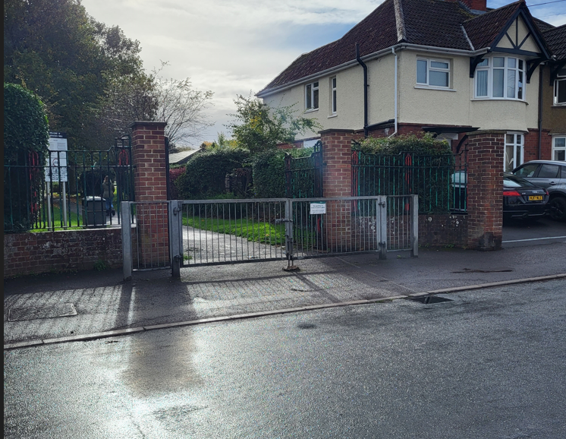

Appendix D – Documents Required

- Certificate of Insurance – Public Liability up to £15m
- Waste license
- Risk Assessments / chainsaws / boats etc.
- Method Statement
- Company reporting structure.
- Evidence of ability to undertake the work as described in the schedule of works.
- Evidence of staff training
- A copy of your environmental credentials and supply chain

