Service specification (DRAFT)
Service Specification No.
Service | Local Care Network Multi-disciplinary Training Provision for Coordinated Care
Commissioner Lead | Kate Moriarty-Baker
Provider Lead
Period | March 2018 -
Date of Review

- Context
On a daily basis, the health and social care system across Southwark does amazing things. With a range of world-class services available across our major hospital sites and in our community, supported by a strong and committed workforce, together we look to support the health and wellbeing of our population.
But we know that things can improve further. Feedback from local people has indicated that they find the health and care system difficult to navigate and that it is not always responsive to their needs. Communication between different parts of the system is not always as good as it should be, and service users can feel unsupported and isolated. We want to fundamentally change this, and move towards a system that joins up care, harnesses local community assets, and works with service users, families and carers to meet their range of needs – whether physical, emotional or social.
To support this, we have set up Local Care Networks, which bring together local health and social care providers alongside voluntary sector and citizen representatives to work collaboratively to coordinate and improve care. Local Care Networks are being established in all six South East London boroughs as part of the ‘Our Healthier South East London’ transformation programme and are part of our whole-system response to deliver on the ambitions set out in the ‘Five Year Forward View’.
In Southwark, there are two Local Care Networks, mirroring the geographies of GP Federations in the north and south of the borough. Local Care Network Boards oversee the coordination and delivery of our work programme. Currently, these Boards include representatives from a range of organisations who work together and with other local stakeholders for the benefit of the population.
Local Care Network Board Members:
- Improving Health Limited, GP Federation (south Southwark)
- Quay Health Solutions CIC, GP Federation (north Southwark)
- Guy’s and St Thomas’ NHS Foundation Trust (acute and community)
- South London & Maudsley NHS Foundation Trust (acute & community mental health)
- King’s College Hospital NHS Foundation Trust (acute)
- Adult Social Care, Southwark Council
- Community Southwark (VCS)
- Healthwatch Southwark Community First Services, Community Pharmacy Federation
Over the last 18 months, LCN partners have come together to design a pathway of care for people with 3 or more long-term conditions (see figure 1). A key component of this pathway is a multi-disciplinary approach to delivering care. However, there is a lack of multi-disciplinary training available to support health and care teams to better coordinate care in line with the LCN pathway, and to facilitate skill-mix changes and new boundary spanning roles that support more joined up care on a geographical basis.
Figure 1: Coordinated Care pathway for patients with 3+ long-term conditions
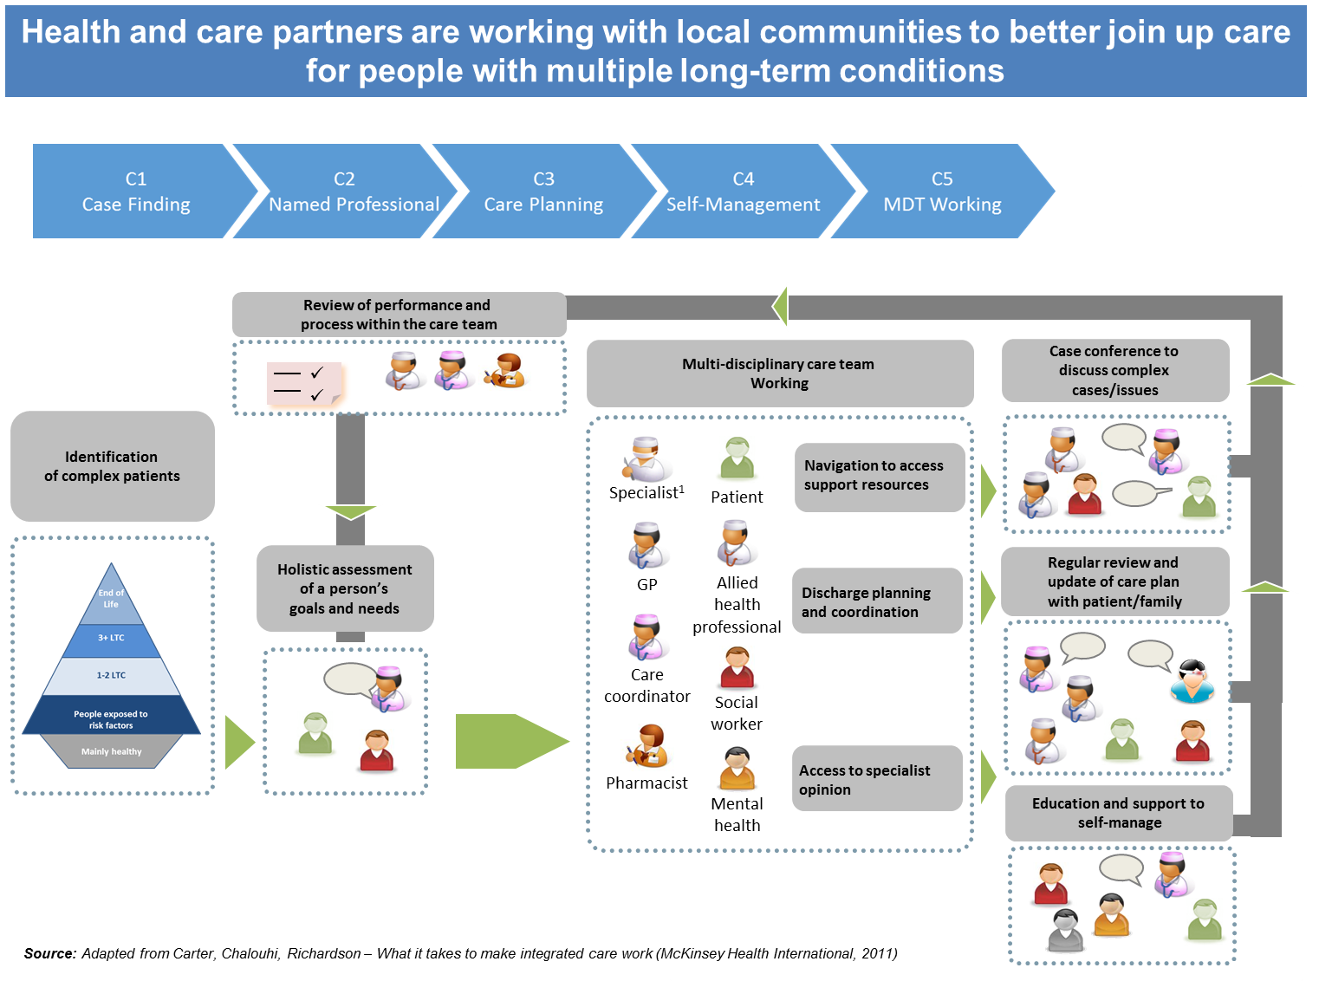
In recognition of this gap in training, Southwark’s Community Education Provider Network (CEPN) agreed to fund a ‘proof of concept’ multi-disciplinary training programme to support staff in the delivery of the LCN care coordination pathway. This training will focus on agreed priority staffing groups working in neighbourhoods/clusters of circa 30-50,000 registered patients, and will be evaluated before a decision to roll-out/ embed the training across LCNs is made.
LCNs will identify an appropriate multi-disciplinary cohort(s) of staff to participate in the proof of concept training programme, once we are clear on the appropriate size of the cohort and programme delivery requirements. However, priority staff groups that are likely to benefit from this type of training are:
- GP’s and Practice Nurses
- Care navigators and VSC link workers
- Community Pharmacists
- Community nurses
- Adult social care workers
- Locality geriatricians
- Community mental health practitioners.
- Scope
2.1 Aims and objectives
- To support multi-disciplinary learning and development, focused on the supporting effective coordinated care for people with complex needs; with a particular focus on those with 3+ Long-term Conditions (LTCs)
- To equip staff to effectively deliver the five core components of the coordinated care pathway (i.e. case finding, named professional, care planning, self-management and multi-disciplinary team working), and support = better health and care outcomes for patients with complex needs.
- To test a ‘proof of concept’ multidisciplinary training model with a view to rolling this out across health and care staff in Local Care Networks.

  - Core requirements of the learning partner are:

- Design and deliver a modular training programme to support multi-disciplinary learning and working. This training programme should reflect the outlined training modules developed for the LCN and set out in figure 3 below.
- Empower staff to provide the best possible outcomes by supporting individual staff members and teams to possess an agreed set of skills to deliver multi-morbidity care. Training modules should ensure participating staff are able to demonstrate the core competencies set out in figure 2 below.
- The training and learning approach should focus on multi-disciplinary learning and the ability to overcome provider boundaries and support effective person-centred coordinated care, including through practical simulations/scenario learning.
- Training should recognise the challenges of workforce capacity and should therefore be a blend of online, face-to-face and group workshop training. Online training may include signposting to relevant pre-existing learning materials as well as bespoke training specific to the LCN care coordination context.
- Learning should be sustainable and able to be re-enforced through peer discussion, protected learning time, team meetings and 1:1’s.
- Engage effectively with LCN provider leads and programme participants in order to refine and improve training during the pilot phase.
- Provide an effective means for staff evaluation in order to demonstrate the required core competencies are attained and support an effective programme evaluation, at the end of the pilot.
- Submit an end of programme evaluation including relevant information/data to inform any future roll-out.

  - Core requirements of the CCG/LCNs include:
      - Identifying an appropriate cohort of staff to participate in the training programme
      - Supporting the training provider to locate and secure appropriate premises (including LCN partner sites) for delivering the training (venue costs are excl. from contract value)
      - Engaging with the successful supplier on a regular basis to ensure programme delivery is on-track in line with requirements, address any delivery issues and linking the supplier into LCN Boards as and when required.
  - Alignment with Coordination Care pathway

A set of core competencies and high level outline training modules have been developed following a scoping and engagement programme with key LCN stakeholders. These are set out below and form the foundations of the proposed multi-disciplinary training programme.
Figure2: Core competency framework
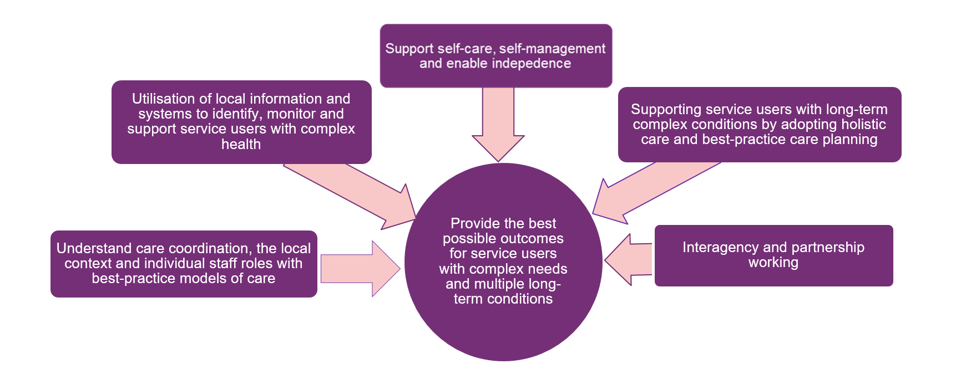
Figure 3: Summary of the high-level training modules and how these link with the care pathway components
Modules | Summary of module | Coordination Care Pathway Component
1. Integrated Care in the Context of the LCN | - An introduction to Local Care Networks  - Partnership and integrated working  - Managing complexity  - Public health and social care perspectives | All components
2. Self-Management and Behaviour Change | 1. The role of self- management support  2. An overview of national/local initiatives  3. Key introductory skills, for example :  - collaborative agenda setting  - importance and confidence scaling  - smarter goal setting  - action planning  - effective follow up  - consultation skills  - communication skills  - motivational interviewing | Named Professional (C2)  Care Planning (C3)  Self-Management (C4)
3. Collaborative Working, Communication and Care Planning | Develop the staff knowledge and skills in relation to effective team work learning;  - Effective communication in health and social care using a range of methods  - How to deliver holistic care planning using the LCN care planning templates  - How to utilise MDT meetings effectively in order to support clear decision making  - How to work effectively in a virtual MDT model – moving from MDT meetings to MDT working  - Considerations for service users, staff, colleagues and families/carers | Named Professional (C2)  Care Planning (C3)  Self-Management (C4)
4. Leadership | Understanding the leadership behaviours required to lead and deliver change across boundaries. The module should cover:  - Understand yourself and others better  - Work effectively with colleagues and lead by example  - Appreciate principles of managing change  - Implement basics of improvement methodology  - Feel empowered to set direction for improvement care | All Components
5. Evidence Based Practice and Service Improvement | Provide staff with a broad knowledge of the key approaches and techniques used in health and social care evidence-based practice, evaluation and service improvement  This module could covers the following:  - Understanding evidence based good practice & translating to the local context  - Service and quality improvement methodologies/tools  - Qualitative and quantitative data collection & analysis tools | All components
6. Person Centred Care | Enable staff to examine the frameworks underpinning approaches to person centred care, and apply these in a practical context (ie. through applied theory).  The module should cover the following topic areas:  - The legal framework and key policies underpinning approaches to personalisation  - Impact of personalisation on recovery, wellbeing, and quality of life  - Approaches to risk management and enablement  - The impact of innovative personalisation practice on local service provision  Enabling service user choice and control, shared decision making and responsibility | Care Planning (C3)  Self-Management (C4)

- Contract Term
The anticipated contract period will be for six months, with an option for extending (based on mutual agreement with the service provider and commissioning CCGs). The anticipated contract start date is 1 March 2018. The service will be commissioned using a NHS Standard Contract and the value of the contract will be the subject of the market engagement event on 19 December 2017.
CSU to insert any other relevant T&Cs usually included in service specs prior to tender?

