**Market Engagement for the Delivery of an Emotional Health and Wellbeing Service**

Derby City Council and Derbyshire County Council are undertaking a Market Engagement consultation with suitably qualified and experienced organisations to seek the views and feasibility of a formal tender for a Provider to deliver an Emotional Health and Wellbeing Service.

This consultation is not an invitation to tender.

As part of a pre procurement exercise, Derby City Council and Derbyshire County Council are issuing this request for information and feedback only in order to assess the reaction of the market and seek the views and feedback of potential Providers to ensure that any subsequent procurement process is focused and efficient.

The service being consulted on will be a specialist trauma informed Emotional Health and Wellbeing for Children in Care and Care Leavers, which may include Unaccompanied Asylum Seeking Children (UASC), Young People displaying harmful Sexual Behaviour and Children on Special Guardianship Orders (SGO’s).

This cohort of children will have experienced Adverse Childhood Experiences (ACEs) and will therefore need trauma informed practitioners, including psychologist, who understand how to work with them most effectively. Some of these children and young people will also have additional needs such as Autism, Learning Disabilities or undiagnosed Neuro Diversity. Not all the children in these cohorts will need the specialist provision that this service will offer. For some children a lower level of mental and emotional well-being support will be sufficient to address their needs; and it is important that this service triages referrals according to need in order to ensure that each child or young person receives the support that they as an individual will find most beneficial. Where it is assessed that the child does not need such specialist interventions, the service will be responsible for providing supportive personalised referrals to whichever service is most appropriate.

We are looking to consult and learn from providers who are able to work effectively with carers to improve placement stability and to reduce the number of children in care who have to be cared for outside the area in specialist ‘therapeutic’ homes or admitted to Tier 4 provision.

We will be holding a face-to-face Market Engagement event in Derby for potential providers on **3rd October 2024.** Timings and venue will be confirmed upon receipt of your expression of interest to attend.

Please email [CYPParticipate@derby.gov.uk](mailto:CYPParticipate@derby.gov.uk) by 5pm 30th September to confirm your attendance.

The event will enable potential Providers to receive further information, ask questions and give specific feedback on the above.

Below are the supporting documents which provide background and wider context to this service provision:

* **Children in Care Needs Assessment 2024**

This needs assessment looks at how we can best meet the emotional and mental health needs of children in care. The main contract which supports the emotional and mental health needs of children in care is coming to an end, so preparation for the future, we wanted to understand as best we could what was required to meet children in care needs.



* **Derby City Children in Care Performance data for quarter four 2023/24**



Please see below some specific headlines for Derby City Children in Care performance data:

At year end 31 March 2024 Derby had 598 children in care. This was a decrease from 620 children seen at the previous year end. This is a reduction of 22 children and equates to a 3.5% decrease.

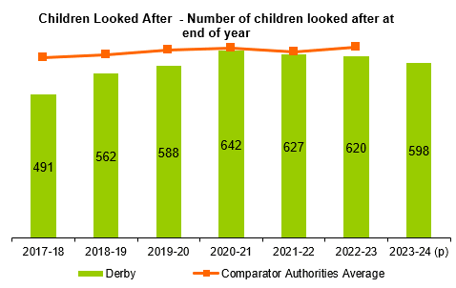

* At year end 31 March 2024 Derby had 101 children in care per 10,000 people aged under 18.Derby’s rate of 101 is well above the 2022-23 comparator authority rate of 80 per 10,000, above the national rate of 71 per 10,000 and above the East Midlands rate of 66 per 10,000.
* The rate of Derby’s children in care per 10,000 people aged under 18 is reducing over time dropping from 108 in 2020-21 to 101 in 2023-24.
* In 2022-23, Derby had the second highest rate per 10,000 in our comparator group.

**Placement Location**

* Derby had 598 children in care at 31 March 2024 and of these 382 were placed within 20 miles of the child’s home address. This equates to 60.4% which is the lower than the figure seen in the previous year (61.6%). Nationally, in 2022-23, the percentage was 70% whilst the comparator authority group was higher with 77%.

**Derbyshire Children in Care performance data for quarter four**

Please see below some specific headlines for Derbyshire County Children in Care performance data:

At year end 31 March 2024 Derbyshire had 1057 children in care. This was an increase from 995 children seen at the previous year end. This is an increase 62 children and equates to a 6.2% increase.

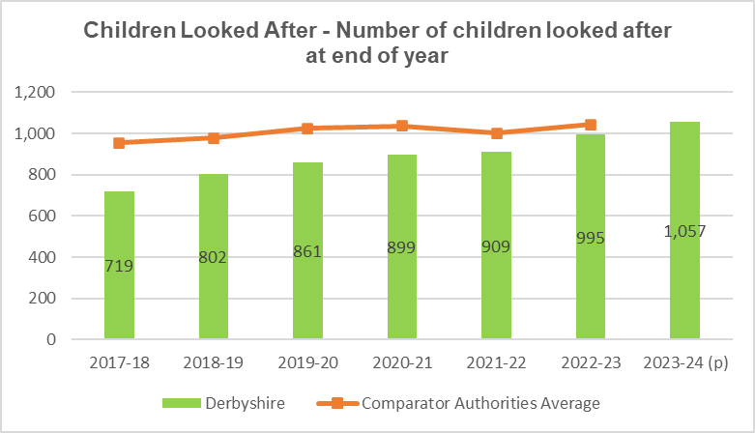

* At year end 31 March 2024 Derbyshire had 69 children in care per 10,000 people aged under 18. Derbyshire’s rate of 69 is below the 2022-23 comparator authority group rate of 74 per 10,000, below the national rate of 71 per 10,000 and above the East Midlands rate of 66 per 10,000.
* The rate of Derbyshire’s children in care per 10,000 people aged under 18 has increased over time.
* In 2022-23, Derbyshire had the fourth lowest rate per 10,000 in our comparator group.

**Placement Location**

* Derbyshire had 1057 children in care at 31 March 2024 and of these **647** were placed within 20 miles of the child’s home address. This equates to **61%** which is the **in-line** withthe figure seen in the previous year. Nationally, in 2022-23, the percentage was 70% whilst the comparator authority group was lower with 64%.
* **Derby 2020-2023 Placement Sufficiency Strategy**

- details how Derby City Council intends to meet the ‘Sufficiency Duty’ set out in Section 22G of the Children Act 1989.

<https://www.derby.gov.uk/media/derbycitycouncil/contentassets/documents/healthandsocialcare/jsna/children-in-care-placement-sufficiency-strategy-2020-23.pdf>

* **Derby City Council - Council Plan 2022-2025**

- outlines our vision for children and young people in creating a safe city, where those that need support can access it at the right time for them.

<https://www.derby.gov.uk/media/derbycitycouncil/contentassets/documents/councilanddemocracy/policiesandplans/derby-city-council-plan-2022-2025.pdf>

* **Derby City’s Integrated Commissioning Strategy for Children and Young People 2020-2023**

- aims to improve outcomes for children and young people through better integrated commissioning across our local area.

<https://www.derby.gov.uk/media/derbycitycouncil/contentassets/documents/healthandsocialcare/jsna/derby-city-integrated-commissioning-strategy-cyp-2020-2023.pdf>

* **Derbyshire 2022-2025 Placement Sufficiency Statement.**

- details how Derbyshire County Council intends to meet the ‘Sufficiency Duty’ set out in Section 22G of the Children Act 1989.



* **Derbyshire County Council - Council Plan 2022-2025**

- outlines our vision for children and young people in creating a safe county, where those that need support can access it at the right time for them.

[The Council Plan 2023 to 2025 (derbyshire.gov.uk)](https://www.derbyshire.gov.uk/site-elements/documents/pdf/council/policies-plans/council-plan/the-council-plan-2023-to-2025.pdf)

* **Derbyshire County Council Integrated Commissioning Strategy for Children and Young People 2023-2025**

- aims to improve outcomes for children and young people through better integrated commissioning across our local area.



Please use this link to access and complete a short MS Form by **2nd October.**

[https://forms.office.com/e/U1mfxT5TUt](https://eur03.safelinks.protection.outlook.com/?url=https%3A%2F%2Fforms.office.com%2Fe%2FU1mfxT5TUt&data=05%7C02%7CLeanne.Paulson%40derby.gov.uk%7Cd4cebbae57df457bf48308dcd727a287%7C0d3ae6223706422c8a6992b85125fc4e%7C0%7C0%7C638621812424466512%7CUnknown%7CTWFpbGZsb3d8eyJWIjoiMC4wLjAwMDAiLCJQIjoiV2luMzIiLCJBTiI6Ik1haWwiLCJXVCI6Mn0%3D%7C0%7C%7C%7C&sdata=OwKPnxgQUfP1t8l33%2BPalC7E9E5gkrGcPPHaYrnOBSE%3D&reserved=0)