Communicator Guide Service - Provider engagement event

Date of Event: Thursday, 15th March
Venue: Seminar Room 4, Kingston Centre, Fairway, Stafford ST16 3TW
Time: 10am – 12.30pm
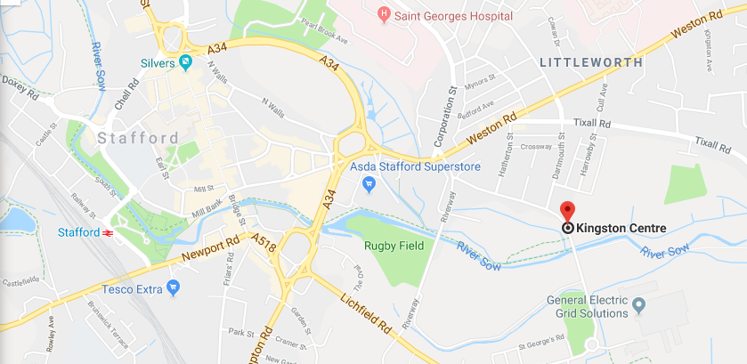
Parking is available on site.

