**Document No. 04b**

**Project title:** **NHS Framework for North of England Branded Medicines - Tranche A and Annual Tranche.**

**Offer reference number: CM/PHR/20/5606**

**CM/PHR/20/5606/01 - NHS Framework for North of England Branded Medicines - Tranche A. Period of framework: 1 March 2023 to 28 February 2025 with an option or options to extend (at the Authority’s discretion) for a period or periods up to a total of 24 months**

**CM/PHR/20/5606/02 - NHS Framework for North of England Branded Medicines - Annual Tranche. Period of framework: 1 March 2023 to 29 February 2024 with an option or options to extend (at the Authority’s discretion) for a period or periods up to a total of 12 months**

**CM/PHR/20/5606/03 - NHS National Framework Agreement for the supply of Risankizumab for the South of England and London. Period of framework: 1 March 2023 to 31 August 2023 with an option or options to extend (at the Authority’s discretion) for a period or periods up to a total of 6 months**

**Assessment Criteria, Stability Protocol and Additional Specification Requirements**

**Assessment criteria**

1. All medicines must

* fully match the NPC descriptor against which they are offered (e.g. co-name medicines must be labelled with the co-name, not individual drug names); medicines requiring specific features (e.g. licensed route; prohibited excipients; scored tablets; container type) must have that feature.
* conform to the fixed gateway criteria listed in Appendix 2 of Document No. 7b Quality Assurance Policy to Support the National Contract Procurement of Licensed Medicines.

1. In addition, the medicines must

* be clearly labelled, with the critical information prominent and readable. The critical information is the generic name (NPCode name) of the medicine, the strength of the medicine, the form of the medicine, the route of administration and posology and warnings.
* be adequately differentiated from other medicines in the range (same molecule) and other Look Alike/Sound Alike medicines from the same manufacturer. Packaging and labelling (primary and secondary) will be considered poorly differentiated if there is no judicious use of colour or differentiation in text size or layout to emphasise the key differences in critical information. This applies to all primary and secondary packaging, and any printed overwraps
* include sufficient, clearly presented technical information on the packaging or in the PIL to direct the intended user to prepare and administer the medicine safely

1. For pre-labelled packs, the pre-label element must be incorporated into the carton artwork. Packs overlabelled with a separate label will be given No Score. The pre-label wording should either be in accordance with the pre-label specifications for each pre-labelled line, if included in the tender specification, or in accordance with the PIL and BNF warnings if there is no specified pre-label.
2. Medicines should also comply with the general good practice principles set out in
   * Promoting safer use of injectable medicines (NPSA Alert 20, March 2007)
   * Design for patient safety: A guide to the graphic design of medication packaging (NPSA 0463A 2008)
   * Design for patient safety: A guide to labelling and packaging of injectable medicines (NPSA 2008) ISBN: 978-1-906624-02-6
   * Best practice guidance on the labelling and packaging of medicines (MHRA December 2020)

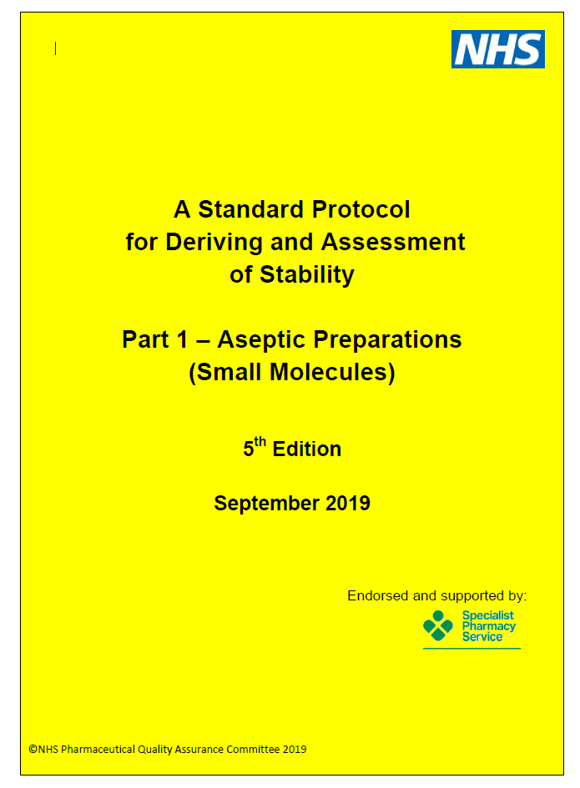

This document has been produced on behalf of the NHS Pharmaceutical Quality Assurance Committee, the NHS Pharmaceutical Production Committee and the NHS Pharmaceutical Aseptic Services Group by the NHS Pharmaceutical Research and Development Working Group. Membership of the NHS Pharmaceutical Research and Development Working Group is shown below.

Mark Santillo (Chair), Regional Quality Assurance Officer, Torbay & South Devon NHS Foundation Trust.

Peter Austin, Consultant Pharmacist and Team Pharmacist Lead, Oxford University Hospitals NHS Foundation Trust.

Caroline Campbell, Laboratory Manager, Quality Control Laboratory, Newcastle upon Tyne Hospitals NHS Foundation Trust.

Lyndsay Davies Senior Pharmaceutical Biochemistry Analyst, Quality Control North West (Liverpool).

Chris Marks, Scientific Officer, Regional Quality Control, North Bristol NHS Trust.

Andrew Merriman, Lead Quality Assurance and Technical Services Pharmacist, Betsi Cadwaladr University Health Board.

Adam Millington, Specialist Pharmacist - Production Services and Clinical Trials, Nottingham University Hospitals NHS Trust.

Phil Weir, Principal Scientist – Head of Scientific Services, Quality Control North West (Stockport).

Industrial, academic and regulatory experts have been consulted in the preparation of this protocol.

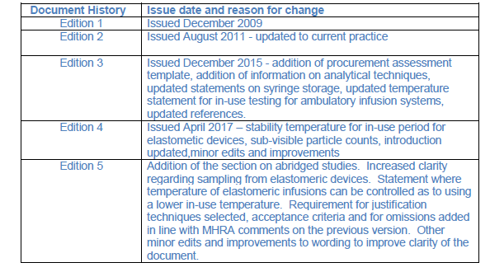

**1. Scope**

Standards produced by the NHS Pharmaceutical Quality Assurance Committee and its sub-committees are produced with a distinctive yellow cover and are therefore known as Yellow Cover Documents (YCDs). This document, produced by the Pharmaceutical Research and Development Group, is the first in a series looking at stability of pharmaceuticals.

This YCD applies to small molecule products of all presentations prepared by aseptic manipulation of sterile pharmaceutical products. In this context, a small molecule is defined as a medicinal drug compound having a molecular weight of less than 2000 Daltons, with two main exceptions. The first exception is any medicinal drug compound comprised of peptide sequences and the second exception are small molecule products produced using sterilisation by filtration that is followed by aseptic filling. For Biopharmaceuticals please refer to A Standard Protocol for Deriving and Assessment of Stability: Part 2 - Aseptic Preparations (Biopharmaceuticals)1.

**2. Introduction**

The 2007 NPSA (National Patient Safety Agency) alert 202 recommended the supply of ready-to-administer products, at least for high risk injectables, rather than aseptic preparation in clinical areas. The practicality of this is in part reliant on the availability of valid and robust stability data.

This protocol, which was prepared jointly by the Research & Development sub-group of the NHS Pharmaceutical Aseptic Services Group, the NHS Pharmaceutical Quality Assurance Committee and the NHS Pharmaceutical Production Committee and which has been updated by the NHS Pharmaceutical Research and Development Working Group, presents a standardised methodology to establish shelf life for aseptically prepared products. It is expected that the principles of this protocol are used for local stability trials, stability trials outsourced to third parties and when the validity of published stability data or commercially supplied stability data need to be assessed. Compliance with this protocol should also be sought from compounded product suppliers when products are outsourced, and Appendix 2 may be used to support that aim.

The principles that inform this protocol are:

2.1 Information available from a manufacturer may not offer the required stability data, for example from the relevant SmPC or from additional information from the medical information department.

2.2 Published stability data may be of limited value because of inappropriate or inadequate analytical methodology, limited study duration or improper processing of analytical data.

2.3 Shelf lives are derived from diverse sources of data including physico-chemical stability, microbiological integrity, consideration of licensed status of the preparation facilities and their compliance with standards.

2.4 Once allocated, the shelf life should be subject to on-going validation including robust control of any changes to materials or components.

Appendix 2 of this document is supplied to assist procurement staff in assessing the suitability of products to be procured as unlicensed small molecule aseptically prepared products, including assessment of the shelf life assigned and stability information supplied or otherwise available for the specific product.

The R&D Group Assessment Template for Aseptic Small Molecule Products should be completed for all assessments of stability for this product group.

**3. Analytical Methods**

The development, validation, and adoption of analytical methods are beyond the scope of this protocol except to note that any method used must be able to indicate stability, be robust and be fully validated. The principles of ‘Guidance on the Validation of Pharmaceutical Quality Control Analytical Methods’3 and ICH Q2(R1)4 (implemented as CPMP/ICH/281/95) should be followed, as appropriate.

**4. Diluents**

The default diluent will normally be 0.9% w/v sodium chloride as a typical diluent used in practice, but 5% w/v glucose should be used where applicable and other diluents may be added or supplemented, if recommended in the SmPC or otherwise required.

**5. Containers**

5.1 General considerations

Care should be taken to check the container proposed to store the product is the same used for each supporting stability study.

Extrapolation of data between different containers and infuser devices may be permissible provided the drug degradation pathway and physical properties of the container are well understood. Critical physical properties of a container include oxygen permeability, water permeability (water loss), light permeability, material constitution and possible extractives and adsorbent potential. Any extrapolation must be evaluated and justified.

5.2 Syringes

Syringes used as storage containers must be fully validated, including adequate consideration of microbiological ingress and physical robustness. Please refer to the ‘Microbiological protocol for the integrity testing of syringes’5. Any syringe used to store medicines must be assessed as compliant with the BP Monograph for plastic syringes ‘Appendix XIX G’6.

In each case, the syringes used in a stability trial, together with the specific closure system, should be specified in the protocol. Consideration should be also given to the inclusion of suitable CE marked drug storage syringes in any new study. Two piece polypropylene syringes may be required for some products although past history indicates that there may be more failures during the integrity testing with those syringes7.

It is preferable that syringes with the plunger attached should not be filled beyond 85% of their marked capacity in order to prevent undue plunger movement, which may compromise microbial integrity during shipping/ distribution; this is as outlined in ‘Microbiological protocol for the integrity testing of syringes’5 and national cytotoxic standardised specifications21.

It is noteworthy that syringes currently used for storage of aseptically prepared medicines are not CE registered as drug storage devices, which has meant manufacturers have often made important changes to the syringes they manufacture without informing the end users. In some cases, changes to syringes have had apparent effects on drug stability and/or adsorption8 when the syringe is used to store aseptically prepared medicines. Therefore, for these products an on-going programme of stability reassessment is strongly recommended. This could take the form of repeated stability testing at defined regular intervals or a programme of end of shelf life testing for the products that feeds into an annual Product Quality Review (PQR).

5.3 Infusion Containers

Non-PVC containers (polyolefin) should routinely be the first choice container. The choice of flexible versus semi-rigid containers is product and/or study specific but it may not always be possible to extrapolate between the two due to fundamental differences in certain properties, which include the material and quantity of residual air.

5.4 Ambulatory Infuser Devices

There are a range of elastomeric devices as well as other ambulatory infuser devices. These should be included in studies when such devices will be used for administration. In addition, the drug contact surfaces need to be understood if data is extrapolated between different types of elastomeric and other infusion devices.

5.5 Glass vials

The type of glass and the nature of the vial stopper are important considerations when using glass vials as final containers. The physical robustness and potential for microbiological ingress should also be considered.

5.6 Eye dropper bottles

Eye dropper bottles may include capped glass bottles (with a screw top or dropper) or plastic three piece eye dropper bottles. A stability study must be carried out in the container in which the product will be supplied; physical robustness and container integrity are important considerations

**6. Concentrations**

Ideally each drug should be studied at each of a low and high clinically relevant concentration. In this way, if there is consistent degradation reaction kinetics of the drug then it should be possible to interpolate to concentrations in between the two. If there is likely to be a significant difference in stability across a range of concentrations or another physical stability issue then additional concentrations may also be required.

**7. Storage Conditions**

Standard storage conditions can be found in Table 1. Control of relative humidity is not required for aseptically prepared products because they are essentially aqueous solutions and the storage times comparatively short. However, the properties of the container need to be assessed and understood (e.g. water loss by weight loss on storage, see above).

**Table 1. A summary of stability testing temperature requirements**

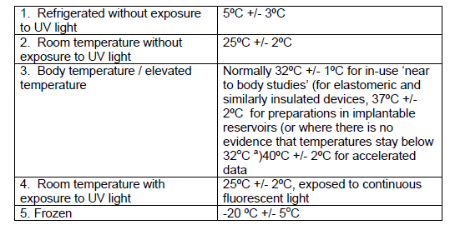

a Represents a “worst case scenario” for device reservoirs worn under clothes

**8. Storage Protocols**

The conditions referred to within this section can be found in Table 1, temperatures for all storage chambers should be constantly monitored, for example using a wireless monitoring system.

8.1 Refrigerator stored products

Products should routinely be stored refrigerated as required by the Farwell Report9 unless that is precluded by physical considerations. The assessment of the maximum refrigerated shelf life and ‘in-use’ shelf life at room temperature should be assessed as part of a study. This may be followed by a second ‘sequential’ study including refrigerated storage followed by in-use conditions for an appropriate period prior to testing (Table 1).

8.2 Room Temperature stored products

Products for which there are solubility issues under refrigeration can be stored at room temperature, which may also be appropriate for Controlled Drugs due to their storage requirements. For Controlled Drugs, stability trials may need to be conducted at room temperature without exposure to UV light (Table 1).

8.3 Devices worn at body temperature

For elastomeric devices or others where evidence exists that the drug solution will not reach temperatures above 32oC then the in-use period should be studied at 32oC +/- 1oC. For implantable devices (installed under the skin) then this should be 37oC +/- 2oC, this would also be appropriate for non-insulated devices or those for which evidence suggests may reach temperatures above 32oC during routine infusion periods.

The rationale behind this standard is based on a series of published studies10,11,12 which have shown that for elastometric devices handled appropriately the drug solution does not exceed 32°C throughout the infusion period.

The Van der Merwe paper10 in particular used a thermocouple placed inside the solution itself and this showed that for the two infusors studied including one with a flexible and one with a rigid shell the solution does not even reach 30°C during 24 hours of simulated use.

Another rationale behind this temperature is that 32°C is the temperature for the EP dissolution test for transdermal devices13 (which is based on a harmonised worldwide standard).

It is important that patients receive instruction on how to handle their infusors as exposure to direct sunlight even within a pouch can have a significant impact on the temperatures seen with temperatures being shown to reach above 40°C in some studies. It is also important that at night the infusor is placed outside of the bed covers if at all possible.

Where technology exists to maintain the infuser at a lower temperature throughout the infusion period, for example below 25oC by using insulated infusion devices, then it is appropriate to use this temperature for the in-use period in the study. It must be borne in mind that the elastomeric infusors are designed to deliver the set flow rate at a set temperature which is often 32oC, therefore, temperatures well below this can have a significant impact on flow rate and therefore dose for continuous infusions.

Care needs to be taken with implantable reservoirs where the device is refilled *in situ* and therefore drug solutions may be stored within them for longer than expected.

8.4 Products stored frozen

For products to be stored frozen the process of defrosting must be documented and fully validated for its impact on stability. In addition, the stability of the product once defrosted must be validated, which may involve refrigeration, or storage at room temperature or body temperature (Table 1). It is not normally recommended that plastic syringes are frozen but if this is necessary robust integrity testing must be undertaken at all stages of storage, thawing and any post thaw storage. There may also be risks associated with freezing products in elastomeric reservoirs that need to be assessed.

8.5 Light exposure

The effect of light on the stability of a medicinal product requires assessment unless the exposure to light is eliminated during routine clinical use. Condition 4 in Table 1 may apply if the product shelf life is dependent on light induced degradation. Under these circumstances further details as to the techniques to be used can be found in ICH Q1(B) Photostability Testing of New Active Substances and Medicinal Products14.

8.6 Study and sampling periods

Sampling periods are study specific and the intrinsic stability of the system will determine the overall study duration as well as each sampling time point.

Sufficient time to allow critical parameters (i.e. those that which will control the shelf life of the product) to be assessed beyond the appropriate confidence interval of its specification limits needs to be built into the stability study. A minimum of 4 justified time points plus the initial data is the minimum required. Note that increasing the number of time points can help minimise the 95% confidence interval, which may otherwise restrict the allocated shelf life. This is particularly applicable to studies of drugs in syringes in which between-day repeatability may be higher than for other container types.

In the case of the critical parameter being the Active Pharmaceutical Ingredient (API) concentration, the study period should allow the concentration to fall to a value that allows a complete understanding of the reaction kinetics. This will not, however, be possible for very stable drugs. Other factors may also be relevant in determining shelf life (see 2.3).

Consideration should be given to carrying out accelerated stability studies for products expected to be or known to be relatively stable. Condition 3 in Table 1 is the temperature normally selected for this purpose.

Abridged studies

Where relatively robust information exists from another study including the preparation’s reaction kinetics, and those data are available to the researcher, an abridged study may be considered to fill in knowledge gaps. For example, techniques that were not used in the original study may need to be used in order to extrapolate a study to a different container type, or to assess an extended infusion period at a raised temperature.

In the case of abridged studies it may be possible to reduce the number of data points or to spread them over the storage period and the final infusion period to cover both aspects of the study. For example a study may be considered to include time points T= 0, one intermediate point of refrigerated storage, the end point of refrigerated storage plus the post infusion temperature storage period data point.

**9. Sample Numbers**

For licensed products and regularly manufactured specials there should be a programme of ongoing stability work. It is required that three independent batches have been studied for licence submissions15.

For studies of aseptically prepared products, the initial stability assessment is often carried out on a single batch, but this must include at least three replicates (independent containers) from each of the starting concentrations selected. The use of two or three fully independent batches (i.e. unique batches of stating materials) affords a much higher level of assurance to studies.

The three samples must be analysed at each time point in duplicate or preferably triplicate. Note that increasing the number of replicates for analysis can help minimise the 95% confidence interval which otherwise may restrict allocated shelf lives.

The result of each sample test should be reported independently or if summarised a measure of spread provided, such as the standard deviation. For example, for samples tested in triplicate an average and spread for each set of triplicate samples as well as an average and spread for all the samples combined for each time point should be reported (example in Appendix 1). For samples tested in duplicate this should be reported as a range for each sample together with the population mean and variance of the three samples.

Ideally test results should be reported as a percentage of the baseline concentration, so as to fully understand the degradation levels.

9.1 Sampling considerations

For containers with a sufficient capacity (for example greater than 60mL), individual units may be regarded as a batch and multiple samples taken from them, pulled dosage units being replaced in storage condition. Note that samples must be removed aseptically to prevent the risk of spoilage. For containers with an insufficient capacity (for example less than 60mL) in order to carry out analysis at all data points it will be necessary to prepare a fully mixed bulk before filling into its storage container to ensure all such containers contain an identical homogenous solution.

For elastomeric infusors the solution homogeneity needs to be assured and it is suggested that dilutions are made before the device itself is filled since mixing within the device itself is difficult due to the lack of air in the device and also the solution added may start to fill the delivery tubing meaning that the initial sample will not be homogeneous. Removal and discarding a validated volume prior to sample removal can also be considered for these devices

It is vital that the sample is representative of the product to be delivered to the patient; there is some concern that products susceptible to adsorption to tubing may be adversely affected if sampled from the terminal end of giving sets for elastomeric devices. In this case it may be better to cut and clamp the tubing nearer to the reservoir, although it is important that the impact of any adsorption to the tubing is understood.

For sub-visible particle counts it is paramount to sample ahead of any in-line filters and so for these samples the tubing will need to be cut ahead of the filter to allow representative sampling.

**10. Testing Protocols**

The minimum testing protocol should include a consideration of the following points.

10.1 Colour, clarity and precipitation

The appearance of the product may be the stability limiting factor, particularly with the formation of visible particles / precipitates. Significant colour changes, even when associated with relatively low levels of degradation, may make the product unacceptable or non-compliant with standards (see relevant BP Monograph).

10.2 pH

The pH is likely to be critical to the stability of most drugs and changes in pH are likely to be indicative of other changes in the stored container that need investigation.

10.3 API concentration

Often API concentration is the critical shelf life limiting factor, usually assayed by HPLC either linked to Diode Array Detector (DAD) or with a standard UV detector, other stability indicating methods may be suitable including UHPLC-MS-MS (see further section 10.5). Analytical method validation needs to be in line with the documents referenced in point 3 above whichever method is used.

10.4 Sub-visible particle counts

The test for sub-visible particulates is an important part of any stability protocol and will normal follow the BP Light Obscuration technique, and if carried out to the Pharmacopoeial standard tests this technique does need relatively large sample volumes. There is evidence that a smaller sample volume will provide equivalent accuracy in terms of particle level analysis16 and therefore smaller sample sizes for particle analysis may be acceptable. The Microscopic Particle Count test may also be used if appropriate17. For suspensions for injection it is expected that assessment of the particle size of the suspension be included in the stability protocol.

10.5 Degradation product concentration

Degradation product concentration may be a critical parameter in shelf life assignment, together with an understanding of the degradation mechanism and/or a risk assessment of the properties of the degradation products. With a validated HPLC assay, the resolution factor between the active ingredient and degradation products is a critical stage of the assay validation procedure.

UHPLC with dual Mass Spectrophotometer detection (UHPLC-MS-MS) allows chemical species to be separated both temporally and spatially and it does not rely upon achieving a physical separation in the same way as standard HPLC methodology.

Provided the system suitability is demonstrated in terms of the instrument response factor for each compound being determined (if analysing a mixture without a physical separation being achieved) it allows the simultaneous quantitative determination of different chemical species in a very short analysis time without prior physical separation. This technique may alleviate the need for forced degradation studies as species detected will enable full identification of the degradants.

There is generally no need to include other related substance tests where those substances are process impurities from the original manufacturing process, and would not change as a result of aseptic manipulation and subsequent storage of the product. However, these may still impact on compliance with the BP monograph for overall related substance limits and this should be considered.

Additional tests are to be included where applicable.

10.6 Moisture loss

Moisture loss is usually measured by weight change over time, which may be particularly applicable to infusion bags (storage condition 2 in Table 1).

10.7 Container extractables and leachables.

For many studies with water soluble drugs, understanding the container leachables is more of a generic issue connected to the container type. If, however, the drug formulation contains solubilising agents or other excipients the level of extractables may need to form part of the stability study.

10.8 Excipient concentrations

Excipients can be critical to both physical and chemical drug stability and may also be important for the clinical usage of the product (for example the inclusion of tissue permeability enhancers in subcutaneous injections). In these cases the concentration of excipient should be an important consideration of the study.

**11. Shelf Life allocation**

11.1 Data Analysis

A simple plot of analytical results against time is usually insufficient for assignment of a shelf life. Various options are available for data handling and the most appropriate choice is dependent on the specific data set.

The principles of ICH Q1E (Evaluation of Stability Data)18, implemented as CPMP/ICH/420/02, should be followed where possible. The method favoured by ICH Q1E is where analytical data is subjected to linear regression analysis after determination of the appropriate relationship between critical parameter and time. An appropriate method of shelf life calculation for an attribute which is known to decrease with time utilises the lower one-sided 95% confidence limit of the regression analysis, and calculation of the time required for the critical parameter to reach the specification limit. For example, if Active Pharmaceutical Ingredient (API) loss is the critical parameter the lower 95% confidence limit of the time to reach 95% of the stated amount is the physico-chemical shelf life.

This technique, however, requires specialised knowledge and statistical software and unless the data are carefully analysed, misinterpretation could occur. This method can therefore only be used if clear statistical conditions and expert knowledge of the analytical system are applied. The potential errors are particularly exacerbated in short-term studies as generally used with aseptic compounded products.

This document offers flexibility of approach and therefore a simplified statistical approach may be acceptable where the one-sided lower 95% confidence limit of the slope is used to calculate the time to 5% degradation (see 11.2 below).

It is often not desirable to use a statistical approach where little or no degradation occurs over the course of the study. Section 8 indicates that a well-designed study should allow for a significant level of degradation to support a good understanding of the reaction kinetics but this is not always possible for stable materials. It is likely for very stable products that shelf life will be assigned for other reasons such as length of study, maximum storage time in syringes, and so on.

11.2 Acceptance criteria

The British Pharmacopoeia (BP) specification for a product is a shelf life specification to which the product must comply at the end of its shelf life. In general, for injections the BP specification is 95 – 105% of stated amount. For this reason it is suggested that, where loss of the active ingredient is the critical parameter, a loss of 5% should constitute the maximum shelf life. The starting concentration for the study must also be within the BP specification for the product.

It is acknowledged that many historical stability studies may not comply with the requirements of this document and that studies need to be optimally designed for certain container types, and particularly syringes, in order to maximise the confidence in the data generated. It is suggested that some pragmatism may be required in the interpretation of such historical studies, but the rationale for accepting more than 5% loss of an active ingredient within a shelf life needs expert consideration.

This may also hold with new studies as there may be certain molecules and presentations where a 10% loss of active can be acceptable, particularly if the BP monograph accepts a larger range such as 90 – 110%. If working to a larger percentage loss then the clinical significance, including assessment of degradation products, must be fully assessed and understood.

Other statistical approaches to data analysis may be used, particularly the Confidence Bound or Maximum Rate method19.

It is important that, when using semi-permeable containers, the impact of water loss is accounted for when calculating API concentrations. Water loss will concentrate solutions and therefore could mask degradation if not accounted for. In these cases the two-sided confidence limits of the slope may be appropriate and should be calculated and compared to both the upper and lower specification limits.

Knowledge of degradation products will be critical, the structure and identity and toxicology, metabolism and clinical effects need to be understood. The level of a degradation product may be a critical parameter in assigning shelf life.

It is important to understand the difference between related substances that arise as process impurities and genuine degradation products. Where a BP limit exists for a degradation product it will need to be the limit applied to the study, and any other approach will require robust justification.

11.3 In-use storage

It is important to understand the use of the product and its storage in clinical areas. If light sensitivity has not been assessed during the stability study then the product should be provided in light protective packaging with the instruction to keep the product protected from light.

Similarly, in-use temperatures must not exceed those studied in the stability testing. It is important that robust change management is used if making changes to clinical protocols particularly if the result is an increase in infusion time.

**12. Stability Study Reports**

Stability study reports should be submitted following a format consistent with the below recommendations.

Introduction

• Giving the reasons why the study was undertaken.

Literature Search

• Describing how this was undertaken and summarising relevant published prior work.

Analytical Methods

• Describing the development, validation, and/or adoption of analytical methods used. The specificity of the method together with its ability to detect degradants must be described. Justification for the techniques selected and the acceptance criteria assigned.

Diluents

• Describing the diluents used, and the rationale for their choice.

Container

• Describing the containers used, and the rationale for their choice.

Concentrations

• Describing the concentrations studied, and the rationale for their choice.

Storage Conditions

• Describing the storage conditions used, and the rationale for their choice.

Storage Protocols

• Describing the storage protocols used, and the rational for their choice.

Sample Numbers

• Describing the number of samples and batches tested, and the rationale for their choice.

Testing Protocols

• Describing the test protocols used, and the rationale for their choice.

Results

• Detailed description of all analytical results. It is suggested that results are presented as a percentage of initial concentration; initial concentrations should be given in the report.

Discussion

• Scientific critique and evaluation of the results including any statistical approach taken to analysis of the data.

Allocation of Shelf Lives

• Description of the methods used to calculate shelf lives and the rationale for their use.

• Description of proposed shelf lives determined from the study.

Conclusions

• Overall conclusions from the study. The report should also justify any omissions in the protocol, the testing programme or data availability and explain any non-conformances such as out of specification or out of trend results.

**13. Extrapolation of data**

It can be reasonable to interpolate data within the range of the study (concentrations, storage temperatures etc.) as long as consistent results are obtained from the concentrations studied. Extrapolation of data beyond that studied is a risk based process and a good understanding of the drug concerned, its reaction kinetics, its solubility and its ability to adsorb to surfaces are all important considerations that require an expert opinion before a decision is made. Extrapolation to different types of container will require an understanding of the differences in properties between the two containers. Robust change control is required for all changes and extrapolations.

**Glossary**

API - Active Pharmaceutical Ingredient

BP – British Pharmacopoeia

DAD – Diode Array Detector

EP – European Pharmacopoeia

HPLC – High Performance Liquid Chromatography

ICH - International Conference on Harmonisation of Technical Requirements for

Registration of Pharmaceuticals for Human Use

MA - Marketing Authorisation

MS – Mass Spectrometry

SmPC - Summary of Product Characteristics

UHPLC – Ultra High Performance Liquid Chromatography

UV - Ultra-violet

**References**

1. A Standard Protocol for Deriving and Assessment of Stability: Part 2 - Aseptic Preparations (Biopharmaceuticals) – NHS Pharmaceutical Quality Assurance Committee. <www.medicinesresources.nhs.uk/en/Communities/NHS/UKQAInfoZone>

2.NPSA Patient Safety alert 20 (28 March 2007) – Promoting Safer Use of Injectable

Medicines. [www.nrls.npsa.nhs.uk/resources/?entryid45=59812](http://www.nrls.npsa.nhs.uk/resources/?entryid45=59812)

1. Guidance on the Validation of Pharmaceutical Quality Control Analytical Methods - NHS Pharmaceutical Quality Assurance Committee March 2005. [www.medicinesresources.nhs.uk/en/Communities/NHS/UKQAInfoZone](http://www.medicinesresources.nhs.uk/en/Communities/NHS/UKQAInfoZone)

1. ICH Q2(R1) Validation of Analytical Procedures: Methodology [www.ich.org/products/guidelines.html](http://www.ich.org/products/guidelines.html)

5. Microbiological protocol for the integrity testing of syringes - NHS Pharmaceutical Quality Assurance Committee, 2nd edition April 2013.

[www.medicinesresources.nhs.uk/en/Communities/NHS/UKQAInfoZone](http://www.medicinesresources.nhs.uk/en/Communities/NHS/UKQAInfoZone)

6. British Pharmacopoeia 2019 Appendix XIX G Sterile Single-use Plastic Syringes (Ph. Eur. method 3.2.8).

National collated data from syringe integrity testing – NHS Pharmaceutical R&D Group. [www.qcnw.nhs.uk](http://www.qcnw.nhs.uk)

8. BD Plastipak Field Safety Notice MS-15-637-FA (issued 28th September 2015)

9.Farwell J. Aseptic Dispensing for NHS Patients (The Farwell Report) Department of Health 1995.

10. What is the maximum temperature reached in elastomeric devices under simulated OPAT conditions? Archives of Disease in Childhood. 101(9), p.e2. van Der Merwe, S. and Green, H. (2016) . Poster presented at NPPG November 2015

11. In Use Temperature Investigation 100mL Dosi-Fuser, The Newcastle-upon-Tyne NHS Foundation Trust, Laura Davies, Carly Henderson, David Caulfield (2016) [www.qaney.co.uk](http://www.qaney.co.uk)

12. Antibiotic stability related to temperature variations in elastomeric pumps used for outpatient parenteral antimicrobial therapy (OPAT). J Antimicrob Chemother dkw582 Rachel Voumard, Niklas van Neygham, Camille Cochet, Celine Gardiol, Laurent Decosterd, Thierry Buclin, Serge de Valliere

13. European Pharmacopoeia 8.0, 2.9.4. Dissolution test for Transdermal patches

14. ICH Q1B Photostability Testing of New Active Substances and Medicinal

Products. [www.ich.org/products/guidelines.html](http://www.ich.org/products/guidelines.html)

15. ICH Q1A(R2) Stability Testing of New Drug Substances and Products. [www.ich.org/products/guidelines.html](http://www.ich.org/products/guidelines.html)

16. Pharmaceutical feasibility of sub-visible particle analysis in parenterals with reduced volume light obscuration methods, European Journal of Pharmaceutics and Biopharmaceutics 85 (2013) 1084–1087, Andrea Hawe , Frank Schaubhut , Raimund Geidobler, Michael Wiggenhorn, Wolfgang Friess, Markus Rast, Christian de Muynck , Gerhard Winter

17. British Pharmacopoeia 2019, Appendix XIII A. Particulate Contamination: Sub-visible Particles (Ph. Eur. method 2.9.19).

18. ICH Q1E Evaluation of Stability Data. [www.ich.org/products/guidelines.html](http://www.ich.org/products/guidelines.html)

19. Norwood, Drug Development & Industrial Pharmacy 12, 553-60, [1986]

20. Assessment Template (Small Molecules) – NHS Pharmaceutical R&D Group. [www.qcnw.nhs.uk](http://www.qcnw.nhs.uk)

21.Chemotherapy Standard Product Specifications <https://www.england.nhs.uk/commissioning/spec-services/npc-crg/group-b/b02/dose-banded-chemotherapy-standardised-product-specifications/>

**Appendix 1 Example of reporting of results from stability trials**

For three replicates each tested in triplicate the report at each time point should be presented as:

Replicate 1 100.3% +/- 1.3%

Replicate 2 99.6% +/- 0.7%

Replicate 3 100.7% +/- 0.5%

Population mean 100.2% variance 0.21%

For three replicates each tested in duplicate the report at each time point should be presented as:-

Replicate 1 99.7% – 100.3%

Replicate 2 100.1% - 101.1%

Replicate 3 99.4% - 100.6%

Population mean 100.2% variance 0.31%

**Appendix 2. Checklist for assessment of stability data for procured small molecule aseptically prepared products (Specials)**

The following checklist is provided as a quick guide to assessing the suitability of procured aseptically prepared Specials from the stability assessment viewpoint. This should be used alongside other assessment tools for unlicensed products.

Preparation:………………………………………………………………………………………

Supplier / Manufacturer:……………………………………………………………………….

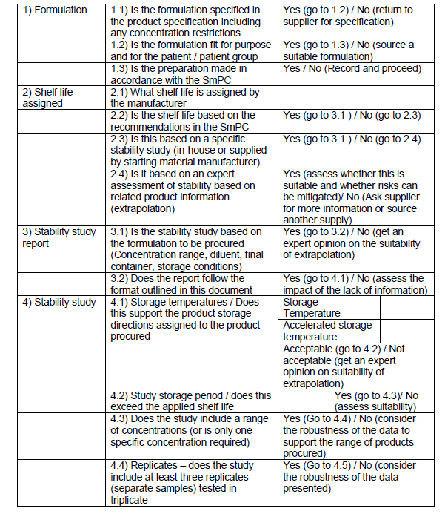

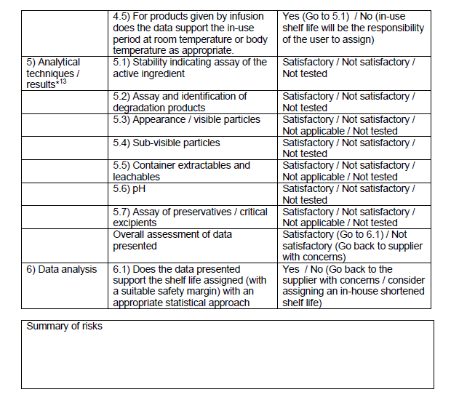

Assessment of stability study for

………………………………………………………………………………………..

The data supplied: Provides assurance that the product will be suitable, safe and efficacious / does not provide suitable assurance

Approved:…………………………….…………………………….Date:……………………

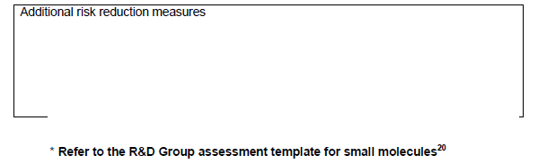

**APPENDIX A**

**Additional Specification Requirements (supplementary to general and regulatory)**

The NHS has additional requirements to those identified within the general specification. Those requirements are specified within this Appendix A to Document No. 04b – Assessment Criteria, Stability Protocol and Additional Specification Requirements.

Awards for these products will be made, where possible, to offers meeting the additional specification (subject to the offers meeting all other award criteria stated in paragraph 12.1.5 of Document No. 02 – Terms of Offer).

Offers for products that do not meet the additional specification will only be awarded to the framework agreement in the absence of any offers meeting the additional specification (subject to the offers meeting all other award criteria stated in paragraph 12.1.5 of Document No. 02 – Terms of Offer).

Offerors product information within PharmaQC will be used to determine whether offered products meet the addition requirements where possible. The Product details and pack details recorded (not artwork or photographs) will be used and, in the absence of the relevant fields being completed, it will be deemed that the offered product does not meet the requirement.

1. **Primary packaging protection from light**

Notwithstanding the requirements in Document No. 09 – Stability Data Requirements, the NHS requires the following products to be contained in primary packaging designed to protect the product from light:

Ciprofloxacin solution for infusion 200mg/100ml

Ciprofloxacin solution for infusion 400mg/200ml

1. **Cytotoxic products in blister packs/sachets or with Child Resistant Closure (CRC)**

The NHS requires the following cytotoxic products to be contained in a blister pack (or sachet) presentation or have a CRC if the presentation is in a bottle/tub:

Cyclophosphamide Tablets 50mg

Imatinib Tablets/Capsules 100mg

Imatinib Tablets/Capsules 400mg

Temozolomide Capsules 100mg

Temozolomide Capsules 140mg

Temozolomide Capsules 180mg

Temozolomide Capsules 250mg

Temozolomide Capsules 5mg

Temozolomide Capsules 20mg

Capecitabine Tablets 150mg

Capecitabine Tablets 300mg

Capecitabine Tablets 500mg

1. **Licensed routes of administrations**

The NHS requires the following product to be licensed for administration both with and without dilution:

Phenytoin Sodium Solution for Injection Ampoule 250mg/5ml

The NHS requires the following product to be licensed for the route(s) of administration to include intrathecal route:

Methotrexate Solution for Injection Vial 50mg/2ml (For IV, IM and Intrathecal Use)

The NHS requires the following product to be licensed for the route(s) of administration to include Intramuscular and Intravenous:

Ondansetron Solution for Injection Ampoule (For IV and IM Use) 4mg/2ml.

1. **Oral liquid products to have Child Resistant Closure (CRC)**

The NHS requires the following oral liquid products to have a CRC:

ATOVAQUONE ORAL SUSPENSION (SUGAR FREE) 750MG/5ML (250ML)

DEFERIPRONE ORAL SOLUTION (SUGAR FREE) 100MG/ML (500ML)

OSELTAMIVIR ORAL SUSPENSION (SUGAR FREE) 30MG/5ML (65 ML)

VALGANCICLOVIR ORAL SOLUTION (SUGAR FREE) 250MG/5ML (48ML)

Where no offered product includes a CRC the product should be such that the end-user should be able to apply one if required.

1. **Patient Packs**

Where offers are received for tablets or capsules or oral solutions/suspensions which do not represent the tendered pack size but represent a suitable alternative patient pack for dispensing awards will be made to the lowest-priced offered patient pack (subject to the offers meeting all other award criteria stated in criteria stated in paragraph 12.1.5 of Document No. 02 – Terms of Offer).