2, Bull Ring Business Centre
Church Terrace
Harbury
Leamington Spa
Warwickshire
CV33 9HL

HARBURY PARISH COUNCIL Tel: 01926 614646
E-mail clerk@harbury-pc.gov.uk

5 November 2018

Dear Prospective Contractor,

Grounds Maintenance Contract from April 2019 to March 2022

We are inviting tenders for our grounds maintenance contracts for which I enclose the relevant details. Tenders may be submitted for all three contracts as a package, singly or in any combination. The following points should be noted:

- Sealed tenders must be returned to arrive at the above address no later than Wednesday, 12 December 2018 at 12 noon.
- Tenders should be costed as fully as possible by item and totalled for each of the three years commencing 1 April 2019, 1 April 2020 and 1 April 2021.
- Documentary evidence of appropriate insurance is to be included with the tenders.
- Tenderers should submit two references.
- Certificates of competence for weed spraying to be supplied with the tender.
- Prior to submission of the tender, contractors will be required to familiarise themselves with the scope and location of the works to be undertaken accompanied by a representative of the parish council. This inspection can be arranged through the clerk to the council.
- Tenders will be opened at the above address on 13.12.18. The council will make a decision on the tenders at its meeting to be held on 24 January 2019 and tenderers will be informed of the decision as soon as possible after that date.
- The parish council reserves the right not to select the lowest or any tender.

If you have any queries regarding the contract, please do not hesitate to contact me.

Yours sincerely,
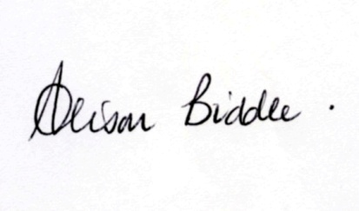
Alison Biddle PSLCC
Clerk to the Council

