Moss Side Farm
Peatland
Restoration
Works
Mini Moss
Moss Side Field Phase 2

Specification

1.1 Site Background information
Moss Side field was formerly agricultural land and is now being re-wet as part of a wetter farming project.
A Mini Moss Phase 1 was constructed last year using topsoil removal and bunding and this Phase 2 will use soil inversion.
There are a number of land drainage pipes within the area resulting in the drawdown of the perched water table within the peat.
Deep trench bunding will control the loss of water.

1.2 Contractor Experience
Contractors are invited to tender for this work, which will require not only skill and experience of this type of work but particularly on boggy, difficult to navigate peat soils. Successful Contractors must demonstrate knowledge of and have regard for the sensitive nature of wetland hydrology and ecology. It is not expected that this work will be sub-contracted out and must therefore be undertaken by the successful Contractor.

1.3 Nature of work
The work will include the following:
- The installation of 1104m of deep trench bunding
- Installation of water control pipes x 1(30m long)
- Peat inversion ha 0.9 ha
- Install 100m of Plygene Bund

2.0 Contact Information
Project Manager
Chris Evans 07979 873504 christopher.evans@naturalengland.org.uk

3.0 Access
The site can be reached via access point are main gate to Moss Side Farm Astley, Manchester M29 7LS. This road is in a dilapidated state but is wide enough and stable enough to allow access for large machinery. The field can be accessed directly from a farm track at the back of the farm.
Access to the site beyond the road is only on foot and by vehicles that are specially adapted to driving on peatland i.e. low ground pressure vehicles.
The centre of the site can be found at SJ 70570 97152
A google maps pin https://maps.app.goo.gl/gneZeDm8SSgkFBXa7 for the gate to Moss Side Farm.

4.0 Project Management
- Day-to-day management and supervision of all machines and operatives will be the responsibility of the Contractor.
- The Contractor will be required to liaise weekly with Natural England (NE) during the project and provide progress reports when required.

5.0 General Principles

5.1 Prevention of enrichment/pollution of the sites
It is vital to the management of the site that there is no nutrient enrichment or spillage of chemicals, of any kind, onto the site. The Contractor shall meet high environmental standards by providing (and using) spill kits for all equipment and using bio-fuels and bio-lubricants in all machines where possible.

5.2 Method of works
Due to the difficulty of transporting any weight around on the peat surface, the work will need to be planned such that access and/or movement of material is done solely on foot or by low ground pressure plant/vehicles.

5.3 Peat/mineral interface
The Contractor must be careful to avoid disturbing the peat/sand or peat/clay interface at all costs. Therefore, great care needs to be taken when excavating/scraping/moving any peat whilst creating the bunds. The client will need to be informed immediately of any occasion where the underlying mineral surface is accidentally exposed. If bunding works encounter the underlaying clay, the clay can be used to form the bunds.

6.0 Works to be carried out

6.1 Creation of deep trench bunds

6.1.1 Background
Bunding techniques for peatland restoration have developed over time and these works reflect current best practice for lowland raised bog restoration. Deep trench bunds will benefit the site by blocking the subsurface water movement.

6.1.2 Bunding required.
1104m of bunding railway view area to form sub-surface peat walls.
This will be achieved by digging to a depth of approx. 2m, turning over the peat and compacting this in place. This compaction is essential for sealing any pipes, cracks or voids in the peat and stopping water leaking.
The surface bunds’ main purpose is to slow the movement of surface water and provide some above ground water storage, which will further counter the effects of drier months.
The top bund must be made with wet putty peat and in line with the trench bunding underneath. It should be no more than 0.5m high and 1m wide at the base. It is then covered with loose vegetation, stripped from the surface when excavating the deep trench bund line.
To achieve the correct method of installation, this technique allows for a number of preliminary inspection digs to determine the required depth of the trench. Once determined, the installation must dig below the water loss depth and ensure good peat is compacted in the trench to seal against water loss. The bunds need to be constructed to at least 0.5m in height and 1m in width on level ground. However, ground levels within the field vary, so in higher areas the top level of the bund can be graded to ground level so that the bund is only a visible above ground in low lying areas.
The extra peat needed for building the bunds will be won by digging a series of shallow scrapes no deeper than 0.5m. Extra borrow pit locations will be discussed on site with NE staff through arrangement with the project manager.
No peat is to be won from within 2 metres of any bund feature or bund construction site. This is to ensure that the newly constructed bunds are not subjected to extra pressure from water pooling.

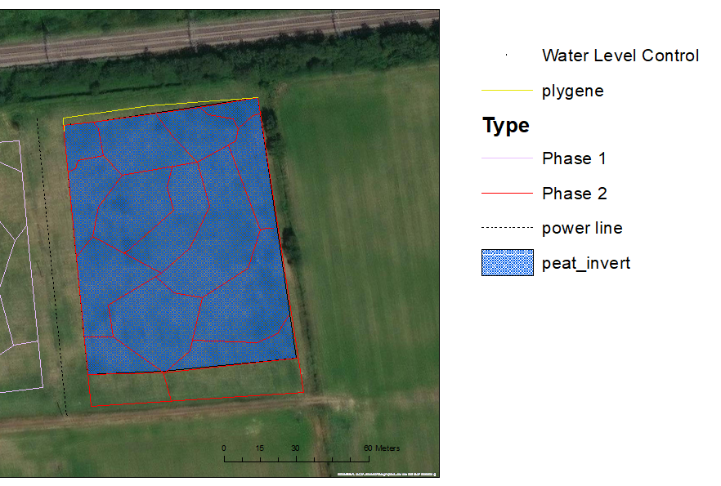
Peat Bunding

Figure 1 Re-wetting plan Mini Moss Phase 2

6.1.3 Plygene

100m of plastic plygene will be installed along the back of the outer bund of the phase 2 Mini Moss bog plant prorogation area (see yellow line fig 1). The works are intended to increase the effectiveness northern boundary bund of the Mini Moss. As there is still active drainage along the railway the plygene bund will act as an additional boundary, stopping water escaping from the bog cells within the mini moss.

A trench is to be dug at a depth of approximately 1.5 metres deep (below natural ground level) by 0.80 metres wide to check there are no pipes in the peat below the plygene. Wet peat will then be backed back in the base to a depth of 1.15m. The plygene lining is to be laid into the outer edge of the cut and buried/sealed using consolidated peat. If the plygene lining is to be installed in sections, it is important that it is overlapped by minimum of 1 metre to ensure it performs to its full potential. Consolidated peat from within the mini moss can be used to back fill and produce fit the top of the plygene into a low bund. The grade of plygene to be used is the heavy-duty 1.25 ml version of plygene silage pit liner. (see fig 2)
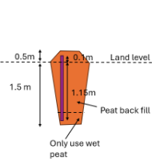
Figure 2 plygene bund

6.2 Installation of Water Control Pipes

6.2.1 Background
The creation of a bunding network will result in water pooling in the ‘borrow pits’ where peat is won to build those bunds. Pooled water exerts higher hydraulic pressures on surrounding peat. Without any means of re-distributing this water and lowering that pressure, the bunds may suffer leakage, erosion caused by over-topping, wave action or a combination - compromising their structural integrity and ultimately resulting in their failure.

6.2.2 Control pipes required
A 25m long overflow pipe will be installed within the bund at the west end of the phase 2 project area linking it to the ditch by the railway (see fig 1). The pipe will be 300mm corrugated plastic pipe. A 90-degree control will be installed on the upstream end of the pipe to allow water levels to be managed. Upstream end of the pipe will be keyed into the bund with the invert level set at the natural ground level at the upstream end and the rest of the pipe buried to provide access along the ditch.

6.3 Soil burying and surface microtopographic forming.

6.3.1 Background
The presence of a soil layer on top of the peat is a significant obstacle to the restoration of lowland raised bog peat converted to farmland in the 1800s. This “night soil” and modified peat layer is restricted to the depth of historical ploughing, so tends to be between 50-60cm deep on chat moss, but can be shallower in areas of pastureland (10-30cm). To restore an area of this type of farmed peatland directly back to bog, all the nutrients and lime within the night soil need to be removed to expose acidic nutrient poor peat to provide the correct conditions for sphagnum and cotton grass to grow.

6.3.2 Soil burying and surface microtopographic forming.
Inversion of the top 1.5 m of peat and night soil, to bury night soil below a layer of wet, nutrient poor & acid peat. The wet peat at the surface will then be compacted to form microtopographic pools across the surface in 5 areas covering 0.9 ha in total. The peat invention will be done by excavator working in retreat, with the peat mass excavated, and then inverted into a trench, then the back of the bucket used to compress the peat and sculpt the pools on the surface, the process will then be repeated to fill the newly cut trench (see fig 3). This will be done over the entirety of the 5 areas highlighted in fig1. The areas will then be enclosed by a deep trench bund to cut any drainage pipes flowing in or out of the area (note this is included as part of the overall bunding total). The result will be a mosaic of wet peat and bog pools ready for the establishment of bog habitat.
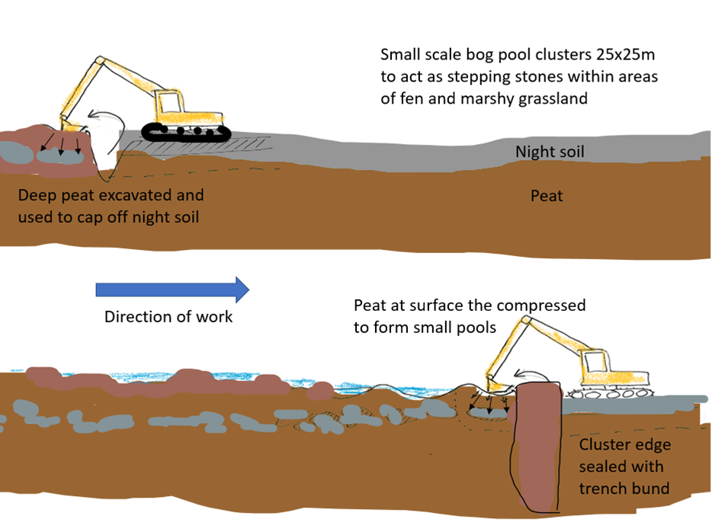
Fig 3. Envisioned working method Night soil burying and surface microtopographic forming

7.0 General work requirements
- All operatives will hold current, relevant certification for all machinery and the contractor will have appropriate public liability insurance cover. All certification, public liability insurance documents and a Health and Safety policy statement must be presented with the tender documents.
- All operators will be experienced of working on wet peatland sites undertaking restoration work of a similar kind.
- The contractor shall provide all equipment, all fuel and maintain all equipment required for the completion of the project, including all appropriate PPE.
- The contractor will be responsible for all first-aid within the contract work force, and a practising first-aider with current certification will be present at all times. The contractor will provide appropriate first aid equipment. Lone working will not take place under any circumstances. Welfare facilities can be provided at the close by Moss Side Farm if required.

7.1 Health and Safety
- A high-pressure gas pipeline runs through and adjacent to two fields.
- A permissive footpath runs to the north and west of the site. We can restrict public access when required for these works.
- The successful contractor will be expected to provide appropriate Risk Assessments and Method Statements.
- A Construction Phase Plan will be required with reference to welfare provided to operatives.
- Toilet facilities including warm water and a rest area can be made available at Moss Side Farm.
- Storage of plant can be provided at Moss Side Farm.

8. Water Voles
Water voles have been recorded in the area historically. Operatives need to be mindful of the potential of voles in or close to drains. NE will undertake a survey before works begin and discuss mitigation measures with the contractor if required.

9. Timescale
The work is expected to be completed by end January 2025.

APPENDIX 1

PRELIMINARIES / GENERAL CONDITIONS
The successful contractor will:
Produce written risk assessments and method statements on all areas of operations.
Allow for production of Construction Phase Plan prior to the start of the works.
Maintain security, safety and protection of the site and works in accordance with HSE guidance and this specification.

Quantities
ITEM | DESCRIPTION | QTY | UNIT OF WORK
1.1 | The installation of deep trench bunding | 1104 | metres
1.3 | Installation of water control pipes | 1 | each
1.4 | Peat inversion | 0.9 | ha
1.5 | plygene | 100 | metres

B

