**Tendring District Council**

**Specification**

**TDC Sports Facilities-**

**Pool Plant Compliance**

**07/2022**



**Our Vision**

***To put community leadership at the heart of everything we do through delivery of high quality, affordable services and working positively with others.***

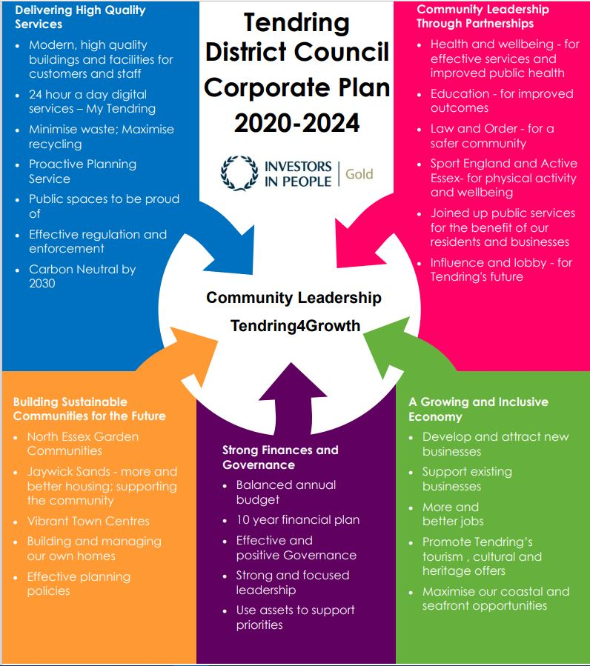

**Our Values**

♦ Councillors and staff uphold **personal integrity, honesty** and **respect** for others

♦ **Innovative, flexible, professional** staff **committed** to delivering excellence

♦ Recognising the diversity and equality of individuals

♦ Working **Collaboratively**

1. **Executive summary**

Swimming Pool & Health Suite Servicing & Maintenance Agreement for the

Following sites/ facilities;

1. Clacton Leisure Centre, Vista Road, Clacton-on-Sea , Essex CO15 6DB
2. Walton-on-the-Naze Lifestyles, Princes Esplanade, Walton on the Naze, EssexCO14 8PZ
3. Dovercourt Bay Lifestyles, Low Road, Dovercourt, Essex CO12 3TA

Tendring District Council operates 3 Sports Facilities within the Tendring peninsula. Each site is a thriving facility & based at the heart of the community. We pride ourselves on offering safe, hygienic, friendly & customer focussed facilities within an ever evolving environment. We endeavour to find the best value for the services that we provide & the products that we use within our facilities. As part of this process we are pleased to present our proposal for your review.

Details of Goods, Services or Works to be tendered

Maintenance Schedule

Monthly servicing of Clacton Swimming Pool, Spa, Steam Room, Sauna & Salt Inhalation Room.

Monthly servicing of Walton Swimming Pool.

Monthly servicing of Dovercourt Swimming Pool.

Planned Preventative Maintenance

This is considered to be the normal preventative maintenance service, during which certain items of the plant (scheduled below) will be stripped for visual inspection and where necessary replaced, to ensure trouble free operation. The frequency of this service will be tailored to meet particular operational needs;

Monthly Servicing/ Maintenance

Clacton Leisure Centre Spa

* Check chemical levels
* Check chemical holding tanks
* Check day tanks are not full of old chemicals
* Check pump baskets and clean
* Check and clean injectors
* Check dosing pumps and tube and suction valves
* Backwash spa filter if required
* Check valves on plant
* Check dosing unit and settings and in line filters
* Check air blower and booster pumps
* Check spa tiling and grout
* Check grab rails
* Check spa suction grills and return grills
* General plant check
* Check defame on dosing inlet
* Check floc dosing and clean injectors
* Check pro zone is working
* Check Spa temperature air and water
* Chlorinate air lines with new pumps on site
* Remove spa jets and chemical clean
* Visual check on the Balance Tank once a month.

Clacton Leisure Centre Health Suite

Steam Room/ Sauna/ Salt Inhalation Room

* Check the generators and control systems
* Check essence pump
* Check all drain valves
* Check benching and tiles/ grout
* Check fire board and wood for wear
* Check lights
* check temperature
* check for sharp edges
* check doors
* check over all plant and cables for units
* Amp clamp sauna heater elements

Clacton Leisure Centre- Swimming Pool

Walton-on the-Naze Swimming Pool

Dovercourt Bay Lifestyles Swimming Pool

* Check chemical levels
* Check chemical holding tanks and day tanks
* Check pump baskets and clean
* Check and clean injectors
* Empty & flush Chlorine tablet feeder (Dovercourt only)
* Chemically cleaner Chlorine feeder (Dovercourt only)
* Re-fill tablet feeder & test (Dovercourt only)
* Check dosing pumps and tubing and suction valves
* Backwash filter if required
* Check valves on plant
* Checking dosing unit and settings and inline filters
* Check pool heat exchanger
* Check tiling and grout
* Check pool steps and inlet grills and suction grills
* General plant check over
* Check Flume pump (Walton only)

3 Times a Year

Clacton Leisure Centre Spa

* Drain spa & chemical clean shell & level deck grating empty spa and start to refill, staff at club to re start plant once full.

**Annually**

Clacton Leisure Centre- Swimming Pool

Walton-on the-Naze Swimming Pool

Dovercourt Bay Lifestyles Swimming Pool

* Check filter media once a year
* Recalibrate Water Testing Photometer’s & TDS Meters in line with Manufacturers recommendations to ensure correct operation.

Clacton Leisure Centre Spa

* Check and clean balance tank once a year and chlorinate with all health & safety lifting equipment, 3 men on site for health & safety reasons.
* Check filter media once year

Walton-on the-Naze Swimming Pool

* Check and clean balance tank once a year and chlorinate with all health & safety lifting equipment, 3 men on site for health & safety reasons.

General inspection of plant and equipment

In addition to the routine maintenance as scheduled, the following inspections will be completed;

Plant and Equipment

* Visually inspect the outside of the filter vessels for general condition and report any defects
* Visually inspect all pipework for general condition and leaks and report any defects
* Check operation of manual isolating valves and report any defects
* Visually inspect strainer baskets and report any defects
* Check circulation pumps for general condition and operation and report any defects
* Check air blower (if fitted) for general condition and operation and report any defects
* Visually inspect condition/integrity of dosing hoses and report any defects
* Visually inspect for general condition dosing tanks and bunds and report any defects
* Visually inspect plant room for general condition (housekeeping) and report any defects

Health and Safety

* Check that chemical storage is correct and report any defects
* Check that all safety warning labels are installed and report any defects
* Check that all safety kit is in good condition and available and report any defects

1. **Requirements for proposal**

All Contractors will need to ensure that the following insurance levels are in place throughout the duration of the Contract. Evidence will be required prior to the confirmation of a contract with any relevant renewal information subsequently relayed to the Operations Manager.

* + Employer’s Liability Insurance  = £5m
  + Public Liability Insurance = £5m
  + Professional Indemnity Insurance = £5m

Where companies are unable to provide evidence of a Safeguarding Policy we would require them to sign up to Tendring District Council’s Safeguarding Policy. Information can be requested from the Operations Manager as applicable.

All Contractors working on site must be aware of Asbestos within the building & must have read the Asbestos Management Plan prior to the commencement of any works. Any Contractors working within these environments will be required to complete a Permit to Work, see section 5(v) & sign/comply with the Asbestos Management Plan taking all necessary precautions.

Permits to Work will be required to be completed on each visit on site where applicable. Please report to the Duty Officer at Reception who will organise a Permit. This must be displayed within your work area whilst on site.

Technical Requirements – These are the things that you would like the supplier to deliver. Provide details of what you need from the Supplier. Do not over specify your needs as this will come at a higher cost.

Copies of Staff Qualifications will be required ensuring that Staff who complete works hold the relevant qualifications/ experience to ensure they are competent to complete the works in line with the relevant governing body & industry standards.

1. **Timescales**

The key dates for this RfQ are:

RfQ Response Deadline: 14/04/2017

Contract Start: 01/05/2017

Contract Duration: 01/05/2017 – 30/04/2017

Populate these with dates relevant for the project: EG Go live date or deadline for the service to be delivered. If this is not relevant please delete.

|  |  |
| --- | --- |
| **Project Milestone** | **Date** |
| Contract Start | 01/05/2017 |
| System start | 01/06/2017 |
|  |  |
|  |  |
|  |  |
|  |  |

1. **The** **Authority’s Policies** **& Statements**

The bidder will need to adhere with the below policies and statements.

* Data Protection (please see Appendix D)
* Freedom of Information (please see Appendix F.

**Modern Slavery**

The bidder self-certifies that they are taking steps to ensure that there is no modern slavery or human trafficking (as defined in the Modern Slavery Act 2015) in their organisation or supply chain relating to the requested services/supplies requirements.

Here is a link to the Act: <http://www.legislation.gov.uk/ukpga/2015/30/contents/enacted>

**Health and Safety**

The bidder self-certifies that they adhere to the Health & Safety at work Act. Any Here is a link to the Act: <http://www.hse.gov.uk/legislation/hswa.htm>

**Environment**

The bidder confirms that they are aware of Tendring District Council’s Environmental Statement, and should they be successful, they are committed to working with the Council fulfil the vision outlined in the Statement.

<https://www.tendringdc.gov.uk/environment>

1. **E-procurement requirements**

Tendring District Council has an fully automated Purchase to Pay (P2P) system.

The successful bidder will be able to:

* View their orders online;
* Update their status;
* Notify delivery; and
* Submit and monitor the status of electronic invoices, once they have been submitted.

Orders will be sent electronically to the successful bidder’s central e-mail address from the contract start date.

The successful bidder will be expected to submit electronic invoices from the contract start date. On approval of the electronic invoice an automatic payment will be made via BACS, direct to the successful bidder’s bank account supported by an e-mailed remittance advice, in line with Tendring District Council’s contracted payment terms.