Appendix 1 - West of England Enterprise Zones and Areas
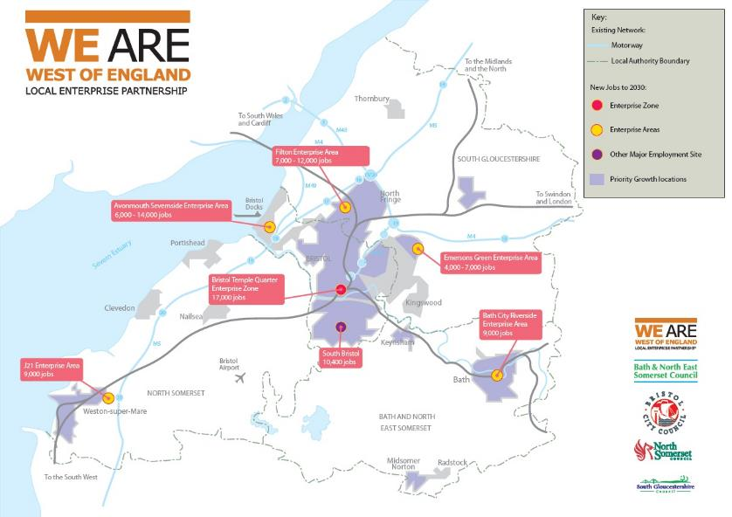
A larger map version is available on-line. Industry sectors, and example businesses and learner groups in each zone / area are given in the table below.

Appendix 1 continued: Examples of potential key sectors and learner groups*
*Please note this is not an extensive list and purely suggested opportunities
Enterprise Zone / Area | Key Sectors | Examples of  Potential learner groups/types/challenges
Bristol Temple Quarter | Professional Services  High Tech  Visitor Economy  Digital  Creative  Construction | - Women Returners  - BME and other underrepresented groups, including people with disabilities  - Traineeships with extra training  - Sector based work academies with additional training
Filton | Advanced Engineering  Manufacturing  Aerospace  Visitor Economy  Hi Tech  Digital  Health (Care / Digital)  Visitor Economy  Construction | - Candidate rejections from Primes (referrals to Aerospace Supply Chain)  - Sector Based work academies  - BME and other underrepresented groups, including people with disabilities  - Traineeships with extra training  - Sector based work academies with additional training

Bath Riverside and  Somer Valley | Health (Care / Digital)  Creative  Digital  Construction (Housing)  Hi Tech  Retail  Visitor Economy | - Candidate rejections from Primes (referrals to Aerospace Supply Chain)  - Sector Based work academies  - BME and other underrepresented groups, including people with disabilities  - Traineeships with extra training  - Sector based work academies with additional training
Junction 21 | Health Care  Food  Hi Tech  Professional Services  Distribution  Construction | - Not in Education, Employment, Training or School (NEETS)  - Over 50’s / Fuller working lives  - Transport to Work  - BME and other underrepresented groups, including people with disabilities  - Traineeships with extra training  - Sector based work academies with additional training
Avon and Severnside Area  Avon and Severnside Area (cont’d) | Distribution  Retail  Manufacturing  Advanced Engineering  Construction  Hi Tech  Low Carbon | - TUPE / Redundancy / Career changers  - Candidate rejections from Primes (referrals to Aerospace Supply Chain)  - Sector Based work academies  - BME and other underrepresented groups, including people with disabilities  - Traineeships with extra training Sector based work academies with additional training
Emerson Green | Retail  Hi Tech  Advanced Engineering  Creative and Digital  Health  Professional Services | - TUPE / Redundancy / Career changers  - Candidate rejections from Primes (referrals to Aerospace Supply Chain)  - Sector Based work academies  - BME and other underrepresented groups, including people with disabilities  - Traineeships with extra training Sector based work academies with additional training

