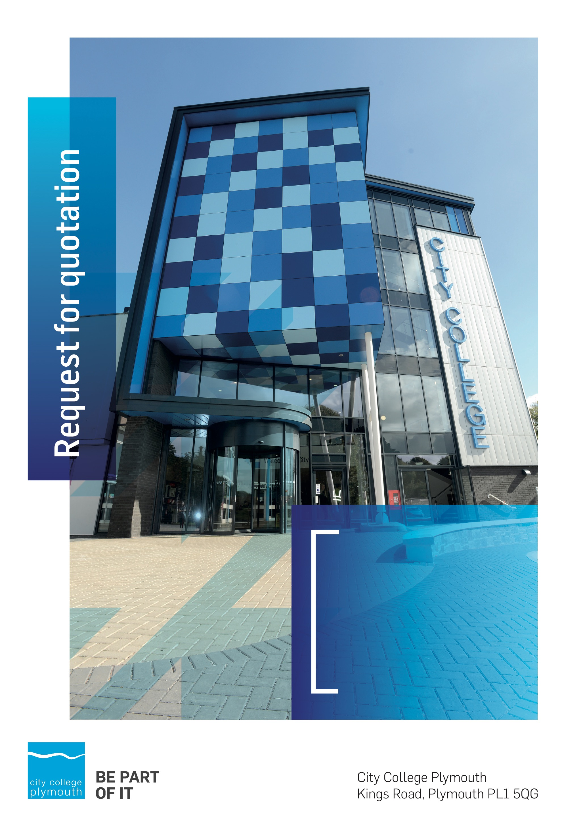

**Request for Quotation**

**RFQ209**

**T Level works 2024**

**Issued 09/02/2024**

# Table of Contents

Table of Contents 3

Confidentiality Statement 3

Open Procedure 5

Submission Questions and Clarifications 5

Electronic Submissions 5

Introduction and Executive Summary 6

Business Overview & Background 6

Our Guiding principle 6

Our Vision 6

Our CORE VALUES 7

Our CULTURE 7

The Way Forward - our Priorities 7

Instructions to Tenderers 8

1.1 Background 8

1.2 Indicative Timetable 8

1.4 Evaluation of RFQ 9

1.5 Evaluation Criteria 9

1.6 Weighted criteria 9

1.7 Assessment of responses 11

Site Visits 14

Safeguarding 14

# Confidentiality Statement

This document, and any attachments thereto, regardless of form or medium, is intended only for use by the addressee(s) and may contain legally privileged and/or confidential, copyrighted, trademarked, patented or otherwise restricted information viewable by the intended recipient only. If you are not the intended recipient of this document (or the person responsible for delivering this document to the intended recipient), you are hereby notified that any dissemination, distribution, printing or copying of this document, and any attachment thereto, is strictly prohibited and violation of this condition may infringe upon copyright, trademark, patent, or other laws protecting proprietary and, or, intellectual property. In no event shall this document be delivered to anyone other than the intended recipient or original sender and violation may be considered a breach of law fully punishable by various domestic and international courts. If you have received this document in error, please respond to the originator of this message or email him/her at the address below and permanently delete and/or shred the original and any copies and any electronic form this document, and any attachments thereto and do not disseminate further.

Thank you for your consideration, City College Plymouth.

Where no notice is given, all information contained herein is Copyright 2024 City College Plymouth.

# Open Procedure

The College fully adheres to the requirements of the Public Contracts Regulations 2015, including for opportunities which are under threshold amounts.

Any Contractor who directly or indirectly canvasses any Member or Officer of the Institution, or advisor concerning the award of the contract for the provision of the services, or who directly or indirectly obtains or attempts to obtain information from any such member or Officer concerning any Tender or proposed Tender for the service will be disqualified from having his/her Tender considered.

## Submission Questions and Clarifications

You may contact the following person if you have any questions or require clarification on any topics covered in this Request for Quotation: 25th February 2024

**Adam Baker**

Procurement Officer

Phone: 01752 505313

Email: tenders@cityplym.ac.uk

All correspondence during the Tender should be channeled via the Procurement Officer using the above details only. Bidders found to have gained an unfair advantage shall be disqualified from the current opportunity and future opportunities with the College for a minimum of four (4) years.

## Electronic Submissions

Electronic submissions in response to this Request for Quotation are required and must meet the following criteria:

Sent via email to: [tenders@cityplym.ac.uk](mailto:tenders@cityplym.ac.uk)

**WARRANTY**:

By submitting your tender bid, you are warrantying to the College that you have not breached our canvassing or soliciting clause.

If any successful tenderer awarded a contract is found to have provided an inaccurate warranty, then the College reserves the right to terminate the awarded contract with immediate effect and re-tender the contract from which the successful tenderer will be excluded from re-bidding and shall be disqualified from any future opportunities for a period of four years.

# Introduction and Executive Summary

The College is looking to appoint a contractor to carry out refurbishment works and fire protection upgrades to its tower block. .

The anticipated value of the supply contract will exceed £25,000. Therefore, as per the Public contracts Regulations 2015 the opportunity will be advertised on the government portal ‘Contracts Finder’.

# Business Overview & Background

City College Plymouth is one of the largest providers of innovative, technical and professional, education in the South West with a national reputation for promoting enterprise, employability and science, technology, engineering and mathematics (STEM). The College plays a central role in the educational, cultural and economic life of the region and works with strategic partners to facilitate growth, raise aspirations and foster wealth creation.

The College was awarded the Teaching Excellence Framework (TEF) Gold award for its university-level provision and its most recent Ofsted inspection confirmed that the College continues to be ‘Good’ with many outstanding features.

City College Plymouth is also one of the first Institutes of technology in the UK Working in collaboration with education providers and employers across the South West to improve the training in science, technology, engineering and maths in order to address skills gaps within these industries and support regional growth.

City College supports the region’s employers with their award-winning Apprenticeship provision, as well as providing a range of courses and bespoke training programmes which enable employees to upskill or retrain to better support their business’ requirements.

The College operates on two main sites within the city, serving 12,500 students and employing over 600 staff. The College operates year round, with opening times from 0800-2100 on some days.

## Our Guiding principle

City College Plymouth has a learning environment and organisational culture that impacts positively on the health, wellbeing and sustainability of our community and enables all of our students and staff to achieve their full potential.

## Our Vision

To be the learning destination of choice

## Our CORE VALUES

Respect, ownership, integrity.

## Our CULTURE

Nurturing a passion for teaching and learning

Enriching our community through knowledge, experience and skills

Enabling every student to be the best that they can be

## The Way Forward - our Priorities

• Staff - our most important investment

• Students - our purpose

• Community - making a difference

• Achievement - reputation for success

• Wellbeing - infusing health into every day

# Instructions to Tenderers

**Instructions to persons tendering to undertake reinstatement works to the Second, Third floor and Fire Protection upgrades to Ground, First, Fourth, Fifth, Sixth, and Seventh floor, Tower Building, City College Plymouth.**

**Tenders must be submitted in accordance with the following instructions.**

**Tenders not complying with these instructions in any particular may be rejected by City College Plymouth (herein after referred to as CCP) whose decision in the matter shall be final.**

* 1. Background

This procurement is being carried out by CCP.

CCP wishes to select a supplier to provide the Services described in the tender documents.

This procurement is being conducted in accordance with CCP’s Standing Orders / Terms and Conditions.

* 1. Indicative Timetable

Please see the indicative timetable for this procurement below. This is provided as a guide only as timescales may change.

|  |  |
| --- | --- |
| **STAGE** | **DEADLINE/TIMESCALES** |
| Request For Quotation (RFQ) Issued | 9th February 2024 |
| Site Visit | 21st February @ 15:00 |
| Deadline for Questions to be Raised | 25th February 2024 |
| Answers to Tenderer questions issued | 1st March 2024 |
| RFQ return date | 1st March 2024 |
| Commence Stage 2 negotiations | 4th March 2024 |

* 1. Notwithstanding your having been invited to tender or your inclusion on any list of selected candidates, CCP makes no representations regarding your financial stability, technical competence, or ability in any way to undertake the works. The right to return to these matters as part of the formal tender evaluation process is hereby reserved to CCP.

Invitations to Tender must be treated as private and confidential. Tenderers must not disclose the fact that they have been invited to Tender or release details of the Tender documents other than on an **in confidence** basis to those who have a legitimate need to know or those of the Tenderer’s professional advisors whom they need to consult for the purpose of preparing the Tender.

# Evaluation of RFQ

The responses to this RFQ will be evaluated on the basis of the most economically advantageous tender (MEAT) with the evaluation criteria weighted according to their relative importance. The questionnaire responses will be scored according to the pre-defined set of criteria and in accordance with the marking guidelines in the tables below. Price will be evaluated on a 'BEST price model', e.g. the lowest price will score the maximum mark and all other tenders will receive a % of that mark based on how close they are to that price.

# Evaluation Criteria

The responses to this RFQ will be scored according to the pre-defined set of criteria and in accordance with the marking guidelines below.

Tenderers who achieve a pass for all mandatory pass/fail questions for their responses will proceed to the next stage of the evaluation process.

The high level weightings for evaluating purposes are as follows:-

* **Quality (service proposal) 40 %**
* **Pricing (Fee proposal) 60 %**

CCP is not bound to accept the lowest tender and neither will it accept any liability in respect of costs associated with preparing submissions or attending interviews/presentations.

# Weighted criteria

The criteria that CCP will apply in selecting a suitable organisation to undertake this work are set out below:-

**Service proposal (40%)**

Your service proposal will be evaluated against the following criteria:

* Experience of Similar Projects – 10%

Please describe or demonstrate your previous experience of similar schemes including, but not limited to:-

* + Relevant project experiences
  + Relevant two stage tendering experience
  + Onsite QA systems
  + H&S record and any onsite systems used

Please endeavor to keep to 2 sides of A4 with separate sheets for project and any other examples.

* Proposed Team – 10%

Please describe or demonstrate the following:-

* + Proposed Contractor Team
  + Proposed Supply chain
  + Proposed Consultant Design Team
  + 2nd Stage Procurement programme
* Logistics - 10%

Please provide the following:-

* + Indicative Construction Programme
  + Site Logistics Plan
  + Site waste Management Plan
* Added Value (5%)
  + Please specify any additional benefits you would provide to the college particularly to college students
* Sustainability (5%)
  + Please detail Sustainability, the Environment and Corporate Social Responsibility including Modern Slavery. Confirm any sustainable activities as a company you undertake

**Fee proposals (60%)**

Contractors should submit their most competitive fee proposals for Prelims, OH+P and Construction Period.

In order to fully evaluate tender returns during stage 2 can you please complete the cost plan document and add in your costed Prelims amount and percentage for OH+P in the required cells

You will note that the college have engaged approved contractor with good insight into the tower building to develop a design and specification these contractors are named in the tender pricing cost sheet. If you wish you may contact them for a quotation or any other contractor you deem suitable for this project.

# Assessment of responses

Responses to the weighted criteria will be given a score from 1-10, then the score for each response will be determined in accordance with the following methodology. In each case, the overall strength/quality of the response will be evaluated in order to determine whether the response should be categorised as Unacceptable, Poor, Weak, Adequate, Good or Excellent and, for these purposes, an indicative (but not necessarily exhaustive) list of the characteristics that will be taken into account are those set out below.

|  |  |
| --- | --- |
| **Score** | **Marking Guidelines** |
| **Score 0** | **Unacceptable.** No response or response which is irrelevant to question or unacceptable.  Does not comply and/or insufficient information provided to demonstrate that there is the ability, understanding, experience, skills, resource and/or quality measures required to provide the services, |
| **Score 2** | **Poor.** Response only partially answers question, with major deficiencies apparent. Little relevant detail.  Considerable reservations of the relevant ability, understanding, experience, skills, resource and/or quality measures required to provide the services |
| **Score 4** | **Weak.** Response almost meets question requirements but remains basic and missing some detail.  Some minor reservations of the relevant ability, understanding, experience, skills, resource and/or quality measures required to provide the services |
| **Score 6** | **Adequate.** Response is adequate and meets the question requirements but remains basic and could have been expanded upon.  Demonstration of the relevant ability, understanding, experience, skills, resource and/or quality measures required to provide the services |
| **Score 8** | **Good.** Response satisfies question requirements and includes a level of detail which adds value to the Customer.  Above average demonstration of the relevant ability, understanding, experience, skills, resource and/or quality measures required to provide the services |
| **Score 10** | **Excellent.** Comprehensive and useful response which exceeds the question requirements. The response is innovative and adds value to the tender. It includes a full description of techniques / methods to be employed and the benefits that will be delivered.  Exceptional demonstration of the relevant ability, understanding, experience, skills, resource and/or quality measures required to provide the services |

The score for each question will then be multiplied by its weighting to provide a total score.

* 1. Tenderers should return the information stated below by **12.00 Midday on 1st March 2024.** Quotations received after the closing date and/or time, submitted through the wrong channels, or are an incomplete response, will be rejected.

Tenderers **must complete** and return the following documents: -

**2:** Tender Offer: Form of Tender

**2.0:** Form of Insurance Details

**2.1:** Certificate of Bona Fide Tender

**2.2:** List of Prelim items for pricing

**2.3:** Tender Pricing Cost Sheet

Tenderers **must provide** their responses to the following Quality Questions: -

* Experience of Similar Projects – 10%
* Proposed Team – 10%
* Logistics - 10%
* Safeguarding 5%
* Added Value 5%

Prices quoted shall be exclusive of VAT and shall be fixed and firm for the duration of the Contract.

* 1. Unit rates and prices must be quoted in pounds sterling and whole pence.

1. Tenders should be submitted exclusive of Value Added Tax (VAT).
2. If CCP suspects that there has been an error in the pricing of the specification, CCP reserves the right to seek clarification as it considers necessary from that Tenderer only.
3. All offers must be written in English.
   * 1. Tenders must not be qualified and must be submitted strictly in accordance with the provisions contained herein. Tenderers must not make changes to these documents. Tenders must not be conditional or be accompanied by statements that could be construed as rendering them equivocal and/or placed on a different footing from other Tenderers. Only Tenders submitted without qualification strictly in accordance with these instructions will be accepted for consideration. CCP’s decision on whether or not a Tender is acceptable will be final and the Tenderer concerned will not be consulted. If a Tenderer is excluded from further consideration the Tenderer will be notified. CCP reserves the right to make changes of a drafting nature to the Contract Documentation. Such changes will be acceptable by the Tenderer without reservation.
     2. If CCP requires to make more substantial alterations to the Contract Documentation, then CCP shall have the right to price the changes, using the Tenderers own submitted prices applied on a quantum meruit basis. Should the revised price structure not be agreed by the Tenderer, then the Tenderer may withdraw.
   1. The Tenderer must indicate at the time of submission of the Tender if they unwilling to meet the statements below:
      1. CCP may inspect any other contractual work of a relevant nature being carried out anywhere by the Tenderer; and
      2. the Tenderer is prepared to attend at CCP’s chosen office to give presentation(s) of the Tenderer’s technical capabilities, quality systems and the resources to be employed in providing the services required hereunder should the Tenderer be successful.
   2. CCP does not bind itself to accept the lowest or any tender and reserves the right to accept a tender either in whole or in part, each item being for this purpose treated as offered separately.
   3. The Tender shall be submitted on the basis that the offer therein shall remain in force for a minimum of 90 days from the date fixed for the submission of Tenders.
   4. CCP expects to enter stage 2 negotiations with the successful contractor within 14 days of receipt of stage 1 returns.
   5. Tenders shall only be submitted on the basis that they are bona fide competitive Tenders. In recognition of this principle it is hereby agreed that CCP shall have the power to cancel the Contract and to recover from the Contractor that amount of any loss arising from the cancellation if either:
      1. The Contractor shall have offered or given or agreed to give any officer or member of CCP any gift or consideration of any kind as an inducement or bribe to influence its decision in the tendering procedure. The word “Contractor” for these purposes shall be deemed to include any and all persons employed by the Contractor, or who are purporting to act on the Contractor’s behalf whether the Contractor is aware of their acts or not; or
      2. The Contractor
         1. shall have communicated to any person other than CCP the amount or approximate amount of the proposed Tender (other than in confidence in order to obtain quotations necessary for the preparation of the Tender or for insurance purposes); or
         2. shall have entered into any agreement or arrangement with any person as to the amount of any proposed Tender or that that person shall refrain from tendering.

## Site Visits

We have set aside 15:00 on 21st February for site visits. Please confirm your attendance by emailing Dom Jennings: djennings@cityplym.ac.uk

## Safeguarding

The College requires that all contractors, prior to undertaking work on the College site, will have been subject to a (DBS) English Disclosure Barring and Services check. You will be required to provide evidence of compliance before commencing work. This requirement may be suspended where works are undertaken during the college holiday breaks or outside of the main school week, providing the College is satisfied any risk to students who may be on site for revision or taster sessions is adequately managed.

All staff on site will be required to comply with health and safety requirements at all times and to wear appropriate identification.

All staff will be required to sign in and sign out when on College premises.