**Nursing Dementia Block Beds for West Sussex County Council**

**Northern Region**

**Early Engagement & Soft Market Testing**

**What is this Engagement and Soft Market testing exercise?**

West Sussex County Council are asking providers to respond to this exercise to support the gathering of information. The exercise is being undertaken for information purposes only and will be used by West Sussex County Council’s (WSCC) contracts and commissioning service to better understand provider interest and ability to provide services that the Council are exploring commissioning. This document does not form a legally binding contract and is not a statement of intent to enter into a contract with any provider.

Please note that this is not the commencement of a procurement process and Service Providers are taking part in soft market testing through this market engagement and are not bidding to provide a service at this stage. Should any procurement arise following this engagement and market testing exercise, a separate notice and information will be provided.

**Background:**

WSCC are inviting views from providers of residential nursing care that deliver dementia nursing care bed services. The Council’s aim is to explore potential interest in relation to the provision of a block contract to provide dementia nursing care services in the northern area of West Sussex. Providers are asked to give their feedback on the points below and to confirm whether this would be of commercial interest to them.

The Council is interested in exploring opportunities for a block of dementia nursing beds in the Council’s northern area. The current thinking is that block beds would be commissioned in the following way although the details are subject to change and any commissioning is subject to approval:

* for an initial one (1) year period with the potential to extend by up to a further period of 2 years, subject to confirmation at the point of a tender publication and to align with a future framework tender to commission residential and nursing care beds across the county
* to operate within the following response timeframes:
  + up to forty-eight (48) hours to assess, seven (7) days per week from the point of referral
  + the commencement of any agreed placements on the same day or next day, following acceptance of the referral
* whereby the Council could pay:
  + for the full contracted number of beds throughout the contract term regardless of whether all of the beds were fully occupied or not. (excluding Funded Nursing Care)
* any uplifts would be subject to the Council’s annual review process and agreed in the Spring of each contract year, at the sole discretion of the Council.

The services would require an **understanding and experience of delivering dementia nursing care** in a residential setting**,** including managing customers with multiple complex needs (MCNs) and/or behaviours that challenge services.

This market testing exercise aims to obtain providers’ views on the potential to deliver the following services:

* A block of dementia nursing care beds in the Northern area (see map below). Providers are asked to submit:
  + The volume of beds which they could commit to delivering as a block contract from Winter 2024/25
  + An anticipated weekly or annual price for delivery of a block contract, excluding Funded Nursing Care (FNC), from an available date on or after 1 January 2025. WSCC is looking at what competitive rates can be offered for a service in this area which provides a guarantee of business for a volume of beds.

To support us with our information gathering, if you would be interested in providing a block of nursing dementia beds as set out above, please can you complete the table and answers to questions 2 – 5 below by **17:00 on Friday the 15th of January 2024.** Please submit your completed document via email to [adultscommissioning@westsussex.gov.uk](mailto:adultscommissioning@westsussex.gov.uk)

1. **Price, Volumes and Location**

**Northern Area**

|  |  |  |  |  |
| --- | --- | --- | --- | --- |
| **Service Location** | **Bed Volume that could be offered for a block** | **Weekly Price (excluding FNC)** | **Annual Price (excluding FNC)** | **Estimated start date** |
|  |  | **£** | **£** | **Winter 2024/5** |
|  |  |  |  |  |
|  |  |  |  |  |

1. **Experience of providing dementia nursing care beds:**

Please tell us how your service could:

* evidence experience of providing safe and suitable dementia nursing care
* support the Council to place customers in and maintain placements for customers with multiple complex needs (MCN’S) and/or behaviours that challenge within your service.

1. **Response to assessment times:**

Would your service have the capacity to respond to referrals within a maximum of 48 hours, seven days a week from the point of referral. **Yes/no**

1. **Services start times:**

Would your service have the capacity to accept a placement into your service and commence the service for a customer on the same day or next day following acceptance of a referral? **Yes/No**

1. **Other considerations**

Please outline any other considerations you would have in reviewing a potential opportunity for a block contract for nursing dementia care in a residential setting that you would like to raise as part of your survey response.

Thank you for your engagement and participation. Should the Council decide to tender services, we will alert you to the opportunity via the Procurement portal.

***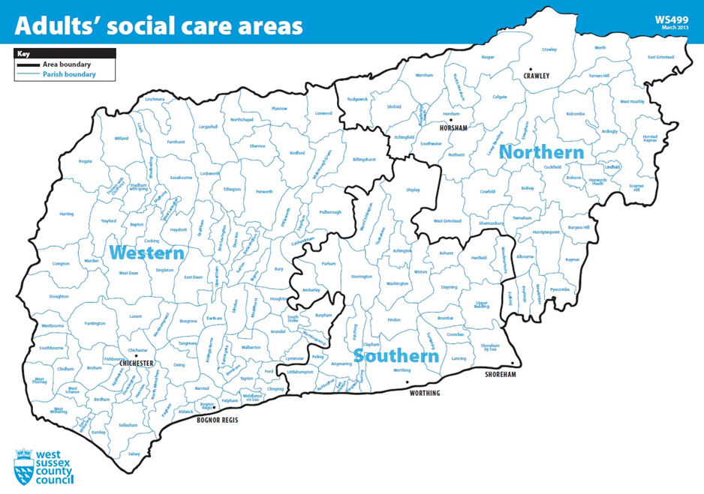*Appendix 1: Map of West Sussex – Adults’ Social Care Areas**