Opportunity to operate a Market at Ghurka Square Fleet Hampshire

INVITATION TO TENDER/TENDER DOCUMENT

HART DISTRICT COUNCIL

PROCUREMENT SERVICES

TENDER FOR: Market Licence

AGREEMENT TO
COMMENCE FROM: 20 DECEMBER 2016

CONTRACT TYPE Licence until 20TH December 2020

Date opportunity posted: Tuesday 14th June 2016
Quotation return date: 12 noon, Wednesday 20th July 2016
Type of quotation: Electronic (alternatives possible see 2.3)
Quotation shall be returned to: procurement@hart.gov.uk
With the subject line: Quotation for Market Licence – 2016
Contact in case of queries: ashley.grist@hart.gov.uk.

DEFINITIONS

In these documents, the following definitions shall apply: Throughout these documents, words imparting the masculine include the feminine and vice versa, unless otherwise stated, and words in the singular include the plural and the plural include the singular.

The Council | Hart District Council, Civic Offices, Harlington Way, Fleet. Hampshire GU51 4AE
Tender | Means the fully completed Tender Document (this document), and those items detailed on the invitation letter, from each Tenderer.
Tenderer | Means an organisation invited to Tender for the services as specified.
Operator | Means the successful Tenderer
Licence Manager | Means a competent employee nominated by the successful Tenderer to act on its behalf in administering the licence.
Licence Period | Means from the date of the acceptance letter to 20 December 2020
Core Terms | Means the core terms to be incorporated into a contract with the successful tenderer.
Supervising Officer | Means the Council’s representative duly authorised to act in the administration of the Contract.
Licence | The licence to be entered into between the Council and the operator for the provision of services from the market site

1.2 The Council currently operates a well-established market from this site and would invite tenders that bring innovation and sustainability to draw customers to the town centre.

1.3 The tender process is to assist us in appointing the best possible solution.

RETURN OF TENDERS

You are invited to submit a Tender for the above in accordance with the terms and requirements of this invitation and any documents, Schedules and Specifications attached. One complete and unbroken copy of this Tender shall be returned not later than twelve noon on Wednesday 20th July 2016.

The Council offers electronic return of tenders. These should be sent to procurement@hart.gov.uk with the subject line of: “Quotation for Market Licence – 2016” and must be received before the deadline in 2.1

Non electronic are possible and returns must affix the attached tender label to the front of an A4 Buff envelope which shall be sealed and bear no name or mark indicating the identity of the sender. Tenderers should ensure that their postal franking machine does not contravene this requirement. Also, tenderers should ensure that their courier service complies with this requirement. The A4 buff envelope must be affixed with the tender label provided within the tender pack.

Tenders delivered by hand should be brought by the specified deadline to the above address between the hours of 9.00 am and 4.00 pm Monday to Friday and a receipt obtained as proof of delivery. All general correspondence prior to final submission of the Tender should be addressed to Mr Ashley Grist via the email address ashley.grist@hart.gov.uk.

Tenders received after the due deadline or which are returned incomplete or which infringe these Tender instructions may be rejected by the Council and returned to the Tenderer without consideration of offer. Tenderers are therefore requested to make every effort to meet the requirements of this Tender invitation.

NOTICE TO TENDERERS

A Tender shall be subject to the general and core terms (if any) set out herein but in the event of inconsistency the core terms within the tender documents shall prevail. Any other terms or Conditions of Contract or general reservations which may be printed on any correspondence emanating from the Tenderer in connection with this Tender or with any agreement resulting from this Tender shall not be applicable to this Tender or to the agreement. Unless otherwise stated by the Council, all information supplied (whether in these documents or otherwise) is for general guidance in the preparation of Tenders and shall not be binding on the Council.

The Council does not bind itself to accept the lowest or any tender. The Council may also accept either all or any part of a Tender or more than one Tender.

The Tenderer must initial any alterations or corrections on the returned Tender.

The specifications enclosed are to be complied with in every respect.

Tenderers that fully comply and exceed the pass mark against every criteria listed will be short-listed. Further detail on the evaluation is given below.

Award & Evaluation

3.6.1 The contract, if awarded, will be awarded, taking into consideration the following criteria:

Criteria / Sub Criteria |  | Marks | Weightings
Price |  | /10 | 40%
Quality | Experience of delivering town markets | /10 | 60%
Quality | Quality and style of stalls | /10 | 60%
Quality | Ability to delivery variety of stalls and sustain them | /10 | 60%
 | Market layout | /10

The quality marks are scored from 0 to 10, a scoring sheet is given below.

Score | Interpretation
0 - 1 | Either no answer is given or the answer provides no evidence that the Tenderer meets any of HDC’s requirements.
2 - 3 | The answer provides some evidence that the Tenderer meets some of HDC’s requirements but only in a minimal way.
4 - 5 | The answer provides satisfactory (or better) evidence that the Tenderer partially meets HDC’s requirements.
6 - 7 | The answer provides good (or better) evidence that the Tenderer meets a majority of HDC’s requirements.
8 - 9 | The answer provides good (or better) evidence that the Tenderer meets nearly all of HDC’s requirements.
10 | The answer provides excellent evidence that the Tenderer fully meets all/exceeds HDC’s requirements.

The pass mark for all criteria is 6 out of 10 and any responses scoring less than 6 for any criteria listed above may be considered to not meet the requirements and therefore fail the evaluation and the Tender may be rejected.

3.6.2 Price Evaluation

Each bidder’s total price will be ranked. The highest bid will receive the full 40% of the marks and the remaining bids will be scored according to their relationship with the highest bid. This means that a bid only marginally lower than the highest bid will score only marginally less than the maximum.

Quality Evaluation

The Tenderer shall provide within the Tender response Method Statement as requested below;

Please note that Method Statements are essential in the evaluation of this tender, therefore failure to submit all requested Method Statements will result in your tender being rejected.

The Quality Criteria will be scored by evaluating the Tenderers’ corresponding method statement response to the heading listed below.

Criteria
Method Statement 1 | Please provide details of your experience of delivering town markets, including how you propose to manage and operate the market
Method Statement 2 | Please detail your ability to deliver a variety of stalls and sustain them, including examples of areas of development
Method Statement 2 | Please detail the style and design of the stalls
Method Statement 2 | Please provide a detailed market layout plan.

The resultant price and quality scores will be transferred across to the overall evaluation model where weightings will be applied to give total scores out of 100%.

Subject to the Special Instructions and Conditions herewith the Tender shall be based on the cost of wages and materials ruling at the date of the Tender. All prices quoted in the Tender shall, unless otherwise stated, include profit, transport, labour, materials, fuel and plant charges, insurance and all other expenses of every kind which under the conditions of Contract are borne by the Tenderer. Prices quoted in the Tender shall be in UK Sterling and exclusive of Value Added Tax. Value Added Tax shall be applied at the appropriate rate ruling at the date of any invoice.

The successful Tender, together with the Council’s written acceptance thereof, will form a binding agreement between the Council and the successful Tenderer.

Price; The Contractor acknowledges and agrees that the Council has entered into this Agreement on the basis of the pricing and method statements supplied to and accepted by the Council.

The successful operator will be required to enter into a licence in a form to be prepared by the Council, which will incorporate the Core Terms

Method Statement; Experience of delivering town markets
Please provide details of your experience of delivering town markets, including how you propose to manage and operate the market

Method Statement; Ability to deliver variety of stalls and sustain them
Please detail your ability to deliver a variety of stalls and sustain them, including examples of areas of development

Core Terms

- The Council gives Licence to the operator to use the Market Site in Gurkha Square Car Park (“the Market Site”) which is shown edged in Blue in the annexed plan for the purpose of a market from 20th December 2016 until the 20 December 2020.
- The Market shall operate between the hours of 8.00am and 5.00pm each Saturday except where those days fall on Christmas Day, Boxing Day or New Year’s Day. A reasonable time is given before and after these times to allow for the purposes of setting up and dismantling the stalls. For the purpose of this Clause, no stall shall be set up prior to 07:30 and all stalls and related equipment shall be removed from the site prior to 18:00 on each day.
- The Operator shall pay £XXXXper annum to the Council and the first 3 months payment shall be made on the date of this Licence and Monthly payment shall be made for the duration of the Licence.
- The Operator agrees to the following:

- To accept the Market Site in its existing condition as at the date of this Licence and to use it only for the purposes of an open market with stalls on it for the sale of all kinds of goods and merchandise but not for the sale of animals or for the sale of any goods and merchandise that cannot be lawfully sold.
- That if on any day that the market is held there is no need for all of “the Market Site” due to insufficient traders and stalls, then that part of “the Market Site” not required will not be used for any other purpose.
- Not to break open or interfere with the surface of the Market Site or to alter any building or erection on it without the express written consent of the Head of Environment & Technical Services or his representative in addition to all other consents and permissions.
- To be responsible for the provision and layout of stalls and to ensure that such stalls shall be of good quality and in good condition. The Council reserves the right to require the Operator to remove any stall that is not in good condition according to the opinion of the Head of Environment & Technical Services or his representative.
- In addition to the payment of the Licence fee to be responsible for the payment of any rates taxes charges for services or any other similar charge that may be attributable to the Market Site as a result of entering in to this Licence.
- Not to interfere with the right of the Council by its Officers and Servants with or without Workmen and others to enter the Market Site.
- Not to assign or transfer the benefit of this Licence.
- Not to hold or permit or suffer to be held or to allow anything to be done on the Market Site so as to be or become a source of nuisance or noise to the owners and occupiers of premises adjoining or in the environs of the Market Site.
- Not to permit any stall to remain upon the Market Site unless there is displayed conspicuously and legibly upon the name and address of the person or persons carrying on business from that stall.
- To accept full responsibility for and indemnify the Council against any damage to the Market Site and any other property of the Council which has been caused by him or any agent of his or any stallholder or any other person associated with a stallholder.
- To indemnify the Council against all claims proceeding and costs and expenses arising in respect of the use of the Market Site for any loss damage or injury caused by or to any person and to obtain the benefit of a policy of insurance for a sum of not less that £5m (five million pounds) in respect of this risk. To produce a policy in evidence of payment of premiums on demand to the Council.
- To ensure that each stallholder carries a public liability insurance cover in the minimum sum of £5m (five million pounds) and such stallholders will be required to cease trading if they are unable to produce evidence of such insurance cover on being requested to do so by the Head of Environment & Technical Services or his representative.
- To pay all charges for the collection and disposal of all rubbish and trade waste arising from the operation of the market.
- To maintain at his own expense any traffic management system to ensure a safe and secure market. This will ensure that both vehicles can pass by the market and that public can access the market and highway safely.
- To comply at all times with the requirements of all legislation relating to Health & Safety at Work and Food Hygiene.
- Not to allow any goods or articles or obstructions of any kind to remain outside the perimeter of the market.
- Any posters and advertisements displayed by the Operator on the Market Site shall relate solely to the activities on it and the size and character and contents of such posters and advertisements shall be subject to the prior approval of the Council through its Head of Environment & Technical Services or his representative. Any such posters shall only be erected on the day of the market and removed on the same day.
- To ensure that at the end of each market day the site is left in a clean and tidy condition to the satisfaction of the Head of Environment & Technical Services or his representative. Should the Head of Environment & Technical Services or his representative consider that it is necessary to carry out further cleaning and tidying operations on the site or its vicinity then the Operator shall reimburse the Council for the total cost of such operations.

- If there is any breach of these conditions then the Council shall have the right to terminate this Licence but without prejudice to any right or remedy that it has in relation to any antecedent breach by the Operator of any provisions of this Licence.
- The parties agree to regular review of the Licence and how the Market is operating, either party can terminate this Licence by giving 6 months written notice of their election to terminate the Licence at any point during the term.
- The Licence shall terminate in the event of the Operator committing any act of bankruptcy or make any assignment for the benefit of his creditors or making any arrangements with his creditors for liquidation of his debts by composition or otherwise.
- Any notice required to be given by either party to the other shall be in writing and shall be deemed to have been properly served if it is sent in a pre-paid Recorded Delivery envelope addressed to the Head of Environment & Technical Services or his representative at the Council Offices, Harlington Way, Fleet Hampshire GU51 4AE or to the Licensee at the address given above. Any such notice shall be deemed to have been received on the day on which it ought in due course supposed to have been delivered.
- Any dispute or difference which may arise with regard to interpretation of the Licence shall be settled by either of the joint Chief Executives of Hart District Council and their decision shall be final.
- Nothing contained in this Licence shall be construed as being demise by the Council to the Operator of the Market Site land.
- For the avoidance of any doubt it is accepted by the Operator that the Council shall have the right to use the Market Site for any purposes whatsoever during the period of this Licence except on any of the dates that the Operator is obliged to hold a market as described in this Licence.

TENDER DOCUMENT – THIS FORM MUST BE USED FOR ALL TENDERS

DECLARATION TO BE COMPLETED BY THE TENDERER

To: Hart District Council

I/We……………………………………………….DO HEREBY UNDERTAKE on the acceptance by the Council of my/our Tender either in whole or in part to operate the Market on such terms and conditions and in accordance with such specifications as are contained or incorporated in the Contract as defined in the Core Terms (see above).

This Tender remains valid for consideration for 13 weeks from the date fixed for return of Tenders.

Pricing Schedule for proposed Licence of the Market:

1. £________________ (Per Annum)

Signature ………………………………….

Name …………………………….(CAPITALS)

I am authorised by the Company detailed below to act on its behalf in this matter and to bind it to this Tender.

Position Held ………………………….

Name and Registered Office Address of Tenderer:
__________________________________________________________________________
__________________________________________________________________________
__________________________________________________________________________

Post Code: __________________________

Tel No: __________________________

Fax No: ____________________________

E-Mail Address: _______________________________

Date: ______________________________

DECLARATION OF BONA FIDE TENDER STATUS

In recognition of the principle that the essence of select tendering is that Hart District Council shall receive bona fide competitive tenders from all those tendering

WE CERTIFY THAT

- The tender submitted herewith is a bona fide tender, intended to be competitive

- We have not fixed or adjusted the amount of the tender under or in accordance with any agreement or arrangement with any other person.

- We have not done and we undertake that we will not do at any time before the hour specified for the return of the tender any of the following acts.:
  - communicate to a person other than the person calling for this tender the amount or approximate amount of the proposed tender (except where the disclosure, in confidence, of the approximate amount of the tender was essential to obtain insurance premium quotations required for the preparation of the tender)
  - enter into any agreement with any other person that he/she shall refrain from tendering or as to the amount of any tender to be submitted.
  - Offer to pay or give or agree to give any sum of money or valuable consideration either directly or indirectly to any person for doing or having done or causing or having caused to be done in relation to any other tender or proposed tender any act or thing of the sort described above

In this certificate:

- “person” includes any person and any body or association, corporate or incorporate

- “any agreement or arrangements” includes any transaction of the sort described above, formal or informal and whether legally binding or not.

DATED this day of 2015

SIGNED (as in tender)

………………………………………………

Duly authorised to sign

For and on behalf of ……...……………………………………….

Ghurkha Square car park plan

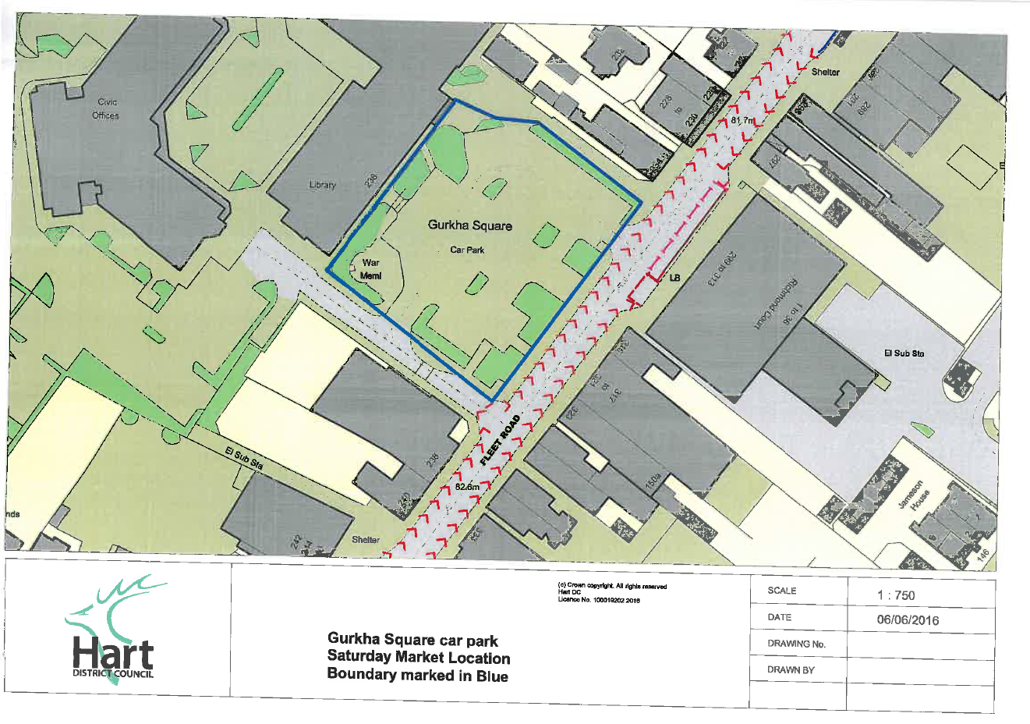
Ghurkha Square car park plan
Tender label

Mr Ashley Grist
Hart District Council
Civic Offices
Harlington Way
Fleet
Hampshire
GU51 4AE

Gurkha Sqaure Market Contract REF – HDC Market
Deadline for Receipt of Quotes 12noon Wednesday 20th July 2016
Quote - DO NOT OPEN

