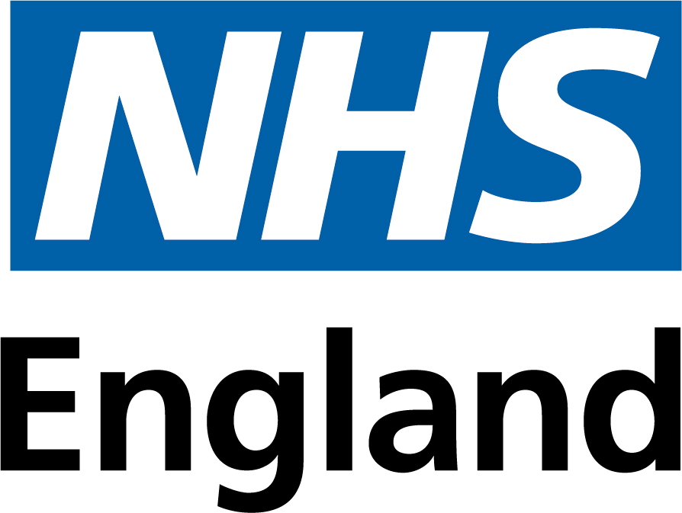

The parties selected to participate in **CM/PHS/22/5661 - NHS National Framework Agreement for the supply of products for the treatment of Blood Disorders including Haemophilia A and B - July 2024** are:

|  |  |  |
| --- | --- | --- |
| **Supplier Name** | **Registered office address** | **SME?** |
| Bio Products Laboratory Ltd | Dagger Lane, Elstree, Hertfordshire WD6 3BX | No |
| CSL Behring UK Ltd | 4 Milton Road Haywards Heath West Sussex RH16 1AH | No |
| LFB Biopharmaceuticals Ltd. | 3 avenue des Tropiques, Les Ulis 91958, France | No |
| Novo Nordisk Limited | 3 City Place, Beehive Ring Road, Gatwick, West Sussex, United Kingdom, RH6 0PA | No |
| Octapharma Limited | Glassworks House, 32 Shudehill, Manchester, M4 1EZ | No |
| Pfizer Ltd | Ramsgate Road, Sandwich, Kent, CT13 9NJ | No |
| Roche Products Ltd | Hexagon Place, Shire Park, Falcon, Way, Welwyn Garden City, AL7 1TW | No |
| Sobi (Swedish Orphan Biovitrum Ltd) | Suite 2, Riverside 3, Granta Park,Great Abington, Cambridgeshire. CB21 6AD | Yes |
| Takeda UK Ltd | 1 Kingdom Street London W2 6BD | No |