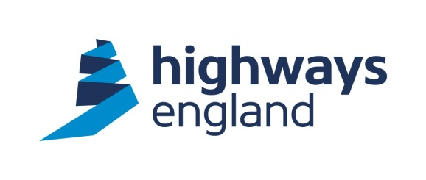  Our ref: ITT 5901  Your ref:  Turner & Townsend Cost Management Ltd  Low Hall, Calverley Lane, Horsforth  Leeds, LS18 4GH | Procurement Delivery Lead  The Cube  199 Wharfside Street  Birmingham, B1 1RN  Tel: 0300 470 5268  9 February 2021
Dear X,

Cost Planning Service Provider Framework
Package P138 – A12 Chelmsford (Junction 19) to A120 (Junction 25)Award Letter

I am directed by Highways England Company Limited to inform you that your Offer dated 19 January 2021 for carrying out the above named contract, is accepted in respect of your proposals for completion in accordance with the Terms and Conditions of the Contract.

The documents below, together with this letter, form a binding contract between yourselves and Highways England.

- The Cost Planning Service Provider Framework, Form of Agreement (and associated documents) dated 16 April 2019
- The Work Package Scope for P138: A12 Chelmsford (Junction 19) to A120 (Junction 25), dated 18 December 2020
- Your Tender for Package Order P138: A12 Chelmsford (Junction 19) to A120 (Junction 25), dated 19 January 2021

The accepted price for the package order is £ 94,357.50 (excluding VAT).

Please note, a Purchase Order number, under Highways England’s financial system (Oracle PFP) will be created shortly and provided to you by the Project Manager. You must quote a valid Purchase Order on each and every application for payment.

You acknowledge that any documents and information submitted by you as part of your Tender or for validation purposes, represent your proposals for meeting Highways England’s requirements, but do not in any way override or modify those requirements. You will remain liable to comply with all the obligations set out in the documents forming part of the Contract. You will not be relieved from compliance with these obligations by any:

(a) Validation, due diligence or sustainability check carried out by Highways England on any part of your Tender;
(b) Evidence, assumptions or other information provided by you with your
Tender or for the purposes set out in paragraph (a) above; or
(c) Clarification requested by Highways England and provided by you (whether orally or in writing) as part of the assessment process.

Please complete and return the acknowledgement slip below.

Yours sincerely

X
Procurement Delivery Lead

Cost Planning Service Provider Framework
Package P138 – A12 Chelmsford (Junction 19) to A120 (Junction 25)

We acknowledge Highways England’s acceptance of our tender for the above contract in their letter dated 9 February 2021.

Signed
Name
Position
Organisation
Date

