Service Specification
Urgent Courier Service (Small items) across NW London

(Delivery of Pulse Oximeters)

- Aim of the Service

The Provider will ensure the timely delivery of pulse oximeters to residential addresses across NW London. The timeframe for the delivery of the oximeters will be dependent upon the urgency of the request.

Urgent requests:
Where the CCG identifies a delivery as “urgent”, the Provider will to deliver the oximeters within a 90-minute window from receipt of request.

Non-urgent requests:
For non-urgent cases, delivery of an oximeter will be delivered during the course of the same working day.

To aid prompt delivery, the Provider is permitted to store the packed equipment/oximeters anywhere across NW London in order to reduce journeys to collect these items. Storage does, however, need to be secure and stock levels of oximeters needs to be tracked by The Provider.

Collection and re-distribution of pulse oximeters
A supply of oximeters will be made available by the CCG to the Provider for onwards distribution. Where these have to be collected from a central location, the Provider will be reimbursed for costs associated with collection at a flat rate to be agreed

To ensure that there is sufficient stock to meet demand across NW London, the Provider will infrequently be asked to re-distribute boxes of pulse oximeters between hubs, GP Practices and hospitals in NW London. The Provider will be reimbursed for costs associated with each drop off made, at a flat rate to be agreed

Packing
The Provider is asked to pack the oximeters in plastic wallets for individual delivery to patients, enclosing leaflets promoting safety-netting advice and information on how to return the oximetry probes. All costs associated with this should be covered within the delivery costs quoted

- Service outline

The Provider will host a contact point where all requests for pulse oximetry delivery are collated and recorded.

Covid Hot Hubs/NW London GP Practices will provide the following details for each request:

- Hub/Practice name
- NW London borough
- The referrer’s name
- First name of patient
- Address
- Contact telephone number
- Special instructions
- The level of urgency required for delivery (urgent or routine)

The Provider will capture all requests received from NW London and provide a weekly report to NW London ICS by close of play each Wednesday. An example of a minimum dataset can be found in Appendix B below.

The Provider may sub-contract services to a third party in agreement with NW London but needs to ensure that all delivery data can be captured and reported against.

Delivery of oximeters are to be made seven days a week from 8am to 8pm including Bank Holidays within the following timeframes:
- Urgent requests – delivery within 90 minutes of request
- Routine requests – delivery same day (maximum within 24 hours)

- Issues and complaints

Any issues noted with delivery of probes will be raised directly by the NW London Hot Hubs/Practices with the Provider.

- For immediate resolution of any issues, the Hot Hub/Practice should call the Provider hotline phone number
- To provide oversight on issues raised and ensure tracking and resolution, the Hot Hub/Practice should also email the Provider, copying NW London
- The Provider will ensure that 100% of patients receive the probes needed within 24 hours
- For all other issues, the Provider will investigate and respond within 48 hours, including a plan for resolution

- Accreditation

The provider will ensure the necessary training and statutory recruitment checks have been undertaken for all service personnel. This should include DBS checks, where appropriate.

The Provider will at all times maintain confidentiality and ensure information provided is utilised in line with GDPR requirements.

- Pricing

Actual contract prices will be determined through the procurement process.

This contract relates to the delivery of devices for the seven “Hot Hubs” and all GP Practices in NW London so the Provider is to invoice NW London CCGs for all delivery requests made by:
- Hillingdon Covid Hot Hub
- Harrow Covid Hot Hub
- Brent Covid Hot Hub
- Ealing Covid Hot Hub
- West London Covid Hot Hub
- Central London Covid Hot Hub
- Hounslow Covid Hot Hub

Or specific, named GP Practices, with their boroughs noted, that are within the management of NW London CCG.

Providers will be paid for provision of the service for on the basis of:
- the collection of devices for the purposes of re-distribution between hubs or to acute Trusts for each collection/ drop off location.
- the delivery to each location as requested.

The cost should be included as a separate line in any invoice submitted and supporting information should be provided outlining the details.

The Provider will be required to invoice according to the Purchase Order (PO) number provided by the NHS Northwest London Clinical Commissioning Group through its payment provider for the provision of the service. Invoices should be forwarded onto:

XXTISMAIL
07P PAYABLES K585,
Phoenix House,
Topcliffe Lane,
Tingley,
Wakefield, WF3 1WE

- Reporting

The Provider is expected to keep clear records of requests received and supply a breakdown of requests per hub on a weekly basis (by close of play on a Wednesday) for analysis purposes (see appendix B below for the minimum dataset required). These should be submitted weekly to Siobhan Herron
– Siobhan.herron@nhs.net , cc’ing nwlccgs.localservices@nhs.net
Appendix A – Hot Hub Contact Details

CCG | Escalated Care Clinic | Address | Post Code | Telephone Contact
Brent | Burnley practice | Willesden Centre for Health & Care, Robson Ave, London | NW10 3RY | 0208 238 5988
Central London | Soho Health and Care Centre | 1 Frith St, Soho, London | W1D 3HZ | 0203 884 9600
Ealing | Mattock Lane Health Centre | Mattock Lane Health Centre, 78 Mattock Ln, Ealing, London | W13 9NZ | 0208 966 6302/01
Harrow | Alexandra Avenue | 275 Alexandra Avenue Harrow Middlesex | HA2 9DX | 0208 966 6300
Hillingdon | Harlington Hospice | Landsdowne House,St Peters Way, Hayes, Hillingdon | UB3 5AB | 01895379305
West London | St Charles Centre for Health and Wellbeing | Clinic 2, Exmoor Street, London | W10 6DZ | 020 8102 5109
Hounslow | The Meadows Centre for Health | 90 Chinchilla Dr, Hounslow | TW4 7NJ | - 19

Appendix B – Sample monitoring spreadsheet
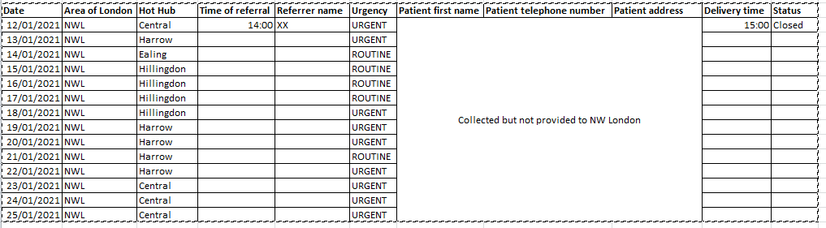

A spreadsheet including all of these data fields as a minimum will be provided to Siobhan.herron@nhs.net and nwlccgs.localservices@nhs.net by close of play on a Wednesday

Appendix C - Per Borough Indicative activity information per month

Borough Name | Expected share of indicative activity | Expected Range of Activity
Brent | 27% | 27-108
Central | 2% | 2-28
Ealing | 15% | 15-60
Hammersmith & Fulham | 3% | 3-12
Harrow | 10% | 10-40
Hillingdon | 2% | 2-8
Hounslow | 10% | 10-40
Westminster | 31% | 31-124
Total | 100% | 100-400 deliveries/per month

