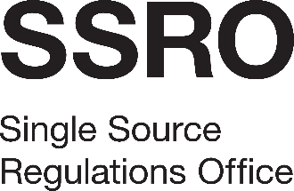

**Guidance development and delivery digitisation**

Appendix 3: Pricing Schedule

[Name of Bidder]

Pricing Schedule

* 1. The pricing element carries a weighting of 30% of the overall award criteria. Bidders should refer to the evaluation methodology in the Invitation To Tender document for further information.
  2. Bidders are required to enter day rates (excluding VAT) in the following table for each level of responsibility, based on the Business Change category. Bidders should refer to the Skills Framework for the Information Age (SFIA) (<https://sfia-online.org/en>) for further explanation of each level.

|  |  |
| --- | --- |
| **Responsibility level** | **Rate per day** |
| 1. Follow |  |
| 1. Assist |  |
| 1. Apply |  |
| 1. Enable |  |
| 1. Ensure/Advise |  |
| 1. Initiate/Influence |  |
| 1. Set Strategy/Inspire |  |

* 1. For the purposes of evaluation, the sum of all rates will be averaged to create a blended day rate, which will then be multiplied by the estimated number of days (7) to generate a notional total price.
  2. A “day” in the context of the rates submitted shall equate to 7.5 hours of service delivery. The SSRO expects the Contractor’s appointed personnel will be able to deliver the services from their office or remotely. Time spent travelling to the SSRO’s offices, if applicable, shall not be charged and does not form part of the day rate.
  3. Bidders are strongly advised to check all figures and arithmetical calculations before submitting their Tender. The SSRO will not allow bidders to amend their pricing after the deadline. If the tender is accepted the supplier will not be entitled to claim, and the SSRO will not allow, any increase in the rates or price.
  4. The SSRO will investigate bids where the rate or price appears to be abnormally low. If the bidder cannot provide substantial reasons for the low rates or prices (which may include justifying the sustainability of the bid over the life of the contract), then the SSRO may reject the Tender.
  5. The Tender must be based on rates or prices which exclude Value Added Tax. This tax, if applicable, will be paid by the SSRO as an addition at the appropriate rate on the invoices when submitted.