Invitation to Quote for Stand Build
AHDB Exports Stand
Gulfood 2022
Dubai

Contact Name: Hayley Hanson Email: Hayley.hanson@ahdb.org.uk

Company Name: AHDB Exports Website: www.ahdb.org.uk

Address: Stoneleigh Park Tel: +44 (0) 7920423410
Kenilworth
Warwickshire
CV8 2TL Contract Period: 9 Jan 2023 to 20 March 2023
United Kingdom

Show Name: Gulfood 2023 Show Dates: 20 – 24 February 2023

Hall: Meat and Poultry Stand Number: F3-2

Stand Size: 64msq Open Sides: 3

Budget: £45,000 (inc VAT)

Show Venue: Dubai World Trade Centre Deadline for submissions: Friday 6 January 2023
Sheikh Zayed Road
United Arab Emirates

- Introduction

This document outlines the requirements for the AHDB Exports stand at Gulfood 2022.

AHDB Exports are part of AHDB (the Agriculture, Horticulture Development Board) and based in Warwickshire, England.

We are a non-departmental Government public body working to promote British Pork and English Beef and Lamb both at home and abroad and will be attending with Hybu Cig Cymru - Meat Promotion Wales (HCC) who promote Welsh Beef and Lamb both at home and abroad.

2. Objective of attending the show

To provide a platform for our levy paying meat producers to create new business relationships with international meat buyers.

3. The Stand

We have booked a prime location for our stand (stand F3-2) in Hall 3. The floor plan can be viewed under point 6 showing our exact location.

Our stand measures 8m x 8m, a total floor-space of 64sqm.

The look and feel of our stand are important and must portray the quality to enhance our Quality British meat. The stand will need to be seen from a distance and be visually appealing.

The design should encompass a high-level fascia board/lampshade to enable us to brand this as GREAT following our brand hierarchy (see point 4) This will enable us to clearly distinguish we are British; ensure we can be seen from a distance and draw people to our stand.

HCC will be in attendance on our stand and therefore the design should allow for dedicated HCC and AHDB branding opportunities but should appear as one open and inviting stand with no partition of areas.

Lighting should be low heat creating.

3.1 Stand Build Requirements

To include all electrics, hot and cold-water supplies, wastewater disposal. Refrigeration units need to be in place and operational by the morning of Sunday 19 February, ready to receive all edible consumables.

Further details on stand build times and services available from the venue/organiser are here - https://www.gulfood.com/i-am-an-exhibitor

The stand needs to have the following elements and provisions.

Demo/Cooking area
This area will be used for Butchery demonstrations and cooking demonstrations, it is a shared space for AHDB and HCC and should be position away from the perimeter of the stand to ensure sampling is only offered to prospective buyers as opposed to passers-by. This area should also be positioned close to the storeroom for practical use.

The demo/cooking area needs to include the following elements

- Counter surface area to be approx. 2.5m long by 0.75 deep – allowing for a dedicated cooking space and a dedicated butchery space.
- 1x Double Induction hob or 2 x Single Induction hob (with frying pans) for cooking meat
- Counter to have underneath lockable storage cupboards with shelves for cooking pans/ingredients
- Bin

There should be a protective partition at the front of the cooking area to protect spectators whilst they watch products being cooked.

Storeroom

- Lockable door.
- SINK-2 dual sink (Lowe refrigeration or equivalent) with hot and cold-water supply, and wastewater disposal.
- Worktop for food preparation
- 2 x H3A fridge underneath the counter (Lowe refrigeration or equivalent)
- Drinking water cooler dispenser with additional bottles and disposable cups
- Quick serve coffee machine and facilities to make a Tea and coffee and soft drinks for those on the stand (approx. 150 servings per day)
- 1 large waste bin
- Wall shelving for literature storage
- Additional double electrical socket
- Coat hooks / rack

Meeting and greeting area
This space is to be used by AHDB and HCC and their exporters to display British Lamb and allow an opportunity to meet with prospective customers whilst offering them hospitality drink and chance to taste the lamb product.

This area should include:

- 2 x A1 display chiller with display grass (Lowe Refrigeration) (1 for AHDB and 1 for HCC)
- 2 x Welcome reception desks with lockage storage underneath with branding to the front (1 for AHDB 1 for HCC)
- 2 x Literature racks
- 55” Plasma TV to display multiple promo videos via USB
- Multiples of poseur tables with 3/4 stools each to provide meeting points. Please note the number of tables and chairs is dependent on visitors being able to walk around the stand freely and without obstruction
- Multiple Electrical sockets for charging items

Sundries
- Drinks: Tea, coffee, sugar, milk, stirrers, soft drinks, and disposable cups for approx. 150 servings per day.
- Disposable cutlery, plates and napkins (approx.100 each per day)
- Red resin cutting board approx. 600x450 mm – raw products
- Yellow resin cutting board 300x450mm – cooked product
- Hot plate scrapper
- J cloths
- Cleaning fluids
- Anti-bacterial spray
- Anti-slip matt for chopping boards
- Disposable latex gloves

4. Graphics

The design of the stand should allow for branding /graphic opportunities on all walls, reception counters and lampshade (both externally facing and internally facing)

AHDB and HCC will provide full and print ready artwork for all graphics panels, you will not be required to provide artwork for production - this will be produced by our design team.

We work to the below brand hierarchy please bear this and the need for separate opportunities for AHDB and HCC in mind and provide adequate, usable spaces /facets / panels for the design team to brand the stand.

Our USP is based around a quality product and so we use imagery of meat products, animals, and landscapes to portray this. Therefore walls / graphic opportunities should not be split by structural panelling.

Top level branding (i.e., lampshade or banner) needs to be seen from a distance in all directions and draw people to our stand. Where the stand design does not incorporate a lampshade, AHDB will design a column or back wall which mirrors the agreed logo and brand hierarchy with GREAT as the primary brand.

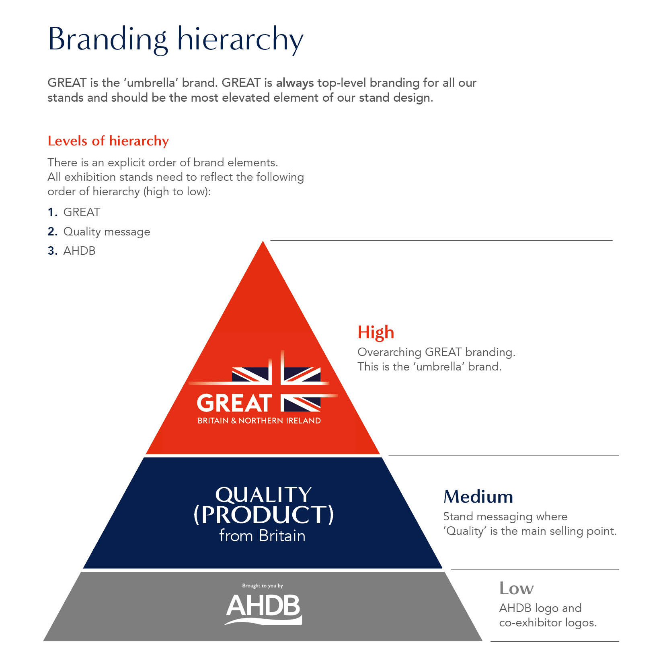

5. Hall Plan

Below is the layout of hall 3 Meat and Poultry, showing the location of our stand.

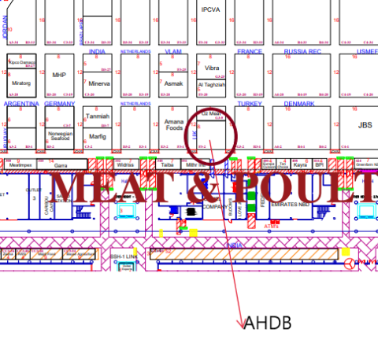
6. Tender submissions

The contractor shall deliver the whole of the services, complete in all parts and furnished with every necessary detail, notwithstanding any omission or inconsistency in the specification.

Your quote should include
- “To-scale” visuals of your stand design, including dimensions
- 3D drawings of the stand design from each angle
- A clearly itemised breakdown of all costs covering all products and services outlined in the brief (noting anything that isn’t included)
- Details of the build materials
- A graphic plan detailing
  - all graphic dimensions (to allow for a quick process once appointed)
  - Artwork timelines (when final print ready artwork is to be supplied)
- Details of if sub-contractors are to be used

Except as otherwise stipulated in the specific conditions of service required, the contract shall remain at the fixed price and rates shall not be revised.

The Stand Manager can order reasonable additions to or reduce from the service specified. These amendments shall be requested in writing and agreed by both parties.

7. Evaluation of Quotes

Our award criteria:

- Price (40%)
- Design, creative impression, and equipment (50%)
- Ability to meet event timelines, artwork, build-up and break-down (10%)

Please email your design proposals to Hayley.hanson@ahdb.org.uk by Friday 6 January 2023

Tender submissions will then be reviewed, and the winning contractor advised on Monday 9 January.

Any interested parties with queries relating to the tender please email Hayley.hanson@ahdb.org.uk who will respond to queries to all interested parties.

