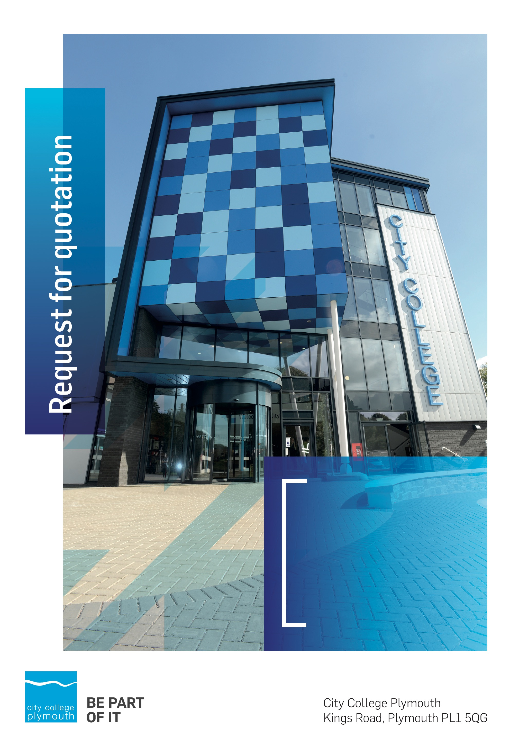

**Request for Quotation**

**RFQ196 Mechanical Maintenance Contract 2022**

**Issued 24/06/2022**

# Table of Contents

Table of Contents 2

Confidentiality Statement 3

Open Procedure 4

Submission Details 4

Submission Deadlines 4

Submission Questions and Clarifications 4

Electronic Submissions 5

Introduction and Executive Summary 5

Business Overview & Background 6

Our Guiding principle 6

Our Vision 6

Our CORE VALUES 6

Our CULTURE 6

The Way Forward - our Priorities 7

Detailed Requirement 7

Tender Process 8

SITE VISIT 9

Timescales 9

Written Submission 9

Safeguarding 10

Pricing 10

Terms and Conditions 11

Validity 11

Selection Criteria 11

Award Price 11

Written submission 11

Assessment of Quotations 12

Freedom of Information Act 2000 12

General Data Protection Regulation (GDPR) 2018 13

Agreement Conditions Acceptance and Declaration 13

Supporting Documentation 13

# Confidentiality Statement

This document, and any attachments thereto, regardless of form or medium, is intended only for use by the addressee(s) and may contain legally privileged and/or confidential, copyrighted, trademarked, patented or otherwise restricted information viewable by the intended recipient only. If you are not the intended recipient of this document (or the person responsible for delivering this document to the intended recipient), you are hereby notified that any dissemination, distribution, printing or copying of this document, and any attachment thereto, is strictly prohibited and violation of this condition may infringe upon copyright, trademark, patent, or other laws protecting proprietary and, or, intellectual property. In no event shall this document be delivered to anyone other than the intended recipient or original sender and violation may be considered a breach of law fully punishable by various domestic and international courts. If you have received this document in error, please respond to the originator of this message or email him/her at the address below and permanently delete and/or shred the original and any copies and any electronic form this document, and any attachments thereto and do not disseminate further.

Thank you for your consideration, City College Plymouth.

Where no notice is given, all information contained herein is Copyright 2022 City College Plymouth.

# Open Procedure

The College fully adheres to the requirements of the Public Contracts Regulations 2015, including for opportunities which are under threshold amounts.

Any Contractor who directly or indirectly canvasses any Member or Officer of the Institution, or advisor concerning the award of the contract for the provision of the services, or who directly or indirectly obtains or attempts to obtain information from any such member or Officer concerning any Tender or proposed Tender for the service will be disqualified from having his/her Tender considered.

# Submission Details

## Submission Deadlines

All submissions for responding to this Request for Quote must be submitted electronically as stated below, no later than:

**15th July 2022**

**12:00 Noon**

Any submissions received after this date will not be considered.

## Submission Questions and Clarifications

You may contact the following person if you have any questions or require clarification on any topics covered in this Request for Quotation: 8th July 2022.

**Adam Baker**

Procurement Officer

Phone: 01752 305313

Email: tenders@cityplym.ac.uk

All correspondence during the Tender should be channeled via the Procurement Officer using the above details only. Bidders found to have gained an unfair advantage shall be disqualified from the current opportunity and future opportunities with the College for a minimum of four (4) years.

## Electronic Submissions

Electronic submissions in response to this Request for Quotation are required and must meet the following criteria:

Sent via email to: [tenders@cityplym.ac.uk](mailto:tenders@cityplym.ac.uk)

Document standards:

* Text must be in Microsoft Word format;
* Price tables must be in Microsoft Excel format (using pricing schedule in Appendix A);
* Supportive evidence may additionally be submitted in PDF format;
* Images, Designs, and other supporting evidence may be in either JPEG or PDF format
* Completed Appendix C Suitability Assessment & Selection Questionnaire (Including Mandatory & Discretionary Exclusions) Parts 1, 2 and 3. - *Please note this suitability assessment will not be viewed unless you are the winning tenderer. Failure at this stage may prevent the contract from being awarded.*
* Signed Agreement Acceptance and Declaration.

*Please note that the College is able to accept submissions sent in a compressed or “.zip” file format, so long as the files contained meet the standards described above.*

**WARRANTY**:

By submitting your tender bid, you are warrantying to the College that you have not breached our canvassing or soliciting clause.

If any successful tenderer awarded a contract is found to have provided an inaccurate warranty, then the College reserves the right to terminate the awarded contract with immediate effect and re-tender the contract from which the successful tenderer will be excluded from re-bidding and shall be disqualified from any future opportunities for a period of four years.

# Introduction and Executive Summary

The College is seeking to appoint a provider for the on-going provision of servicing and maintenance of its mechanical equipment to include Boilers, Hot water systems, Convectors, Extraction units (vent axia), Air condition and ventilation plant situated across its sites

The anticipated value of the supply contract will exceed £25,000. Therefore, as per the Public contracts Regulations 2015 the opportunity will be advertised on the government portal ‘Contracts Finder’.

.

# Business Overview & Background

City College Plymouth is one of the largest providers of innovative, technical and professional, education in the South West with a national reputation for promoting enterprise, employability and science, technology, engineering and mathematics (STEM). The College plays a central role in the educational, cultural and economic life of the region and works with strategic partners to facilitate growth, raise aspirations and foster wealth creation.

The College was awarded the Teaching Excellence Framework (TEF) Gold award for its university-level provision and its most recent Ofsted inspection confirmed that the College continues to be ‘Good’ with many outstanding features.

City College Plymouth is also one of the first Institutes of technology in the UK Working in collaboration with education providers and employers across the South West to improve the training in science, technology, engineering and maths in order to address skills gaps within these industries and support regional growth.

City College supports the region’s employers with their award-winning Apprenticeship provision, as well as providing a range of courses and bespoke training programmes which enable employees to upskill or retrain to better support their business’ requirements.

The College operates on two main sites within the city, serving 12,500 students and employing over 600 staff. The College operates year round, with opening times from 0800-2100 on some days.

## Our Guiding principle

City College Plymouth has a learning environment and organisational culture that impacts positively on the health, wellbeing and sustainability of our community and enables all of our students and staff to achieve their full potential.

## Our Vision

To be the learning destination of choice

## Our CORE VALUES

Respect, ownership, integrity.

## Our CULTURE

Nurturing a passion for teaching and learning

Enriching our community through knowledge, experience and skills

Enabling every student to be the best that they can be

## The Way Forward - our Priorities

• Staff - our most important investment

• Students - our purpose

• Community - making a difference

• Achievement - reputation for success

• Wellbeing - infusing health into every day

# Detailed Requirement

The College is seeking to appoint a provider for the on-going provision of servicing and maintenance of its mechanical equipment to include Boilers, Hot water systems, Convectors, Compressors, Air condition and ventilation plant situated across its sites

1. Kings Road - 29,112m/sq
2. PACE - 569m/sq
3. Oceangate - 1,097m/sq
4. Picquet Barracks - 1,706m/sq

The College has previously been running on a reactive basis but wishes to change this to a proactive planned maintenance program to include a better understanding of all assets providing a service plan for each element and identifying when end of life replacements are needed. To achieve this we understand much work will be required to identify all of the existing elements that require planned preventive maintenance and provide a clear brief to comply with appropriate British Standards with the aim of extending component life cycle and reducing breakdowns moving forward.

To achieve this we will require the services of a special service provider to complete a full asset list along with appropriate service and maintenance schedules. The ultimate aim is to have all service contracts on a full comprehensive contract to include service, maintenance, breakdowns and callouts. This will enable the College to improve the condition of all plant and reduce call outs, and after Year 1 be able to have a clear understanding of on-going yearly costs.

It is also a wish that all new service contractors will provide live electronic paperwork for all service, maintenance, call outs and breakdowns. This will ensure that all details are easily accessible and accurate records are available.

The contract is for an initial one (1) year to establish the current position with a view to extend for a further two (2) of the fully comprehensive contract plus two (2) years to a total of five (5) years.

We require the following to be achieved as a basic overview.

Year 1 –

* Identification of all elements and full asset list with accurate locations.
* Undertake service schedules with details of component replacements at relevant stages.
* Full condition survey with clear identification of EOL items including risk and cost.

Review of contract to ensure the above has been met with opportunity to modify the contract in line with findings in year 1.

Year 2-5

* Carry out maintenance to meet all British Standards. Work with the college to improve the provision.

Please note in appendix E we have provided the current asset list we have including where possible makes and serial numbers. This is in no way intended to be an extensive list and part of the work requested in year one is to get this fully updated.

## Tender Process

The Tender will be a 2 stage process:

**Stage 1**

Completion of PPQ requirements to include draft service, call outs and standard replacement cost breakdown as per Appendix A of items in appendix E (this is not guaranteed to be fully representative of the assets on site)

Provide a report detailing the approach that would be taken to achieve a Planned Maintenance provision, including case studies similar projects undertaken within Education. Please indicate how often you would intend to service the college equipment during the contract period.

Please also include proposed response times, how the ongoing contract would be managed and details of the sustainability and environmental impact.

Following stage 1 the college will look to shortlist 3 companies to come in present their views

**Stage 2**

On site presentation to the college facilities team demonstrating how you intend to assist the College with this plan, to include your abilities, resources and experience.

This will include a Q&A further probing details provided in your initial submission.

## SITE VISIT

If a site visit is required please contact Dominic Jennings – [djennings@cityplym.ac.uk](mailto:djennings@cityplym.ac.uk) the Premises Manger to arrange.

## Timescales

|  |  |
| --- | --- |
| **Action** | **Date** |
| Tender Issued | 25/06/2022 |
| Deadline for Queries | 08/07/2022 |
| Site visits | Arranged on request |
| Tender Response Date | 15/7/2022 |
| Shortlisting of tenders | w/c 18th July |
| Presentations | To be arranged |
| Award Date | 15/07/2022 |
| Contract Start date | 01/08/2022 |

Please note timings are subject to change.

## Written Submission

We also require a written document which details your company offer with particular interest to the following areas. This submitted document will be scored as per the table on page 6.

* Responsiveness, lead times, service.
* Proposed contract management arrangements for the duration of the contract
* How you intend to collate the asset list in the first year and how reports will be provided to the college
* Experience of undertaking similar contracts within the education sector preferably within FE.
* Sustainability, the Environment and Corporate Social Responsibility including Modern Slavery

## Safeguarding

The College requires that all contractors, prior to undertaking work on the College site, will have been subject to a (DBS) English Disclosure Barring and Services check. You will be required to provide evidence of compliance before commencing work. This requirement may be suspended where works are undertaken during the college holiday breaks or outside of the main school week, providing the College is satisfied any risk to students who may be on site for revision or taster sessions is adequately managed.

All staff on site will be required to comply with health and safety requirements at all times and to wear appropriate identification.

All staff will be required to sign in and sign out when on College premises.

# Pricing

Bidders should provide their pricing for each of the key points in Appendix A.

Pricing in year 1 should include full servicing and setting up the asset list including all the requirements as outlined in the RFQ document. We anticipate in the first year there will still be a need for call outs and ad-hoc repairs until the scope of a comprehensive contract is finalised.

We are aware that from year 2 onwards the final price is dependent on the work done in year 1 so please just use your estimated value. The final value will be discussed and reviewed at a meeting near the end of the 1st year of the contract

Please feel free to breakdown the cost further to the individual elements, ie boilers, air con and price these separately.

Once the comprehensive annual maintenance prices has been agreed should be firm and valid and not subject to increase or escalation of any kind throughout the contract except for an annual increase no more than the RPI rate in April of that year subject to notification and approval by the college.

# Terms and Conditions

The College’s normal business terms are 1-2 months from the date of invoice. Payment will become due subject to the above upon the College’s full acceptance of the goods/services. This Request for Quotation and any resulting purchase order will be subject to the College’s General Terms and Conditions of Purchase of Goods/Services – see Appendix B.

# Validity

Bidder’s offers should be open and valid for acceptance for a period of no less than ninety [90] days from the date of submission.

# Selection Criteria

The successful supplier will have provided the Most Economically Advantageous Tender (MEAT) to the college. It should be noted that the bidder with the lowest submitted prices will not necessarily be down-selected. All bidders will be notified via email of the results of the outcome no later than 90 days from the date of submission. The date of contract award will be provided within that email.

The marking criteria follows:

|  |  |
| --- | --- |
| **Category** | **Weighting** |
| Price | 50% |
| Report including education experience | 25% |
| Contract management | 10% |
| Responsiveness / Lead Times | 10% |
| Sustainability & Environmental Impact | 5% |

Please see table below for more details on the scoring method.

## Award Price

Lowest quote price divided by quote price multiplied by 100

## Written submission

|  |  |  |
| --- | --- | --- |
| **Assessment** | **Score** | **Interpretation** |
| **Excellent** | 4 | *Comprehensive response supported by examples*  *Description fully supported by details that demonstrate the applicant’s ability to provide the required services.* |
| **Good** | 3 | *Broad response supported by relevant examples.*  *Description well supported by details that demonstrate the applicant’s ability to provide the required services.* |
| **Satisfactory** | 2 | *Reasonable response supported by some evidence.*  *Description adequately supported by details that demonstrate the applicant’s ability to provide the required services.* |
| **Poor** | 1 | *Limited response not well supported by evidence.*  *Description inadequately supported by details that demonstrate the applicant’s ability to provide the required services.* |
| **Unacceptable** | 0 | *No response or insufficient information provided.* |

# Assessment of Quotations

Bidders must ensure that their quotation fully addresses all information requested within this RFQ document. Bidders must ensure that any quotation fully meets the specification required. The College reserves the right to discount any quotation which does not fully meet the specification.

The College reserves the right to seek clarification with bidders upon receipt of quotations.

# Freedom of Information Act 2000

Under the Freedom of Information Act 2000 the College cannot guarantee that information provided by bidders during the course of this RFQ procedure or any resulting contract will be held a confidential. The College will not routinely release information to interested parties unless required to do so in order to meet our statutory obligations.

# General Data Protection Regulation (GDPR) 2018

All bidders must comply with the General Data Protection Regulation (GDPR) 2018 in respect of using and processing personal information. Bidders must have in place technical and organisational safeguards to protect personal data from unauthorised use, disclosure or loss.

The College reserves the right to request a copy of your privacy statement if you are the successful bidder.

# Agreement Conditions Acceptance and Declaration

Bidders are required to sign and return the attached Agreement Conditions Acceptance and Declaration. Appendix D

# Supporting Documentation

Appendix A: Pricing Schedule

Appendix B: City College Plymouth Standard Terms & Conditions

Appendix C: Suitability Assessment & Selection Questionnaire

Appendix D: Agreement Conditions Acceptance and Declaration

Appendix E: Existing asset lists