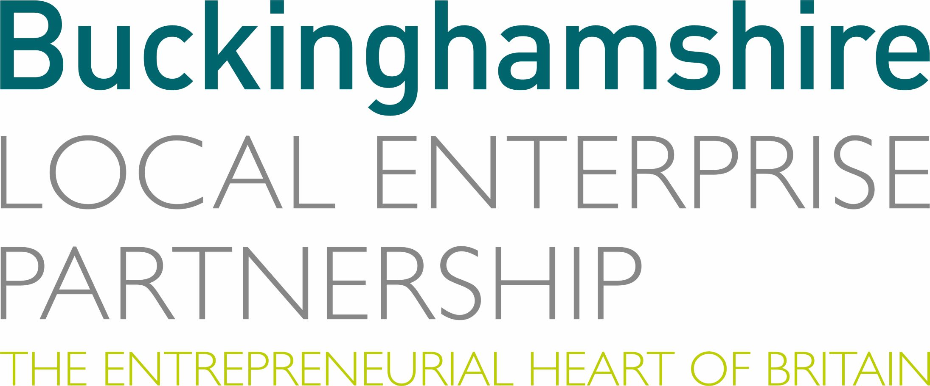

INVITATION TO QUOTE FOR

An Audit of Buckinghamshire’s Green Economy

Issued by:

Buckinghamshire Local Enterprise Partnership

Date: 20 December 2021

Contact:

Caroline Hargrave

caroline.hargrave@buckslep.co.uk

DD: ​ | 01296 327348
M: | 07908 895227

INSTRUCTIONS

Introduction

  - This invitation is issued by Buckinghamshire Local Enterprise Partnership Ltd (Companies House No. 11912208), registered at Claydon House Business Centre, 1 Edison Road, Aylesbury, Buckinghamshire, HP19 8TE

  - The lead for the procurement is Caroline Hargrave, Research Manager, Buckinghamshire Local Enterprise Partnership, caroline.hargave@buckslep.co.uk or 01296 327348

Submission of Quotes

  - Please submit your quote via email to caroline.hargrave@buckslep.co.uk no later than noon on 20 January 2022.

  - We expect to select our preferred bidder during the week commencing 24 January 2022, but ask that quotes will remain open for acceptance for a minimum of 90 calendar days.

  - The confirmation of contract award will follow the project initiation meeting with Buckinghamshire LEP to be held in February 2022, date to be arranged.

Form of Quote

  - In preparing your quote, we ask you to provide a method statement, a pricing schedule (including day rates), to submit the CVs of key staff who will work on the project, and provide two referees who can attest to the quality of similar work you have undertaken.

  - The method statement should include a description of the steps you would take to undertake the audit and a timetable.

  - The provision of references will require you to submit a description of similar work you have done for others, together with the name and contact details of the client. We will approach the referees you name and ask them to verify the claims you have made.

Financial Arrangements

  - This is a single contract for consultancy services and does not preclude existing or future contracts with Buckinghamshire LEP for other consultancy services.

  - All prices exclude VAT and include travelling and subsistence expenses and all other disbursements.

  - Payment will be 50% on completion of mid-way milestones, and 50% on completion of project.

Timetable

 | Event | Date
 | Invitation to Quote issued | 20 December 2021
 | Return of submissions | 20 January 2022
 | Selection of preferred bidder | w/c 24 January 2022
 | Project Initiation Meeting | February 2022
 | Project end date | Mid-May 2022

Contract Documents

  - The project contract document will be based on Buckinghamshire LEP’s standard Consultancy Agreement

SPECIFICATION

Aims and objectives

Buckinghamshire LEP wish to commission research to:

- Map and understand Buckinghamshire’s green economy
- Identify local green economy opportunities and challenges
- Benchmark and monitor Buckinghamshire businesses journey to net zero over the coming years
- Make recommendations regarding the role of Buckinghamshire LEP and economic development partners (including Buckinghamshire Business First and Buckinghamshire Council) in driving forward local, national and global net zero ambitions

Ultimately, the findings of this research will inform local net zero economic strategy.

Project details

The project will include:

- Developing an evidence base

This will consist of two elements.

- Innovation for net zero

- Mapping and categorising local businesses operating in the green economy (defined as the sectors identified in the Green Jobs Taskforce report, July 2021, which is referenced in Net Zero Strategy: Build Back Greener, October 2021. These are listed in table 1 below)

- Identifying Buckinghamshire’s green economy specialisms.

Which local companies are leading the way nationally and internationally? Are there clusters of green economy activity in / near to Buckinghamshire?

- Identifying opportunities for growing these and other green specialisms in the County

- Business journey to net zero

- Benchmarking the extent to which Buckinghamshire’s business population as a whole are adopting net zero strategies (including switching to cleaner fuels and improving resource and energy efficiency) and net gains being achieved.

- Making policy recommendations

- Articulating the opportunities and challenges for green innovation and business journeys to net zero in the County

- Making recommendations regarding the role of Buckinghamshire LEP and economic development partners (including Buckinghamshire Business First and Buckinghamshire Council) in driving forward local, national and global net zero ambitions in the short, medium and long term. What should the LEP and partners be doing over the next 5, 10, 15, 25 and 30 years?

Ultimately, the findings of this research will inform local net zero economic strategy (including skills strategy).

Table 1. Green economy sectors
- Well-established green sectors which will experience significant growth
- electricity networks
- smart systems technologies
- buildings retrofit sector
- building fabric energy efficiency
- modern methods of construction for retrofit and especially new build
- offshore wind

Green sectors that are predicted to grow ahead of the transition to net zero
- hydrogen
- Carbon Capture, Usage and Storage (CCUS)
- climate resilience market

Sectors experiencing significant transformation
- automotive
- heating and cooling
- circular economy
- oil and gas

Outputs

We require the following outputs from the project:

- An interactive map, that we can maintain locally, plotting the location of Buckinghamshire’s green economy innovators (such as that produced by the West Midlands Observatory - Green Growth Storymap (arcgis.com)).

- A list of local green economy businesses (where they are located, their size (employment/turnover) and what they do)

- A dashboard and underlying methodology for local stakeholders to benchmark and monitor Buckinghamshire businesses journey to net zero over the coming years.

- A written report (including a short, clear executive summary) including policy recommendations

Supporting information

We wish this project to take into account recommendations set out in the government’s Net Zero Strategy, along with the following local strategies:

- Buckinghamshire’s Local Industrial Strategy
- Buckinghamshire’s Economic Recovery Plan
- Buckinghamshire’s Local Energy Strategy
- Buckinghamshire’s Climate Change and Air Quality Strategy.
- Buckinghamshire’s Local Skills Report

We also wish this project to take into account existing activity being undertaken within the County. Including:

- Low carbon workplaces grants
- The Buckinghamshire Business First Net Zero Collaboration Circle
- Green innovation activity being undertaken at Buckinghamshire’s Enterprise Zones

Steering group members

The project will be overseen by a steering group, comprising representatives from Buckinghamshire LEP, Buckinghamshire Business First and Buckinghamshire Council.

Buckinghamshire Business First (the County’s business support organisation) has a membership of around 14,000 local businesses, including links to many of the County’s net zero innovators.

Buckinghamshire LEP has begun to develop a list of local green economy businesses. This will be shared with the successful bidder.

Budget

Our budget for this project is £25,000

Timescales

The deadline for completion of the project is mid-May 2022.

Quote

- I have examined the Invitation to Quote and offer to undertake the services required in accordance with the bid documents for prices detailed below.

Insert pricing schedule here

- All prices exclude VAT and include travelling and subsistence expenses and all other disbursements.
- I understand that Buckinghamshire Local Enterprise Partnership is not bound to accept any quote received. This quote remains open for acceptance for 90 days from the return date fixed in the Invitation to Quote.
- I certify that my company has taken out or will hold Professional Indemnity Insurance for a minimum level of £0.5 million (for each and every claim) on or prior to the Commencement Date.
- I understand that Buckinghamshire LEP may be subject to the requirements of the Freedom of Information Act 2000. The schedule of reserved information below is my company’s request for information contained in this quote not to be released for reasons which are allowed in the Act.
Reserved Information | When available for disclosure | Relevant Section of Act | Reason
Response to the Invitation to Quote | After award of Contract | Section 43(2) | Commercial confidentiality
Please add as necessary

- I have included a Method Statement setting out my organisation’s understanding of your requirements and the general approach we would take to meeting the specification.
Method Statement

Please describe the methodology you would use to undertake this project.
This could include:
- interviews with local stakeholders
- details of how you would identify green economy companies (which could involve web scraping, the use of AI etc)
- a business survey / interview
- how you would produce a map and dashboard that could be maintained by local stakeholders on an on-going basis

Please include a provide a project plan and a project risk assessment

- I have included short CVs of the key personnel I intend to deploy in delivering the services required.
- I have included details of clients for whom my company has provided similar services together with contact details for referees who can be approached to verify the claims made.
Referee 1
Contact name, company, phone number, email and project name
Description of the services supplied
Referee 2
Contact name, company, phone number, email and project name
Description of the services supplied

- I have attached my organisations standard terms and conditions which will form the basis of the contract with Buckinghamshire LEP.

Name………………………………………………………………

Position………………………….…………………………….……

Company……………………………………………………………

Date………………………………………………………………….

Note, Buckinghamshire’s Skills Strategy will be refreshed in early 2022. Current strategy is set out in the Buckinghamshire Local Skills Report. It is envisaged that the refreshed strategy will set out goals in relation to ensuring the local economy has access to the skills needed to enable the transition net zero.

