# Schedule 7B

**Order Form for Standard Goods and Services – Mini Competition**

**DN645180 - Provision of Rubrik Backup Licences**

**Call-Off Contract under the HealthTrust Europe LLP Framework Agreement for the provision of Enterprise Level Information Communication Technology (ICT) Solutions for hardware, software, programs, applications, security, computer science, managed services, consultancy, support and associated services – 2019 (reference number: SF050716) dated 27th September 2019.**

|  |  |
| --- | --- |
| **The Authority** | **Manchester University NHS Foundation Trust,** Cobbett House,  Manchester Royal Infirmary, Oxford Rd, Manchester M13 9WL, UK |
| **The Supplier** | **CDW Limited** of One New Change, London, EC4M 9AF, United Kingdom |
| **HealthTrust**  **Europe Contract Reference** | **HTE-005703** |

The Supplier and the Authority hereby agree as follows:

1. Following the completion of a mini-competition exercise (“**Mini-Competition**”), the Authority wishes to enter into a Contract in respect of the Goods and Services pursuant to the Framework Agreement.
2. The Contract incorporates, and the Supplier agrees to abide by, the following documents to the extent that they are not inconsistent with paragraphs 4-6 below:
   1. the Mini-Competition Specification of the Authority’s requirements as appended at Appendix 1 overleaf.
   2. the Mini-Competition Response Document submitted by the Supplier, including the Contract Price, as appended at Appendix 2 overleaf.
   3. the Call-Off Terms and Conditions set out at Appendix A, as applicable, to the Framework Agreement (including the front page and all Schedules thereto); and
   4. The End User Terms (defined further below).
3. Where the Call-Off Terms and Conditions set out at Schedule 1 of Appendix A to the Framework Agreement apply, the Authority acknowledges and agrees to the HealthTrust Europe Key Provisions, in particular , as stated below for the avoidance of doubt:
4. In the event that the Authority terminates its agreement with HealthTrust Europe (made pursuant to the provisions of the UHCW Framework) for convenience or otherwise, and such termination takes effect before the end of the Initial Term (as defined in the UHCW Framework) or in the event that the Authority’s agreement with HealthTrust Europe (made pursuant to the provisions of the UHCW Framework) expires without being renewed on or after such Initial Term, HealthTrust Europe shall notify the Supplier of such termination or expiry in accordance with the provisions of Clause 16 of Schedule 1 of the Framework Agreement (“**Beneficiary Withdrawal Notice**”). Upon receipt of such Beneficiary Withdrawal Notice by the Supplier, the Supplier shall cease to apply for the benefit of the Authority, the Contract Price or any special discounts in relation to such supply which applied solely by reason of the operation of the UHCW Framework and its associated services and/or framework agreements or any contract made between the Authority made pursuant thereto and further the Authority shall no longer be permitted to place Orders or benefit from the Contract Price, save with the prior written consent of HealthTrust Europe
5. The Authority acknowledges and agrees that the Supplier is subject to an activity based income (ABI) management charge in relation to any Orders placed by the Authority under the Framework Agreement.
6. The Authority and the Supplier agree that (in addition to the Authority’s right to enforce the Contract) HealthTrust Europe may enforce any term of the Contract as principal in respect of ABI and Management Information and as agent on behalf of the Authority in respect of all other terms.
7. **The Commencement Date of the Contract shall be 27/01/2023**
8. **The Term of this Contract shall be 3 years from the Commencement Date**

**5.1 Total Value £ £1,351,036.68 (Exc. VAT)**

1. Data Protection

6.1 In performing its obligations under this Contract, the Supplier does not expect to process personal data for the Authority or any other person and will only process personal data on behalf of the Authority or any other person hereunder upon receiving a separate formal written instruction from the Authority to the Supplier requesting the Supplier to do so.

6.2 In the event that the Authority separately instructs the service provider or third party contractors or suppliers (including any sub-contractors of the Supplier) whether verbally or in writing to process personal data or makes personal data available to them without instructing the Supplier to process that data then it engages those entities directly for those separate processing purposes and the Supplier shall not be a data processor for those separate processing arrangements.

1. Supplier shall use reasonable endeavours to deliver the Goods and/or Services under this agreement by the agreed delivery date.
2. The payment profile for this Contract shall be 30 days from Invoice.

1. The Authority may terminate this Contract forthwith by notice in writing to the Supplier at any time on ***three (3) months*** written notice. Such notice shall not be served within ***one (1)*** year of the Commencement Date. Billing will be annual in advance.
2. The Provision of services
3. The Services shall be provided, and Goods delivered by the Supplier at the

**Premises and Locations:**

Cobbett House, Oxford Road, Manchester, M13 9WL

1. Use of Subcontractors

The Authority grants permission for the Supplier to Sub -contract any of its obligations/ specific obligations under this Framework Agreement. This shall not impose any duty on the Authority to enquire as to the competency of any authorised Sub-contractor. The Supplier shall ensure that any authorised Sub -contractor has the appropriate capability and capacity to perform the relevant obligations and that the obligations carried out by such Sub-contractor are fully in accordance with the Framework Agreement.

1. The end user license agreement (EULA) applicable to the relevant Software Product, as stipulated by the Manufacturer of that Product appended at Appendix 9
2. The Contract Managers at the commencement of this Contract are:
   1. for the Authority:

Karen Flintoft,

Deputy Director of Informatics Commercial Services

Karen.Flintoft@mft.nhs.uk

* 1. for the Supplier:

Aaron Fitzpatrick, Account Director.

1. Notices served under this Contract are to be delivered to:
2. for the Authority:

Karen Flintoft,

Deputy Director of Informatics Commercial Services

Trafford General Hospital

Davyhulme, Manchester

M41 5SL

1. for the Supplier:

Head of Legal.

Legal@uk.cdw.com.

1. In this Contract, unless the context otherwise requires, all capitalised words and expressions shall have the meanings ascribed to them by the Framework Agreement and/or Call-Off Terms and Conditions.
2. The following Appendices are incorporated within this Contract:

|  |  |
| --- | --- |
| Appendix 1 | Authority Specification |
| Appendix 2 | Contract Price |
| Appendix 3 | Software and EULA |

# Signed by the authorised representative of THE AUTHORITY

|  |  |  |  |
| --- | --- | --- | --- |
| Name: | ..Jenny Ehrhardt.................... | Signature: |  |
| Position: | ...Group Chief Finance Officer | Date | 17/03/2023 |

**Signed by the authorised representative of THE SUPPLIER**

|  |  |  |  |
| --- | --- | --- | --- |
| Name: | Penny Williams | Signature: |  |
| Position: | VP of Sales | Date | 17/03/2023 |

**Appendix 1 Authority Specification**



**Appendix 2 Contract Price**

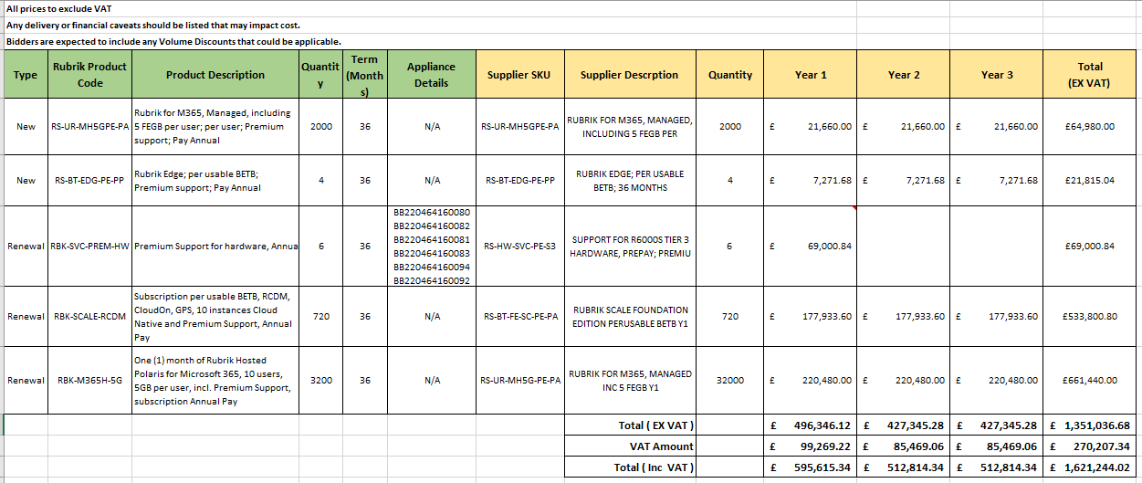



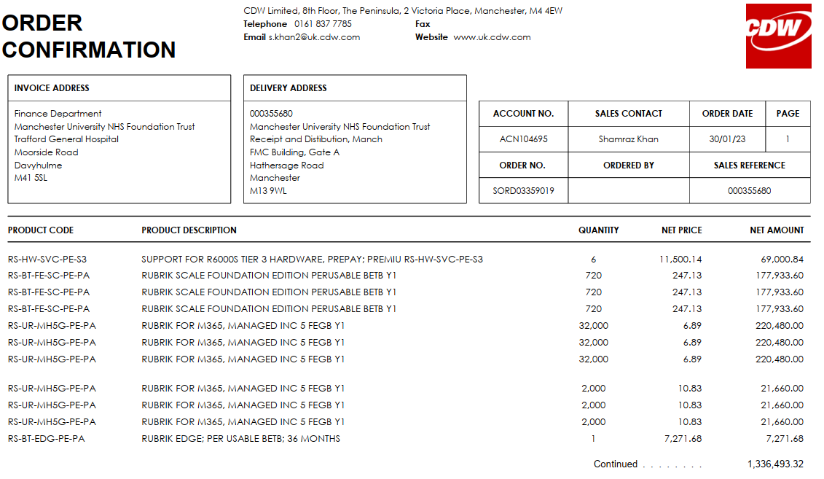

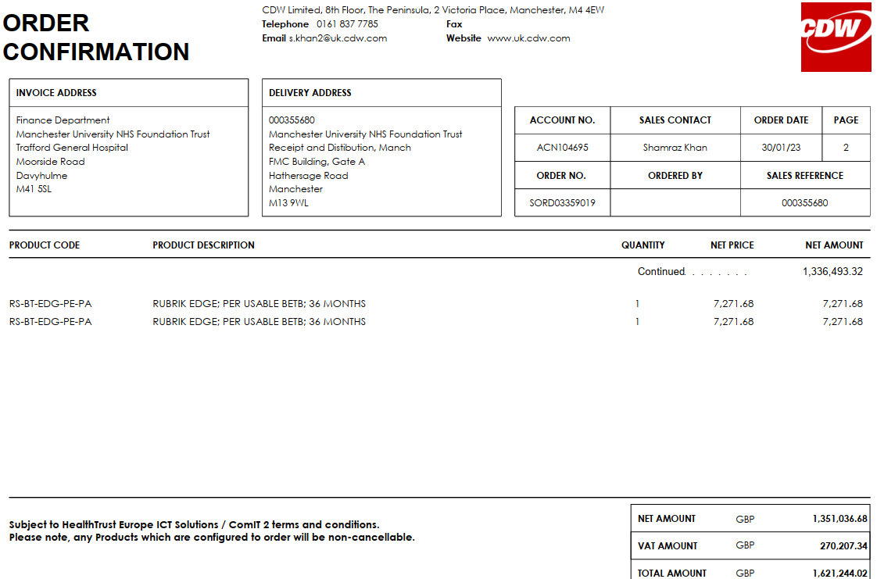

**Appendix3**

**Software and EULA**

[https://www.rubrik.com/legal](https://urldefense.com/v3/__https:/www.rubrik.com/legal__;!!HUqgN_M!u6hCzdoAA5vJIbkJVwHOxPc5RTV6l4zRvRZR5YktiJH_KuhzWv0r2GBQhKCzBLKywx421ZSJHw1s5wVyq4dRDWJI$)